Where can you find The Bishop Ruocco Council at work?

In the Catholic Church
We take an active role in prayer groups. Assist at Parish Picnics. Sponsor scholarships and seminarians. Promote the Culture of Life. Host special Prayer Services.

With Special Needs Children
We raise about $7,000 a year to fund equipment for Special Needs Children. Host special needs fairs for the children and their families.

With our Youth
We host a Basketball Free Throw Contest for the area towns and for the larger district. Provide Coats for Kids for less fortunate youth.

In our Families
Provide help and support for bereaved families. Help brother Knights and their families in time of need.

In the Community
Donate time, money, food, clothing to local charities. Provide support to local Pregnancy Care Centers. March in the July 4th parade. Run a food concession at the Country Fair.

Share your Spirit with others by joining us today!

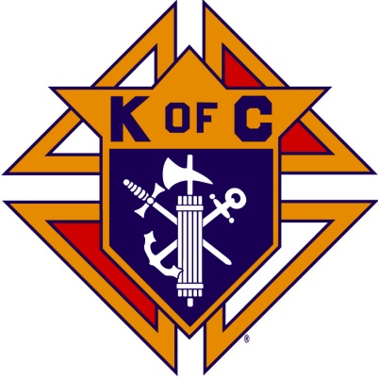
Knights of Columbus
Bishop Ruocco Council #9275

2-21-2024
Bishop Ruocco
Council
Knights of Columbus

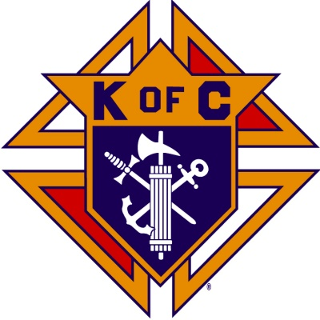

Charitable Service
In Support of
Faith, Family,
Community and Life

Serving the Communities of
Chelmsford, Littleton, and Westford
Knights9275.com

Who are the men of the Bishop Ruocco Council?
The Bishop Ruocco Council is a group of Catholic men that take an active role providing assistance to those around us in need.
We are especially focused on helping children and adults with mental and physical handicaps.
We also work closely with the Pastors and Priests of our local parishes to make ourselves available to the needs of the Faith Community.
We gather in the name of Charity and to be around others with a common faith.

Our Parishes
Holly Rood Collaborative
Saint John The Evangelist
Saint Mary
Saint Margaret of Scotland
Blessed Trinity Parish
Saint Anne
Saint Catherine of Alexandria
What will Membership in Our Council do for You?
- Strengthen your Faith
- Help you to meet families from your Parish
- Provide you with opportunities to help those around you in need
- Build friendships that will last a lifetime
Interested in learning more?
If you are a Catholic man in the Chelmsford/Littleton/Westford area that is looking for a low pressure way to strengthen your faith, and help the less fortunate, then perhaps you would like to join us. We are family men with many commitments and so we understand the many demands on your time.
Our motto is "do what you can".
These are a few of the various council activities that you can choose to participate in and approximate time that you may devote.
- Annual Tootsie Roll Drive (3 hours)
- Annual Special Needs Fair (2 to 3 hours)
- 4th July Parade (2 hours)
- 4th July Food Booth (2 to 4 hours)
- Monthly Social Events (1 to 2 hours)
- Monthly Business Meetings (2 hours)

Here's how to contact us:
You can reach us in a variety of ways, and we will contact you to answer your questions, and be assured that there will be absolutely no pressure.
By MAIL:

Knights of Columbus
Bishop Ruocco Council
1521 Gorham St.
Lowell, MA 01852

EMAIL:
knights9275@gmail.com
Our Council Website:
knights9275.com

Join Online
You can join our order through the Supreme website kofc.org/joinus. Use our council number 9275 in the application.
Our council leaders will then be notified and we will guide you through membership in our local council.
Supreme Website:
kofc.org

