Fill out top part (MUST BE FILLED OUT COMPLETELY, in inches–

[feet & inches for height] )

DANCER’S NAME
BUST
WAIST
SIZE CHART HIPS
GIRTH
LEOTARD SIZE
HEIGHT
INSEAM
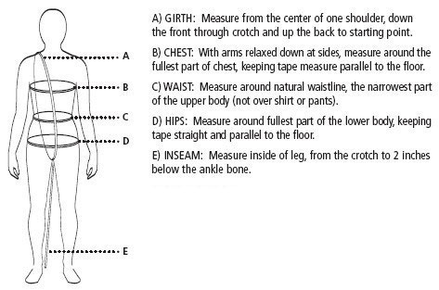
FOR OFFICE USE ONLY
CLASS COMPANY SIZE

