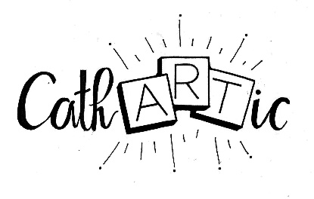

Cathartic C.I.C.
Referral Form
Date of Referral: _______________________________

Referral made by:
Name: _________________________________________________________
Organisation: ____________________________________________________
Address: ________________________________________________________
________________________________________________________
Email: __________________________________________________________
Telephone: ______________________________________________________

Client information
Name: _________________________________________________________
Address: ________________________________________________________
________________________________________________________

Reason for Referral: ________________________________________________________________________________________ ________________________________________________________________________________________________________________________________________________________________________________________________________________________________________________________________________

Please indicate which programme(s) the referral is being made for
  - Weekly Creative Art Sessions
  - Bespoke At Home Art Sessions
  - SEND Holiday Art Workshops
  - Teenage Resilience and Self-Esteem Programme
  - The Inter-Generational Project
  - All About Me
  - A Trip Down Memory Lane
  - Make Your Mark – collaborative creations within an establishment

Please scan and email to maria@catharticcic.com/nicky@catharticcic.com

