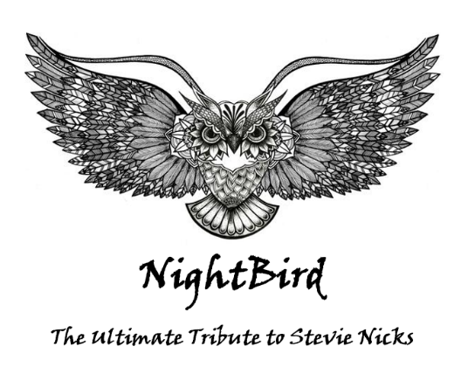

NIGHTBIRD SWFL- INPUT LIST
CH # | INPUT | MIC | STAND | NOTES
1 | KICK | CAD KM212 | SHORT BOOM | DRUM RISER 8X8 UR
2 | SNARE | CAD SN210 | CLIP | DRUM RISER  8X8 UR
3 | TOM 1 | CAD TM211 | CLIP | DRUM RISER 8X8 UR
4 | TOM 2 | CAD TM211 | CLIP | DRUM RISER  8X8 UR
5 | FLOOR TOM | CAD TM211 | CLIP | DRUM RISER 8X8 UR
6 | OH (LT) | CAD CM217 | MEDIUM BOOM | DRUM RISER  8X8 UR
7 | OH (RT) | CAD CM217 | MEDIUM BOOM | DRUM RISER  8X8 UR
8 | CAJON | AKG 58 | SHORT BOOM | DC (2ND SET)
CH # | INPUT | MIC | STAND | NOTES
9 | CONGA | Sennheiser | CLIP | 6x8 RISER UL
10 | CONGA | Sennheiser | CLIP | 6X8 RISER UL
11 | CONGA | Sennheiser | CLIP | 6X8 RISER UL
12 | CONGA | Sennheiser | CLIP | 6X8 RISER UL
13 | BONGO | AKG Dynamic ND267 AS | CLIP | 6X8 RISER UL
14 | DJEMBE | AKG D112 | SHORT BOOM | 6X8 RISER UL
15 | GONG | AKG D2300S | LONG BOOM | 6X8 RISER UL
16 | PERCUSSION TREE | Rode NT-5 Condenser | LONG BOOM | 6X8 RISER UL
17 | PERCUSSION TREE | Rode NT-5 Condenser | LONG BOOM | 6X8 RISER UL
18 | BASS GUITAR | DIRECT XLR LINE OUT | GUITAR STAND | ULC
19 | TOP KEYS | DIRECT LINE (BOX) | 2 TIERS | 4x8 RISER UR
CH # | INPUT | MIC | STAND | NOTES
20 | BOTTOM KEYS | DIRECT LINE (BOX) | 2 TIERS | 4X8 RISER UR
21 | ELECTRIC GUITAR | BETA 57 | SHORT BOOM | DRC PEDAL BOARD DLC
22 | ACOUSTIC GUITAR (MARK) | DIRECT LINE (BOX)  Wireless | GUITAR STAND | DRC
23 | ACOUSTIC GUITAR (KAREN) | DIRECT LINE (BOX) | GUITAR STAND | DR
24 | VOCAL (LEAD-ANGELA) | SHURE WIRELESS SM58/GLXD4 | LONG BOOM | DC
25 | VOCAL (BACK-LIZ) | BETA 58 | STRAIGHT | DL
26 | VOCAL (BACK-TROY) | SHURE 58 | LONG BOOM | DLC
27 | VOCAL (BACK-MARK) | BETA 58 | LONG BOOM | DRC
28 | VOCAL (BACK-KAREN) | BETA 58 | LONG BOOM | UR
 | IEM WIRELESS | SHURE PSM300/P3T  DIRECT LINE (BOX) |  | LEAD VOCAL (ANGELA)
 | IEM WIRELESS | SHURE PSM 300/P3RA  DIRECT LINE (BOX) |  | BACK VOCAL (TROY)
 | GUITAR WIRELESS SYSTEM |  |  | POWER EXTENSION

*8X8 DRUM RISER NEEDED (UC)
*8X8 CONGA/PERCUSSION RISER NEEDED (UL)
*Adequate power extensions for additional stage lighting.
*We carry our own mics unless otherwise discussed in advance
*Contact: Angela Chang 765-490-6726

