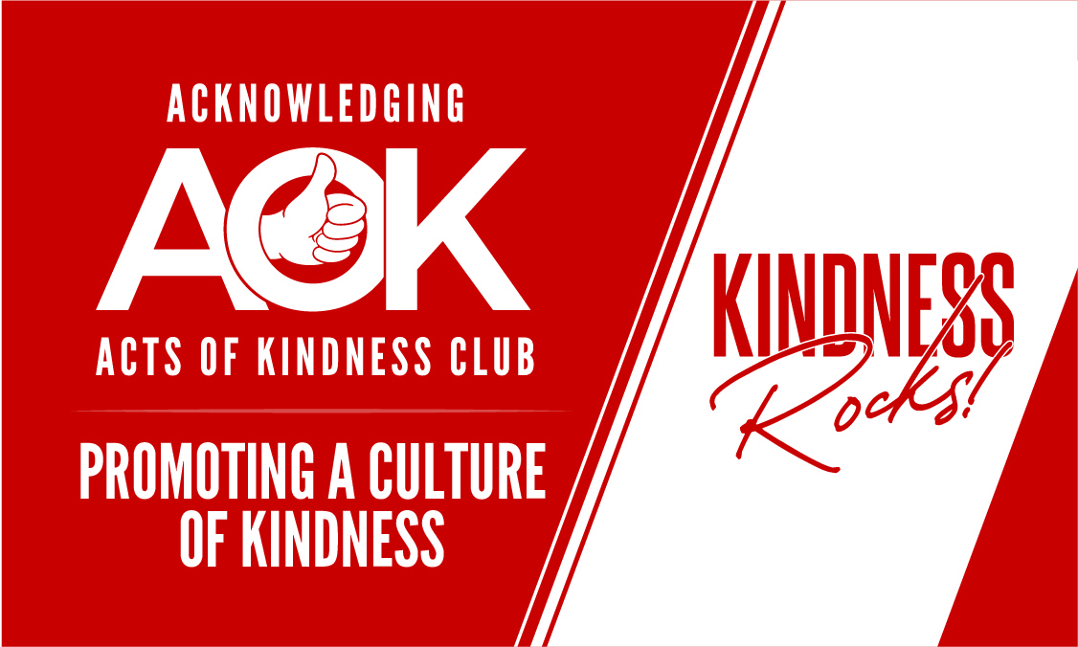

Acknowledging Acts of Kindness Club Newsletter
April 2020
First of all, a warm welcome to our new members Sue Perencevic ( Pine Hills), Sandy Palmer, Bruce Howorth (Duval), and John Cornell. Our membership is growing (81) and you can all help by getting the word around. The best advertisement is word of mouth and my experience is that folks just love what we do. Do you have any friends or neighbors who would like to be a part of our club?
Dealing with the Pandemic
To say the least, these are trying times and I hope you are all doing well. We all have to do our part and make some sacrifices, but I am a total optimist. We will defeat this, and be stronger because of it. Times like this also bring out the kindness in people and examples abound of stories of people helping people.
Hopefully, our next meeting will be Thursday, May 14th at 12:30 in the Bacall Recreation Center. We will keep you posted of any changes.
We had to cancel or postpone some key events to include the St. Pats Day Parade and two very exciting Level two acknowledgements. Thanks to all of you who volunteered for these events. And with the current social distancing guidelines we are limiting the passing out of our kindness cards. Also, our programs to focus on educational groups, businesses, and social groups are also in a state of suspension.
Oh well. Like we say in The Villages, ‘It Is What It Is”. Here are a couple of things to help you lighten up:
Married couples during the pandemic
What happens when engineers are quarantined
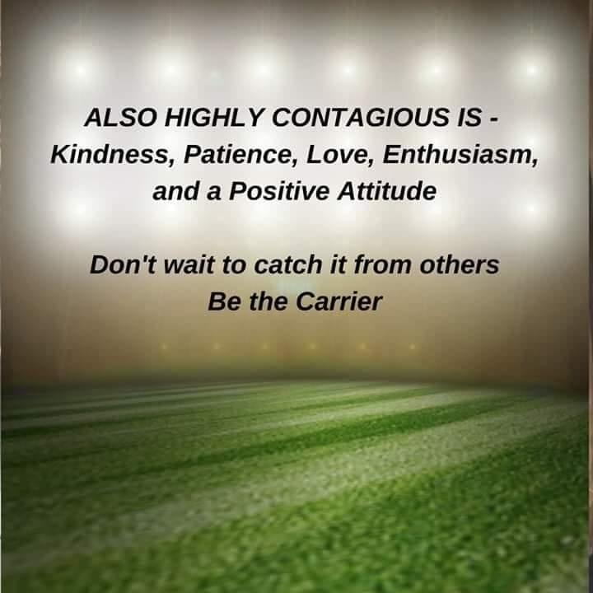

AAOK Club one-pager
I am asked frequently for a short description of our club and my guess is that many of you are too. Attached is a one-page description that you can use to share with those who ask you for more information about the club. You may even want to send this to some friends to tickle their interest.
Billy’s Baseballs – A Nice Story
Our new member, Irene Bolton, has organized a group here in The Villages to craft Billy’s Baseballs to be sent to our troops. Her former student, Billy Cook, started this effort as a Bar-Mitzvah project with the goal of sending 100 baseballs with messages of love, thanks, hope, and praise to our troops. They are currently at about 15,000 balls with help from a lot of friends!
Thank you, Irene, for all your efforts. She also handed out cards as well as the one page description of our club to all those involved. I hope Irene will be able to share this story at our next meeting.
Visit the Billy’s Baseball website at http://www.billysbaseballs.com/.
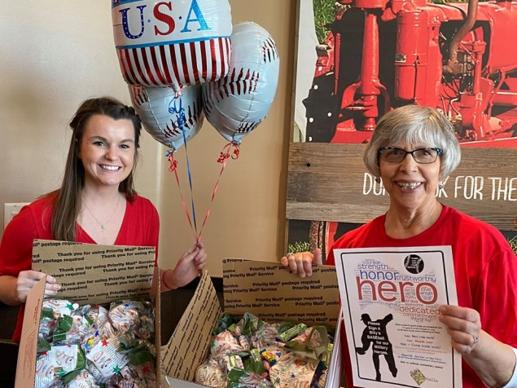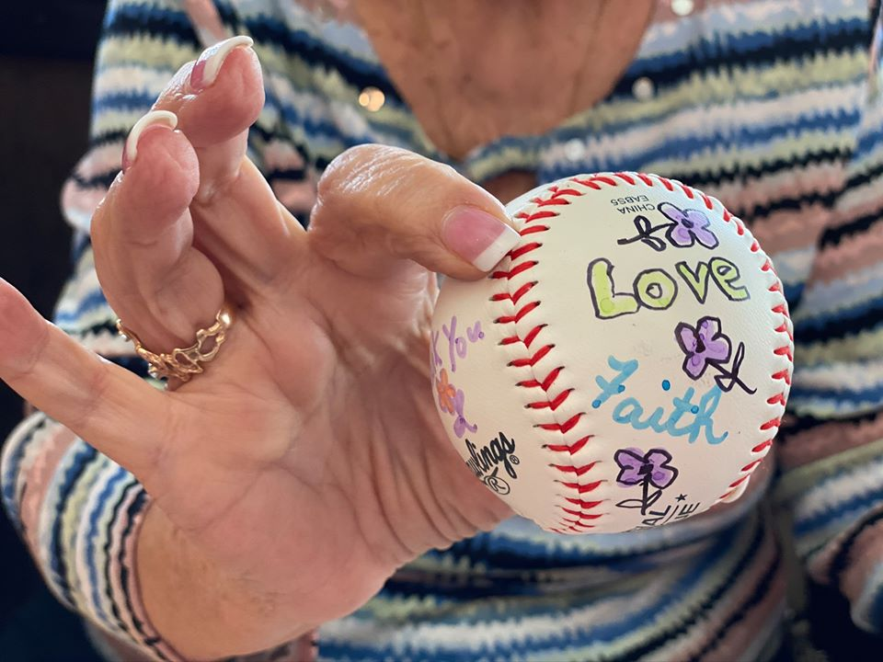
Village Neighbors Magazine
Denise Lasley has been a member of our club from the start, and is also a Content Coordinator for Village Neighbors Magazine. She wrote a wonderful article about our club in the magazine a few months ago. She wants to have a monthly feature about our club events. What a great idea! The first will be about Anne Sheehan’s Dayton, Ohio activities.
If you have any ideas about what you would like to see featured in subsequent issues please let me know. And thank you, Denise, for doing this!
Kindness Certificate
In last month’s newsletter we introduced our new Kindness Certificate (designed by Chardell Kern). My plan was to showcase this by awarding it to two of our members. One of them was Anne Sheehan. It also turned out that I couldn’t make the meeting, but I did have a chance to present this to Anne at her St. Pat’s Day party in front of a lot of her friends. The bad news is that she and her husband, Terry, decided to shorten their visit to The Villages and scoot on back to Ohio.
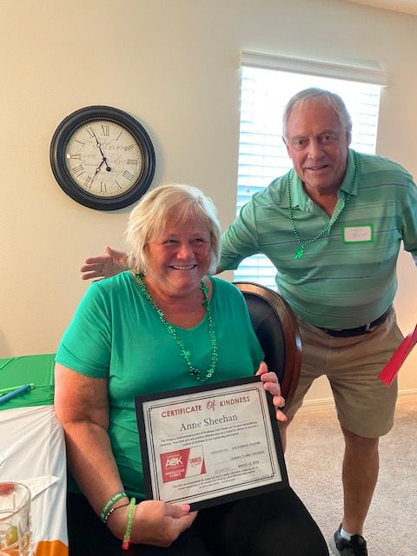
I’ll keep you wondering about the other recipient, and you will find out in May. Let me know if you have someone in mind that deserves one of these.
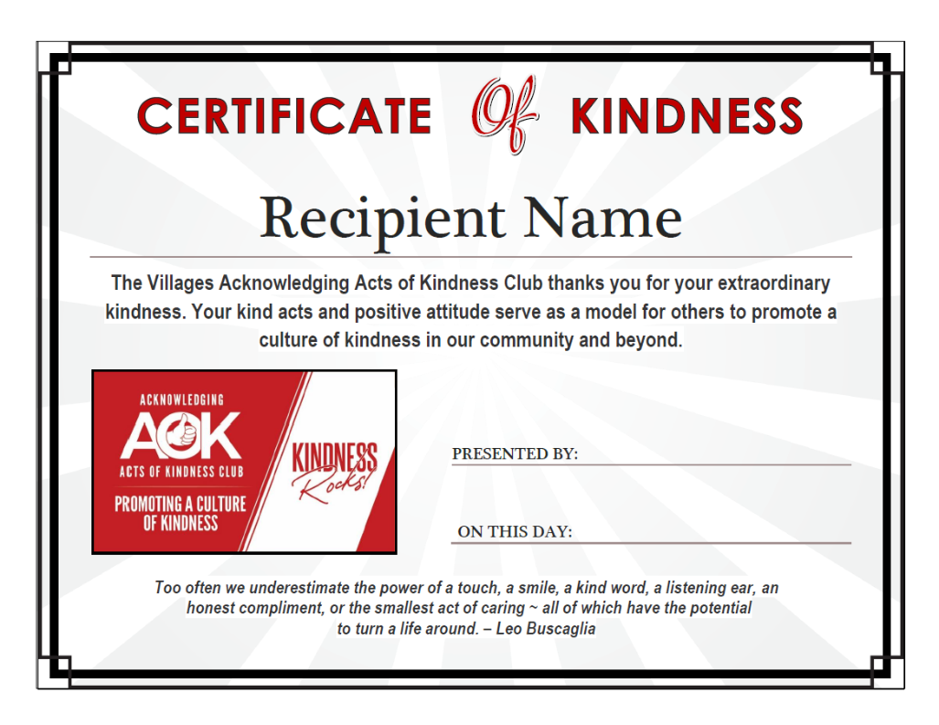
New Book
I am working on a new book which is tentatively titled, Kindness Rocks: How to Live a Life of Kindness. One of the appendices will be “Thoughts on Kindness from My Friends’. If you would like to contribute a 100-200 word piece on this please let me know. Here’s your chance for fame!
Ideas to Enhance our Club’s Mission
Our mission is to promote a culture of kindness. Our focus has been mostly on acknowledging acts of kindness. I think we have been very successful with this. But perhaps, as we look into the future, there are a lot more ways we can realize our mission. So let’s give this a try – kind of a virtual brainstorming session.
In what ways could our club promote a culture of kindness? Send me your thoughts on this and I will track them. I will then get them back to you so we might build on them some more. This should be fun, and it will be a great way of keeping you from being bored out of your mind during this period.
Club Shirts
Here is the status on club shirts. We currently have 5 T-Shirts left (3 LG and 2 XL). These are just $10 each. We also have 8 collared shirts in various sizes. These are $20 each. Money from these sales goes directly into our treasury. When these are sold we will be getting all of our shirts through Custom Apparel in the Southern Trace Plaza off Rte 466. At Custom Apparel you will be able to get the shirt design of your choice with our logo. You will also be able to have your name on it for a slight charge. The only thing we ask is that your color be our club’s red.
Stay safe and well - Lindsay Collier

A kind heart is a fountain of gladness making everything in its vicinity freshen into smiles. - Washington Irving

