Ascension Parish First

Line DANCE

Workshop Social & Competition

***Concert featuring***: Special Musical Guests;

ENT DISTRIKT -MIC360, SWAGGA WILKES

singing their **MEGA** hit song,

“Same Ole 2Step”

Friday, July 20, 2018 - Doors open at 5:30

The Crystal Chateau Event Hall

36501 Mission Street, Prairieville, LA 70769

presented by, Ascension’s very own

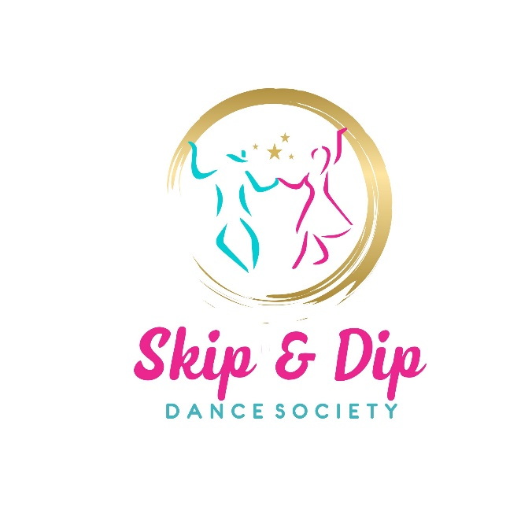

In partnership with

DESMA

Enjoy Party Entertainment LLC. &

“No Supervision” Dance Studio LLC.

**Dance Workshop Coordinator**:

Professional Dance Instructor, Ms. Lauren Fontenot

**HOST HOTEL:** America Best Suites Inn 17301 Airline Hwy Prairieville, LA.

To receive the elite group rate of $66.00, mention the

“**Ascension Line Dance Workshop & Social**”. Limited Rooms book by July 10th.

**Food & Drinks will be available with Advanced Ticket Purchase. Please no alcoholic beverages. This workshop is all-inclusive as to levels of dances taught.**

|  |
| --- |
| Our purpose is to have most of the attendees dancing and not sitting. During open dance times, we will dance to your requests. Couples & Group dancers are welcomed.  **The Workshop is for People who love to dance especially Line Dance.**  To get the most out of the workshop, come prepared to   * Learn new Line Dance steps * Learn how to Start, lead & promote your group for fun or exercise * Meet old friends & make new friends * Get Information about **Group Competitions**, most of all Have Fun!   ***Professional Photographer will offer Pictures***  ***All Groups Invited: Country, Latino, Salsa, & Soul Groups!!!*** |
| **COMPETING Group Registration Form - Please Print & Submit**  **Group Lead Name _______________________________Address______________________________**  **Group Name** __________________________**# of Members in Group**______Type_____________________________  **Song_______________________________________ Competing________ Workshop Only ________ Group Picture __________**  **Email ____________________________________________Phone: ________________________**  Tickets are all Inclusive   |  |  |  | | --- | --- | --- | | **Workshop & Concert**  **BEFORE - July 1st,** | $45.00 x _____ | $ | | **Workshop & Concert**  **AFTER - July 1st,** | $55.00 x _____ | $ | | **Step Sheet Booklet** | $3.00 x ______ | $ | | **C Checks payable to DESMA for HER** Total Enclosed | | $ |   **Mail to: Louise Bergeron, 18389 Petroleum Dr. Baton Rouge, LA 70809**  By the submission of this form by the party listed above signifies the following: “I agree to hold the organization of this event and their agents harmless from all suits, claims, or demands of every kind and character arising out of and in conjunction with this event. I understand the physical risks of attendance or participation in this event and assume full responsibility for any injury or personal damages or loss resulting from this event named above. I certify that I am 18 years or older (applicable to Legal Guardian if under 18 years).”  Your canceled check will serve as your confirmation. **Contact; Barbara** **contact@desma4her.org** or **phone: 225-240-1170**  ***If you are coming as a Line-Dance Group, please include name on sheet and WEAR You Group Attire!***  ***www.desma4her.org*** |