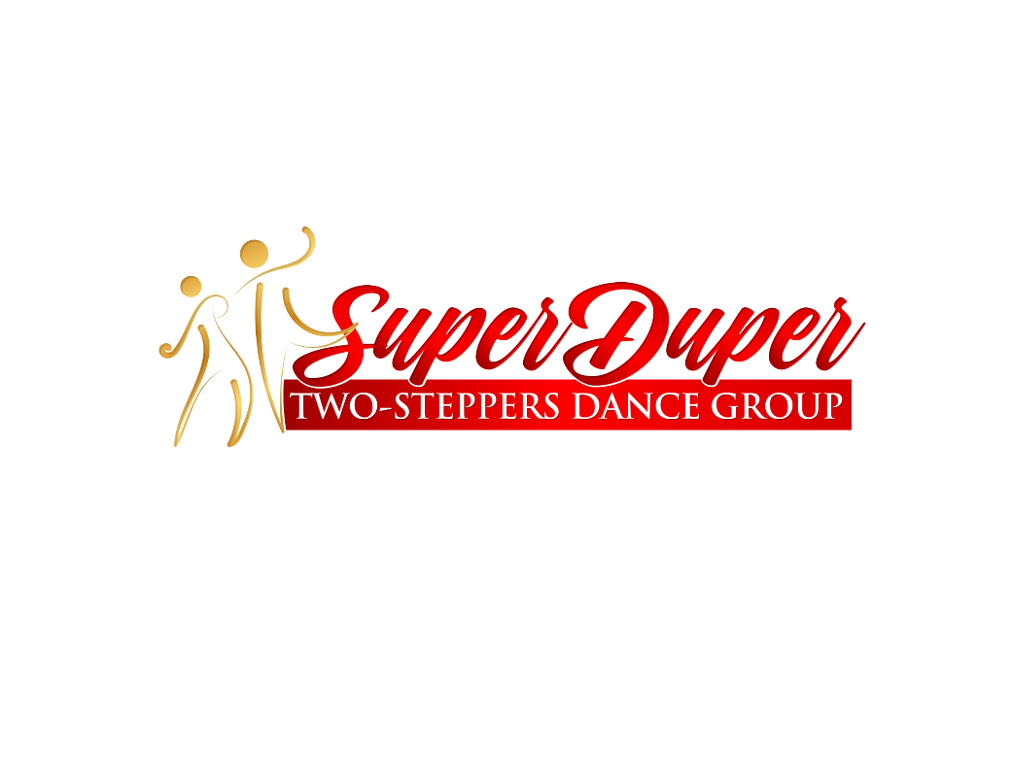

**“All-star Coed Group”**

Join other dancers & learn some fun Line Dances or just come for the great exercise, we teach many different line dances to all genres of music like **Country, Top 40, Hip Hop, Ballroom, Blues, Funky, Latin, Irish, Swing and much more.** Looking for Line Dancing fun in the Baton Rouge area, then you want to come here. We have the real hardwood dance floor, with air conditioning.

We Meet

***Tuesday & Thursday Evenings***

**The Crystal Chateaux**

36501 Mission Street

Prairieville, LA

...the MOST experienced line instructor! **Lauren Fontenot**, dance instructor extraordinaire, has over 15 years teaching thousands of people to dance.

 NO SUPERVISON DANCE STUDIO

***For Information: Lauren or Barbara 225-240-1170, visit desma4her.org***

*A study at the Albert Einstein Medical Center in the Bronx, N.Y. found dancing to be the only regular physical activity associated with a significant drop in the incidence of dementia, including Alzheimer’s disease. Other studies have shown Line Dancing Lessons to be a significant help in areas of memory, balance, cardiovascular and vertigo. And it’s a ton of fun!*

*****Anybody is Welcome to come!***