Attn: Community Leaders
Donations Needed
Tutoring Supplies: Needed for students K-12.
*Elementary and college rule paper, dictionaries, folders, book bags
*Pens, pencils, highlighters, calculators
*Glue bottles and glue sticks
*Scissors, crayons, rulers, notebooks, binders, trapper keepers, erasers
*Laptops, kindles, and/or iPads

Administration Supplies:
*File cabinets, file folders, vanilla folders, staplers/staples, pens, pencils
*Paper clips, paper binders, rubber bands, copier paper, colored copier paper, office phones, heavy duty copiers/printers, image transfer printer kits, plastic paper stand holders, plastic sign holder, tabletop displayette, brochure and leaflet holders, desktop paper holder
*Desktop computers, laptops, office chairs, oval table, office dusk
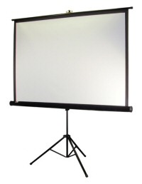
Projector Screens
Projector
Desktop Computers

Thank you for reviewing the items needed for our organization. The items above are greatly needed to continue our work in the communities that we serve. Delivery of donations can be discussed. In addition, all donations are tax deductible. Please email us at stlsmartkidsinc@gmail.com or give us a call at 314-884-1486.

