Smart Kids, Inc.

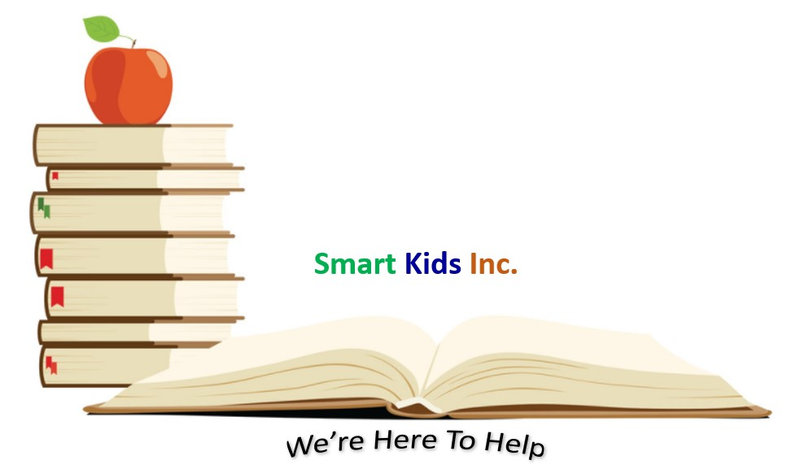

11520 St. Charles Rock Road, Suite 102

Bridgeton, MO 63044-2732

P: 314-455-3735

F: 314-455-3746

[www.smartkidsinc.org](http://www.smartkidsinc.org)

**Position:** Camp Counselor  
**Reports To:** Camp Director   
**Location:** Bridgeton, MO   
**Organization:** Smart Kids, Inc.   
**Employment Type:** Seasonal

**Compensation:** Paid $15 HR/Practicum/Internship/Federal Work Study  
**Dates of Employment:** 05/12/2025 – 08/01/2025

**Position Overview:**

The Camp Counselor is responsible for providing a safe, positive, and enjoyable experience for campers at Explore St. Louis's summer camp. Working as part of a team, the Camp Counselor will supervise and engage children in a variety of recreational and educational activities, ensuring that campers have an enriching and memorable experience. This role requires strong interpersonal skills, patience, enthusiasm, and the ability to be a positive role model.

**Key Responsibilities:**

* **Supervision and Safety:**  
  Ensure the safety and well-being of all campers, providing appropriate supervision during activities, meals, and downtime. Maintain a high level of vigilance, responding quickly and effectively to any emergencies or incidents.
* **Activity Planning & Implementation:**  
  Lead and participate in a variety of recreational, educational, and arts & crafts activities. Adapt activities to suit the age and abilities of campers and ensure that they align with the camp's mission and goals.
* **Camp Group Leadership:**  
  Act as the primary point of contact for a group of campers, fostering positive relationships with each child. Promote teamwork, communication, and respect within the group. Provide guidance and support to campers throughout the day.
* **Role Model:**  
  Exhibit positive behavior and serve as a role model for campers, including adhering to camp policies and guidelines. Encourage good behavior, conflict resolution, and social responsibility.
* **Camp Administration:**  
  Assist with camp registration, check-ins, and other administrative tasks as needed. Keep accurate records of attendance, health forms, and incident reports.
* **Communication with Parents and Guardians:**  
  Communicate effectively with parents/guardians regarding camper progress, behavior, and any concerns that may arise. Participate in parent meetings or events as necessary.
* **Team Collaboration:**  
  Work closely with other camp counselors, camp leadership, and volunteers to ensure the smooth operation of camp programs. Contribute to a positive team environment and attend staff meetings or trainings as required.
* **Additional Duties:**  
  Assist with camp setup, cleanup, and other logistical tasks. Participate in camp promotional events or fundraising activities as needed.

**Qualifications:**

* **Experience:**  
  Previous experience working with children in a camp, educational, or recreational setting is preferred but not required.
* **Skills:**
  + Strong communication and interpersonal skills.
  + Ability to work effectively with children, peers, and camp leadership.
  + Ability to lead, motivate, and engage children in a variety of activities.
  + Ability to handle stressful situations calmly and effectively.
  + Strong organizational and time-management skills.
* **Physical Requirements:**  
  Ability to lead and participate in physical activities, including walking, running, swimming, and other camp-related physical activities. Ability to lift, carry, and set up equipment as needed.
* **Certifications (if applicable):**
  + CPR and First Aid certification (or willingness to obtain prior to camp).
* **Personal Attributes:**
  + Energetic, enthusiastic, and passionate about working with children.
  + Responsible, dependable, and professional.
  + Flexible and adaptable to changing situations.
  + Positive attitude and a desire to contribute to a meaningful cause.

**Working Conditions:**

* This position may require working outdoors in various weather conditions.
* Camp Counselors may need to work 8:30 am – 5:00 pm.
* Must be available for the entire duration of the camp season, including training days prior to the start of camp.
* Ability to work in a team environment and collaborate with diverse staff, volunteers, and community members.

**How to Apply:**

Interested candidates should submit a resume and brief cover letter explaining their interest in the position and experience working with children to [info@smartkidsinc.org](mailto:info@smartkidsinc.org). Please include “Camp Counselor Application” in the subject line. In your cover letter, please include why you are passionate about working with students and how your skills can contribute to our mission. Please fill out an employment application at [www.smartkidsinc.org/employment](http://www.smartkidsinc.org/employment) .

Smart Kids, Inc. is an Equal Opportunity Employer and encourages individuals of all backgrounds to apply. We are committed to creating an inclusive environment and ensuring equal opportunities for all.