York - Northeast 2025 Spring Training Classes
All classes start at 8am. If you have any questions regarding any of these classes, email your questions to: York-TechSupport-NE@JCI.Com
To register for classes, go to: www.YorkTechSupportNE.com
- Upon registering, you will receive an email confirmation. If you don’t receive an email within 30 min of registering, check your spam folder, it likely got flagged.
- The day before the scheduled class, you will receive an email reminder from York-TechSupport-NE@jci.com (for virtual classes, you will receive the link and instruction for the class the day before the class).
- Once the email has been sent with the class link, the class will no longer be available for registration on the website. Its paramount that you register at least 48 hours before the class is scheduled to be held.

- Commercial Blower VFDs
This is a 4 hour class intended for service technicians who install, set up and start commercial packaged and split systems utilizing VFD drives.

Course Materials Include:
- VFD Electrical Characteristics
- Navigation
- Key Parameters
- Commissioning
- Alarm Codes
- Diagnostics & Replacement Instructions

- Commercial AC Charging & Diagnostics Packaged & Split
This is a 4 hour class designed to help installation and service technicians to determine and verify refrigerant charge in York commercial package and split systems.

Course Materials Include:
- Weighing in Refrigerant
- Lineset Information
- Subcooling/Superheat Target
- Field Measurement
- A2L and RDS Information

- Compressor (Hermetic) & Condenser Coil Diagnostics & Replacement
This is a 4 hour class intended for installation and service technicians who install & service residential and light commercial systems and perform compressor diagnostics & replacements.

Course Material Includes:
- Heat Pump Model Descriptions
- Installation
- Control Wiring
- Operation
- Diagnostics
- Leak Detection Best Practices
- Warranty Processing Procedures

- Equipment Airflow Measuring & Adjusting
This is a 4 hour class designed to help install and service technicians determine the amount of airflow needed, the amount of airflow present and how to adjust in both commercial and residential applications.

Course Materials Include:
- Required Airflow
- Application
- Field Measurement
- Outside Air Settings
- Finalized Report
- New 9 Speed Motor Information
- JHVTC/JHE Information

- Residential AC Charging & Diagnostics
This is a 4 hour class designed to help installation and service technicians to determine, verify and diagnose refrigerant charge in York residential split systems.

Course Material Include:
- Refrigerant Circuit Review
- Understanding Superheat/Subcooling
- Correct Charging Methods
- Confirming Charge Without Gauges
- Troubleshooting
- A2L and RDS Information

- SSE Simplicity Board Advanced
This is a 4 hour class intended for service technicians who install, set up and start commercial packaged and split systems.

Course Material Includes:
- SSE Operation Review
- Simplicity Board Navigation (as applied to service)
- MAP Controller
- Updating Firmware
- Backing Up & Restoring Unit File
- Cloning for Multiple Unit Set Up
- Diagnostics
- Board Replacement Sequence
- CWCVT Information (MAP Replacement)

- SSE Simplicity Board Diagnostics
This is a 4 hour class intended for service technicians who install, set up and start commercial packaged and split systems.

Course Material Includes:
- Simplicity Board Navigation
- MAP Controller Use in Diagnostics
- Understanding Trending Files and How to Use Them
- Diagnostic Codes Explained
- Common Mistakes
- Troubleshooting Docs for HS1 & SD Shutdown Alarms
- RDS Diagnostics

- Understanding Dehum (Commercial & Residential - Virtual Only)
This is a 4 hour class designed to help service technicians understand air properties and how it’s effected by humidity and how to better control humidity.

Course Materials Include:
- Psychrometric Chart
- Air Properties
- Understanding Effects of Humidity
- Humidity Control

Locations & Dates

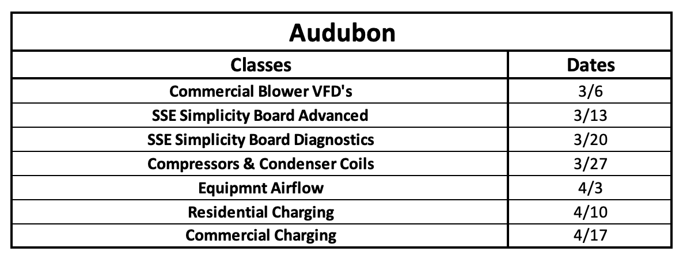

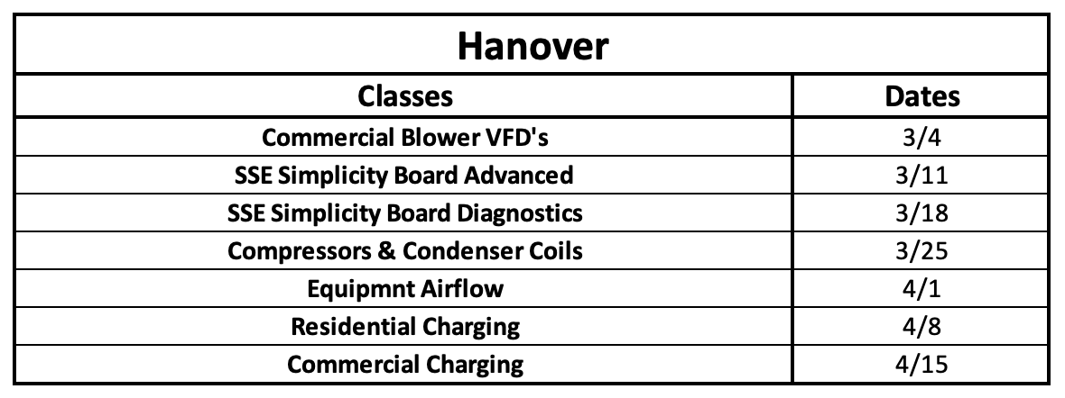

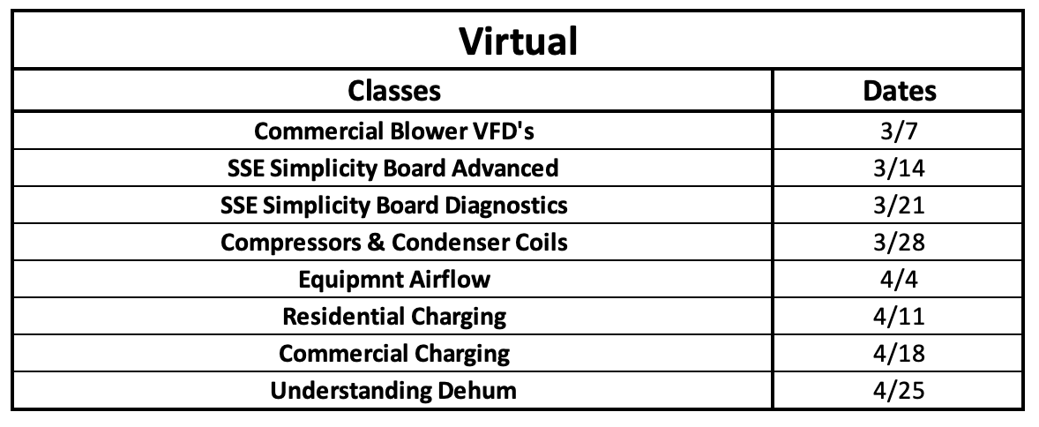

To register for classes, go to: www.YorkTechSupportNE.com
On Home Page go to: Training >2025 Spring Training

