Please select one or more stallions for your application:
☐ Daloumie Duke of Earl ☐ Dartdale Peter Boy ☐ Castle Hill Rob
Section 1
Owner Information
Owner name(s)
Owner address
Owner email
Owner phone number(s)
Social media page(s)
Prefix
Do you have applicable experience with animal breeding?
What experience do you have breeding horses? If any (enter NA if no experience breeding horses)
Have you used frozen AI to breed horses in the past? |  | ☐ Yes  ☐ No
If yes, did the mare successfully deliver a foal from these breedings?
Are you familiar with the typical and potential costs of breeding a horse?
Do you own or lease a farm where you keep your horse(s)?
Have you reviewed the literature from Select Breeders Services provided with this application? |  | ☐ Yes  If yes, do you have any concerns?  ☐ No  If no, are you an experienced  breeder?
Is your current vet experienced with equine reproduction best-practices? |  | ☐ Yes  If yes, please provide their name  and location.  ☐ No  If no, do you have access to a vet  that is?
Have you previously registered a Dales pony? |  | ☐ Yes  ☐ No  If no, are you committed to  registering with the Dales Pony  Society?
Have you previously transferred ownership of a Dales pony with the Dales Pony Society? |  | ☐ Yes  ☐ No  If no, are you committed to  keeping ownership records updated  with the Dales Pony Society?
Why are you interested in breeding with the selected stallion?

Section 2
Please complete section 2 of this application and attach photos of your mare (conformation photos preferred) to the email for submission.

Mare Information
DPS Registered Mare Name
DPS Number
Mare year of birth
Have you run a Sparks report for your mare breeding to the selected stallion? | ☐ Yes - please provide a copy of this report  ☐ No  If no, do you give DPCNA permission to request  this information from the Dales Pony Society for  this application?
Is your mare’s registration up to date with the Dales Pony Society? | ☐ Yes  ☐ No  If no, what is not up-to-date?
Has your mare had a recent breeding soundness examination? | ☐ Yes  If yes, please provide the report  ☐ No  If no, are you willing to have your mare examined  for breeding soundness?
Have you bred this mare before? | ☐ Yes  If yes, how many breedings and did you get a live  foal?  ☐ No  If no, has your vet checked her for breeding  fitness? When?
If yes to question above, please provide:  - Number of progeny  - Registered names of progeny  - Pure-bred or part-bred | Number of progeny:  Registered names of progeny:  Pure-bred or part-bred:
Is your mare up-to-date with vaccinations and coggins? | ☐Yes  ☐ No  If no, why?
Does your mare have any chronic health issues? | ☐ Yes  If yes, what are the condition(s)?  ☐ No
Has your mare been tested for FIS? | ☐ Yes  If yes, are you willing to share the results?  ☐ No
Has your mare been tested for PSSM? | ☐ Yes  If yes, are you willing to share the results?  ☐ No
Do you plan to sell or retain a foal produced from this breeding? Please check all that apply | ☐ Retain Filly  ☐ Retain Colt  ☐ Sell Filly  ☐ Sell Colt  ☐ TBD
Does your mare currently or in the past have a ridden/driven career? | ☐ Yes  If yes, please provide details?  ☐ No
Does your mare participate in any of the following disciplines? | ☐ Trail riding  ☐ Dressage  ☐ Jumping/eventing  ☐ Driving  ☐ Western  ☐ Pony club - youth  ☐ Broodmare  ☐ Other: Please describe

Appendix – Stallion Information

Stallion Name: Daloumie Duke of Earl “Duke”
DPS# 16072, Stallion License # D.P. 398 DOB: September 13, 2016
Color: Grey Height: 14.2 Genetic Testing: FIS Negative
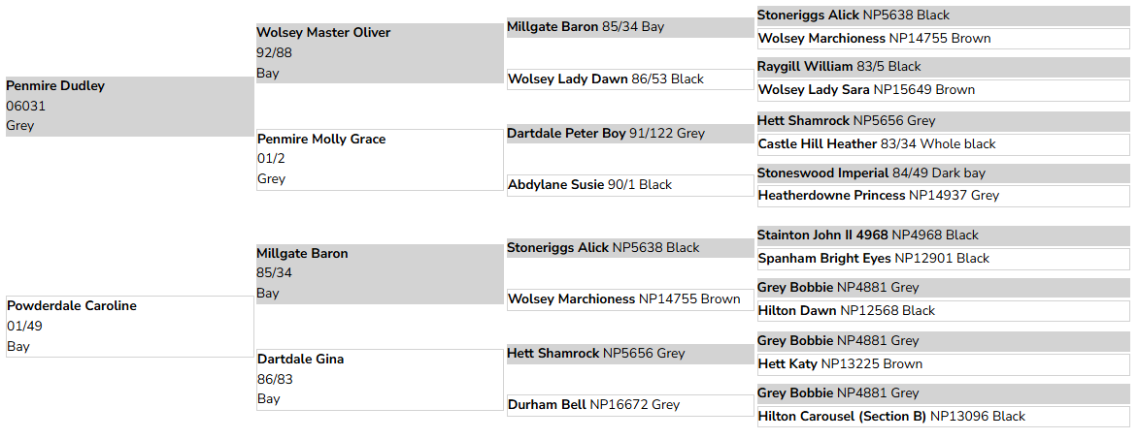

Storage location: Select Breeders Services, Chesapeake City, MD
Duke is a grey UK stallion that has frozen semen stored at Select Breeders Services in Chesapeake City, MD for distribution in the United States and Canada. We are offering a limited number of doses per year to DPS-registered purebred Dales pony mares located in the US and Canada at a cost of $500 per dose, plus $450 per shipment. Please complete section 1 of this application, if you have one mare you would like to breed to Duke. If you have multiple mares, please download a second application and complete only section 2.

Stallion Name: Dartdale Peter Boy
DPS# 91/122, Stallion License # D.P. 098 DOB: May 3, 1991
Color: Grey Height: 14.2 Genetic Testing: FIS Negative
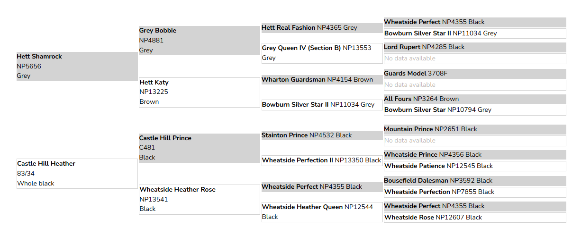
Storage location: Select Breeders Services, Chesapeake City, MD
Dartdale Peter Boy is a grey UK stallion that is no longer available for live-cover, but has frozen semen stored at Select Breeders Services in Chesapeake City, MD for distribution in the United States only. We are offering a limited number of doses per year to DPS-registered purebred Dales pony mares located in the US only at a cost of $400 per dose, plus $450 per shipment. Please complete section 1 of this application, if you have one mare you would like to breed. If you have multiple mares, please download a second application and complete only section 2.

Stallion Name: Castle Hill Rob
DPS# 94/89 Stallion License # D.P.143 Vol.16 DOB: September 13, 2016
Color: Black Height: 14.1 Genetic Testing: FIS Negative
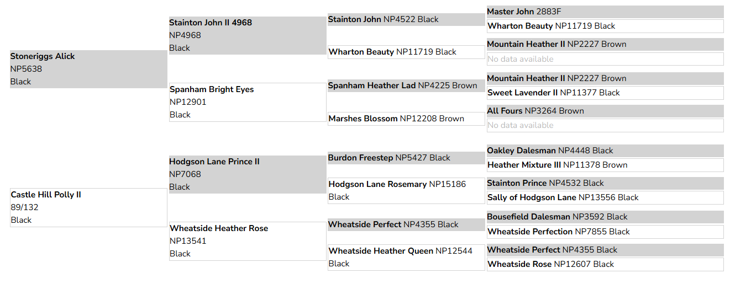
Storage location: Select Breeders Services, Chesapeake City, MD
Frozen semen is stored at Select Breeders Services in Chesapeake City, MD for distribution in the United States. We are offering a limited number of doses per year to DPS-registered purebred Dales pony mares located in the US only at a cost of $400 per dose, plus $450 per shipment deposit (includes shipping tank rental). If the shipment, tank rental, and return of the shipper cost less than $450, the remainder of the deposit will be returned to the mare owner. Please complete section 1 of this application, if you have one mare you would like to breed to Castle Hill Rob. If you have multiple mares, please download a second application and complete only section 2.

