
2026 DPCNA Performance Points Competition Registration
RIDER NAME: _______________________________________________________
RIDER: Junior (18 or under as of Jan 1, 2026) or Adult: _________________________
OWNER NAME:______________________________________________________
Are you a DPCNA Member? ____________________________________________
Are you a DPS member? If so, what is your member#?_______________________
HORSE/PONY NAME: _________________________________________________
HORSE/PONY DPS REGISTRATION #: ______________________________________
EMAIL ADDRESS: ____________________________________________________
MAILING ADDRESS (for awards): ________________________________________
___________________________________________________________________
___________________________________________________________________
EQUINE ACTIVITY LIABILITY ACT WARNING:
CAUTION: HORSEBACK RIDING AND EQUINE ACTIVITIES CAN BE DANGEROUS. RIDE AT YOUR OWN RISK. Under the laws of most States, an equine activity sponsor or equine professional is not liable for any injury to, or the death of, a participant in equine activities resulting from the inherent risks of equine activities.
By signing below, I (as the participant or as the Parent/Legal Guardian of the minor identified below) acknowledge the risks related to equine activities, and in conjunction with my participation in the DPCNA Performance Points Competition, I hereby release, waive and covenant not to sue, and further agree to indemnify, defend and hold harmless DPCNA and agents of DPCNA from any liability related to the DPCNA Performance Points Competition.
Signature: ______________________________________ Date: ______________

Print Name:_________________________________________________________
Parent/Guardian Signature: (Required if Rider/Driver/Handler is a minor)
________________________________________________Date: ______________

Print Parent/Guardian Print Name: _______________________________________
2026 DPCNA Performance Points Competition Rules
- Participating horses/ponies must be located in North America and DPS Registered (Pure Bred or Part Breed).
- The owner must be a member of either DPCNA or DPS.
- US-resident registration cost $25 per Pony, $35 for Canadian residents.
- You can join at any time of the year, but registration and payment must be submitted before points begin to accumulate. Example: If you register July 13th, only events on or after July 13th count towards year end awards.
- 2026 Points run from April 1st 2026 to December 31st 2026.
- Participants must maintain a separate registration and log for each Pony
- Integrity is expected. Those caught falsifying records will be ineligible for year-end awards, and receive a 3-year ban from participation. A second offense will result in a permanent ban.
- Year End Awards will be given for 4 categories (Dressage, Driven, Ridden, In Hand). Additional categories can be added at the discretion of the DPCNA Board of Directors.
- High Point Awards will be granted for Adult and Junior Category.
- Dales Pony Ambassador of the Year Award will be given to the Dales Pony who gets out in the public the most with any combination of shows, clinics, trail rides or driving in public areas, educational events – anything that gets the Dales Pony into the public view.
- You cannot log the same activity/event/show in more than one category. For example, you cannot log for both show points and event hours for the same horse show.
- Show Points will be accumulated based on the following scale:
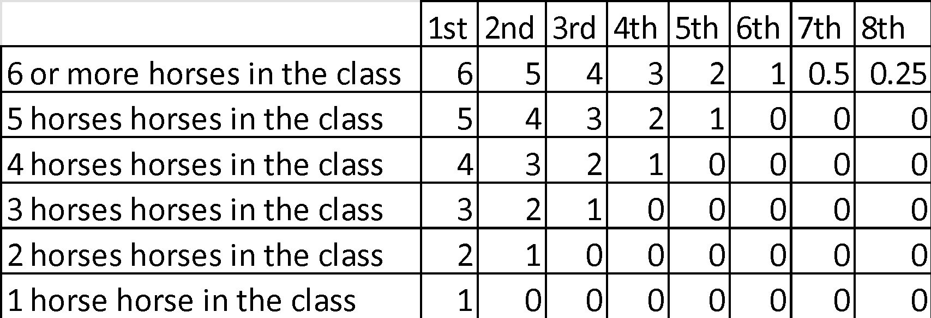

- Any show that is double judged counts as two separate shows (2 sets of points). The same applies to multiple judged events with one set of points being awarded for each judge.
- Double points will be awarded for the DPCNA Show and the DPS Photo Show.
- Event points will be accumulated based hours your pony is in public (not stalls), examples:
  - At at 6 hour clinic in the ring all 6 hours - 6 points
  - At an expo, 30 minute breed demo - 0.5 points
  - At an expo, 2 hours in booth promoting the Dales Pony breed - 2 points
  - At an expo on a stall separate from the booth / presentation area - 0 points
- Videos and photos can be submitted to DPCNA for use by DPCNA on social media platforms. Videos and photos that are selected for re-use will be awarded 0.10 points for each submission. To submit, please send via fb messenger (Dales Pony Conservancy North America) or email dpcnasecretary@gmail.com with “DPCNA Points Submission” in the email title.
- An exhibitor may petition for corrections of error of any reports on any show results by filing a request and proof of error with the DPCNA Board of Directors. The petition must be filed within 14 days after the standings are published to the DPCNA website.
- The DPCNA Board of Directors will handle all disputes. All decisions of the Board will be final.
- To be counted towards awards, all logs must be submitted to DPCNA by midnight December 31, 2026. No late entries will be allowed. Logs may be submitted electronically or by mail.
- Awards will be announced no later than February 15, 2027.
2026 DPCNA Performance Points Competition Rules
By signing below, I (as the participant or as the Parent/Legal Guardian of the minor identified below) acknowledge that I have read and agree to abide by the above rules.

Signature: ______________________________________ Date: ______________

Print Name:_____________________________________
Parent/Guardian Signature: (Required if Rider/Driver/Handler is a minor)
________________________________________________Date: ______________

Print Parent/Guardian Print Name: _______________________________________

