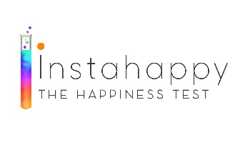
Contract

Client Name:
Client Address:
Client Telephone Number:

This is a contract between Rashida Mustafa working at the Didsbury Counselling and Therapy Centre, 212A Burton Road, M20 2LW and
for clinical or psychotherapeutic intervention as Rashida sees appropriate during the course of the therapy.
The therapy will commence on @£100 as agreed on, for each session.
While Rashida does not enforce a cancellation fee, clients are urged to be considerate of their commitment to the therapy and to try to keep appointments as far as is within their control.
The sessions will end when either Rashida or the client sees fit.
All communications within the therapy are confidential except where the safeguarding of an individual is concerned or under court order. Please ask me for more details if required.

Signed:
Date:
Signed:
Date:

