The Canadian Scent Hurdle Racing Association

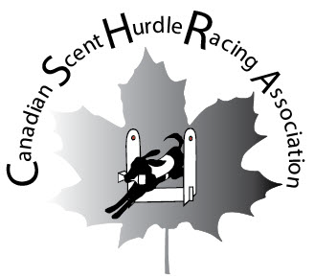

Bylaws, Corporate Policies and Procedures and Official Rules of Racing

|  |  |
| --- | --- |
| Revision: | Rev 8 (Originator - G. Harris, Reviewer - E. van Husen) |
| Date: | May 2022 |

The sport of Scent Hurdle Racing started in Canada in the 1970s in Manitoba and Saskatechewan. It moved into Alberta in the 1980s and Alberta has continued to race scent hurdle all these years.

### Scent Hurdle Racing is a relay race between two teams of four dogs, their handlers, and box-loaders. Each team races their dogs simultaneously over a series of three, or four, hurdles spaced ten feet apart and the two lanes of hurdles spaced a minimum or twelve feet apart from each other. Each dog must retrieve a specific scented and numbered dumbbell, from a square dumbbell box set twelve feet beyond the last hurdle in each lane. As each dog retrieves his handler's dumbbell, the dog immediately returns over the hurdles to the handler and the next dog is sent to repeat the same performance until the fourth dog on the team has completed his run. The first team to successfully complete the course will be declared the winner of that heat. The first team to win two heats will be considered the winner of the race. Once one team has won two heats, the race is over.

Team colours are used in the handler outfits, dog jackets, dumbbells, dumbbell box and inserts. Each dog has a number on its jacket that corresponds to the number on its dumbbell and insert. The heights of the jumps are set by the shoulder height of the smallest, or veteran, dog competing in each heat.

There are five judges: Starting Judge; two line judges and two box judges. They watch for infractions such as stepping over the start line, propelling dogs over the start line, failure of the dogs to bring back correct dumbbells, etc. In some cases, a dog may run again after the other dogs on his team with his time added into the team time. Penalty seconds may be added to team times for other infractions. Judges confer after each heat to decide on the winner.

Scent hurdle is fast paced with plenty of action and excitement for dogs, handlers and spectators. All dogs who are able to enter CKC Agility, Obedience and/or Rally Obedience are allowed to participate in Scent Hurdle tournaments held in conjunction with CKC events and Independent tournaments. Dogs not eligible to compete at CKC events may be eligible to participate at Independent tournaments.

**Rules of the Canadian Scent Hurdle Racing Association**

As Revised May 2022

In order to hold Scent Hurdle Tournaments in conjunction with Shows and/or Trials in Canada, the Board of Directors of the Canadian Kennel Club stated that "Scent Hurdle Racing be permitted, provided that:

* C.K.C. Permission is obtained to conduct this as an attraction, not as an official class;
* it is not held while judging of any official classes are in progress;
* it does not delay any judging of the Trial and/or Show;
* dogs competing in this event must be eligible for entry at an agility, obedience, or rally obedience trial held under C.K.C. rules."

Any Club offering Scent Hurdle Racing at their Shows and/or Trials must make every effort to ensure that these regulations and all other CKC Regulations are strictly adhered to.

In order to hold Scent Hurdle Tournaments independent of the Canadian Kennel Club the following need apply:

* Application must be made to the CSHRA Board of Directors minimum of 6 weeks prior to the date of racing in order to be approved and the membership be notified;
* Hosting clubs of independent tournaments will make every effort to ensure that these regulations and all other CKC Regulations are strictly adhered to.

All dogs may participate in CSHRA Independent Tournaments except for those who fit into the following categories:

* Dogs under 12 months of age;
* Bitches in season;
* Any dog that displays aggression towards any person or any dog on tournament grounds.
* Dogs recovering from any communicable condition that are less than 14 days post treatment
* Dogs with physical limitations who cannot perform the task.

Dogs with physical limitations who are able to play scent hurdle will be required to obtain a **Letter of Permission** form, signed annually, by a Registered Veterinarian or Canine Physical Therapist. This will need to be on file with CSHRA Regional Representative and the dog’s handler must have a copy on hand at each Tournament, where it will be presented to the Starting Judge. The Starting Judge will have final decision as to whether or not the dog with physical limitations can race or is showing signs of distress and should stop racing at any time during the tournament.

**TABLE OF CONTENTS**

1. Bylaws 1

2. Policies and Procedures 10

2.1 Interpretations 10

2.2 Racing Dates 10

2.3 Participation 11

2.4 Judges 11

2.5 Entries 11

2.6 Benching 12

2.7 Premium List 12

2.8 Program of Judging 13

2.9 Equipment 13

2.10 Protests 13

2.11 Discipline 13

2.12 No Liability 14

2.13 Voting Privileges 14

2.14 Amendments 14

2.15 Membership in the Association 14

2.16 Registration of a Dog 14

2.17 Registration of a Team 15

2.18 Changing Teams 15

2.19 Types of Teams 16

2.20 Team Point Scoring 17

2.21 Scent Hurdle Racing Titles and Awards 17

3. Rules of Racing 19

3.1 Description of Competition 19

3.2 Description of Hurdles 21

3.3 Description of Dumbbells 21

3.4 Description of Dumbbell Box 22

3.5 Description of Inserts 22

3.6 Placement of Hurdles 22

3.7 Height of Hurdles 22

3.8 Starting Lines 22

3.9 Centre Line 22

3.10 Team Captain 23

3.11 Box-Loader 23

3.12 Dress of a Team 23

3.13 Starting the Race 23

3.14 Team Run-Off 23

3.15 Racing Times 24

4. Judging 25

4.1 Judging of Scent Hurdle Tournaments 26

4.2 Interference 26

4.3 Retrieval of an Incorrect Dumbbell 26

4.4 Starting Line Penalties 26

4.5 Dumbbell Box 26

4.6 Dead Heat 26

4.7 Judging Roles 26

4.8 Violatons and Penalties 28

5. Equipment Drawings 30

5.1 Dumbbells 30

5.2 Dumbbell Box 31

5.3 Hurdles 32

5.4 Racing Jacket 33

5.5 Placement of Hurdles 34

APPENDICES

Appendix A - Fee Schedule 35

APPENDIX B - Application for Independent Tournament 36

APPENDIX C - Dog Registration Form 37

APPENDIX D - Incident Report 38

APPENDIX E - New Club/Team Registration Form 39

APPENDIX F - Request for CKC Certificate 40

APPENDIX G - Request for Exception Team Status 41

APPENDIX H - Tournament Entry Form 42

APPENDIX I - Tournament Scoring Sheet 44

APPENDIX J - Updating Dog CKC Titles 45

APPENDIX K - Membership Form 46

APPENDIX L - Letter of Permission (Veterinary) 48

APPENDIX M - Letter of Permission (Physical Therapist) 50

APPENDIX N - Witness Statement 52

**1. BYLAWS**

For the purposes of these By-laws, the following interpretations shall apply:

**1. Forms of Words**

1. Words in the singular include the plural, and words in the plural include the singular.
2. Words using masculine gender include feminine gender, and words using feminine gender include masculine gender.
3. “May” is to be construed as permissive and empowering.
4. “Must” or “required” is to be construed as a compulsory obligation.

**2. Name and Area of Operation**

1. The name of the Association is **Canadian Scent Hurdle Racing Association**. The official abbreviation shall be **CSHRA**.
2. The Association will operate in Canada.

**3. Objects**

a) The objects of the Association are:

i) To protect and stimulate interest in the sport of Scent Hurdle Racing.

ii) To encourage sportsmanlike competition at all Scent Hurdle Races.

iii) To promote humane positive motivational training methods through the sport of Scent Hurdle.

iv) To set the regulations and standards pertaining to the sport of Scent Hurdle Racing in Canada.

v) To educate the public on the sport of Scent Hurdle Racing.

vi) To be the only official body for the recording of accumulated points towards individual dog points and dog titles.

vii) To conduct sanctioned and approved events under the rules of The Canadian Kennel Association (CKC) and abide by the principles of the CKC Code of Ethics.

viii) Independent Tournaments may allow eligible non-CKC registered dogs.

b) The Association is operated on a non-profit basis. Any resulting surplus will not be used to the benefit of any member.

c) The members of the Association adopt, and may from time to time revise, by-laws as required to carry out these objects.

**4. Membership**

a) Membership Year

Membership in the Association is based on the calendar year.

b) Eligibility

Any person interested in the sport of Scent Hurdle Racing may become a member.

c) Membership Rights

All members have the same rights and privileges.

d) Dues

Membership renewal dues are payable prior to a members participation in a tournament for that membership year. New members may join and pay their dues at any given time during the calendar year.

e) New Members

Membership may be obtained by sending a completed membership application form to the National Treasurer along with the membership dues.

f) Termination of Membership

Memberships may be terminated for the following reasons:

i) Resignation:

Any member in good standing may resign from the Association upon providing written notice to the Secretary.

ii) Expulsion:

A membership may be terminated by expulsion as provided in Section 13.d) of these by-laws.

g) Voting Privileges

i) All members in good standing are granted voting privileges.

ii) All members of the Board of Directors are entitled to one vote on matters before them, except for the President who will vote only in the case of a tie.

**5. Board of Directors**

a) The Board

The Board is comprised of the National President, National Vice-President, National Secretary, National Statistician, National Treasurer and Regional Representative(s). Board members are elected for one-year terms and will serve until their successors are elected. General management of the Association is entrusted to the Board.

i) The National President will chair all Board and General meetings of the Association and has the duties and responsibilities outlined in the by-laws.

ii) The National Vice-President will assume the duties and exercise the responsibilities of the President upon the direction of the President, or if the President is unable to carry out his/her duties and responsibilities.

iii) The National Secretary will keep a record of all Board and General meetings of the Association, and of the final outcome of votes taken in the order of business. The Secretary is responsible for receiving and issuing correspondence on behalf of the Association, keeping a roll of the current members, and carrying out other duties as prescribed in the by-laws.

iv) The National Statistician will:

- record all information for the Association and maintain records.

- record all tournaments, races, dog points, .

- submit the dog points to team captains within a reasonable time after each

tournament.

- track and keep record of all Dog Registrations and DRN #s

v) The National Treasurer will collect and receive all revenues of the Association and deposit in an Association bank account as approved by the Board, in the name of the Association. The books of the Association are open to inspection by the Board at any time, and a financial report will be provided at every Board meeting and AGM. The financial records of the Association are the property of the Association.

vi) The Regional Representative(s) will:

- Arrange to have Scent Hurdle Tournaments included at licensed CKC Shows and/or Trials and to have it advertised in their Premium Lists. Ideally, this should be done before the start of the New Year so that all teams may be informed as to how many competitions will be available.

- Liaise with scent hurdle clubs/teams wishing to host Independent Tournaments. Review scent hurdle club/team request to host independent tournaments and present to the Board for approval.

- Arrange Judges for each race and ensure that they are familiar with regulations on the judging Scent Hurdle Racing.

- Obtain the co-operation and permission of CKC representative in the arranging of the races.

- Arbitrate any disputes that may arise between teams or others involved directly or indirectly in Scent Hurdle Racing and, if necessary, contact the Association or CKC Representative for assistance or guidance. In the case of a formal protest, conduct a hearing to hear both sides of the case and submit his/her recommendations to the Board for its decision.

- Track and keep record of Physical Limitation Letters of Permission forms. Physical Limitation Letters of Permission forms are to be resubmitted annually.

- Promote the sport of Scent Hurdle

- Responsible for filing the CSHRA Bylaws with the Registrar of Corporations (Alberta) if there are any rescissions, alterations or amendments to these Bylaws.

b) Vacancies

Should a vacancy occur on the Board, the Board may appoint a member of the Association to fill the vacancy. If the position of President becomes vacant, the Vice-President will automatically fill it. The resulting vacancy will be filled by a majority vote of the Board.

c) Terms of Office

The elected Board members will take office immediatelyfollowing their election at the AGM. Former Board members will turn over all properties and records relating to the positionat the AGM.

d) Directors must reside within the area of operation of the Association.

**6. Regions**

The Board of Directors has the authority to establish and manage Regions as needed.

**7. General Meetings**

a) Annual General Meetings

The annual general meeting (AGM) of the Association will be held once each year at a place, date and hour designated by the Board. The Secretary will issue notice of the AGM to each member at least three (3) weeks before the meeting date. Quorum for the AGM is 33 1/3% or the minimum of fifteen (15) members in good standing. Written proxy votes will be accepted at all meetings but will not constitute part of the percentage in attendance required for a quorum.

b) Special General Meetings

1. The Board may call a special general meeting at any time by providing advance notice to the members.
2. The Board must call a special general meeting if the Secretary receives a formal request signed by at least 33 1/3% or a minimum of fifteen (15) members in good standing. Special General Meetings will be held at a time, date and place designated by the Board.
3. The Secretary will issue notice of a special general meeting to each member three (3) weeks before the meeting date. The notice of meeting will indicate the purpose of the meeting. No other Association business can be conducted. Quorum for special general meetings is 33 1/3% or a minimum of fifteen (15) members in good standing.

c) Board Meetings

i) The first Board Meeting will be held as soon as possible following the election of the Board. Other Board Meetings will be held at times and places as agreed to by a majority of the Board.

ii) Board Meetings may be carried out in person or by phone, Skype, fax, mail, e-mail or any other electronic media and will be conducted by the Secretary.

iii) Quorum for Board Meetings is the majority of Board members.

**8. Association Year**

The Association’s fiscal year runs from January 1 to December 31.

**9. Finances**

A separate and independent bank account will be held in the name of the Association. All cheques drawn from the Association account must have the signature of 2 officers.

**10. Voting**

Voting at the AGM and special general meetings is limited to members in good standing who are at the meeting (or who have provided their proxy to a member in good standing who is in attendance). Voting shall be by show of hands except where either a ballot is requested by at least one member or where written proxy votes are in use.

Proxy votes will only be used for election of The Board and items which are listed on the Agenda.

**11. Elections**

a) Ballots

The election of Board members will be conducted by secret ballot at the AGM. Two members in good standing will count ballots at the meeting. These members will be chosen by the members at the meeting, and must not be members of the current Board, or candidates on the ballot.

The person receiving the largest number of votes for each position will be declared elected.

b) Nominations

Nomination of eligible members may be made by written petition to the Secretary at least 1 week before the AGM. The petition must be signed by 2 members and accompanied by a written confirmation of the candidate’s willingness to accept office. Nominations may also be accepted from the floor at the AGM provided 2 members support the nomination and the candidate has indicated a willingness to accept office.

Only ballots from current members will be counted.

**12. Committees**

a) Standing Committees

The Board may appoint standing committees to advance the work of the Association in matters as appropriate. These committees are subject to the final authority of the Board.

b) Committee Appointments

Any committee appointment may be terminated by majority vote of the Board upon written notice being issued to the appointee. The Board may appoint a successor.

**13. Discipline**

a) Canadian Kennel Club Suspension

Any member who is suspended, debarred, expelled or deprived of privileges of the Canadian Kennel Club will automatically be suspended from the privileges of this Association for a like period.

b) Complaints

Any member may lay a complaint against another member for alleged misconduct prejudicial to the best interests of the Association or the sport of scent hurdle. A written complaint must be filed with the Secretary, together with a deposit (the amount to be determined by the Board), which will be forfeited if the defendant is not found guilty.

Within 10 days of receiving a complaint, the Secretary will forward a notice of hearing and a copy of the complaint to the defendant, complainant and each member of the Board.

A hearing will be held within 30 days of receiving the complaint. A majority of the Board members must be present during the hearing. If a complaint is laid against the Secretary, the President shall act in accordance with these by-laws.

c) Hearing

The Board will ensure that both the complainant and defendant are treated fairly and in accordance with the rules of natural justice. If the complaint is sustained after hearing all the evidence presented by the complainant and defendant, the Board may, by majority vote, impose an appropriate penalty. The Secretary will notify each party of the decision within 10 days.

d) Expulsion

Expulsion of a member is accomplished during a Special General Meeting following a proper hearing and upon the recommendation of the Board. The President will read the complaint and report the findings and recommendations of the Board. The defendant will also be invited to speak on his/her own behalf. The members present will then vote by secret ballot on the proposed expulsion. A 2/3 vote of those present is necessary for expulsion. Proxy voting is not permitted.

At the discretion of the Board, expulsion may also take place by mail-in vote. A 2/3 vote of all eligible voters is necessary for expulsion.

**14. Amendments**

a) Proposal for Amendments

Amendments to the constitution and by-laws may be proposed by the Board or by written petition addressed to the Secretary and signed by a majority of members in good standing. The Board will consider amendments proposed by petition at their next regular meeting. The amendments must be presented to the members of the club, with the Board’s recommendations, within 30 days of receipt.

b) Amendment by Vote

These By-laws shall not be rescinded, altered or amended except by a special resolution of the Members as defined in Section 1 (d) of the Societies Act.

*“The By-laws of a Society shall not be rescinded, altered or added to except by special resolution of the society.*

*Section 1 (d) “Special Resolution” means:*

*(1) a resolution passed at a general meeting of which not less than 21 days’ notice specifying the intention to propose the resolution has been duly given, and*

*(2) by the vote of not less than 75% of those members who, if entitled to do so, vote in person, by fax or by mail.*

*or,*

*a resolution proposed and passed as a special resolution at a general meeting of which less than 21 days notice has been given, if all the members entitled to attend and vote at the general meeting so agree, or*

*a resolution consented to in writing by all the members who would have been entitled at a general meeting to vote on the resolution in person."*

1. Proxies are not permitted.

d) Alberta Registries Approval

Upon acceptance to the Alberta Societies Act, each rescission, alteration or amendment to these By-laws shall be registered with the Registrar of Corporations (Alberta), by the Alberta Regional Representative, in accordance with the Societies Act.

**15. Indemnification**

Each officer, director and committee member of the Canadian Scent Hurdle Racing Association shall be indemnified by the Canadian Scent Hurdle Racing Association against all costs, expenses and liabilities reasonably incurred by him/her connection with/or resulting from any action, suit or proceeding to which he/she may be made a party by reason of his or her being or having been a director, officer or committee member of the Association, except in relation to matters which shall have been occasioned by the willful misconduct or dishonesty of such officer, director or committee member. The foregoing right indemnification shall cover all amounts paid in settlement of any such action, suit or proceeding when such settlement appears to be in the interest of CSHRA. The foregoing right shall be in addition to any other rights to which such officer, director or committee members may be entitled as a matter of law.

**16. Dissolution**

The Association may be dissolved at any time upon the request of at least two-thirds (2/3) of the members of that Association who are in favour of the decision. Proxies are not permitted. In the event of the dissolution of the Club, for any reasons other than reorganization, none of the property or proceeds of the Association shall be distributed to any members. After payment of any Association debt, the assets will be given to a charitable organization selected by the Board.

**17. Books and Records**

The Board of Directors shall ensure that all necessary books and records of the Association required by the Societies Act or these By-laws are regularly and properly kept by the Association.

a) Auditing

The books, accounts and records of the Secretary and Treasurer shall be audited at least once each year by a duly qualified accountant or by two members of the Association elected for that purpose at the Annual Meeting.

b) Financial Statements

A complete and proper statement setting out the Association’s assets, liabilities, income and expenses shall be prepared on an annual basis and presented at each Annual General Meeting.

c) Fiscal Year

The fiscal year of the Association shall be based on the calendar year.

d) Inspection of Books and Records by Members

The books and records of the Association may be inspected by any member of the Association at the Annual Meeting or at any time upon giving reasonable notice and arranging a time satisfactory to the officer or officers having charge of same. Each member of the Board shall at all times have access to such books and records.

**18. Order of Business**

At meetings of the Club, so far as the character and nature of the meeting permit, will be as follows:

Roll call

Minutes of the last meeting

Report of the president

Report of the secretary

Report of the treasurer

Report of committees

Election of the Board (at the AGM)

Unfinished business

New business

Adjournment

At meetings of the Board, the order of business will be as follows, unless otherwise directed by a majority vote of those present:

Reading of minutes of last meeting

Report of secretary

Report of treasurer

Report of committees

Unfinished business

New business

Adjournment

# **2. Policies and Procedures**

**2.1 Interpretations**

### 2.1.1 "Association" means the Canadian Scent Hurdle Racing Association.

### 2.1.2 "Board of Directors" means the Board of Directors of the Canadian Scent Hurdle Racing Association.

### 2.1.3 "Club" except as otherwise indicated means a club, organization, or association formed for the purpose of sponsoring a team for Scent Hurdle Racing.

### 2.1.4 "Dog" whenever used in these regulations includes both sexes, neutered or not.

### 2.1.5 "Regional Representative" is a person responsible for Scent Hurdle Racing within his/her Region.

### 2.1.6 "Exhibitor" means owner or owners or handler of dog. All handlers of dogs competing in a point race must be full members of the Canadian Scent Hurdle Racing Association.

### 2.1.7 “Team” a team shall consist of four to twelve dogs, handlers, and one or two box-loaders, registered with the Canadian Scent Hurdle Racing Association's Statistician.

### “Regular Team” is a team registered for the calendar year and includes teams made up of any breed of dog .

### “Blended Team” is a team for dogs from regular teams who join together to enter a particular tournament.

### “Exception Team” is a team that is entered for a tournament, either Regular or Blended, and for “cause” has fewer than four dogs present at the beginning of the tournament.

### 2.1.8 “Dog Points” are awarded to each dog that is racing in a heat, if the team successfully completes a heat. If a team incurs a Loss of Heat violation, all dogs on the opposing team that were scheduled to race will receive dog points, whether the heat was completed by the opposing team or not.

### Dog points are accumulated towards individual dog titles.

### 2.1.9 “Tournament” is the event, with races against other teams and heats within those races.

### **2.2 Racing Dates**

These are set by the Regional Representative with permission of the Show and/or Trial giving Club.

## **2.3 Participation**

## 2.3.1 Participation is considered a privilege accorded a person by the Board and may be withdrawn.

## 2.3.2 Any person participating agrees to the authority of the Association and its Board of Directors.

## 2.3.3 No person expelled from the C.K.C. or the Association may compete, judge, or handle any dog at a tournament.

## 2.3.4 DEFINITION - A "person" shall include member, person, partnership, club, association, company, or corporation. The definition of "expelled" shall include expulsion, suspension, deprivation of privileges, and debarment as set forth in Section X, Article XV of the bylaws of the Canadian Kennel Club.

## **2.4 Judges**

### 2.4.1 It is the duty of the Regional Representative to ensure that a minimum of five judges are present at each tournament and that the judges are familiar with the regulations for Scent Hurdle Racing.

### 2.4.2 The Association may set standards for judges and means of testing.

### 2.4.3 Handlers of dogs or any member of a racing team shall act as judges only if no one else is available to perform these duties.

### 2.4.4 Complaints against judges will be raised with the Regional Representative; however, all judges' decisions are final. Arguing with a judge during or at the completion of a race is strictly forbidden and may be subject to disciplinary action.

### **2.5 Entries**

### 2.5.1 Only dogs eligible for entry at a licensed agility, obedience or rally obedience trial held under CKC rules may be entered in and compete at tournaments held at CKC sanctioned event. At Independent Tournaments eligible non-CKC registered dogs may be allowed.

### 2.5.2 Entry forms for point races must describe breed, , name of owner/handler, CKC registration number, call name, and team number of each dog. Entry fee is to be set by the hosting club.

### 2.5.3 Entries must be received by the Show and/or Trial giving club's secretary not later than the closing date for entries for the Show or Trial. The Regional Representative and Statistician must receive a duplicate copy of the entry form before the closing date. Entry forms are to be supplied on request by the Regional Representative.

### 2.5.4 Authorities of any Show and/or Trial may decline to accept entries for just cause and no one shall have any claim or recourse against organizations or officials that do so. Authorities must file reason for doing so to the Regional Representative not less than ten (10) days after the Show and/or Trial.

### 2.5.5 A dog need not be entered in other than the tournament in order to compete.

### 2.5.6 Bitches in season are not permitted to compete. It is the responsibility of the handler not to race a bitch in season.

### 2.5.7 At the time of closing of entries, for a Tournament to proceed, a minimum of three teams from at least two different clubs need to be entered.

### If, after entries close with only a minimum of three teams from at least two different clubs, one teams pulls, the tournament may only proceed if sufficient members are available to fulfill the various judging roles.

## **2.6 Benching**

Where a tournament is held in conjunction with a benched Show, a dog entered for the tournament must conform to the requirements of the Show Committee.

RINGS - The Team Captains and the Starting Judge must ensure that the area for racing is large enough for minimum safe racing requirements.

## **2.7 Premium List**

The Premium List must contain information as to what dates the Scent Hurdle Racing is being offered for points as well as any prizes being offered. It is the responsibility of the Trial or Show giving club to include this information. When the Premium List is created add a request to bring an insert for dogs running on blended teams in addition to dumbbells and racing jackets. This is not binding on the race organizer but suggested to ensure all dogs have an insert, jacket, and dumbbells.

## **2.8 Program of Judging**

## 2.8.1 The Team Captains and the Regional Representative(s) must be sent a program of judging, stating the approximate time the tournament is to be held and how many teams are entered.

## 2.8.2 Tournaments must not interfere with or be run while judging of any official classes is in progress.

## **2.9 Equipment**

### 2.9.1 All equipment other than rubber matting (if the tournament is run indoors) is to be supplied by each team. Jumps and equipment for tournaments is to be supplied by the appointed team, unless otherwise agreed in advance. The Regional Representative(s) will be responsible for arranging any alternative arrangements.

### 2.9.2 Each Team must have its own set of jumps, dumbbells, dumbbell box, and dog jackets. The Regional Representative(s) will ensure that jumps are brought to each tournament.

### **2.10 Protests**

### 2.10.1 A protest against a dog, his owner or handler may be made by any Team Captain of a Team entered and competing at the tournament or by a member of the Club holding the Show and/or Trial but must be made within ten days of the tournament. It must be in writing and lodged with the Regional Representative(s) with a deposit of $25.00 which will be refunded if the protest is sustained. The Regional Representative(s) must hold a hearing with both parties involved and submit his/her recommendations in writing to the Board. The Board will then make a ruling on the protest and advise the charged party of their decisions by registered mail within ten days.

### 2.10.2 An appeal may be made in writing by any charged person to the Board of Directors within ten days of receipt of notice of the Board's decision. This appeal must be accompanied by a fee of $25.00, which will be refunded if the decision is reversed.

### **2.11 Discipline**

### 2.11.1 The Board of directors may take disciplinary action against any club, person, company, or partnership for any act of omission or commission, which violates any section or sections of these regulations.

### 2.11.2 The administering of any drug except as prescribed by a veterinarian, which alters the nervous system by stimulation, sedation or tranquillization to a dog competing at a tournament shall be considered a misconduct and person or persons so charged will be subject to disciplinary action in accordance with this section. As well, any points accumulated by that team may, at the Board's discretion, be cancelled.

### 2.11.3 The Starting Judge may take summary action against any person inside or outside the ring interfering with the running of the tournament.

### 2.11.4 The Board, at its discretion, has the power to reverse the Starting Judges decision and/or remove any points awarded.

### 2.11.5 Arguing with the Judges or in any way subjecting them to any indignity shall be considered a serious offence and will be subject to disciplinary action by the Board.

### **2.12 No Liability**

The Canadian Scent Hurdle Racing Association shall not be responsible to any person, partnership, club or corporation, for any loss or damage arising at or by reason of any tournament held under any rules adopted by the Association.

**2.13 Voting Privileges**

2.13.1 Board of Directors - members of the Board shall be entitled to one vote per member on any matters before them, except for the President who will vote only in the case of a tie.

2.13.2 Membership - members will be entitled to a single vote per membership.

**2.14 Amendments**

These regulations for Scent Hurdle Racing are subject to amendments as herein provided by the Association.

a. Amendments may be proposed by an association, council or committee, executive or   
 representative, group, or by four ordinary members of the Scent Hurdle Association.

b. Amendments must be approved by a majority of the members voting by returned ballots.

c. Effective date of amendments is to be set by the Association.

d. The Association has the power to prescribe regulations of submission and procession of amendments.

e. The Association will provide notification of proposed changes three weeks before voting on them.

f. Approved amendments will be provided to the current members after acceptance.

## **2.15 Membership in the Association**

Membership must be obtained by sending a completed membership application form to the National Treasurer. Membership fees, which are set at the Annual General Meeting and listed in the Schedule of Fees, are to be sent to the National Treasurer. The New Membership form will be sent to the Team Captains at the start of the year or when a new member joins and be posted on the Facebook page.

## **2.16 Registration of a Dog**

2.16.1 All dogs need to be eligible for entry in agility, obedience, or rally obedience trial held under CKC rules. Independent Tournaments may allow eligible non-CKC registered dogs.

2.16.2 Every dog competing in scent hurdle racing must have a dog registration number (DRN). A DRN may be obtained by submitting the Dog Registration Form, along with the one-time fee listed in the Fee Schedule, to the National Statistician before the dog competes in a tournament.

2.16.3 The dog registration shall include call name, registered name, CKC registration/PEN/CCN number (if applicable), breed,, date of birth, owner details and height at the withers.

2.16.4 A new dog may be registered at any time during the year. All dogs must registered to a team.

## **2.17 Registration of a Team**

### 2.17.1 To register a regular team, the Team Captain must supply the Regional Representative with a list of all the handlers, dogs and DRNs, and box-loader, which make up his team.

### 2.17.2 The team may be registered at any time during the racing year (January 1- December 31)

### 2.17.3 A team shall consist of a minimum of four dogs, their handlers and/or box-loader, one of whom shall be designated as Team Captain. Eight more dogs and handlers and/or one more box-loader may be listed as alternates.

### 2.17.4 Any member in good standing of the CSHRA may serve as a box-loader at a tournament. This shall include registered team members. The same person shall serve as box-loader for all heats in a race. At the Start Judges discretion the box loader may be changed between heats.

### 2.17.5 Once registered, new dogs may be added to the team up to a maximum of twelve, however, once the maximum is reached, no substitutes or removals are allowed unless approved by the Regional Representative with exception of 2.18 below.

## **2.18 Changing Teams**

### With requests to the Regional Representative and National Statistician the following changes will be considered:

### 2.18.1 If a dog is listed on an entry form at the beginning of the year and has not raced, an application may be made to be removed from the team; or to join a new team.

### 2.18.2 If a dog is listed on and raced with a team but relocates, application may be made to be removed from the team and join another team in a different location.

### 2.18.3 If a dog stops racing for reasons of injury, health, retirement, death and will no longer race for the remainder of the calendar year, then application may be made to remove the dog from the team and reuse the number for another dog.

## **2.19 Types of Teams**

### 2.19.1 **Regular** team includes teams made up of any breed of dog. The same dogs will appear on the entry form for each tournament for the year with the exception of Blended or Exception Teams.

### 2.19.2 **Blended** team is for dogs from Regular teams who join together to enter a particular tournament. The Blended team must submit their entry by closing date of show/trial/ tournament. Blended teams may not participate in national standings but the dogs that race on the team will receive individual dog points for each successful heat run.

2.19.3 **Exception** teams: the intent of this conversion privilege is to allow teams that have already entered a tournament but who, for unforeseen circumstances/causes, find themselves unable to field a complete team of at least four dogs, to run with a dog, or dogs, from another club/team.

“Cause” shall include but not be limited to circumstances such as dog injury, illness, or other unforeseen situation.

Exception teams may ‘borrow’ a dog, or dogs , from another entered team(s), prior to the start of the tournament*.*

### Conversion to an Exception team with the permission of the Regional Representative or delegate and the Starting Judge for ‘cause’ shown, a team entered as regular or blended team may be converted from its original status to an exception team entry prior to the prior to the start of the tournament.

A team may not enter a tournament as an exception team.

A team that is declared an exception team shall be clearly shown on the scoring sheets and declared prior to the start of racing at the captains meeting. Once approved, no changes can be made to the Exception team. Dogs listed on the exception team shall race together for the entire tournament.

A dog’s club/team affiliation is not affected by reason of running on an exception team.

An exception team is not eligible for tournament awards or placements.

An exception team will not be rewarded any wins in any races or heats. A team racing against an exception team must complete the minimum number of heats in order to record a win. Dogs running on exception teams will however still accumulate individual dog points towards titles for each successfully completed heat.

2.19.4 No team may borrow dogs from another team for league competition other than where the rules allow for Exception teams.

**2.21 Scent Hurdle Racing Titles and Awards**

Only dogs actually running in heats can win points. All times are for a team of four dogs and handlers. Times would be obtained by the Regional Representative for each region, and recorded by the Starting Judges at each tournament. Results would be collected and kept on forms provided by the C.S.H.R.A. at each point race.

### **2.21.1 Dog Points**

* A clean heat of over 35 seconds earns 5 points.
* A clean heat of under 35 seconds earns 10 points.
* A clean heat of under 30 seconds earns 20 points.
* A clean heat under 25 seconds earns 30 points.

A heat taking over 80 seconds shall not earn any points. The Starting Judge will stop the heat after 80 seconds.

2.21.2 **Titles Certificates**

* 50 points = Scent Hurdle Dog (SHD)
* 100 points = Scent Hurdle Dog Excellent (SHDX)
* 250 points = Scent Hurdle Dog Champion (SHDCh)
* 500 points = Scent Hurdle Dog Masters (SHDM)
* 1000 points = Scent Hurdle Dog Master Excellent (SHDMX)
* 1500 points = Scent Hurdle Dog Master Excellent – Silver (SHDMX-S)
* 2000 points = Scent Hurdle Dog Master Excellent – Gold (SHDMX-G)
* 2500 points = Scent Hurdle Dog Master Champion (SHDMCh)
* 3000 points = Scent Hurdle Dog Grand Master Champion (SHDGMCh)
* 3500 points = Scent Hurdle Dog Grand Master Champion – Silver (SHDGMCh-S)
* 4000 points = Scent Hurdle Dog Grand Master Champion – Gold (SHDGMCh-G)
* 4500 points = Scent Hurdle Dog Grand Master Premium Champion (SHDGMPCh)

# 3. RULES OF RACING

### **3.1 DESCRIPTION OF COMPETITION**

### 3.1.1 The Race Area will be determined by the Starting Judge with the participation of the Team Captains. It will be large enough to provide a safe racing environment. Two lanes will be set up in the Race Area.

### 3.1.2 Each Scent Hurdle race consists of two teams of four dogs and their handlers and a box loader for each team. Each team starts racing their dogs simultaneously, at the judge’s whistle, over a series of three or four hurdles spaced ten feet (10’) apart and the two lanes of hurdles spaced a minimum of twelve feet (12’) apart. Four hurdles is the usual number but a tournament may be approved to use three hurdles for locations too small to safely accommodate four hurdles. If three hurdles are used 3 seconds will automatically be added to the team’s total running time for each heat. Each dog must retrieve a naturally scented, numbered dumbbell from a square dumbbell box, set twelve feet (12’) beyond the last hurdle in each lane. As each dog retrieves its dumbbell, the dog returns over the hurdles and across the finish line, with its dumbbell, to its handler and the next dog is sent to repeat the same performance until the fourth dog on the team has completed his run. The first team to successfully complete the course will be declared the winner of that heat. The first team to win two heats will be considered the winner of the race. In the event that a heat does not have a winning team, a maximum of 5 heats will be run in a race.

### 3.1.3 Teams may be unable to compete for various reasons, such as inability to field a full team part way through a tournament due to lameness, human illness, or a dog disqualification due to crossovers. If a team is unable to compete in a scheduled race for any reason, the opposing team may run two heats against an empty lane. Dog points are given for successful heats.

### 3.1.4 Each dog on the winning team must go over the hurdles, retrieve the correct dumbbell, return over the hurdles and carry its dumbbell across the finish line faster than their opponents, without performing any actions which would result in a loss of heat violation

### 3.1.5 Both dumbbell boxes shall be started in the same initial position and this position will be such that the lowest number being used is in the home position (6 pm position as viewed from the starting line) before the first heat. After each heat, the dumbbell box shall be rotated by the box-loader in accordance with the Starting Judges decision.

### 3.1.6 Upon entering the competition area, the handlers shall put their dogs on a Stay, one behind the other, in the order that they will race, behind the starting line. Once the racing order has been determined, then the Starting Judge will determine the position of the dumbbell box.

### 3.1.7 At a command from the Starting Judge, "Place your Dumbbells," the handlers will leave their dogs, behind the start line, and place the dumbbells on the dumbbell box. The spare dumbbells will also be carried down at the same time and be handed to the box-loader. The dumbbells will be placed on their corresponding numbered positions in the designated area on the dumbbell box. The handlers will then return in an orderly fashion to their dogs. No changing of dogs running in the heat will be allowed after the dumbbells have been placed.

### If any team members with numbers 5, 6, 7,8,9,10,11 or 12 are being used, inserts must be inserted on the dumbbell box in such a manner as to have the numbers in increasing numerical clockwise order.

### At the Judges command "Get Set", the handler of the lead dog should position himself and his dog behind the starting line ready for the starting whistle. At the sound of the whistle, the dog will be sent over the course and the handler may use both voice and hand signals but shall not propel the dog over the starting line.

### Each dog must retrieve his handler’s naturally-scented dumbbell, return over the hurdle course and carry its dumbbell across the finish line before the next dog starts his run.

### 3.1.8 If the dog retrieves the correct dumbbell, a team blank dumbbell is placed in the box by the box loader to take its place, so that all four spaces are always occupied by a dumbbell.  If the dog retrieves the incorrect dumbbell, the box loader will place the spare dumbbell of the incorrect dumbbell taken in the space.

### 3.1.9 The box loader does not need to place a blank dumbbell in the fourth space after the last dog has run. The next dog shall not be sent until the previous dog’s nose has crossed the starting line (finish line) on his return run. A dog that does not bring back the correct dumbbell across the finish line must be sent again after the fourth dog has completed the course. In the case of a close finish, the dog whose nose crosses the finish line first is the winner.

### 3.1.10 Each dog must retrieve his handler’s naturally-scented dumbbell and return over the hurdle course before the next dog starts his run. The box-loader shall place on the empty space of the dumbbell box one of the teams blank dumbbells. As each dog retrieves a dumbbell, a team blank dumbbell is put down to take its place so that all four spaces are always occupied by a dumbbell, except after the last dog has raced. The next dog shall not be sent until the previous dog’s nose has crossed the starting line (finish line) on his return run.

### A dog that does not bring back the correct dumbbell across the finish line must be sent again after the fourth dog has completed the course.

### In the case of a close finish, the dog whose nose crosses the finish line first is the winner.

### In the event the dog does not carry its dumbbell across the finish line, the dog must be resent after the fourth dog has completed the course.

### 3.1.11 If a dog begins to retrieve an incorrect dumbbell, or starts to go around one of the hurdles, the handler may correct his dog by voice or signal or both but may not leave the starting area. If a dog cannot be corrected in this manner, the handler should recall his dog to the starting area and prepare to re-run his dog after the fourth dog has completed its run. In the event of such a recall, the next dog may be sent to retrieve as soon as the defaulting dog crosses the finish line.

### 3.1.12 In the event an incorrect dumbbell is retrieved, the box-loader will place a previously scented spare dumbbell on the box.

### 3.1.13 In the event that a dog retrieves more than one dumbbell in a single run, provided that one of the dumbbells retrieved is that dog’s dumbbell to retrieve, then the dog is considered to have successfully completed the heat.

### 3.1.14 In the event that a dog knocks over a hurdle during the course of the race, there is no penalty provided that the offending dog completes the course in accordance with the rules. It is the responsibility of the box-loader to reset the hurdle into its proper position before the next dog is sent or at the end of the heat.

### 3.1.15 In the event the dog does not carry its dumbbell across the finish line, the dog must be resent again after the fourth dog has completed the course.

### **3.2 Description of Hurdles**

Hurdles shall be of a light weight construction. The height of the uprights shall be between 24 and 32 inches and the space between the uprights two feet. Sufficient boards should be made to allow the adjustment of the height between six inches and sixteen inches at one, two, three or four inch variations including a base of six inches. The minimum jump height is six inches.

**3.3 Description of Dumbbells**

3.3.1 Dumbbells shall be of all-wood construction, two required for each dog.

* The two ends faces (identification area) shall be a flat surface which is a minimum of two-and-one-half inches square to a maximum of four inches square.
* The end profile can be blocked or beveled. A minimum of a half inch to a maximum of two inches.
* The diameter of the dowelling may be varied between one-half inch and one-and-one-half inches for the difference in the sizes of dogs.
* The overall length of the dumbbell should be a minimum of four inches to a maximum of nine inches.

### 3.3.2 Dumbbell Identification - Each team dumbbell must be uniform in end area and color. The block ends of the dumbbells must be painted in the team colors. The outside surface of the block ends must display a number two inches high, corresponding to the number on the jacket of the dog. Numbers shall be selected from the numbers one through twelve. No numbers shall be duplicated on any one team and numbers must be on both ends of the dumbbells and clearly visible to the judges.

### 3.3.3 Dummy Dumbbells - Each team must have a minimum of five. These dumbbells must conform in end area and color to the numbered dumbbells. They shall be identified with a letter "X" two inches high instead of a number.

### **3.4 Description of Dumbbell Box**

A dumbbell box shall be:

* A wooden dumbbell box twenty-four inches by twenty-four inches by three inches high (24” x 24” x 3”).
* A platform will be recessed half to one inch. This will allow for a half to one inch divider and perimeter molding to meet the total height of three inches. A divider running from corner to corner creating four equal sections.
* The sections of the box shall be numbered 1, 2, 3, and 4 in a clockwise direction in six-inch-high numbers.

The box shall be painted in team colors with the numbers painted in a contrasting color.

Existing dumbbell boxes made prior to January 1, 2016 will be grandfathered.

**3.5 Description of Inserts**

Inserts to fit into each quarter of the completed box are needed for each corresponding number allocated to a dog. These numbers will include for example:1, 2, 3, 4, 5, 6, 7, 8, 9, 10, 11 and 12. The numbers on the inserts are to be six-inches-high. Inserts will be placed in the box in increasing numerical clockwise order.

**3.6 Placement of Hurdles**

Three or four hurdles shall constitute a hurdle lane. The hurdles shall be placed as follows: the first hurdle must be four feet from the starting line. The hurdles shall be ten feet apart and the dumbbell box shall be twelve feet beyond the last hurdle. All the hurdles and the dumbbell box shall be placed in a straight line and the distance between the two hurdle lanes shall be a minimum of twelve feet.

**3.7 Height of Hurdles**

The height of the hurdles shall be no less than six (6”) inches and no more than sixteen (16) inches. The heights of the hurdles shall be the same and may not be set lower than four inches below shoulder height of the smallest dog competing in each heat, or the six-inch (6”) minimum. In the event of veteran dog, seven years or older, the veteran dog would drop the height of the hurdle to six inches. In an Independent Tournament a dog running with a Letter of Permission form may drop the jump height to a minimum of six (6”) inches as specified in their Letter of Permission form. The height of the jumps will be determined by the smallest dog or veteran dog or maximum jump height specified on Letter of Permission form, whichever will be the lowest jump height. The height of the hurdles shall be set as near as possible to four/six inches below shoulder height of the smallest or veteran dog or dog running with a Letter of Permission at Independent Tournaments or the nearest one-inch increment. It shall be the responsibility of the team to set the jumps at the proper height. The height may be set higher than the allowed minimum but may not exceed the sixteen-inch maximum. Should there be a question regarding the height of the jumps, the Starting Judges decision shall be final.

**3.8 Starting Lines**

Starting lines shall be located four feet from the first hurdle and shall extend the full width of both hurdle courses. Handlers must remain behind the starting line from the time the first dog is sent to retrieve until the heat is completed

**3.9 Centre Line**

There will be a center line drawn, or if this is not possible then an imaginary center line will be used to divide the distance between the two courses in half, thereby allowing six feet on either side. The center line will run from one end of the Racing Area to the other end.

**3.10 Team Captain**

Each team will appoint one of its members to act as Team Captain for the year. The Captain shall keep his team ready and alert for competition. The Captain should be familiar with the Scent Hurdle Racing regulations and is the only one on the team who is allowed to discuss the rules with the judges. He/she will indicate to the judge when his team is ready for the next heat and will handle all draws for team order of racing at a competition. The Captain is also the only one on the team that has the authority to file a formal protest. Team Captain is responsible for ensuring, with the National Treasurer, that all members involved with their team during a tournament (box loaders, coaches, dog handlers, etc), whether they be people with dogs registered to their team, or people running their dogs blended onto their team for a tournament, have a current year CSHRA Membership. Heats involving a non-CSHRA Member will result in all dogs involved in that heat forfeiting their points earned during that heat.

**3.11 Box-Loader**

The team box-loader(s) must be a registered member of the Canadian Scent Hurdle Racing Association in good standing. The box-loader shall stand at a minimum of eight feet from the box and will approach the box during a race only to substitute or replace the dumbbells in the designated area on the box. After doing so, he will return to his position eight feet away from the box. The box-loader must not aid or encourage the dogs in any way. The box-loader must stay eight feet away from the dog at all times or be behind the box-loader’s line. The box loader may change between the heats of a race with the judge’s approval.

**3.12 Dress of a Team**

In order to maintain uniformity of a Regular team’s appearance, matching colors for handlers, box-loaders, dog jackets, dumbbells, dumbbell box and inserts are strongly recommended. For example, shirt, jacket, sweaters, uniforms, etc. should be in matching colors. Numbers are to be on both sides of the dog jackets and crests are allowed but must not obscure the numbers.

For Exception Teams, the ‘borrowed’ dog(s) can use their own regular team racing jacket, dumbbell and insert unless arrangements can be made for the correct colour racing jacket to be worn. A unique mark (eg various coloured tape to be applied to racing jacket, dumbbell and insert) should be placed in front of the numbers on the jacket, dumbbells and insert of the ‘borrowed’ dog to differentiate duplicate numbers in a heat. If there are no duplicate numbers then the unique identifies will be the different colour racing jacket or dumbbell.

**3.13** **Warm-up Time**

At the discretion of the Judge and the tournament organizer a warm-up runs may be permitted before racing begins.

Required for warm-ups:

* One or two teams to volunteer their box(es) for use as the warm-up box(es).
* One or two volunteer box-loaders

During the warm-up one or both lanes will be available to use for warm-up. Handlers who wish to participate will leave one dumbbell at the end of the lane and a volunteer box-loader will place them in the box. Each dog will be allowed one warm up run. Additional runs may be permitted at the Judge’s discretion.

**3.13 Starting the Race**

The Starting Judge shall always use a starting whistle to begin the races.

**3.15 Racing Times**

Scent Hurdle racing held in conjunction with CKC events may be held after Best in Show judging, or during the lunch break, as long as it does not conflict with or hold up any regular official judging. The racing day and time shall be at the discretion of the club hosting the shows and trials. Racing times at Independent tournaments are set by the club hosting the event.

# **4. judging**

# **4.1** Judging of Scent Hurdle Tournaments

### 4.1.1 There shall be a minimum of five judges present at each Scent Hurdle Tournament. They will be the Starting Judge, two Start Line Judges and two Box Judges

### 4.1.2 Starting Judge – He/she is the ruling judge and their decisions are final. Other judges must report all fouls to him/her. He/she may expel any dog on either team that he/she considers unfit to compete or any handler on either team who interferes with another dog or handler. Any dog racing with a LOP must be reported to the Starting Judge before the tournament begins.

### 4.1.3 Box Judges - They will observe the action at their respective boxes and also watch for fouls on the course itself and report any fouls noted to the Starting Judge upon completion of the heat. They will ensure that the box is rotated by the box-loaders in accordance with the Starting Judge’s decision before each heat, and will ensure that all of the dumbbells have been placed in the designated area at the start of the race and between dogs.

### 4.1.4 Upon completion of each heat the Judges will confer before the heat is awarded to the winning team in order to insure that all fouls have been taken into consideration prior to the Starting Judge's final decision.

### 4.1.5 Handlers of alternate dogs or any member of a racing team shall act as judges only if no one else is available to perform these duties.

### 4.1.6 When one team has successfully completed a run, the judge may at his discretion call a halt to the re- running of any dogs on the opposing team and thereby end the heat. It will be deemed to be a dead heat.

### 4.1.7 When no team successfully completes a run in the first two heats of a race, the judge shall declare the race ended and no win will be awarded.

### **4.2 Interference**

Should a dog interfere with the opposing team by passing over the centre line dividing the course at any time during the running of the race, the Starting Judge will signal the offence by blowing their whistle to stop the heat. The team with the offending dog or handler shall automatically lose the heat. The opposing team will automatically win that heat without being required to complete the course and the opposing team will be awarded either (a) five (5) points per dog that was scheduled to run in that heat and the heat will be given 40 seconds as the time or (b) the points for their actual time if they had already finished running when the crossover occurred.

A dog that crosses over the line twice in a tournament will be excused from the remainder of the tournament. Should two dogs from opposing teams both cross the centre line, the heat shall be considered a dead heat and must be re-run. In order to constitute interference, the dog's front and hind legs must have crossed the centre line. If a dog begins to cross the centre line but can be successfully corrected either by voice and/or signal, before his hind legs cross the line, then the heat will continue.

**4.3 Retrieval of an Incorrect Dumbbell**

In the event that a team retrieves two incorrect dumbbells of the same number, the team will automatically lose the heat provided the opposing team can successfully complete the course.

**4.4 Starting Line Penalties**

Each handler, or dog, that steps over the starting line before the preceding dog has crossed the finish line will be penalized two seconds by the judge at the completion of the heat. There will also be a two-second penalty for a dog that is propelled over the starting line. If a dog crosses the start line before the starting whistle sounds, the heat will be ruled a dead heat and the dogs will be recalled for a new start.

Should a handler step over the starting line while his own dog is racing this will cause the loss of the heat to that team, providing the opposing team successfully completes the course.

**4.5 Dumbbell Box**

The box-loader must not at any time aid or encourage any dog or signal the retrieval of an incorrect dumbbell. In the event he does so, his team shall lose the heat providing the opposing team successfully completes the course.

**4.6 Dead Heat**

A heat shall be considered a dead heat when:

1. Both teams have committed fouls so as to disqualify them from the heat.

2. One team is disqualified and the opposing team cannot successfully complete the course.

3. A false start is made by either team.

**4.7 Judging Roles**

**4.7.1 Starting Judge (Head Judge)**

**-** Is the ruling judge and his decisions are final.

**-** Other judges report all fouls to him.

**-** He/she may expel any dog on either team that he/she considers unfit to compete, or any handler on either team who interferes with another dog or handler

**4.7.2 Box Judge**

The box judge will observe the action at their respective boxes and also watch for fouls on the course itself and report any fouls noted to the starting judge upon completion of the heat.

4.7.3 **Line Judge**

**-** Will time for one team.

- Will report start/finish line violations, such as handler crossing the start line; premature release of a dog (causing a crossover); propelling of the dog over the start line, incorrect dumbbell being retrieved. Report any fouls noted to the starting judge upon completion of the heat.

### **4.7.4 General**

* All dumbbells to be naturally scented
* Starting whistle starts race
* No changes to dogs running in the heat after placement of dumbbells
* Boxes must start in the same positions before heat
* Rotation of boxes will be done by the box-loaders in accordance with the Starting Judges instructions

## 

# 4.8 Violations and Penalties

|  |  |
| --- | --- |
| ERROR | PENALTY |
| The nose of the dog goes over starting line before the nose of the previous dog crosses starting line | Two second penalty |
| Handler or dog goes over starting line before preceding dog’s nose crosses the finish line | Two second penalty |
| Propelling dog over starting line | Two second penalty |
| Incorrect jump height (too low for height of shortest dog) | Loss of Heat (N/T) |
| There must be four dumbbells on the board at all times. Make sure they are replaced with "X" or numbered dumbbells on right number | Loss of Heat (N/T) |
| Handler goes over starting line while own dog is racing | Loss of Heat (N/T) |
| Centerline interference when all four paws go over centerline | Loss of Heat (N/T) |
|  |  |
| Dog crosses all four legs over centre line while race is running. | Loss of Heat (N/T) |
| Handler crosses starting line while own dog is racing | Loss of Heat (N/T) (if other team successfully completes the course) otherwise Dead Heat |
| Dog incorrectly retrieves its dumbbell twice. | Loss of Heat (N/T) (if other team successfully completes the course) otherwise Dead Heat |
| 2 dogs from opposing teams cross centre line | Dead Heat (race must be re- run) |
| Box-loader aids or encourages dog or handler (e.g. signals correct or incorrect dumbbell has been retrieved.) | Loss of Heat (N/T) (if other team successfully completes the course) otherwise Dead Heat |
| Not enough dumbbells, or dumbbells incorrectly placed on the box | Loss of Heat (N/T) (if other team successfully completes the course) otherwise Dead Heat |
| Box-loaders within 8 feet of dog while NOT behind the box-loader's line | Loss of Heat (N/T) (if other team successfully completes the course) otherwise Dead Heat |
| Dog crosses start line before whistle blows | Dead Heat (race must be re- run) |
| Hurdle broken, safety issue for dogs | Dead Heat (race must be re- run) |
| Hurdle knocked over, extra dumbbell in race area, etc | No penalty provided it does not interfere with the running of the race and the dog completes the course according to the rules. Hurdle must be reset by the box-loader before the next dog is sent if determined to be unsafe. |
| Dog crosses centre line twice in a tournament | Dog is excused for the remainder of the tournament |

1. Box-loaders may be changed between races Changing of box-loaders between heats is allowed at the Starting Judges discretion.

2. Both dumbbell boxes are started in the same position and will be decided by the Starting Judge before each heat.

3. Dumbbell boxes are to be rotated by the Box Loader as decided by the Starting Judge. This position can be changed from heat to heat but must be the same for both teams.

4. A dog which has brought back the incorrect dumbbell or goes around a hurdle on the way down or back may only be re‑sent once after the fourth dog has completed the course

5. Once the dog has retrieved its dumbbell, the dumbbell must be replaced with a dummy (X) dumbbell.

6. Should a dog, from one team cross the centre line dividing the course at any time during the running of the race, the Starting Judge will signal the offence by blowing their whistle to stop the heat. The team with the offending dog shall automatically lose the heat and the opposing team will automatically win that heat without being required to complete the course and the opposing team will be awarded five (5) points per dog that were scheduled to run in that heat and a 40 second time. If the opposing team has already finished the race, the actual race time will be used. Should two dogs from opposing teams both cross the centre line, the heat shall be considered a dead heat and must be re-run. All Judges Decisions are final!

# **5. EQUIPMENT DRAWINGS**

# **5.1** Dumbbells

(ALL DRAWINGS, MEASUREMENTS/DIAMENTIONS ARE UNDER REVIEW).

## 

## 5.2 Dumbbell Box

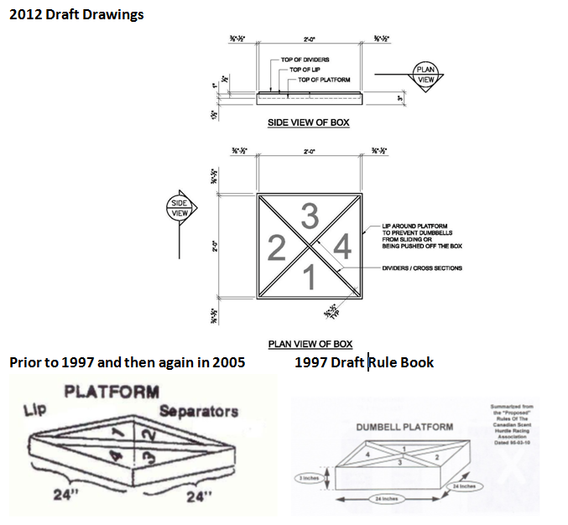(ALL DRAWINGS, MEASUREMENTS/DIAMENTIONS ARE UNDER REVIEW).

## 5.3 Hurdles

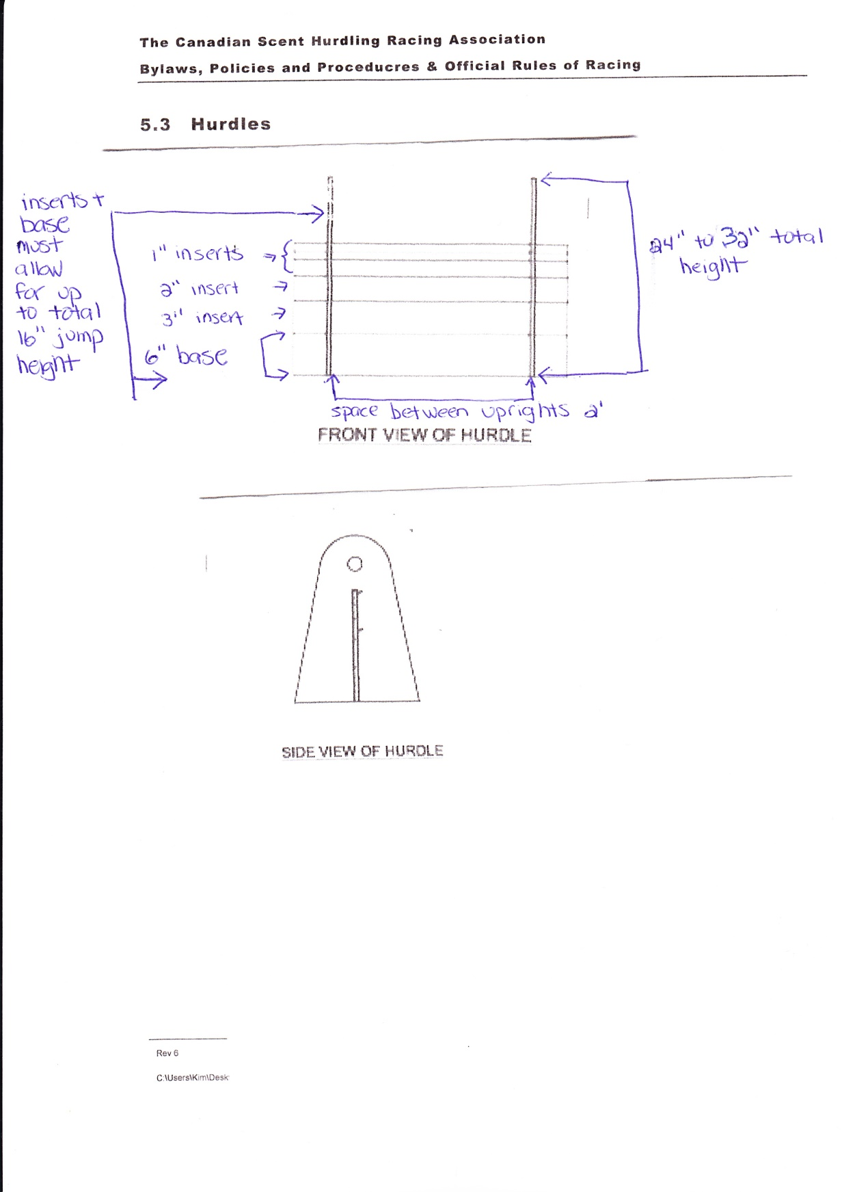(ALL DRAWINGS, MEASUREMENTS/DIAMENTIONS ARE UNDER REVIEW).

**5.4 Racing Jacket**

For information on making of Racing Jacket please contact the CSHRA Secretary for more information.

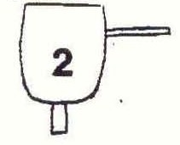

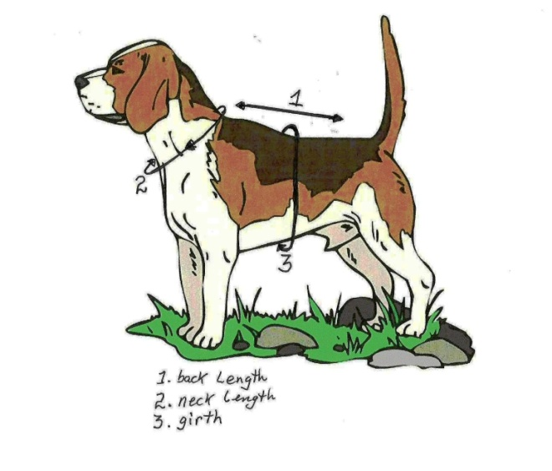

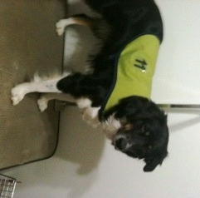

**5.5 Placement of Hurdles Using 4 Hurdles**

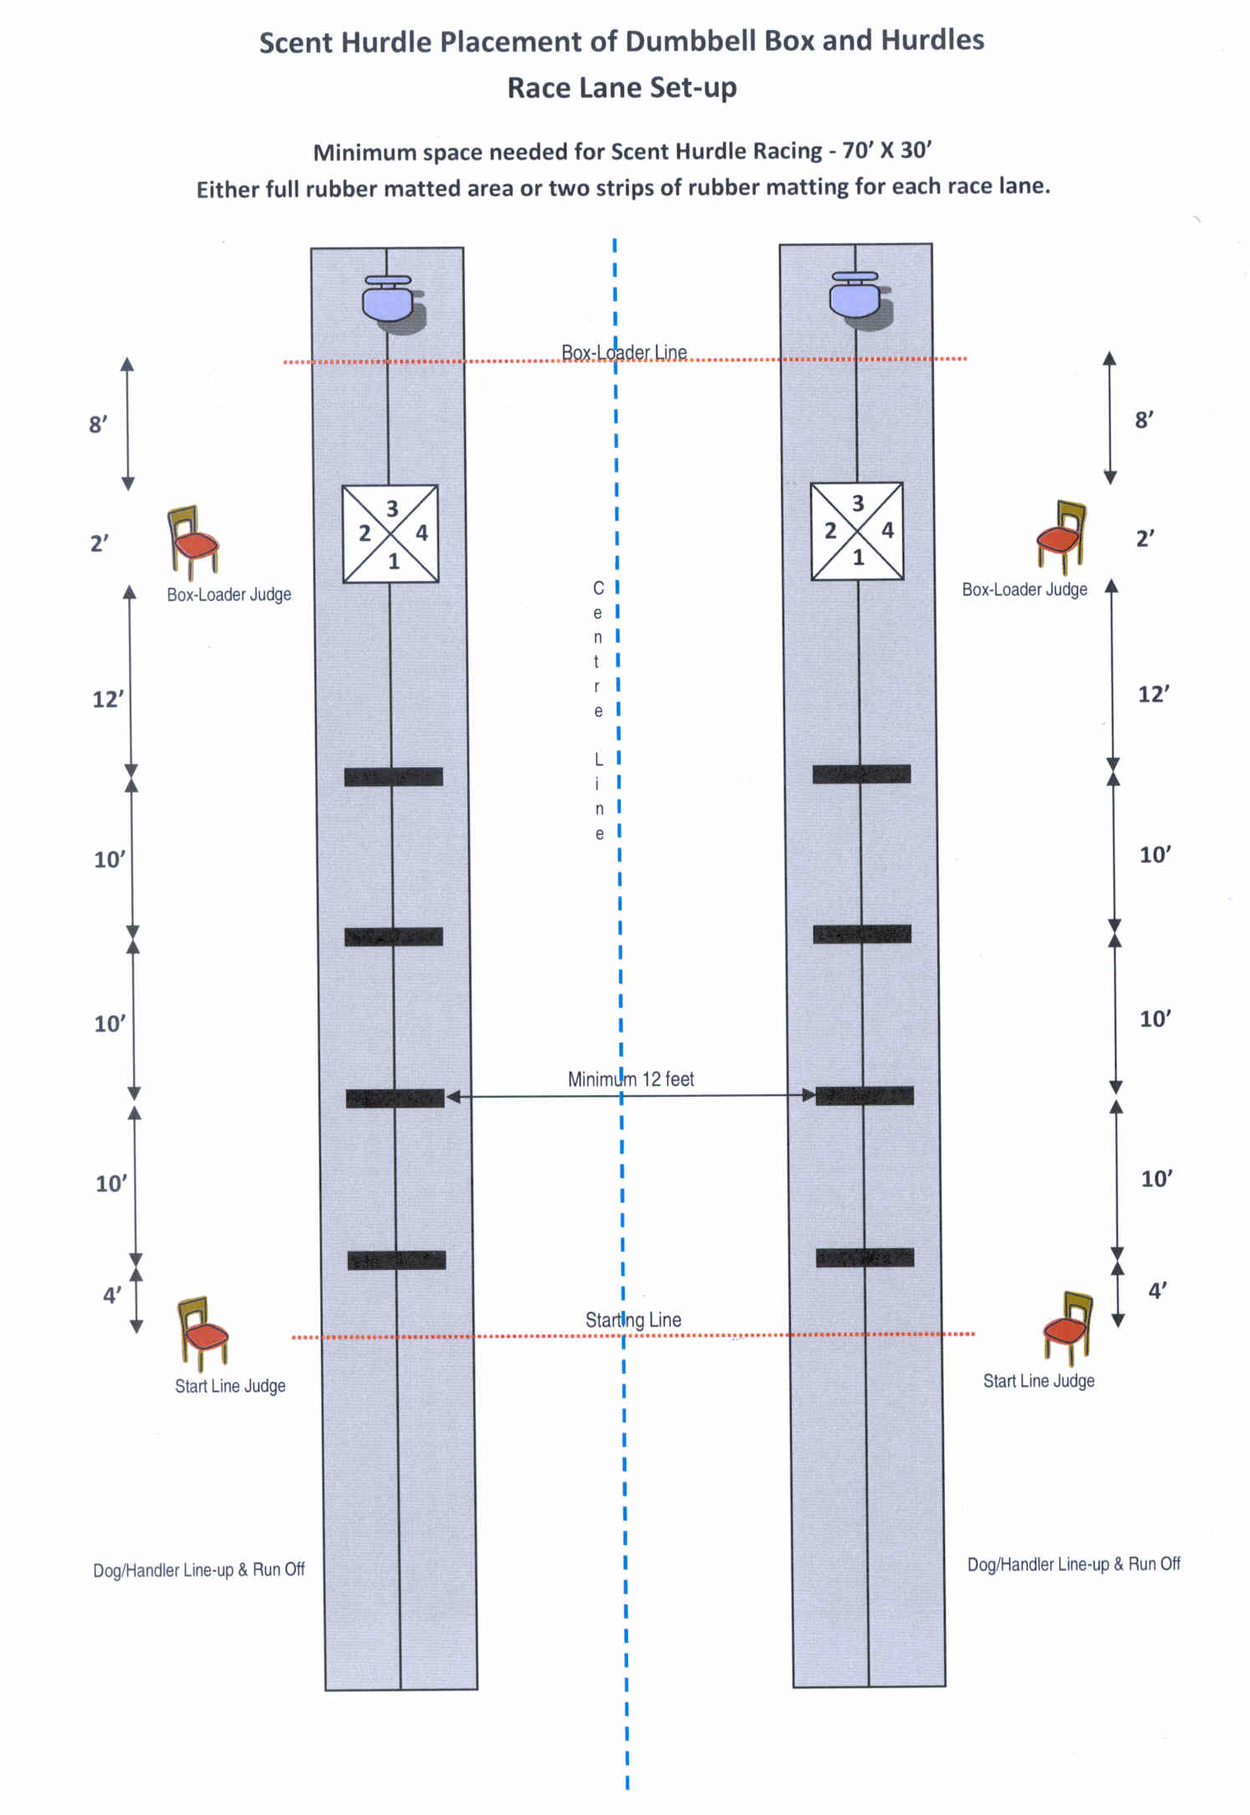

**In Tournament using three hurdles the distances for the first and last hurdles remain the same. A middle hurdle is removed.**

**APPENDIX a**

**FEE SCHEDULE**

CSHRA Membership $15/calendar year

CSHRA Dog Registration (one-time fee) No cost

CSHRA Team Registration No cost

CSHRA Team Entries Set by Tournament hosting club

CSHRA Appeals $25

CSHRA Protest $25

**APPENDIX B**

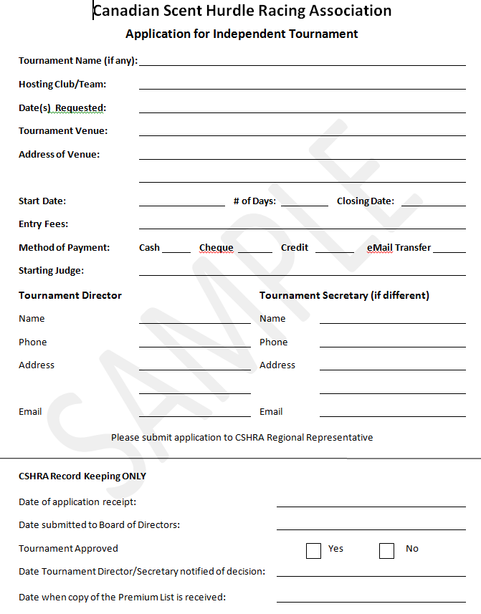**Application for Independent Tournament**

**APPENDIX C**

**Dog Registration Form NEED NEW FORM**

**APPENDIX D**

**Incident Report**

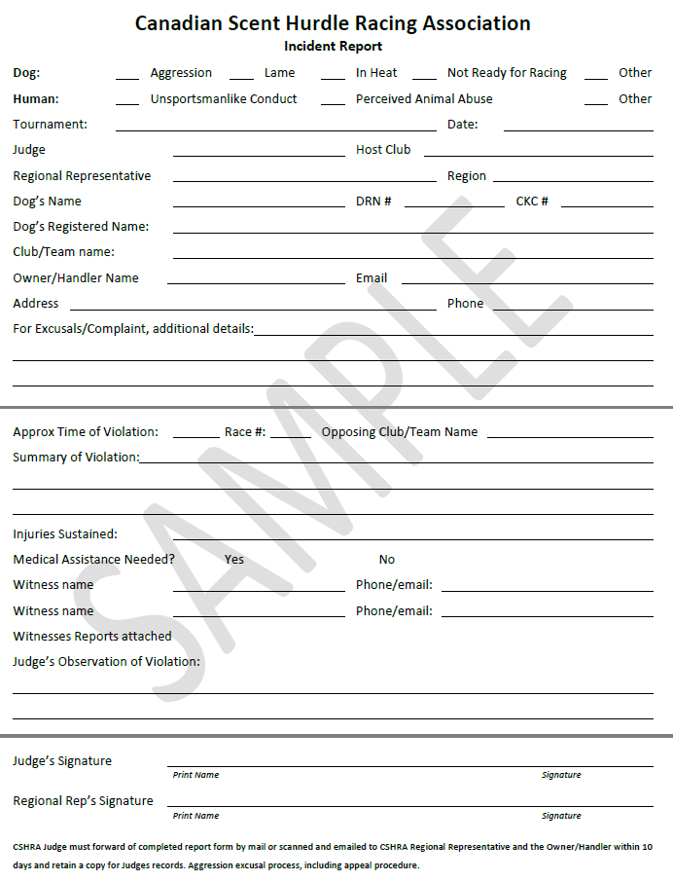

**APPENDIX E**

**New Club/Team Registration Form**

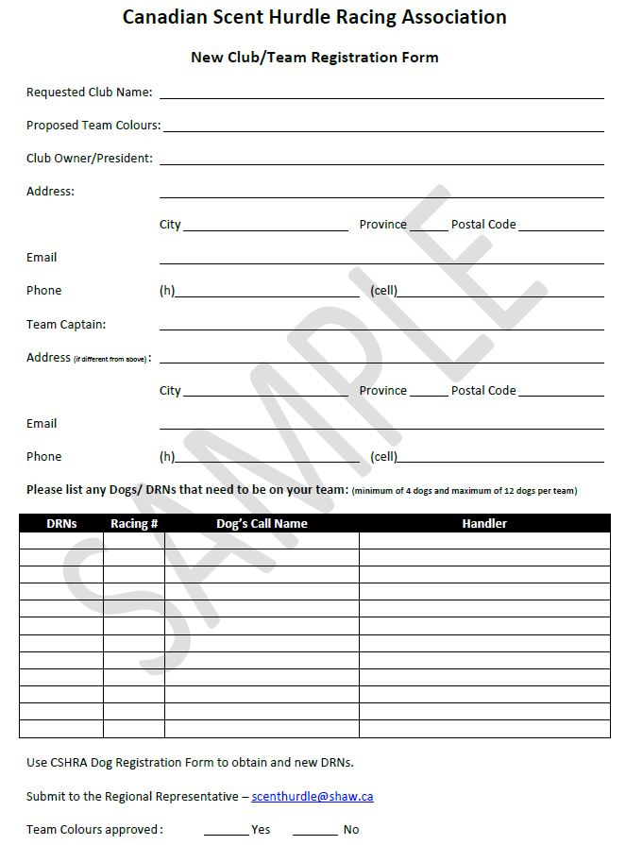

**APPENDIX F**

**Request for CKC Certificate**

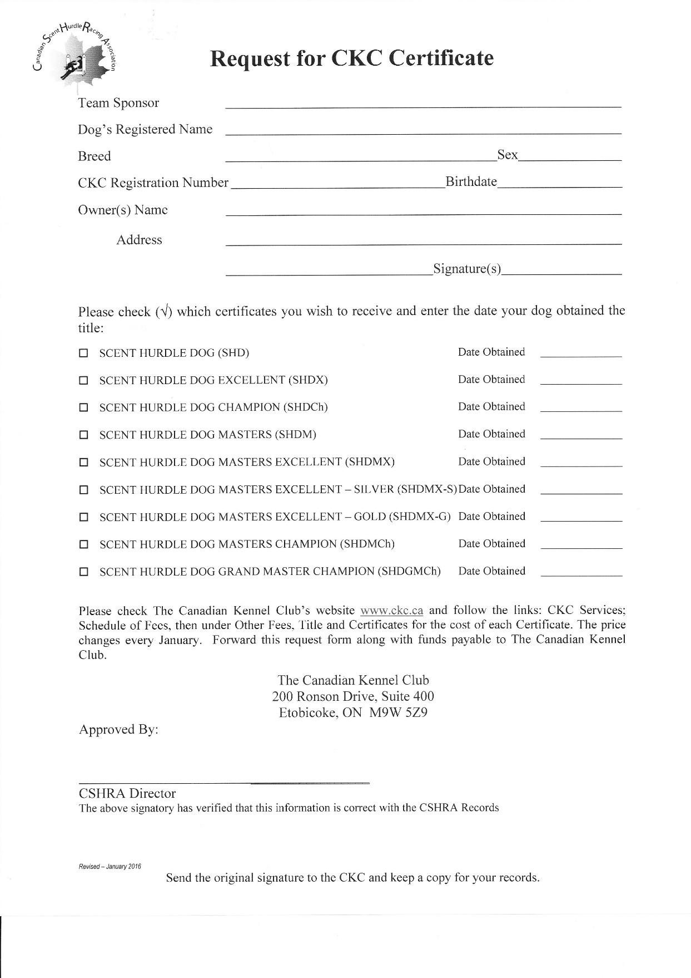

**Appendix G**

**Request for Exception Team Status**

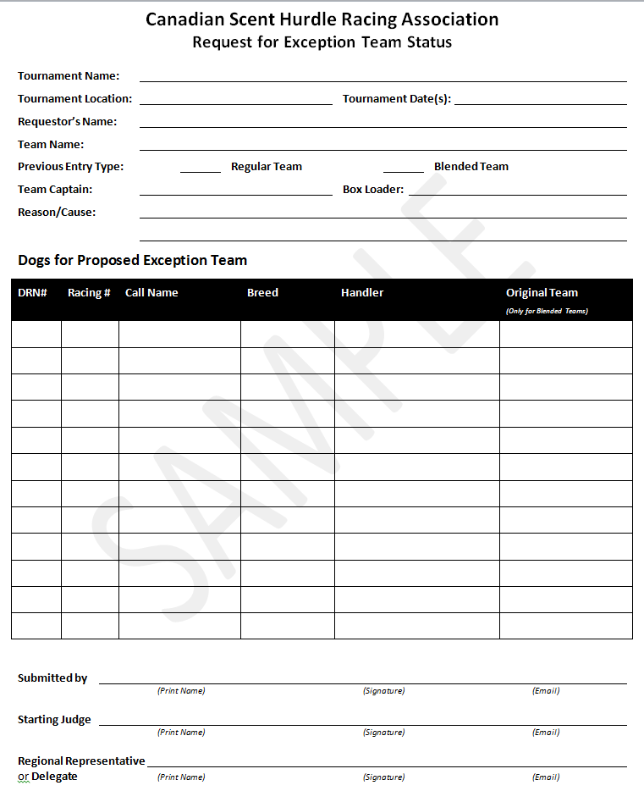

**Appendix H**

**Tournament Entry Form**

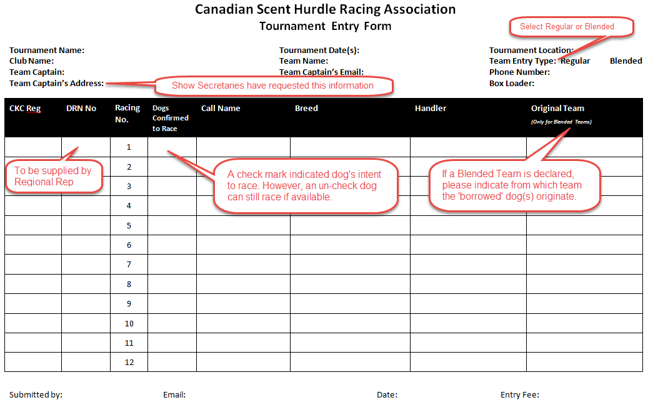

An example of possible Regular Team entry

## 

Examples of possible Blended Team entries

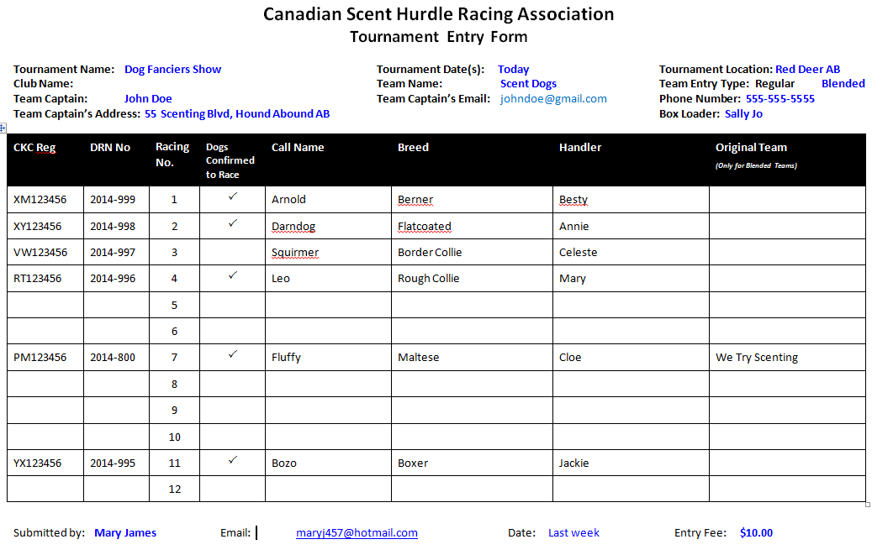

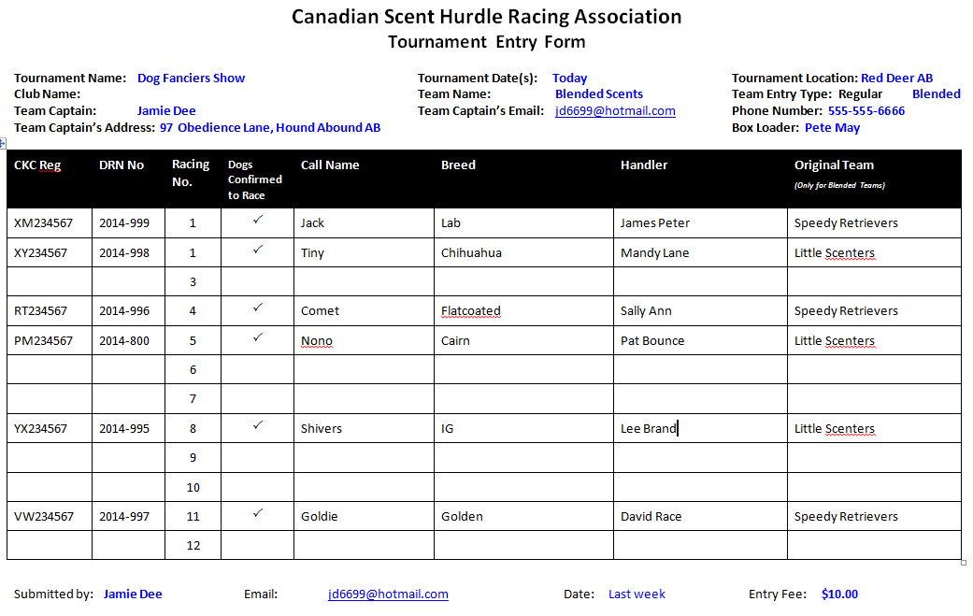

**Appendix I**

**Tournament Scoring Sheet**

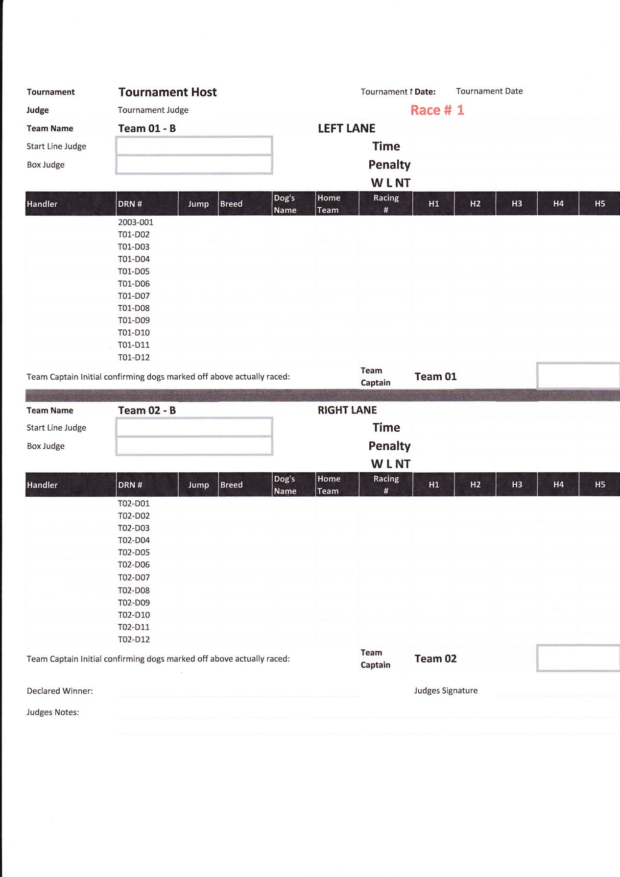

**Appendix J**

**Updating Dog CKC Titles**



# 

**APPENDIX K**

**membership Form NEED NEW FORM**

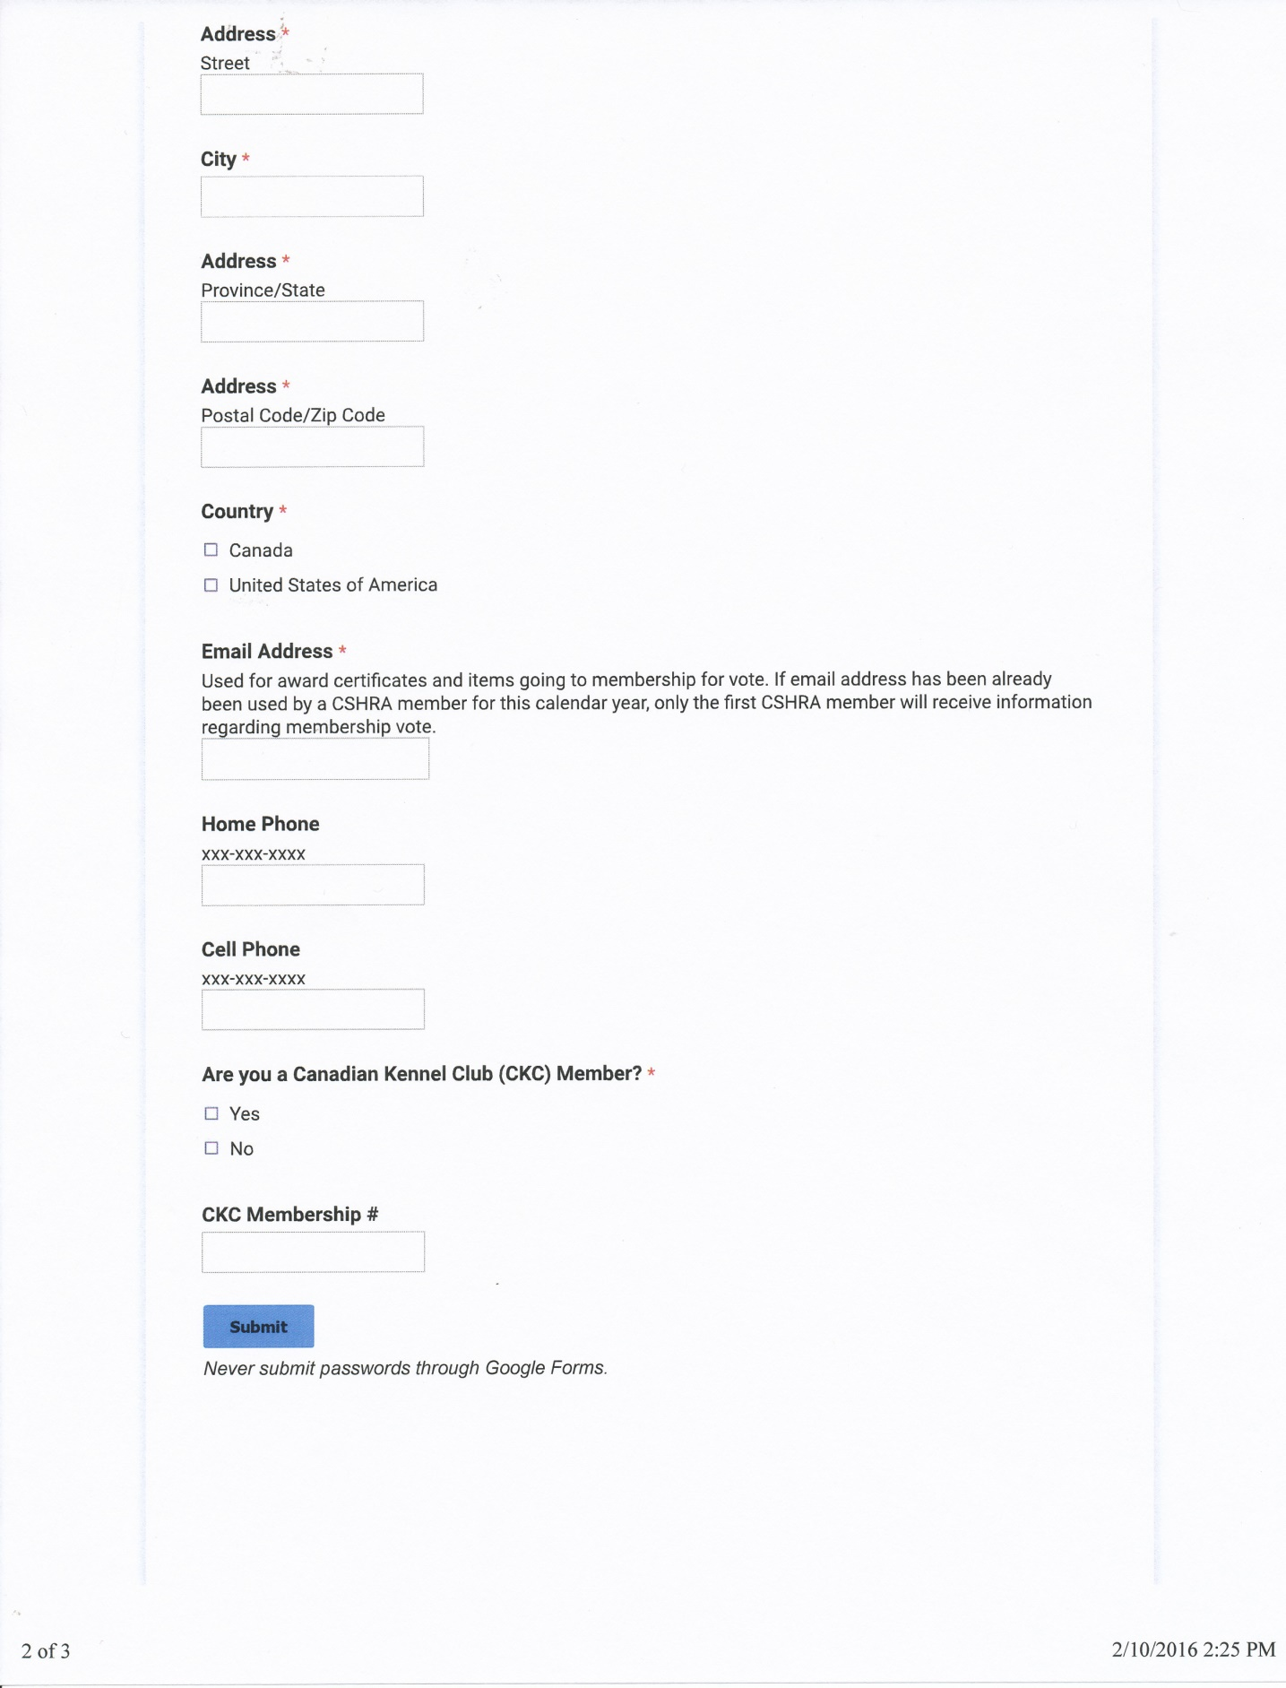

**Appendix L**

**Letter of Permission (Veterinary)**

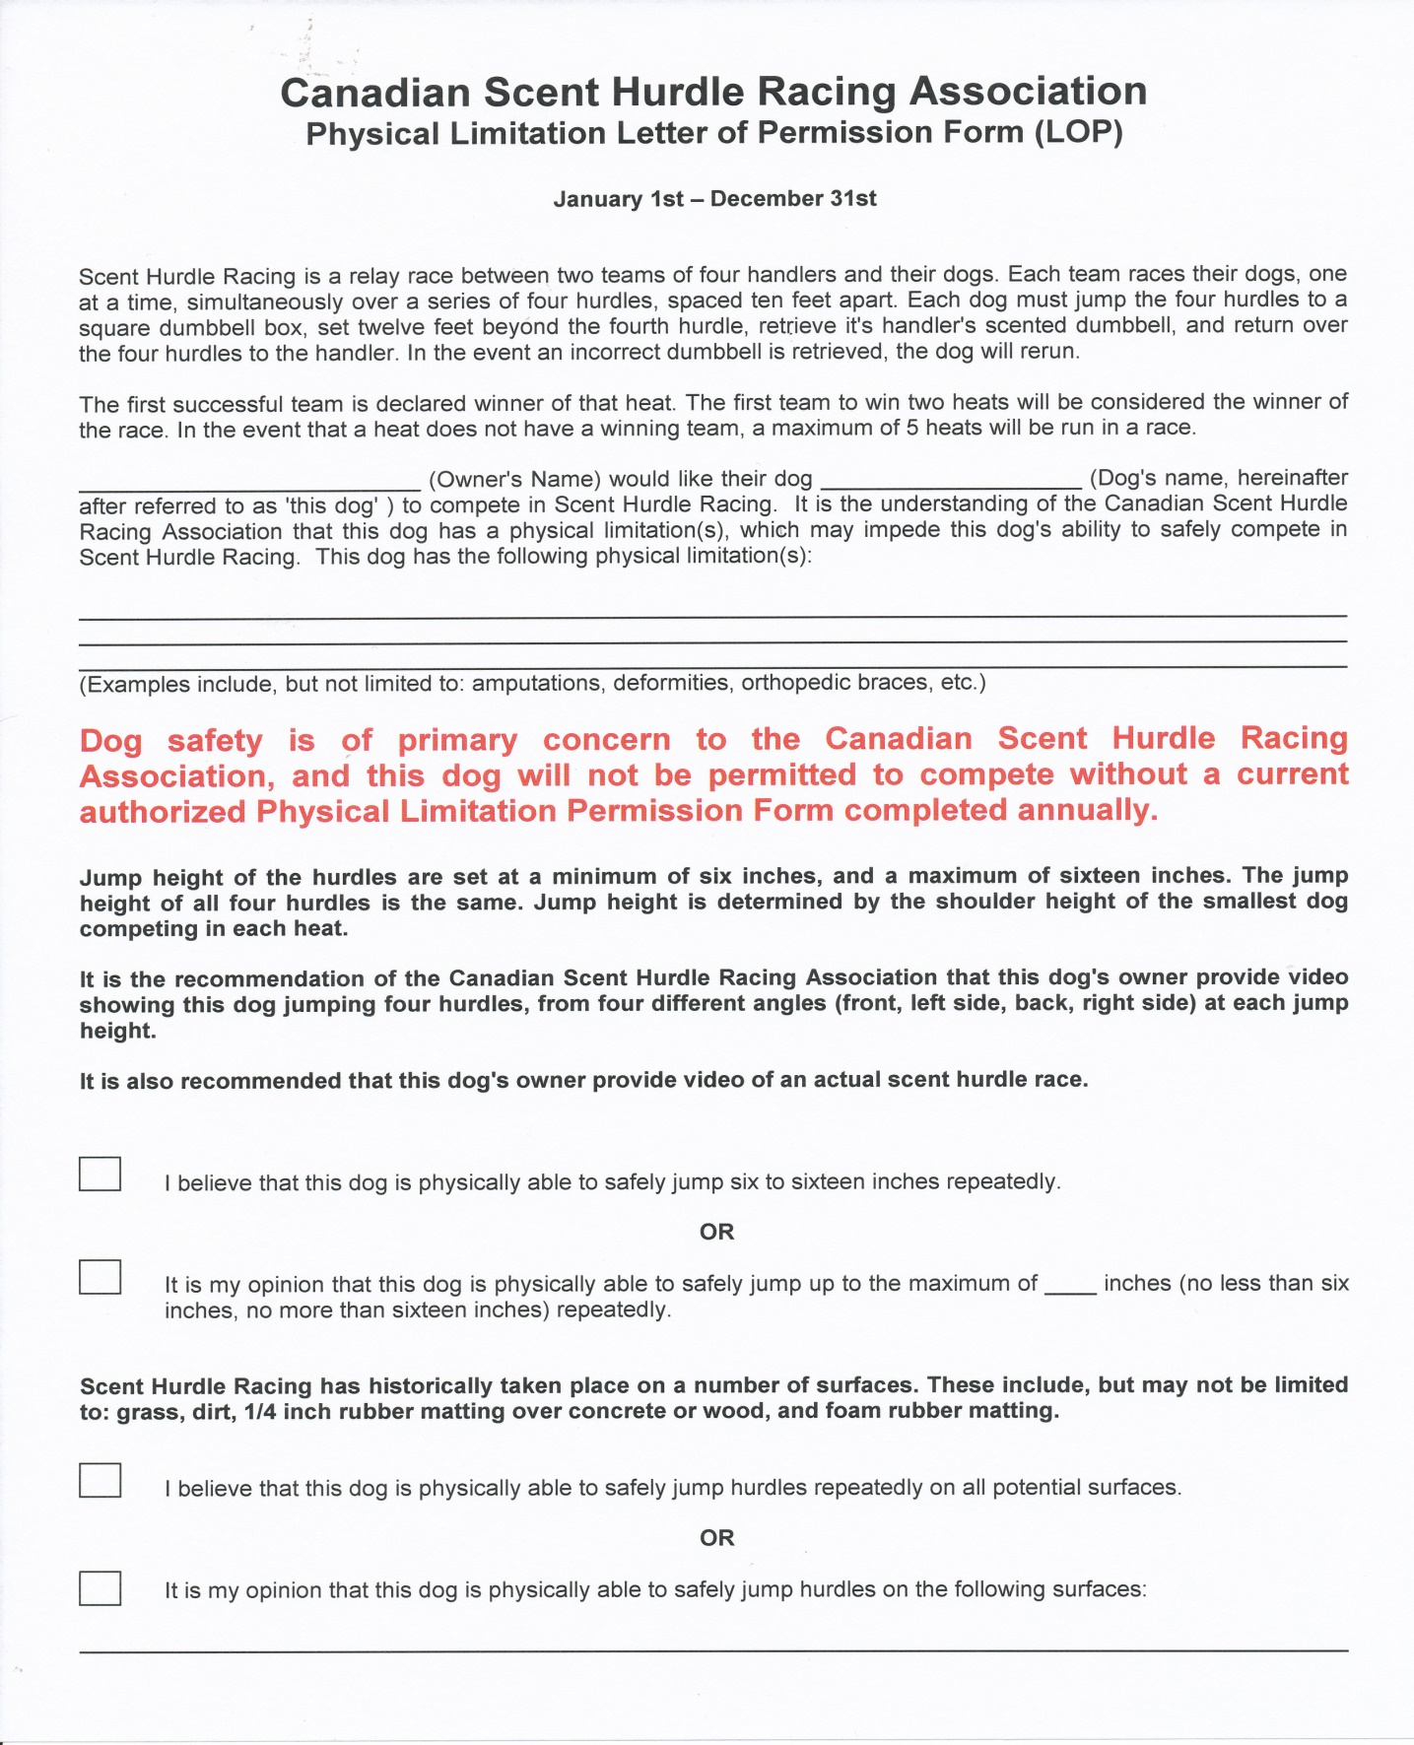

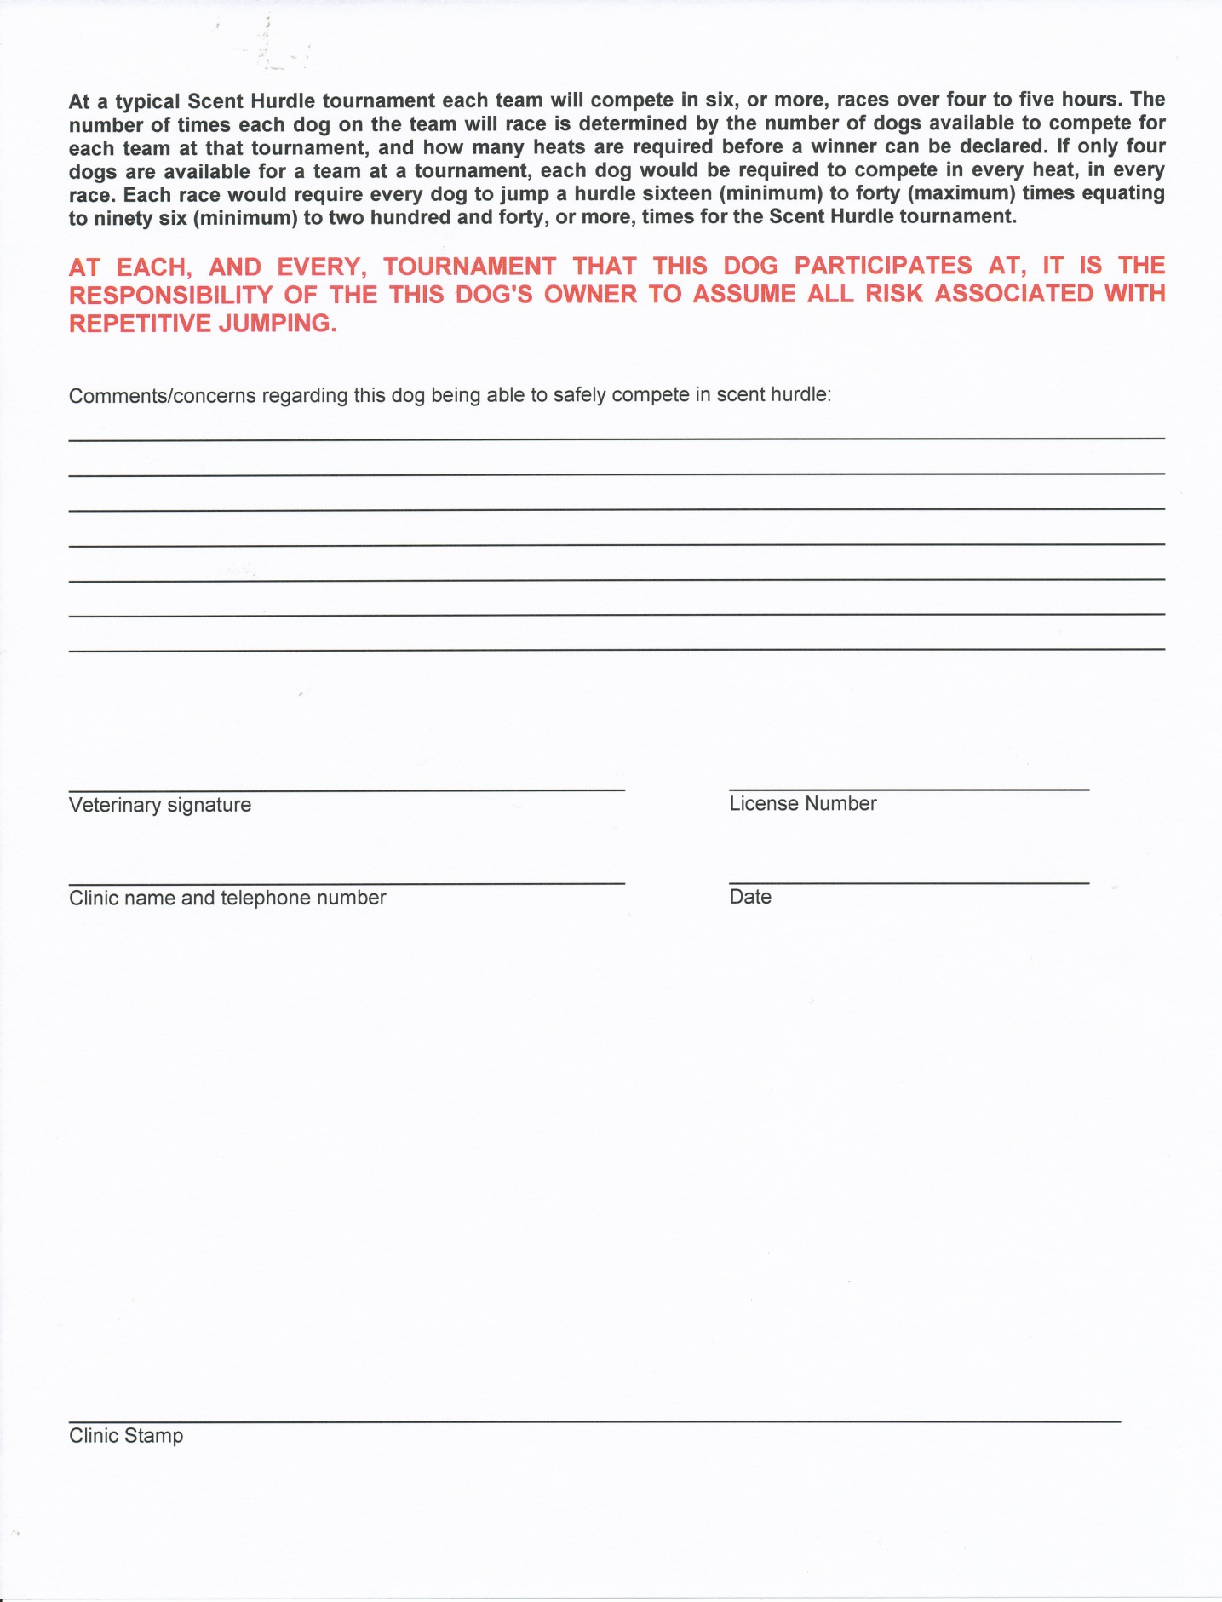

**Appendix M**

**Letter of Permission (Physical Therapist)**

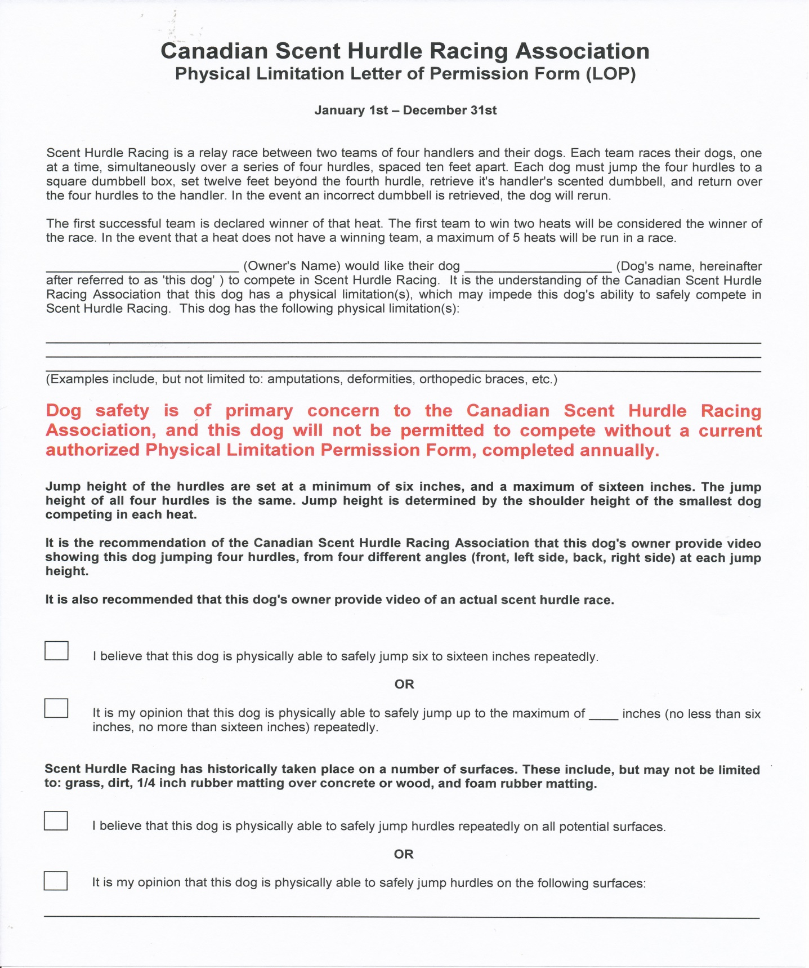

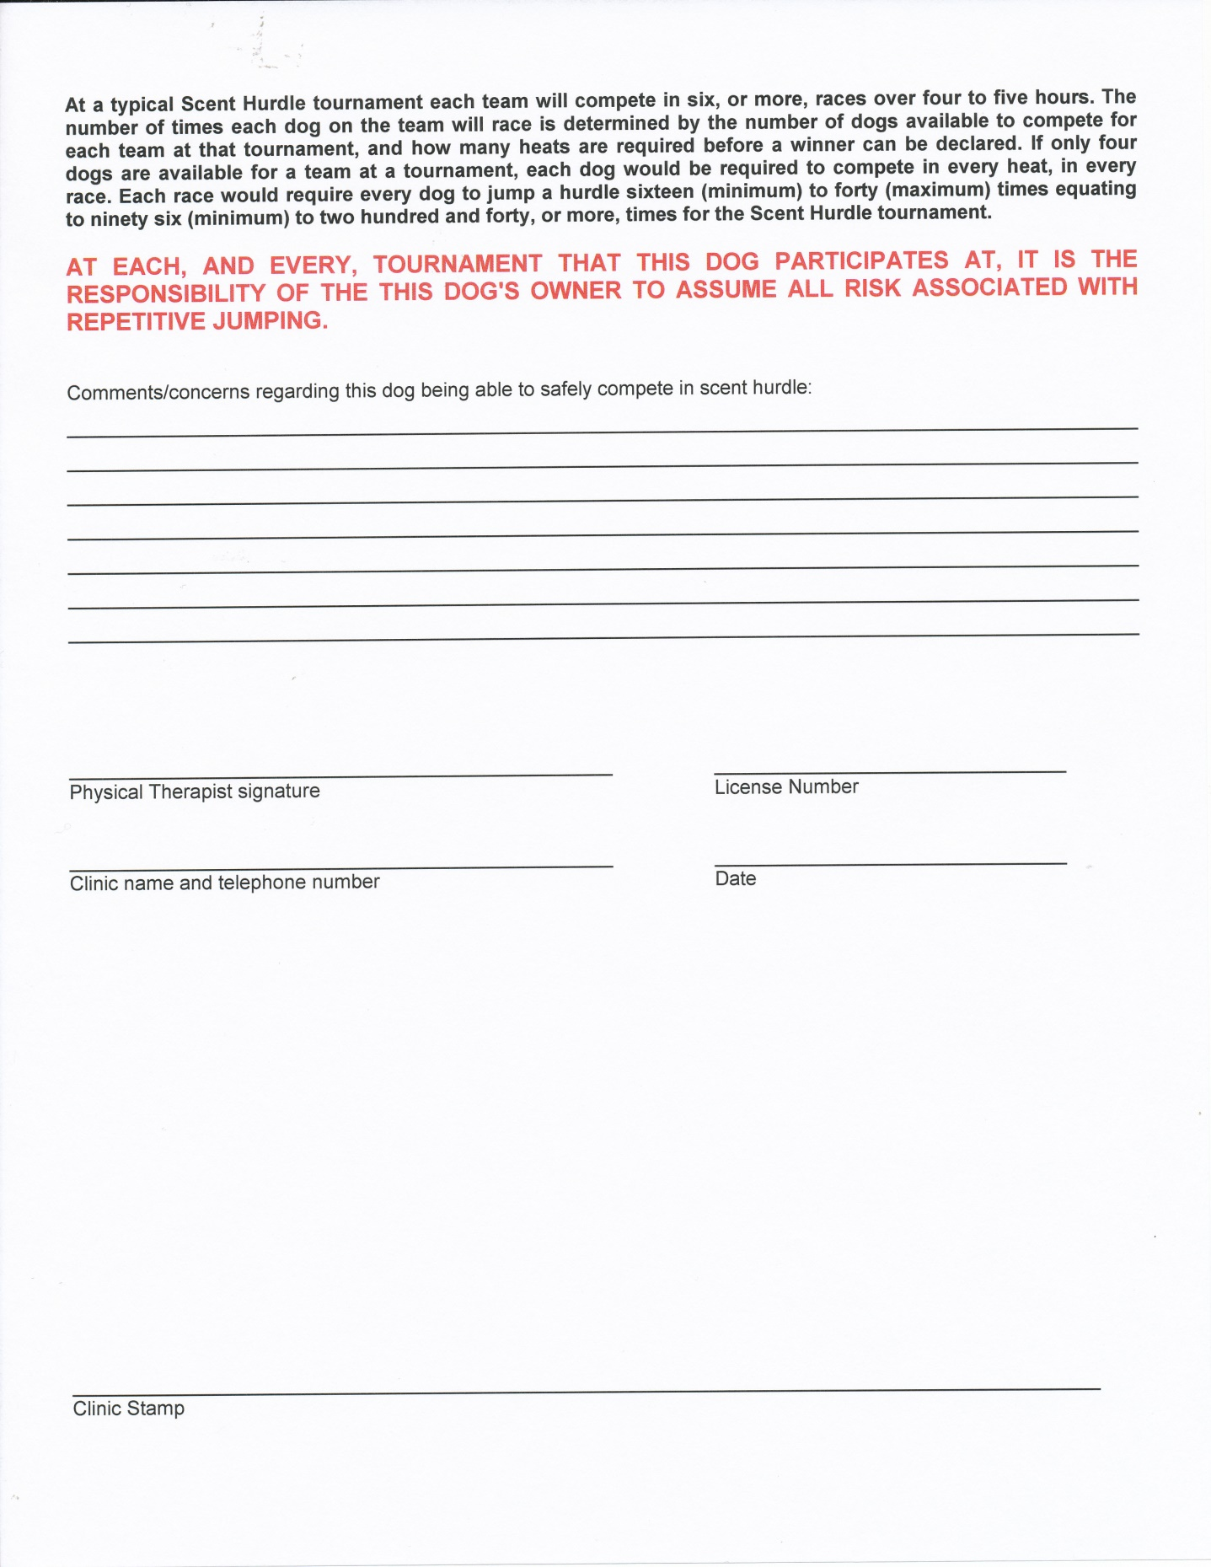

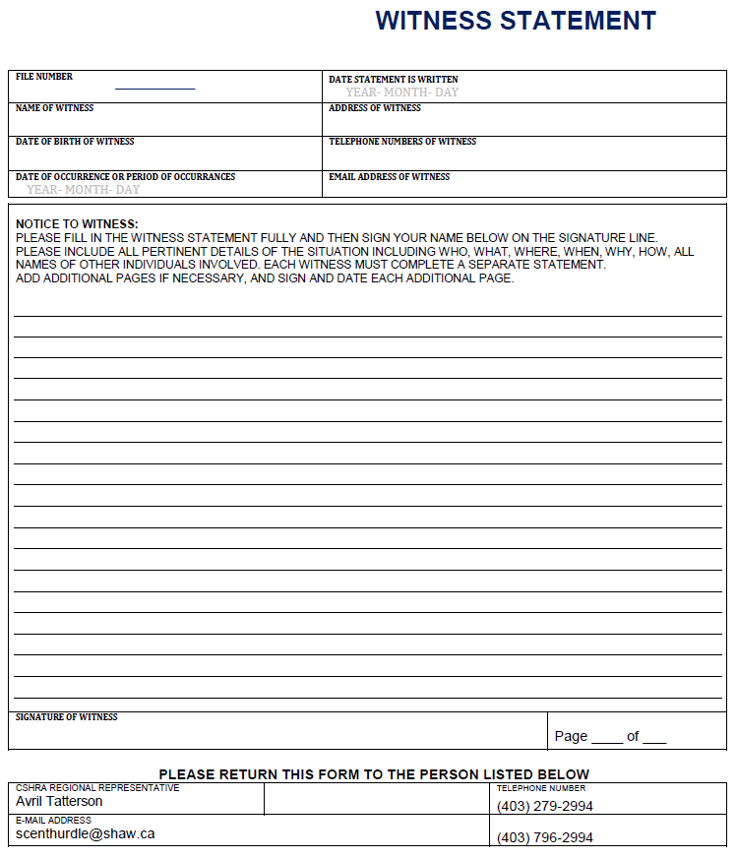**APPENDIX N**

**WITNESS STATEMENT**