Dear Provider,

Now more than ever, there is a dire need to help people obtain peace and overall better health. We would like to introduce you to a pathway towards meeting that growing need. We launched a new Mission for relaxation, peace, and natural health; ***Spiritual Spa Days Well Balanced (SSDWB)***. SSDWB is a not-for-profit Mission and proud supporter of ***Genesis Energy Alliance Restoration***, ***The G.E.A.R. Up Project (G.E.A.R. Up).***  G.E.A.R. Up is a Christian-based non-profit organization, managed by volunteers, helping communities and Church families G.E.A.R. Up with health-focused choices, and the full Armor of God. As a SSDWB Provider Partner you would also be a supporter of The G.E.A.R. Up Project! For a more in-depth summary of our strategy see <https://spiritualspadayswellbalanced.com/spa-day-mission>

***Our Mission***

Bring a message of Temple Wellness to the Church Body.

***Our Core Team Intention***

Using everything God gave in Heaven and on this earth to develop Ephesians 6:10-11 Warriors and Ambassadors for God, thereby glorifying Him in our actions.

***Our Vision***

The Church Body living a Well-Balanced Faith Journey in the Likeness of His Image: Spirit, Soul, and Body.

***Decree from God***

My people perish for lack of knowledge.

Our Mission’s focus and strategy for the last 9 years has been to provide a well-balanced approach to one’s faith journey. We are excited to share with you our growth plan that includes Spiritual Spa Day Retreats, Mobile Events, and Health Harvest! Our Spa Days & G.E.A.R. Up Project events enable us to incorporate Providers who have a similar vision of providing services, products, and information to our Contributors and participants. As the spirituality of our audience grows and their knowledge deepens concerning their physical health, so does their desire to seek trusted Providers for holistic services, natural products, and spiritual counsel.

Sessions for our participants include, Spirit and Soul Theology, Temple Fitness, Guided Biblical Deep Breathing Meditation, and Temple Wellness (TW) information sessions. TW sessions include topics on the study of the interworking of the body, Earthing / Grounding, expert information on EMF Protections, Depression and Anxiety, Detox, and much more. For more details: <https://spiritualspadayswellbalanced.com/sessions>

TW information sessions are greatly enhanced when there is unity among others yearning for the same Mission outcome (i.e., Trained, Certified, Licensed Providers). Provider Partners become another reliable resource for TW sessions at our Retreats and Health Harvest. As a Provider Partner you are given online advertising, and options to consider for offering exclusive coupons for services or products for our SSDWB Contributors. There is also an option to participate in our exclusive Provider Partner Health Harvest event, and be featured in our e-magazine.

We would like to discuss more about including you in our Mission and Vision. When you become a Provider Partner with the SSDWB Mission, you become an extension of who we are, the hands and feet of Christ. We humbly request your consideration for partnering with us, and establishing a professional and God glorifying relationship.

Sincerely,

Michele Ungarino – Founder

The Volunteer Team

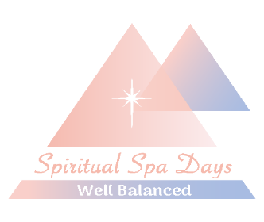 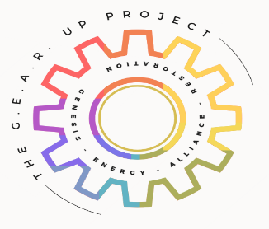 r 1/6/25 lb