Pre-Authorized Giving
Change of Offering
The Cathedral Church of
Saint Alban the Martyr
Prince Albert, Saskatchewan

Parishioner’s Name

________________
Current Envelope number

I/We have already signed up for Pre-Authorized Giving. I/We would like to change the amount and or frequency of my/our offering by direct debit.

I/We (the above named parishioners) authorize the Cathedral Church of St. Alban the Martyr to debit my/our account in the amount of $ ___________
□ once per week (Mondays) or □ once per month (the 3rd), beginning in _______, 202_. This is for givings in respect of my / our annual offerings.

Date Parishioner’s Signature

____________________________________
Date Parishioner’s Signature

*Please note Pre-Authorized Giving instructions in place will continue unless this Change of Offering form is completed and returned.

The heart of the giver makes the gift dear and precious.

-Martin Luther
All things come of thee,
and of thine own
have we given thee.

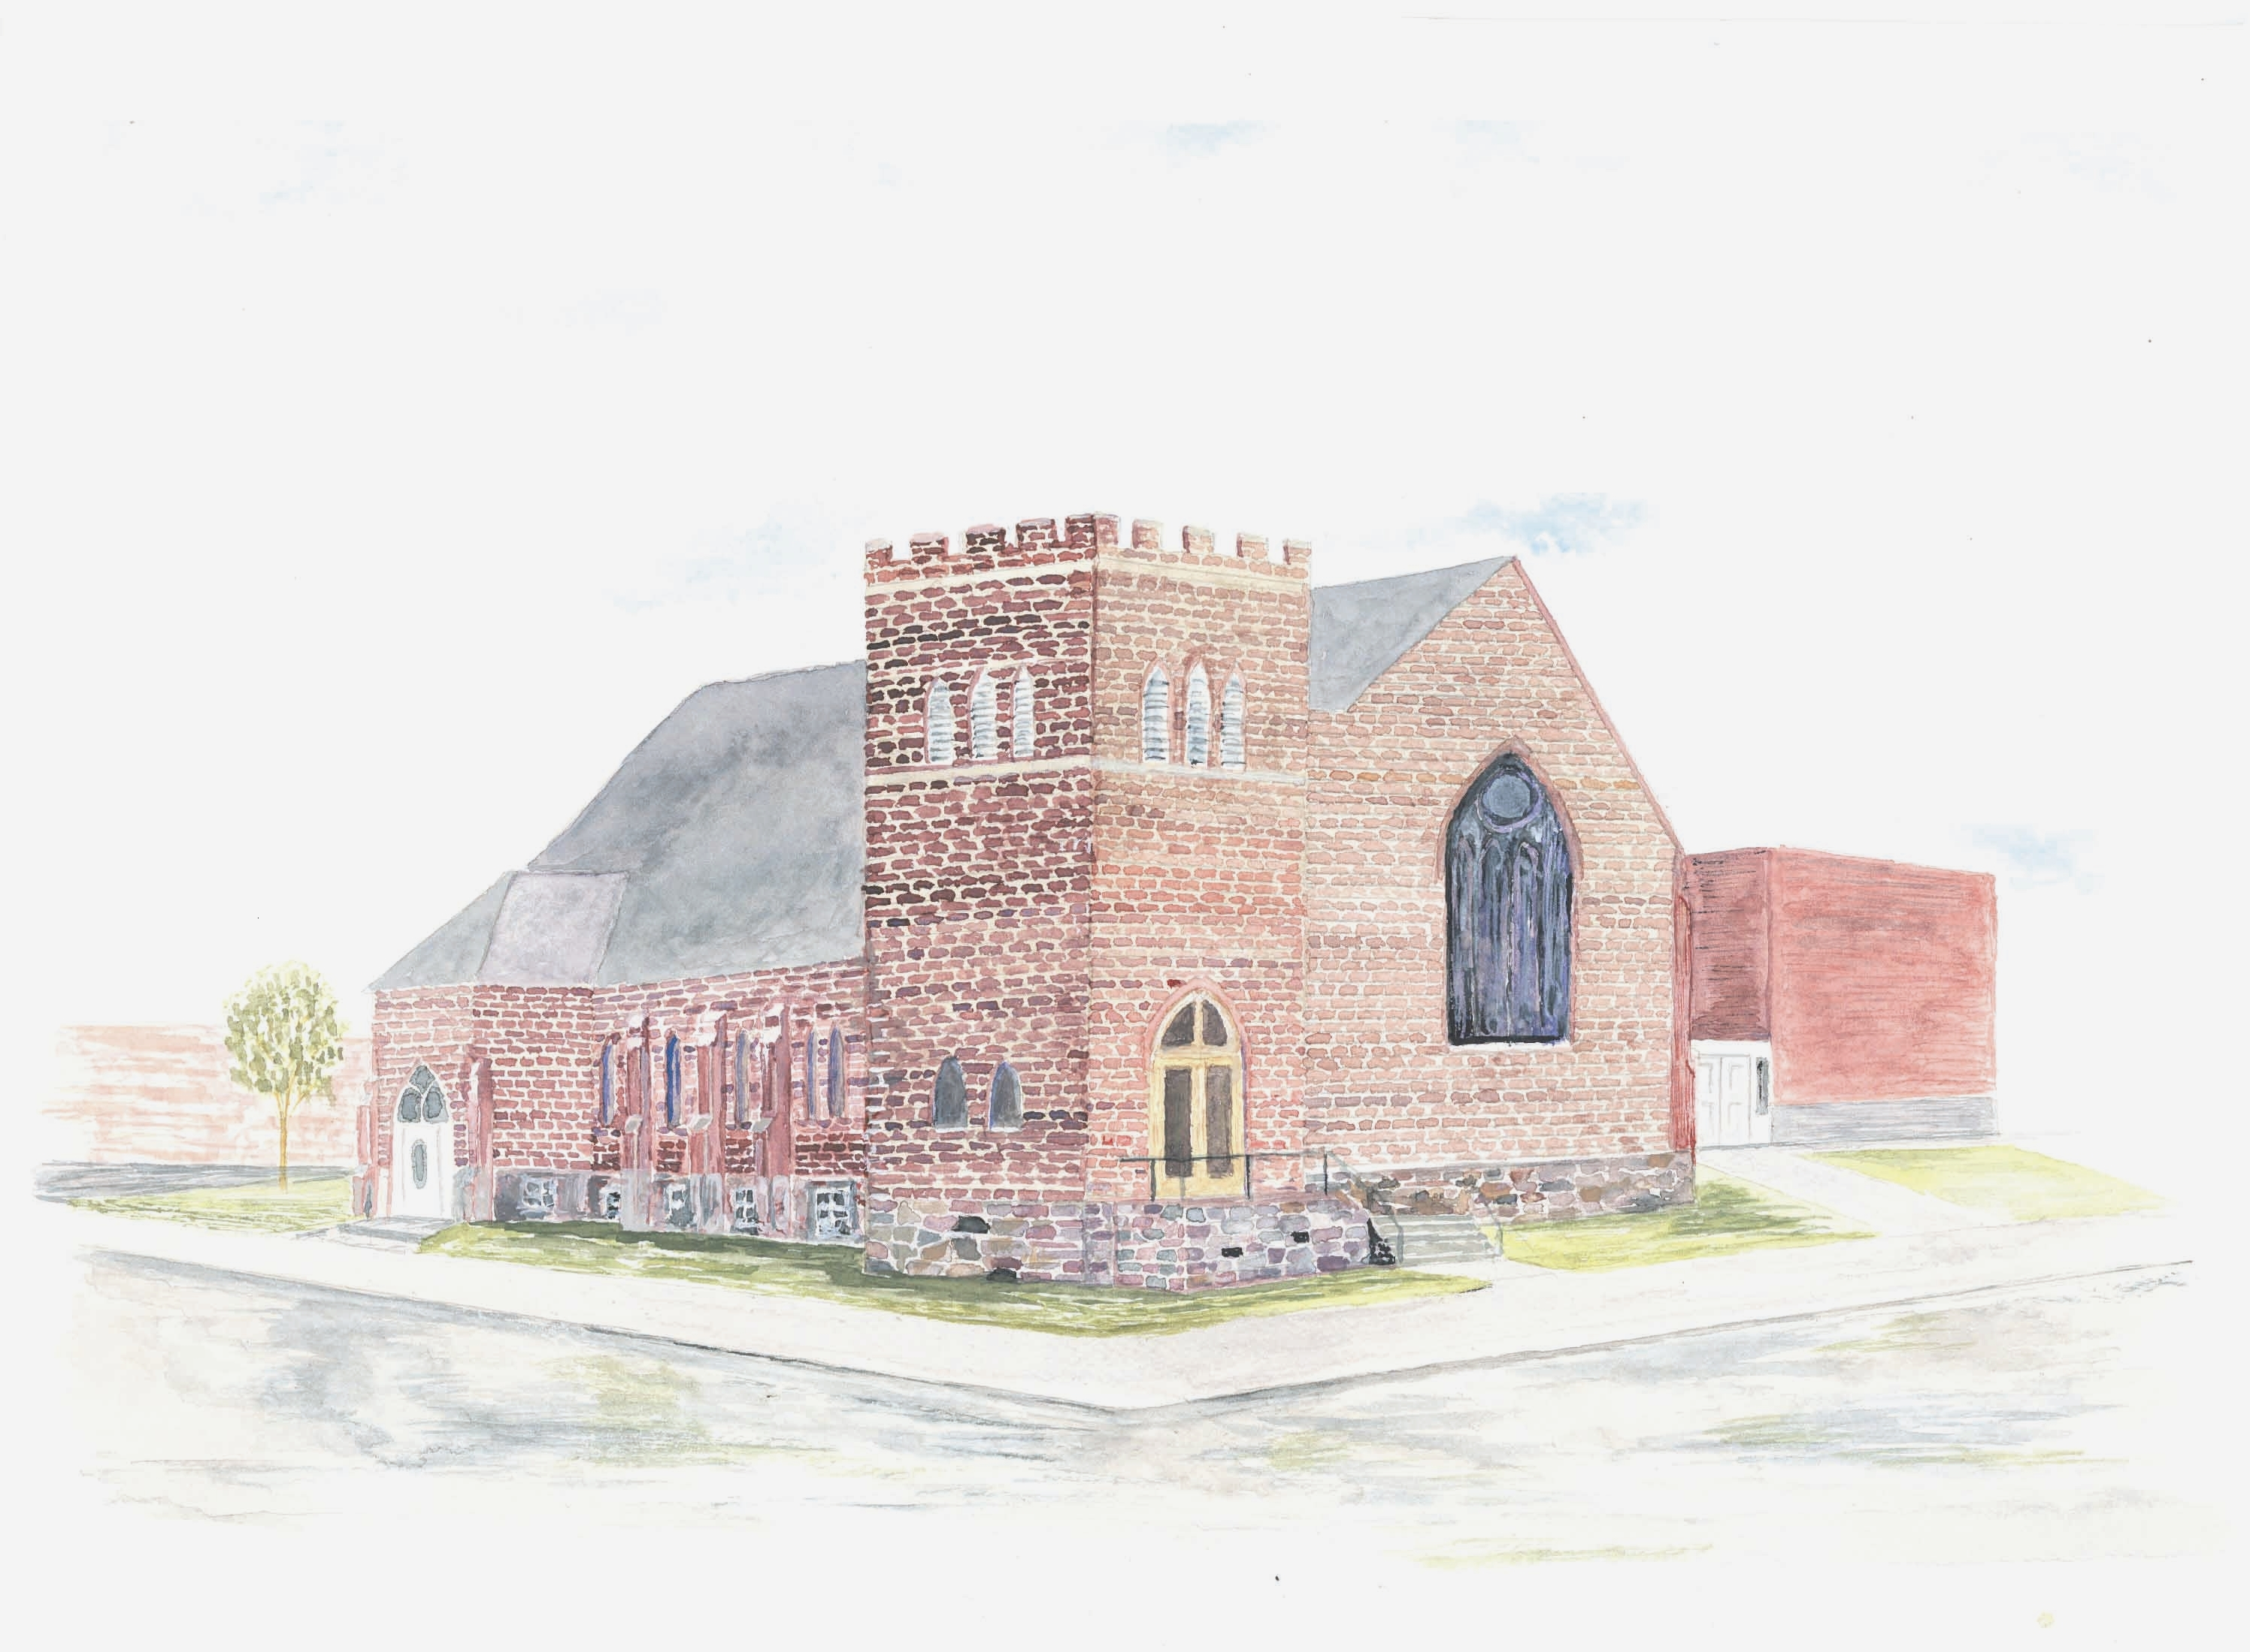

The Cathedral Church
of
St. Alban the Martyr

Prince Albert, Saskatchewan

Please consider…

Pre-Authorized Giving

Pre-Authorized Giving

When you go away from home, the power, water, and heat still work in your house…

When you are away from your church, ministry still continues…

Just as bill paying and pay cheque transactions have become easier through pre-authorized withdrawals and automatic deposits, so the Cathedral is making it
easier for you to support our ministries even when you are not here…

It’s Convenient
Pre-authorized giving is a weekly or monthly giving option available at no charge to you.

It eliminates the need for you to write a
cheque each month for your regular donation.

It’s Assured
If you are away on holidays, out of town on
business or ill, your offering will be made, ensuring the continued ministry of the
Cathedral.

Here’s What To Do
- Whatever you now give weekly, monthly, quarterly, or annually, simply convert to a weekly or monthly amount.

- Complete the attached form and enclose it with a cheque marked “VOID” in the envelope provided and place it on the offering plate or send it to the Cathedral office. Your offering will be deducted from your bank account in the same way you honour many of your other commitments in life.

- After you sign up, you will receive special offering cards to place on the collection plate at services to remind you of your participation in the Offertory.

What About Records?
Offerings are recorded automatically and individually on your monthly bank statement or passbook. These offerings are recorded at the Cathedral and included on your annual tax receipt.

If Your Circumstances Change
At any time the amount of your offering can be changed. Simply notify the Cathedral Office of the change. There is a Change of Offering form on the back of this leaflet which you can fill out to change the amount or frequency of your offering. If your banking information changes, please provide a new “VOID” cheque.
New Authorization Form
For those not yet participating in Pre-Authorized Giving
The Cathedral Church of
St. Alban the Martyr
Prince Albert, Saskatchewan

___________________________________
Parishioner’s Name

___________________________________
Financial Institution

I/We (the above named parishioners) authorize the Cathedral Church of St. Alban the Martyr to debit my/our account in the amount of $ ___________ □ once per week (Mondays) or □ once per month (the 3rd), beginning in ________, 202_. This is for givings in respect of my / our annual offerings.

Each donation shall be the same as if I/we had personally issued a cheque authorizing the bank to pay the Cathedral as indicated and to debit my/our account the amount specified. I/We will notify the Cathedral Office promptly in writing if I/we move the account from one bank or branch to another, or if there is any change in the specified amount. The authorization may be cancelled at any time upon two weeks written Notice by me/us to the Cathedral. Any delivery of this authorization to the Cathedral constitutes Delivery by me/us to the bank. I/We are all the Persons who are required to sign on the above Account. I/We will receive a signed copy of this Authorization.
Current envelope number______.

Date Parishioner’s Signature

____________________________________________
Date Parishioner’s Signature
Please attach a “VOID” cheque

