The Flow of an US Pony Club Rally
(What happens at a pony club rally, and in what order)
Up, Out, and On the road early
The competition won’t wait for you. You will be told the time the rally grounds open and the time of the rally briefing. Get to the rally grounds ON TIME!! Getting there late is stressful for everyone, 4-legged as well. Plan ahead. Clean you tack, set out your attire, load your water, hay, and equipment the night before. Have your directions printed out. Look at a map and know where you are going! You are part of a team, being late doesn’t just affect your performance and score, it effects your team mates
as well.
Unload horse and equipment  Unload your horse. Make sure he is comfortable and then start unloading your equipment. Someone on your team will be responsible for bringing the team rally box. The Stable Manager will begin setting up the team tack room. Please be as helpful as possible. You are responsible for your own equipment; tack, grooming, boots, etc. Do not expect the Stable Manager to set your things up as well as setting up the tack room. | Parents are allowed to help unload your horse and equipment, but that’s it!  Parents are not allowed to set up your team tack room. They must leave the competitor area after assisting with unloading.
Parents LEAVE competitor area!!! Yeah!  For fairness and fun, parents are not allowed to do this work for you. You are competing, not your parents. They will leave after helping you unload and you will not see them again until the rally is over. (They will see you, they are now spectators) If they help you at all after the official start of the rally you could get disqualified for ‘unauthorized assistance’. | Help…  Do you need help with something after your parents have left the team area? Ask your team captain, or stable manager, or teammates, or any one of the horse management judges (they are everywhere). Have an emergency? Go to the horse management tent and tell them you need  to contact your parents.
Set up team Tack room
There are particular rules to setting up a tack room properly. Each member on the team, not just the stable manager, is responsible for knowing the horse management rules. The team Stable Manager will implement these rules and set up most of the tack room. BUT, if your stable manager is not there, YOU are expected to know where everything is!
Attend Rally Briefing
At the briefing, the rally organizers will give all the competitors important information about today’s rally. Every team member should attend the briefing, although, they do not take attendance and it is usually not mandatory. BUT, and it is a big BUT, if you don’t go, you are still responsible for the information given at the briefing. Saying “but I didn’t know because I didn’t go to the briefing” will not be accepted as a valid reason for doing something incorrectly. If you can’t go to the briefing, make sure someone on your team has the job of reporting back to the whole team everything
relayed at the briefing.

Course walk  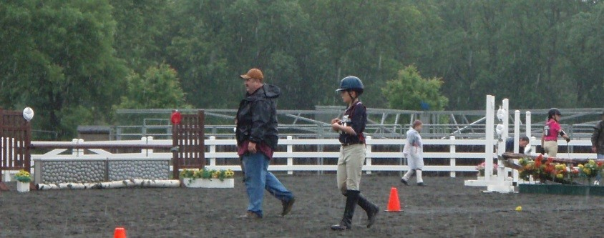 | In a show jumping, tetrathlon, and eventing rally, you will be given a time when you will be allowed to walk, on foot, the course you will be riding. At no time may you ever school your horse over the course. Coaches and teammates may walk the course together.
Go to Turnout Inspection  A Turnout Inspection (also called “Formal Inspection”, or just simply “Formals”) is the presentation of yourself and your horse to competition officials. Your attire, tack, and mount will be checked for appropriateness, safety, and cleanliness. You will be given a time for your turnout inspection, DO NOT BE LATE! You will receive penalty points for lateness. This is avoidable! Wear a watch, know how to read it, know your inspection time, and GET THERE! When it comes to your turnout, 5 minutes early is on-time, on-time is late, and late is very, very bad. | 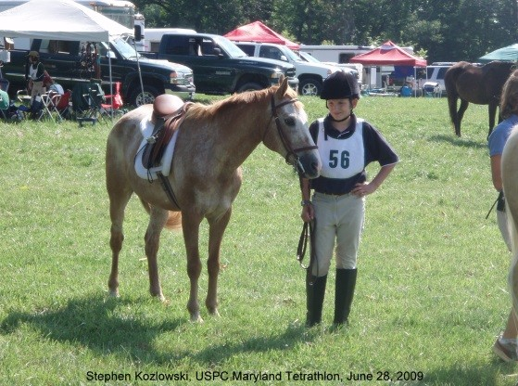
Warm-up  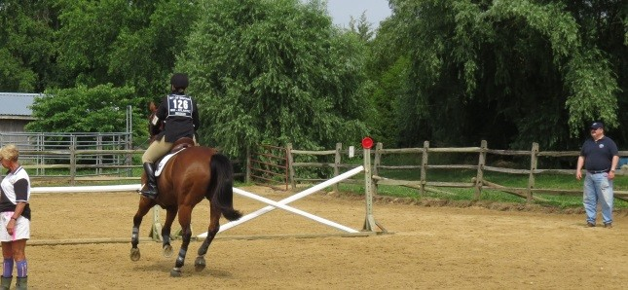 | You will be given a time for all your rides; dressage, tetrathlon, polox, eventing, etc. You have to figure out when to get to the warm-up arena to properly warm up your mount before going into the competition ring. You may never mount your horse until after your turnout inspection/safety check. Also, you are never allowed to jump in the warm-up ring without a coach  present.
Ride  Depending on the rally sport, you will ride a number of times. Usually, Dressage – 3 tests, Show Jumping – 3 rounds, Eventing – Dr, SJ, XC, Tetrathlon – 1 jump round. Refer to the sport’s rulebook on the USPC website for specifics. | 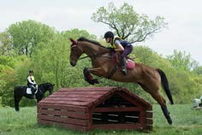
Turnback  When all riding is completed for the day, competitors have 1 hour to bring their mount to the horse management judges for a turnback check. The purpose of the turnback is to check that you have properly cooled out your mount and properly cared for your tack after riding. At the rally briefing you will be told which parts of your tack to bring with you to the turnback check. | 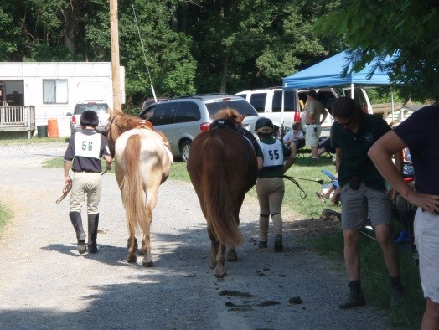

Relax with your team  You will have time between course walks, warm-up, and riding to relax. But just a bit. It is not okay to relax while your horse needs your attention. Nor should you be sitting while your teammates need your help. | 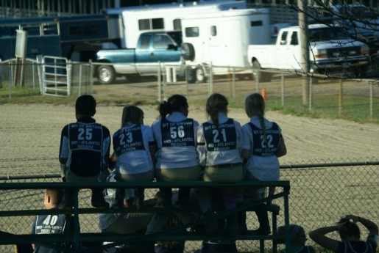
Awards
After scores are tallied. It is customary to either leave your riding clothes on, or change into a Shore Riders club polo.

Remember, awards are more than a color; you have been awarded the opportunity to
learn about teamwork, leadership, cooperation, compassion, and horse care,
all the while being able to spend the day with horses.
Pack up Tack Room and on the road again. | The competition is not over until you leave the grounds. All horse management rules are in effect until you have packed-up and pulled out.  EVERYONE on the team helps clean up, pack up, and load-up from the rally. Make sure the team equipment is put back into the rally trunk properly; another Shore Riders Team will need to use it for the next rally.  When you are done packing your things, help your teammates with theirs. Always help with handling the horses.  And if you see someone struggling, even, or especially, someone NOT on your team, always offer to help. This kindness to others will come back to you 10-fold!

