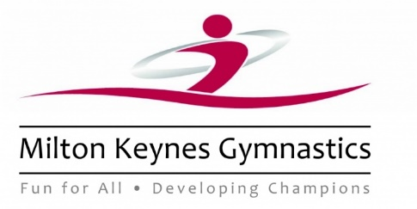

**Kit List – Portugal International Open 2019**

**Gymnastics Equipment**

Leotards x 2 or 3*

Plain black Leggings x 3* or stirrups

Black socks x 2 (we will provide)

‘Invisible’ bra*

Lots of hairbands & grips*

Water bottle

Lanyard (Provided by the gym)*

**General**

**Passport and EHIC Card\***

Shorts and T-shirts for 4 days

Underwear and socks

Light Pyjamas

1 x light jumper

1 x light raincoat

Party clothes

Trainers

Flip-flops or beach shoes

Sun hat

Toiletries and sanitary protection

Brush

Sun-cream

Swimwear and beach towel

Sunglasses

V Small soft toy!

**Other**

Phones/cameras may be brought but are responsibility of the owner and will be taken at lights out*

Up to €50 Spending money*

*These items should definitely be carried in hand-luggage