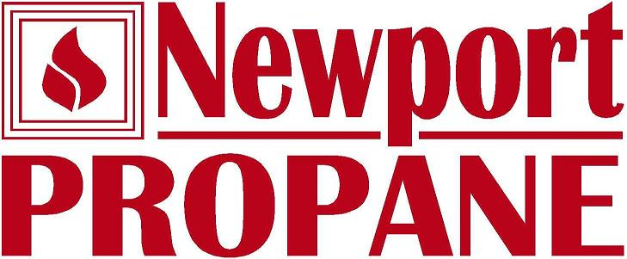

To whom it may concern:

I would like to take this opportunity to recommend Anchor Telecom. We at Newport Propane made the switch to VOIP 4 years ago. The process was seamless, Dan at Anchor was on site to help us get comfortable with the new system. Dan walked us though each step on how to set up our phones to voice mail. Our new system has so many more options than a land line its fantastic. We made a wise choice in going with Anchor, their team has been right there for any issues all along the way. For an example, I had forgot to adjust the incoming call cycle on some holidays, Anchor Technicians were able to fix my mistake quickly and keep our customers in contact with us.
We at Newport Propane are very pleased with the level of service after the sale with
Anchor Telecom.

Regards,

Tom Watson
Operations Manager
Newport Propane

