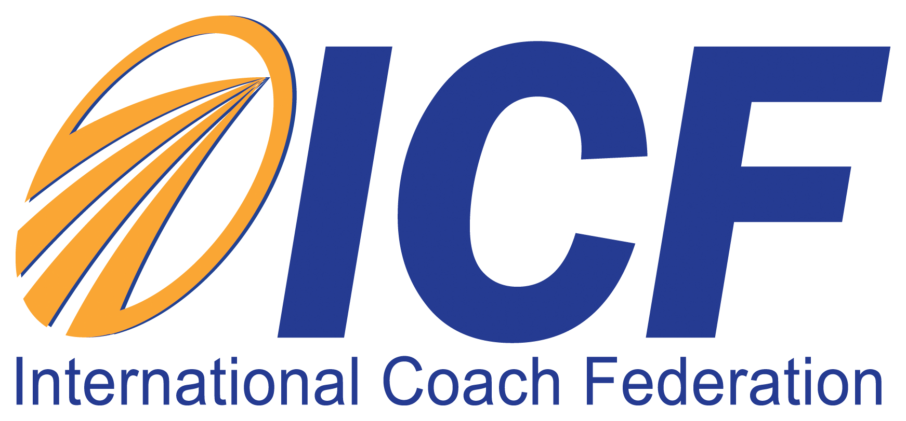

Client Testimony/Photo Authorization and Release Form

I understand my testimony, made on behalf of Next Conversation Coaching, may be used in connection with publicizing and promoting Next Conversation Coaching. I authorize Next Conversation Coaching to use my name, photograph, brief biographical information and testimonial.

I grant Next Conversation Coaching, its representatives and employees the right to use my name, photograph, brief biographical information and the testimonial in various marketing initiatives. I understand that this information may be used in various mediums for such purposes as publicity, illustration, advertising and Web content. I authorize Next Conversation Coaching to copyright, use and publish these materials in both print and electronic formats for purposes of publicizing Next Conversation Coaching.

In addition, I waive any right to inspect or approve the finished product wherein my likeness or my testimony appears. I agree that I will make no monetary or other claim against Next Conversation Coaching for the use of my name, photograph, brief biographical information and testimonial.
I have read, understand and agree to the above.

_______________________________________
Client Testimonial Provider Printed Name

_______________________________________
Client Testimonial Provider Signature
_______________________________________
Date

