**“Tri To Kick Cancer”**

**Matthew James Turnbull – August 2024**

**What?**

World Record – Most triathlons completed in 24 hrs in consecutive countries

World Record – Fastest time to complete 10 triathlons across 10 countries

World Record – Most countries covered in a single Iron Distance triathlon

4000 meters of open water swimming – 200km of road cycling – 50km of road running

(More than an iron man distance in under 24hrs!)

**When?**

August 2024

**Who?**

Matt Turnbull (Teacher/ Actor/ Musician/ Triathlete), 46 yrs old, father of 2 boys, married to Kelly (a nurse) born and raised in Hartlepool, North of England

**Why?**

This has never been attempted before! It is logistically and physically possible and all elements have been considered with team in place but it is a HUGE feat of endurance with very specific and particular logistical needs including; ocean swimming, speed boats, time trial cycle riding, helicopters, road running and car/motorbike support.

Matt **has given up his full time job as a teacher to train for this challenge** and devote up to 18 hours a week to focus on the level of swim, bike and run training required to be in top physical form. He wants to leave a legacy for his sons and to inspire other people whilst raising as much money as possible for charity.

A huge part of the project is to inspire the next generation to dream BIG and believe that they can overcome their own personal barriers to achieve amazing things.

It is hoped that Matt will be able to visit local schools and share his story of success with students of all ages to inspire them into a life of sport and activity. He hopes to do similar with sports clubs where he can support as a qualified coach and inspire children into the disciplines of swimming, cycling and running.

A huge inspiration for Matt to undertake this challenge is to cast a light onto the amazing people in our own town, his family and friends living with cancer. It is for this very reason that he will put himself through many months of arduous training and physical danger to raise money for cancer research.

**Where?**

In 2022 Matt’s son Ben set a junior world record for the fastest time to complete adult sprint triathlons across the four home nations (Ireland, Scotland, England and Wales). He did this in at 14 years old and in only 17hrs and 48 minutes which was an astonishing feat. Matt coached his son and organised all logistical aspects so knows what is required to complete 10 triathlons in one day. Ben is an inspiration to his own dad as Matt tries to achieve something amazing like his son. Locations are in place and both British and European teams are in place, as are the boat and flight captains.

1. **Dundalk Ireland**

**(Brown Shoe Triathlon Team – Support)**

1. **Newry Northern Ireland**

**(Brown Shoe Triathlon Team – Support)**

1. **Cairngaan Scotland**

**(Stranraer Triathlon Team – Support)**

1. **Whitehaven England (Possibly Isle of Man)**

**(Manx Triathlon Team)**

1. **Rhyl Wales**

**(The Triathlon Company, Buckley – Support Team)**

1. **Dunkirk France**
2. **De Panne Belgium**
3. **Cadzand Holland**
4. **Weiswampach Luxembourg**
5. **Dasberg Germany**

**(European teams TBA)**

**Why Matt, why now?**

Matt has history of huge challenges and records but none that that match up to this. He has taken himself to his physical limits on many occasions to raise funds for deserving charities. 2024 will mark his RETIREMENT from ultra endurance challenges. At 46 years old this will be the last time he puts his body through such rigours.

**World Record Coach - 4 Triathlons, 1 Day, 4 Countries 2022**

**Role Model Of The Year 2019 - Hartlepool & Tees Valley Pride**

**Coach Of The Year 2018 - Hartlepool and District Sports Council**

**Athlete Of The Year 2017 - Hartlepool and District Sports Council**

**2017 Consecutive Ironman British Record Holder (7 in 7 Days)**

**2016 European Silver Medalist  - Sprint Distance Duathlon**

**2016 British Silver Medalist  - Olympic Distance Duathlon**

**2015 British No1 Alcobendez European Duathlon AG Champs**

**2015 Big Lime Triathlon Winner & Course Record Holder**

**24 hr Road Ride (350mile +) – Completed 2011**

**26.2 Hr Ultra Run (87.5 miles) – Completed 2012**

**Half Marathon Swim (11.8 miles) – Completed 2012**

Matt Winning “Role Model of the Year 2018” for his endurance challenges and charity work.

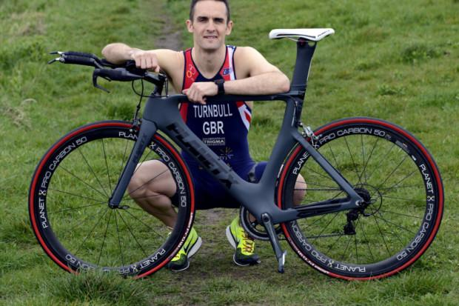

Matt Representing Team GB and achieving Silver Medals at both European Championships and National Championships in 2016.

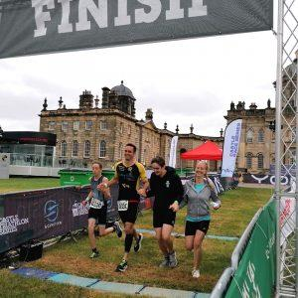

A family thing – Matt Racing the Castle Howard Triathlon (3rd Place Vet) with his family in 2021. Ben 15, Dylan 17 and wife Kelly.

**Training**

Training in swim bike and run to the level required is a serious feat in itself. Early in the year long training plan training will require 3 x 1 hr pool swim sessions, 3 x 1 hr Bike sessions and 3 x 1 hr run sessions as well as gym based strength and mobility sessions. This will quickly extend to add up to 6 more hours of Bike and run to develop the aerobic capacity to cope with the rigours of this challenge. There will also be regular appointments with physio, Amatsu, doctors and other specialists to ensure that at FORTY SIX, Matt is able to keep himself in the physical shape required to succeed.

**Nutrition**

Part of the journey for Matt is to get his body to the composition to be as fast and light as is optimal. Due to three bouts of Covid and various injuries and his age, Matt needs to lose 10kg across the year to ensure his power to weight ratio is optimal. This will require a very strict diet and nutritional focus to obtain his optimum which is likely to be in the 80kg mark. Key nutritional choices will aid with recovery, reduced inflammation and support injury prevention.

**Charity**

Matt has chosen to raise funds for “Cancer Research” is the first charity he raised funds for through his endurance pursuits back in 2012 when he completed his first Ironman in the memory of a dear family friend.

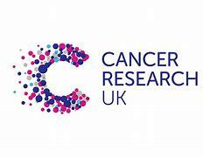

**Funding**

The challenge requires a lot of high speed transport between countries to achieve the record within 24hrs. Over the next 12 months Matt will work with charitable foundations, companies, philanthropic individuals and other sources to secure the funding required to ensure all aspects of the travel between countries are paid for. All funding, sponsorship and donations to the running of the challenge will help towards raising as much money as possible for the charities. Any funds secured will go towards funding the following aspects of the challenge; speed boat/ captain hire, helicopter/ pilot hire, fuel for bike/car transport, accommodation prior and directly after the challenge. Any other aspect of the challenge will be self-funded by Matt.

**Potential Points of Interest**

Matt Set a British record in 2017 for consecutive Ironmans.

Matt coached his son Ben (14) to a triathlon world record.

Matt had an unstable upbringing; domestic violence and drugs in the home. Throughout these childhood adverse experiences he was raised by his single mother who inspired him to be both mentally and physically strong after she managed to overcome the experiences that they endured.

Matt was excluded from school aged 9 for violent behaviour. Undiagnosed emotional trauma was part of this.

At 46 this will be a particularly amazing endurance feat to complete; exploring the ageing body and science to reverse and improve fitness.

The relationship with his two sons as they move into their adult life and wishing to inspire and motivate them.

365 day journey from a 3 time covid and Long Covid sufferer aiming to get back to peak physical fitness.

The logistic nightmare of organising and timing the transit between countries; three speed boats, two helicopters, a transit van and a team of Bikers!

Recci of all locations in the months before the event and sharing tourist information about each location.

Meeting and practicing the swim and bike disciplines with TEN teams across Europe (the dangerous nature of riding in a pace line at 30 miles an hr!) The danger of training and racing in open water; cold water shock, cramps, sea animals, waves, currents etc

The history of the 10 locations chosen for the triathlons.

Interviewing the specialist, nutritionists, physios, coaches and other professionals supporting Matt.

Injuries and accidents in prep and training. Injuries and accidents during the challenge itself will make for interesting and exciting viewing.

Meeting and interviewing those affected by cancer that are linked to the project. Matthew has two aunties who are currently living with cancer with very different future prospects and many close friends and fellow athletes that he is inspired by.

**“Tri To Kick Cancer” - Feature Documentary**

**Directed by Award Winning Director Paul Suggitt**

***7VEN PRODUCTIONS DOCUMENTARY OF THE CHALLENGE***

Throughout 2024, Matt will be followed by acclaimed documentary film production company 7ven Productions, helmed by director Paul Suggitt as they record his journey to, and through, his unbelievable challenge in August. The documentary with share intimate stories of his progress, interviews with specialists and professionals, talks with friends and family who share their stories with cancer, and the mad cap 24 hours of triathlons; speed boats, helicopters, motorbikes, sea swimming, time trialling and running down the clock in ten countries across Europe.

