Things to do / Questions to discuss

Please look at this panoramic picture closely, and do the following:

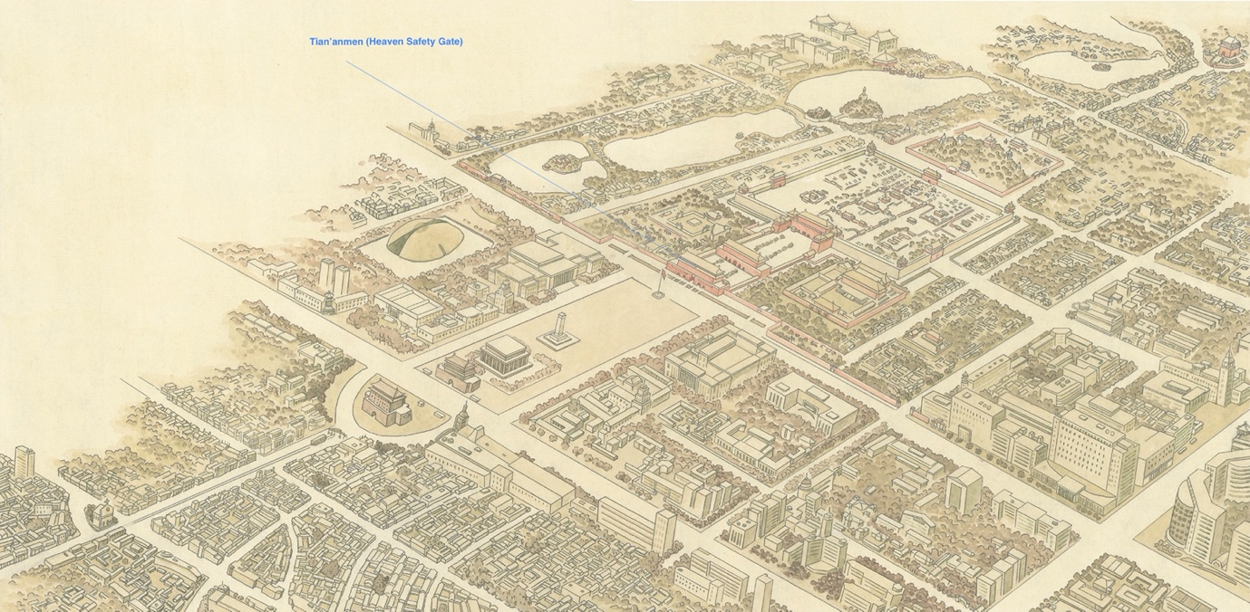
(the panoramic picture can be downloaded at )

1, Can you find and draw the central axis line in the picture?

2, The position of the Tian’anmen（The Heaven Safety Gate）has been marked. Can you find where the other major buildings mentioned in the book are and mark them with your pencil?

3, Can you identify the symmetricaly located structures in the picture?

4, What are the other symmtrical structures you’ve seen before? What are the things you like about being symmetrical, what you don’t like, and why?

5, What are the “Three Main Halls”? Find the location in the panoramic picture, what are their names? Whar were they served as? Look at the page of the Three Main Halls, tell us what you think is harmonious in the buildings.

6, Imagine you were living in the royal family in Beijing city in the Qing Dynasty. Where and how would you spend a day in the Forbidden City?

7, Do you see the water body at the west of the palace? It’s Zhongnanhai (Mid-South Sea) , official residence of current Chinese leaders. One of the Qing emperors was imprisoned there. Try find out who the emperor was, and why he was imprisoned.

Extended reading/watching:
Videos:

Forbidden City From Above - The Largest Palace in the World

Asian Art Museum, The Forbidden City

Lonely Planet: Forbidden City - Beijing

National Geography, Inside the Forbidden City, Beijing

Books:
The Forbidden City – Geremie R. Barmé

China: A History (illustrated) -John Keay

