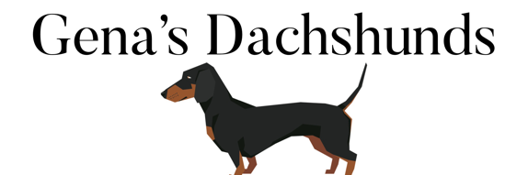Here at Gena’s Dachshund’s we offer happy, healthy puppies to people wanting quality Dachshund puppy as a permanent home pet.

Our goal is to ensure this puppy is in their forever home. Our puppies are raised inside our home with the parents and other dogs to ensure they are well socialized from birth until they leave to go to their new home. It is our desire to provide you with a happy, well socialized, well-mannered and in most cases, well on their way to being paper trained puppy.

To reserve your new pet a non-refundable deposit is required. This deposit is applied to the final purchase price of your new pet. The non-refundable deposit will serve as an agreement between Gena’s Dachshund’s and the buyer and this contact will at that time become a binding contract.

**HEATH GUARANTEE**

Your puppy is guaranteed to be in good health to the best of our knowledge at the time of purchase. They are up to date on shots and have had worming treatment every two weeks since birth. This health guarantee is good for (2) weeks after taking possession of your new puppy. We urge you, as a new parent, to have your puppy checked out by a licensed veterinarian within (2) weeks of taking possession of your new pet. Should this exam reveal a serious medical condition, your puppy will be replaced immediately if a puppy is available or when another puppy becomes available. A letter from the examining veterinarian listing the illness or condition must be returned with the puppy within the guarantee period of (2) weeks.

Your puppy also comes with a limited health guarantee for one (1) year from the date of birth for life threatening hereditary disorders that may show up later in the pups first year of life. This health guarantee covers only life-threatening conditions that can be proven hereditary by a licensed veterinarian. Although extremely rare, should this occur during the one (1) year time frame, Gena’s Dachshund’s will work with you on a one-on-one basis to come up with a solution so our customer will be satisfied.

Common canine parasites such as fleas, ticks, worms, mites, coccidian, giardia, etc. are not covered under this health guarantee. Gena’s Dachshund’s follows a veterinarian recommendation for parasite control and vaccination schedules to insure you are receiving a health puppy. At no time will Gena’s Dachshund’s be responsible for Vet bills or any other expenses once the puppy leave our premises. Gena’s Dachshund’s does not guarantee size, color or exact details of future growth and development of your new puppy.

**PURCHASE AGREEMENT**

Gena’s Dachshund’s wants to be sure that all our puppies remain in a happy home. If for any reason your conditions changes that warrant you giving up your puppy, we ask that your contact Gena’s Dachshunds first. Gena’s Dachshund’s reserves the right to refuse the sale, return of deposit and puppy for any reason. Buyer agrees to provide fresh water and quality food for this puppy. Buyer agrees to maintain this puppy in good physical and mental health including routine healthcare, vaccines, treatment for parasites (internal and external) and lots of good old family love. buyer agrees that under NO circumstances will this puppy be placed in a pet shop, animal shelter or similar establishment. Buyer agrees that this puppy will NOT be resold. Buyer agrees that under NO circumstance will this puppy be used for breeding unless otherwise arranged and agreed to by Gena’s Dachshund’s.

Signature: Date: