 | IDEST Ltd Trainer
Newsletter August 2025 | Volume 25, Number 2
In this issue:  - Volume 25, Issue No 2  - Comparison Chart teaching  - IDEST Ltd in South Africa  - E-cards & E-certificates  - Compressor Maintenance Course (RSC)  - Meet with Dave Wright, DRCL, Pattaya  - New order form  - Promote your centre on IDEST Ltd website  Contact Us  Website:  http://www.idestuk.org  Training Manager:  training@idestuk.org  Administration:  alistair.reynolds@idest.co.uk  Director:  neil@bristolchanneldiving.co.uk | Volume 25, Issue No 2  Welcome to the second issue of TRAINER for 2025. I have not produced any other issues this year as there was little to pass on to you. It has been a very busy year but not one with a lot of changes.  Now, I have some news and so, in this issue we cover a shortfall in our training of TIC2, update you on new moves in South Africa, herald the switch to electronic cards and certificates for 2026 as well as remind you of the new order form. A meeting with Dave Wright brought a few new ideas to the table and let’s promote your centres more with pictures on our website.  Comparison Chart teaching  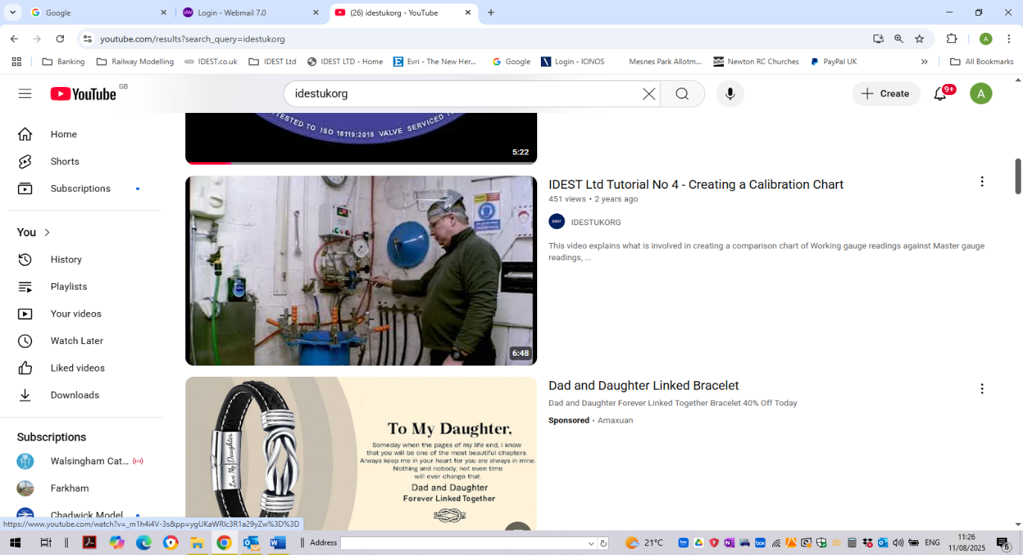  It was identified at a recent inspectors’ meeting that some technicians cannot produce a comparison chart during their inspection. Part of the inspection expects technicians to DEMONSTRATE how they create a comparison chart.  Many technicians report that have never been shown how to produce a comparison chart and it is not currently included in the TIC2 course materials.  The comparison chart is the chart you create each month, which compares the Working gauge pressure to the calibrated Master gauge pressure.  Clearly if a technician is not shown how to do this on a course, then it relies on another technician to pass this knowledge on, as in-house training.  IDEST has produced a video on how this chart is created and it is listed on our YouTube channel, IDESTUKORG. It is Training Video No 4, produced with the kind assistance of Steve Ellis at Divers Air, Wrexham.  When the TIC2 course materials are revamped, this training will be included. In the meantime, can you ensure that students either watch this video while attending the course or that the YouTube link is given to them before they leave your centre.  IDEST Limited in South Africa  We have recently been in communications with a contact in South Africa, with the aim of setting up an IDEST Ltd Training Centre.    This training centre will be able to train dive centre technicians the inspection of cylinders by presenting the IDEST Ltd TIC1.  It would appear that there is virtually no legislation in SA regarding the need for formal training of dive centre staff.  Other courses that the contact is keen to promote, is the Regulator Servicing Course (RSC). The aim is to use to ensure that customers have their regulators service by approved technicians.  The course materials will be amended to cover SA legislation and local requirements. All this work is being done by our local contact.  It is hoped to have this up and running by the beginning of 2026.  E-cards & e-certificates  The change from office-printed certificates to training-centre printed certificates has produced a range of versions unfortunately.  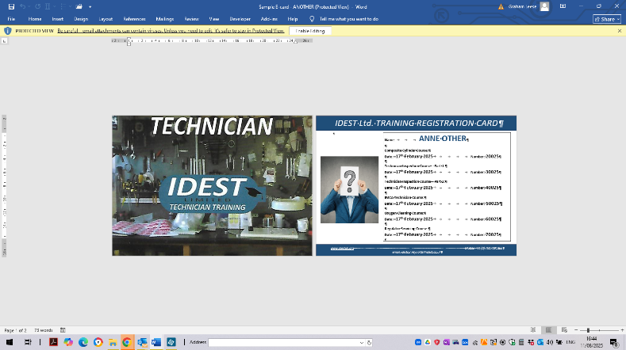  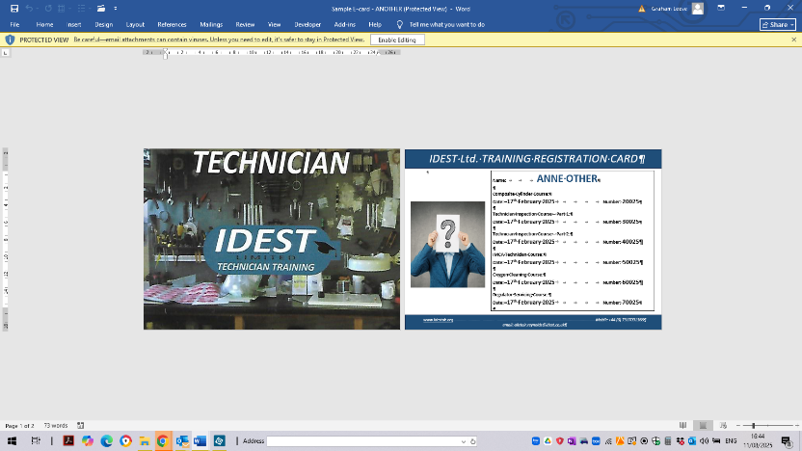  Some centres have not changed over and other have struggled to obtain the required terracotta marble paper.  As such it has been decided to bring the work back into the Admin Office and produce the certificates and cards.  From the beginning of 2026 these certificates and cards will be electronic. E-certificates and e-cards will be produced by me and forwarded to the centres for your records. You can then forward these to your students.  Most diver training agencies are apparently working with e-cards and e-certificates, so it is time IDEST Ltd caught up.  So, watch this space…..  Compressor Maintenance Course (CMC)  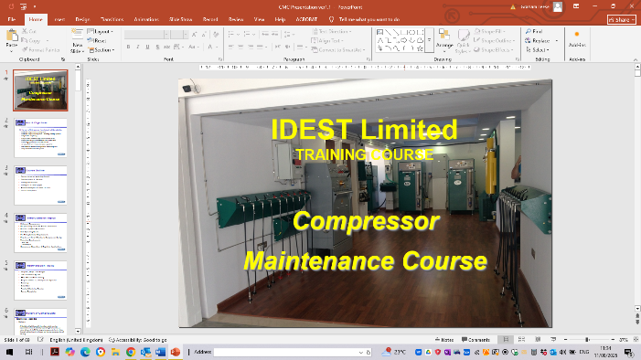  This course is the latest of our products, and is currently being written by myself and Chris Demetriou.  The Instructor Manual is nearly complete. Once this has been reviewed, amended and approved, the PDF version will be produced.  From this PDF version of the IM, the student materials will be produced in a similar fashion.  A PowerPoint presentation is always the start of this journey and this has been already produced, as you can see from the image above.  As soon as the course is available, I will be sending out an email to let you know and will add all the instructor resources to the BOX folder for you to use.  Meet with Dave Wright, DRCL, Pattaya    On 11th August, I met up with Dave Wright from Dive Right Co Limited in Pattaya, Thailand, who was over in the UK for a visit.  We had a very productive meeting and discussed lots of aspects that could help other training centres worldwide.  He offers an add-on to his Dive Masters courses that gives the DMs more knowledge about cylinder inspection and regulator servicing. These are the TIC1 and the RSC courses. These DMs have found these two courses very interesting and helped them find employment.  If you have not considered promoting these two courses to PADI Dive Masters that you qualify, perhaps here is an opportunity to put together a complete ‘package’ for DMs in the future.  New Order Form  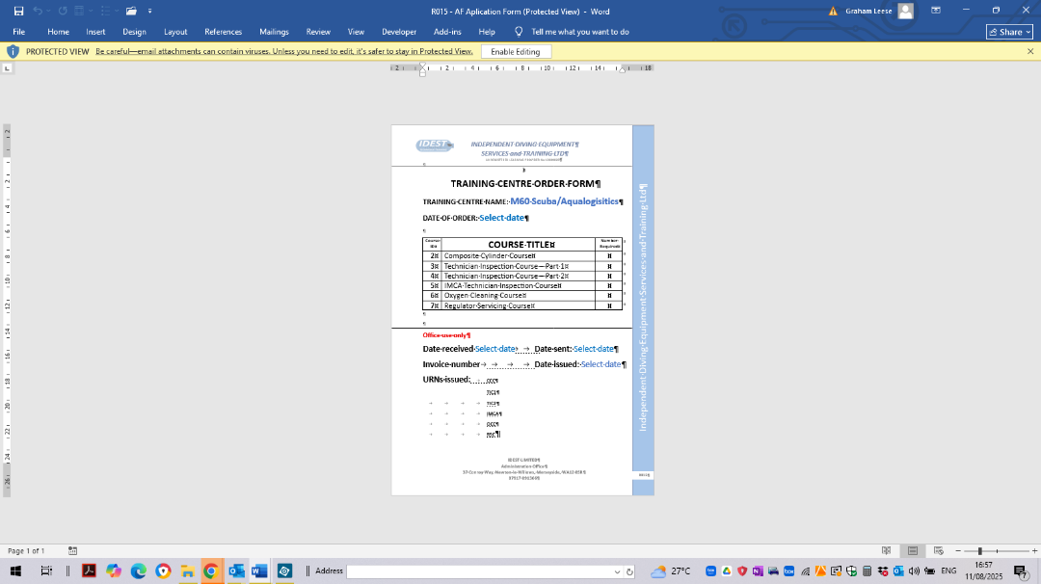  To help track orders for course Application Forms, I have created a proper order form, R015. This form was sent out to all centres recently, with a request to use this in future for any order of course Application Forms.  As my email message explained, Different centres have different abbreviations for the courses. This has caused me sending the wrong application forms and having to change invoices as a result.  This order form should ensure that you order the appropriate application forms for the correct courses. It also helps me track the URNs that issue to each centre.  This links to the student tracker sheet to ensure no two students get the same URN as has happened in the past. It also keeps track of the invoice numbers issued, so I know I have issued one and for what goods.  Promote your centre on IDEST Ltd website  Another idea that was received recently, was that training centres could promote their facilities more on the IDEST Ltd website.  It was suggested that centres could send in pictures of their classroom and workshop facilities, along with a picture of their lead instructor!!!! These could then be added to the IDEST Ltd website, next to the centre’s contact details.  So, if want to have further promotion of your training centre and the courses, on the IDEST Ltd website, please send in a few pictures for us to use.  I do hope you will take up this opportunity, as it will improve the website image and promote your centre and courses at the same time.  IDEST Ltd Training Centres update  This is the current list of Training Centres:  - Bristol Channel Diving Services, Cardiff. TC001  - M60 Scuba, Stockport. TC003  - Sunderland Scuba Centre, Sunderland. TC004  - C & R Testing, Sowerby Bridge. TC007  - D V Diving, Northern Ireland. TC009  - Moray Firth Dive Centre, Moray. TC011  - Discover Diving IOM. TC012  - Innovative Technology Asia Co Ltd, Phuket, Thailand. TC014  - Dive Right Co. Ltd, Pattaya, Thailand. TC016  - Cylinder Testing Station, Redditch. TC017  - Scuba Shack Ltd, Sedgley. TC018  - Rec2Tec Diving, Milton Keynes. TC019  - Poole Diving Ltd, Poole, Dorset. TC020  Training Centres leaving since the last issue of TRAINER  NONE

