 | IDEST Ltd Trainer
Newsletter January 2025 | Volume 25, Number 1
In this issue:  - Volume 25, Issue No 1  - Unused Paid Invoices  - Poole Diving Ltd  - New symbol for Training Centre  - Annual Registration Renewals  - IMCA Refresher Courses  - Centre-issued Certificates  - IDEST Ltd Training Centres Update  Contact Us  Website:  http://www.idestuk.org  Training Manager:  training@idestuk.org  Administration:  alistair.reynolds@idest.co.uk  Director:  neil@bristolchanneldiving.co.uk | Volume 25, Issue No 1  Welcome to the first issue of TRAINER for 2025. A very Happy New Year to you and your staff. We do hope it will be a great year for you and the training side of your business.  In this issue we cover some unusual topics for a change. These items have been brought up at various meetings of inspectors and Scheme Committee.  It is hope that the changes will be seen as improvements to the systems we have and may even reduce your costs, albeit only slightly.  Unused Paid Invoices  A recent audit of the accounts has highlighted that some centres had not paid for some invoices. Suitable emails have gone to those centres and hopefully the situation will be resolved.  This audit also identified that some centres had paid for Application Forms but had not used them.  At £40 an Application Form, it could be an expensive waste of money.  I will be checking which Application Forms have not been used and will be getting in touch with the centres concerned.  Better to use those Application Forms and make your money work better for you.  Poole Diving Ltd  It is with great pleasure that we welcome Poole Diving in to the group of approved IDEST Limited Training Centres.  This brings the total number of Training Centres, world-wide, to twelve.  This far exceeds the predicted number as stated in the five-year business plan written in 2021  New symbol for Training Centres  Nick Clark took over the administration of the IDEST website from me and has made some great improvements.  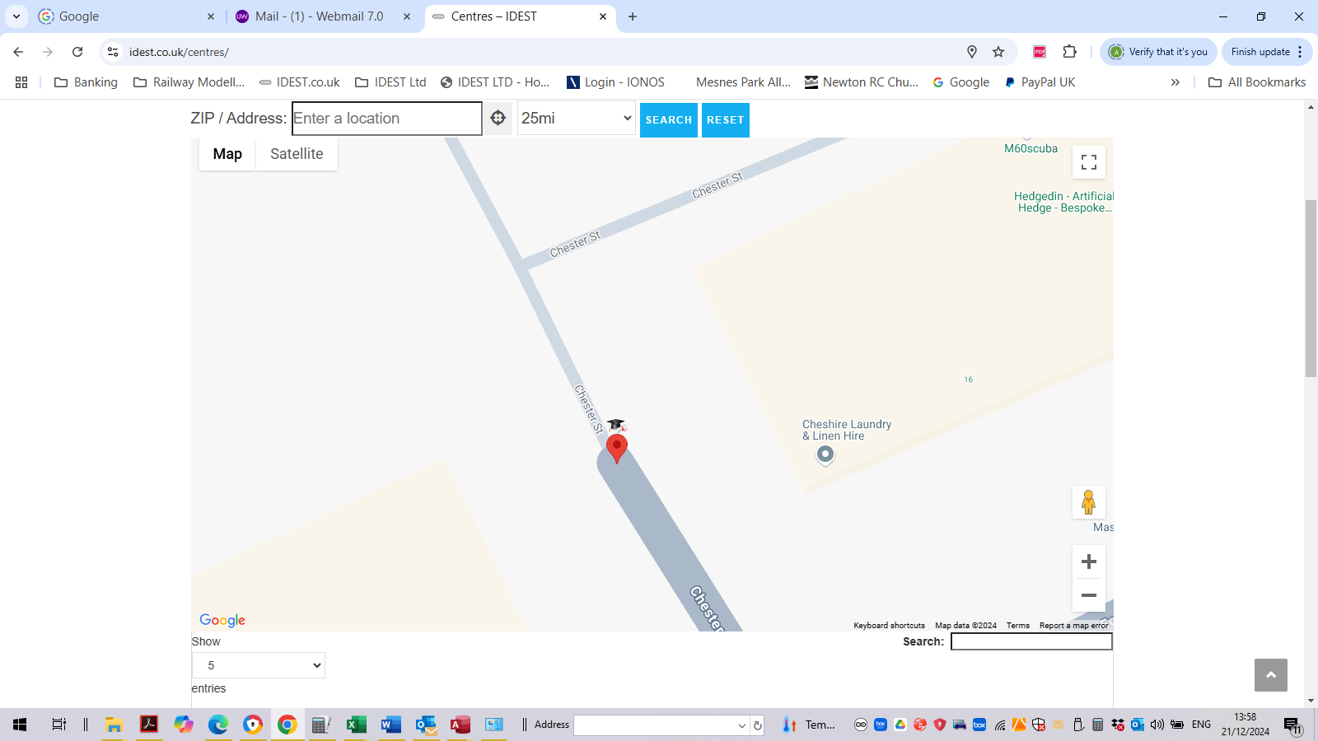  He has updated the map to ensure that all current centres are shown and also centres that are no longer with us, have been removed.  One intriguing improvement that Nick has made is to give our Training Centres a new location identifier.  The new location identifier is still red in colour, but has a mortarboard and scroll above it. This clearly identifies our current Training Centres from Inspection and Test Centres.  Annual Registration Renewals  The 1st January is the start of the new registration for 2025 and if you have not received your wall certificate, you have probably not renewed and are technically not a Training Centre any more.  Please make sure you have paid the invoice that was sent out in November 2024.  We would hate to lose you and reduce the number of IDEST Limited Training Centres.  IMCA Refresher Courses  At a recent Inspectors’ meeting, these courses were brought up for discussion. The question asked was, ‘Should these have a time limit attached to them?’  The result of the discussion was that they should have a three-year limit and that after this time, a refresher course must be attended, in order for the qualification to be valid.  As a result, any student that received a certificate of attendance or a qualification certificate, MUST attend a refresher course after three years.  This also has a knock-on effect to the IMCA course materials. The PowerPoint presentation will need updating, the assessment question paper will need amending. The current qualification certificate will have to revert back to an attendance certificate, showing a ‘VALID UNTIL DATE’ on it.  This work will take priority over the next few weeks and should be uploaded to the Instructor Resources folder by the beginning of February 25.  In the meantime, if you have any IMCA students, please pass on this formation and make it clear there is a time limit to their validation.  Centre-issued Certificates  Steve Gibson, Sunderland Scuba Centre, raised the question, at a recent Scheme Committee meeting, as to whether Training Centres could print the student certificates in-house.  As a result, it has been decided that ALL CENTRES can print their student certificates in-house and present them to the students at the end of the courses. These MUST be printed on TERRACOTTA MARBLED PAPER to maintain the house style.  The template used for the certificates will be sent to all Training Centres with their company details already included. All that needs to be done is to fill in the necessary student’s name, course date, the URN and the date of issue.  This will improve the service we provide our students and reduce the cost of posting admin-issued certificates on to each individual student.  HOWEVER, it will be necessary for you to include copies of these issued certificates in the paperwork you send back to me at Admin, for our records.  IDEST Ltd Training Centres update  This is the current list of Training Centres:  - Bristol Channel Diving Services, Cardiff. TC001  - M60 Scuba, Stockport. TC003  - Sunderland Scuba Centre, Sunderland. TC004  - C & R Testing, Sowerby Bridge. TC007  - D V Diving, Northern Ireland. TC009  - Moray Firth Dive Centre, Moray. TC011  - Discover Diving IOM. TC012  - Innovative Technology Asia Co Ltd, Phuket, Thailand. TC014  - Dive Right Co. Ltd, Pattaya, Thailand. TC016  - Cylinder Testing Station, Redditch. TC017  - Scuba Shack Ltd, Sedgley. TC018  - Rec2Tec Diving, Milton Keynes. TC019  - Poole Diving Ltd, Poole, Dorset. TC020  Training Centres leaving since the last issue of TRAINER  NONE

