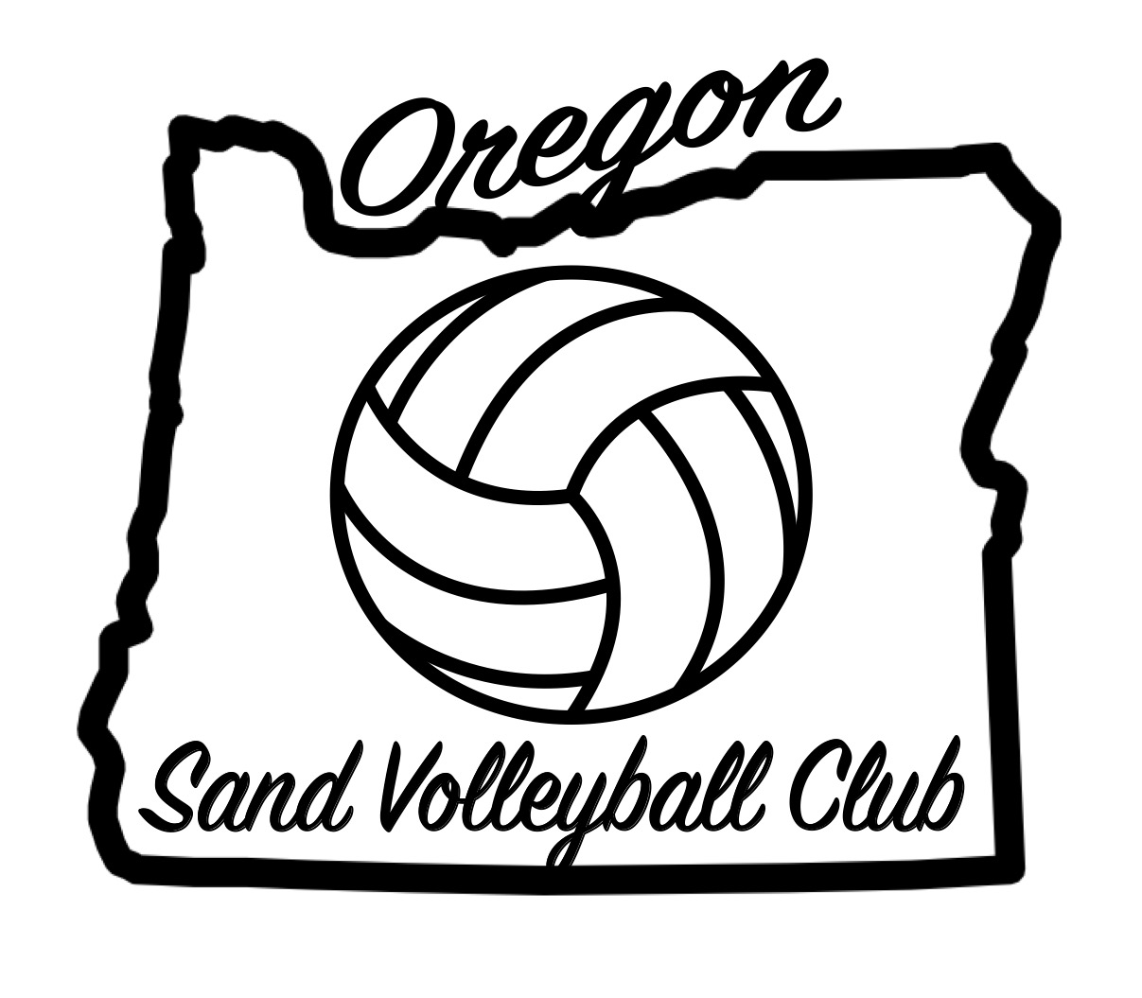Oregon Sand Volleyball Club Handbook

This handbook outlines the rules and regulations of the 2019 Oregon Sand Volleyball Club season.

Mission Statement:
Oregon Sand Volleyball Club’s mission is to encourage, guide and train girls to a higher level of volleyball. We set our goals for standards above and beyond so girls are prepared and ready for beach club, indoor club, college and beyond.

Goals:
The goals of the Oregon Sand Volleyball Club are to:
- Provide a unique opportunity for competitive and committed athletes to develop and expand their athletic skills to their potential and strive for excellence
- To increase their knowledge and understanding of individual and team skills
- To increase their knowledge and understanding of the game itself and how to see the game beyond just watching the game.
- To excel in a sport in which you have to play every spot on the court which will heighten your skill set.

Our Method of Operating:
Oregon Sand Volleyball Club creates a learning environment filled with sportsmanship, team building, leadership, integrity, self-discipline, and a hard work ethic as the foundation for all team/club interactions. Under the direction of experienced and expertly trained coaches, athletes will participate in intensive instruction. They will learn skills to achieve a high level of success by demonstrating understanding and expertise related to the fundamentals, strategies, and communication required for membership in a successful team. Skill development and effective decision making will be modeled in a positive environment.

You are purchasing training time for your child to grow in the sport of volleyball. We will train you to win, and coach you so that you are set and ready to compete in any sand tournament you register for

Coach’s Responsibilities:

- Provide each player and her family a schedule of practices and competitions as well as directions to view the club handbook on the club website
- Establish policies for supervision, training and coaching conduct
- Provide a communication tree for all families and players
- Prepare a schedule of drills and objectives prior to each practice
- Teach proper technique and fundamentals to all players
- Teach and model proper strategies for optimal individual skill and team play
- Communicate clearly to each player her role on the team and redirect her efforts when they stray from the mission
- Balance hard work, FUN, and discipline during all practices and competitions
- Provide a positive and trusting environment for all players, including opportunities for reflective discussions and competition debriefing
- Lead by example: present as a positive role model for all players both on and off the court
- Support and encourage all OSVC teams to play with confidence and commitment to winning
- Prepare each athlete to respond appropriately to a variety of situations that occur both on and off the court
- Be current on all required background screenings, C.E.V.A. memberships and I.M.P.A.C.T. training through C.E.V.A.
- At no time will it be acceptable to cancel a practice due to lack of players attending. OSVC coaching staff will be required to cater a practice based on number of players in attendance

Player’s Rules & Regulations:

As a member of the club it is critical that you understand that you do not represent only yourself. Your communication, attitude, behavior and interaction represent our club, your coaches, family, and community. Whether you are on or off the court, we expect all players to maintain a positive image and attitude that reflects highly on all of the activities and behaviors described below.

Player Expectations:
- Attend all practices. If a player faces a situation that challenges his/her ability to attend a practice or game, it is the player’s responsibility to contact his/her coach, not the responsibility of his/her parents.
- Be a team player; the team comes first, no matter what challenges are presented.
- Behave and communicate with a positive attitude at all times; if a teammate makes a mistake, encourage her to do better next time, not criticize the past.
- Play and interact with strong club/team spirit and pride.
- Be a leader on and off the court.
- Stay physically and mentally focused at all practices and competitions; give 110% at all practices and tournaments.
- Show respect to all teammates, parents, coaches, fans and referees.
- Do not provide, use, or condone the use of tobacco products, alcoholic beverages, or recreational drugs. Do not remain in a location where these activities may or do take place. The use of any illegal substance will not be tolerated.
9) Be responsible; clean up after yourself (sand courts, cars, hotels, restaurants, schools)

Practice Rules:
- Players must arrive at practice at least 15 minutes early; allow time to put up the lines on the court, stretch and warm up. (Coaches are not responsible to set up or take down equipment.)
- Arrive at practice mentally prepared; have personal goals set for yourself before each practice.
- An OSVC practice t-shirt/jersey or sports bra must be worn to all practices and tournaments; publically demonstrate pride of your club and teammates.
- Respect that practice is finished when the coach dismisses the team; not before.
- RUN everywhere! (Don’t walk!)

Tournament Rules:
- It is your responsibility to be at the tournament site at the stated time for check in.
- It is your responsibility to clean up your mess after the tournament is over.
- It is your responsibility to ref even if you lost.
- It is your responsibility to uphold yourself to the highest manner as you are representing the Oregon Sand Volleyball Club.

Officiating:
- Your team is required to keep score and officiate when their team is selected to do so. You are representing Oregon Sand Volleyball Club so you will ref to the best of your ability. It is not the parent responsibility to ref yet the players.

Parents’ Responsibilities:

- Transportation: Parents are responsible to provide transportation to and from tournaments, as well as to practice sites.

- Financial: Parents are financially responsible for your child, whether or not you attend a tournament. If you will not be accompanying your daughter to a tournament, be sure to give her enough money to cover food costs, cost of the tournament entry fee is a must. If you do not pay for the entry they can’t play in that tournament period.

- Communication: Contact your team parent prior to a tournament if you do not have tournament information. All tournament information is posted on the club website. It is your responsibility to know the location of the tournament and directions to get there.

- Quitting: In the event a child or parent decides to no longer participate with Oregon Sand Volleyball Club, ABSOLUTELY no refunds will be given at any time regardless of the situation.

SPECTATOR CODE OF CONDUCT

I WILL

- I WILL abide by the official rules of USA Volleyball.
- I WILL display good sportsmanship at all times.
- I WILL educate myself on the unique rules of this facility and abide by them.
- I WILL generate goodwill by being polite and respectful to those around me at this event.
- I WILL immediately notify the Event Director and/or Program Administrator in the event that I witness any illegal activity.
- I WILL acknowledge that the spectator seating around the courts are for the primary use of those watching the match in progress.
- I WILL acknowledge that spectators may rightfully choose to remain in a seat for an entire match without switching sides of the court when the teams switch.

I WILL NOT

- I WILL NOT harass or intimidate the officials including line judges and scorekeepers.
- I WILL NOT participate in any game or game-like activities unless I have a current membership card with USA Volleyball.
- I WILL NOT bring and/or carry any firearms at any USA Volleyball event.
- I WILL NOT bring, purchase, or consume alcohol at any Youth/Junior volleyball event.

JUNIOR CLUB PERSONNEL CODE OF ETHICS

It is the duty and obligation of USA Volleyball affiliated Junior Club Program administrators, directors, coaches and other club personnel to assure the following Code of Ethics is followed and adhered to by all individuals who have an active role in a USA Volleyball Junior Club Program in any Region of USA Volleyball.

In a continuing effort to promote safe, healthy and ethical communication, relationships and treatment of all USA Volleyball players and personnel, all adults associated with a junior club program must read, accept and submit this Code of Ethics before they are eligible to actively participate in a junior club program associated, affiliated, or participating in USA Volleyball.

1. All adult club personnel affiliated with a junior program must be a registered member with a Region of USA Volleyball and USA Volleyball.

2. All adult club personnel including coaches, chaperones, assistant coaches, trainers, etc. affiliated with a junior program intending to participate in USA Volleyball must have an approved and current background screen on file as per USA Volleyball policy. It is intended that the term “all adult club personnel” be all inclusive and not limited to only those categories identified herein.

3. A head coach or assistant coach affiliated with a junior program must also: be an adult (see Region definition of an adult) and be IMPACT certified according to USA Volleyball and Region policies.

4. If allowed by Region rules, an assistant coach who has not yet met the age of majority in the state of residence must be supervised by a head coach recognized by the Region and must meet all applicable Region and USA Volleyball requirements. Individuals who are registered as junior players and also have an interest in coaching should contact their region regarding coaching eligibility.

5. Responsibilities:
A. A head coach or other equally qualified club personnel must be present at all practices and competitions. A head coach, adult club representative personnel or registered chaperone must be present during team-supervised travel. This individual shall be responsible for the moral, legal and ethical well-being for each participant during team/club activities.

B. Coaches shall understand the unique power of a coach-athlete relationship. Coaches and all other club personnel shall not exploit athletes and shall avoid any relationships which could compromise the integrity of the learning and participation process, impair their professional judgment and/or take advantage of a situation for their own personal gain or gratification.

C. All club personnel must understand that all forms of sexual abuse, assault or harassment of a current or former athlete are unethical and illegal even when an athlete invites or consents to such behavior or involvement. Club personnel shall not engage in sexual/romantic relationships with current athletes or other participants over whom there is/was authority. See B above.

D. All club personnel shall insure that all individuals have met all Regional Volleyball Association and USA Volleyball membership requirements prior to participation in any club, team and/or Region/National USA Volleyball activity.

E. All club personnel must inform the players and their parent(s)/guardian(s) about any Region and/or USA Volleyball transfer policy. This policy may restrict or prohibit a participant from transferring to another club or team if specified criteria have been met. Likewise, all club personnel must inform the players and their parent(s)/guardian(s) of any rules or policies regarding coaching transfers during a particular season.

F. All club personnel shall abide by and inform the players and their parent(s)/guardian(s) of applicable regional recruiting policies.

G. All club personnel may not participate in, require another individual to participate in, or condone any act considered to be illegal under federal, state or local laws and/or ordinances.

H. All club personnel shall strive to educate their athletes and personnel to respect, honor and adhere to the rules of the facility being used during practices, tournaments or events. In this regard, the rules of the facility shall have priority over the rules of the Regional Volleyball Association.

I. All club personnel shall ensure that all activities are suitable for the age, experience and ability of their athletes.

J. All club personnel shall seek professional medical advice when making decisions regarding an injured athlete's ability to continue training or playing.

K. All club personnel shall, while serving in a professional capacity, avoid any drug, tobacco or alcohol use while in the presence of athletes.

L. All club personnel shall not supply or condone the use of drugs, alcohol, tobacco, fireworks, ammunition, firearms, knives or any item or material that can be used as a weapon, to any of the participants or athletes and shall report any athlete using or in the possession of the same.

M. All club personnel shall not allow, encourage, condone or require any behavior that threatens an athlete’s amateur status or Regional, USA Volleyball, school and/or collegiate eligibility.

N. All club personnel shall maintain all relationships with other club personnel on a professional and confidential basis.

O. All club personnel must be positive role models. This includes being courteous, respectful and polite to players, parents, other coaches, club directors, event personnel, and officials.

P. All club personnel will not engage in any physical, verbal or emotional harassment, abusive words or actions, or coercion of current and/or former athletes.

Q. All club personnel will immediately report any suspected case of illegal activity, abuse, assault, harassment, or ethical violations of this club personnel code of ethics to the appropriate authorities, including Regional Volleyball Administrators.

Any violation of this Code may result in sanction being issued against the club representative, the individual(s) and the club/team involved. These sanctions may extend to the loss of eligibility of the club representative, the individual(s), the entire club and the team involved.

