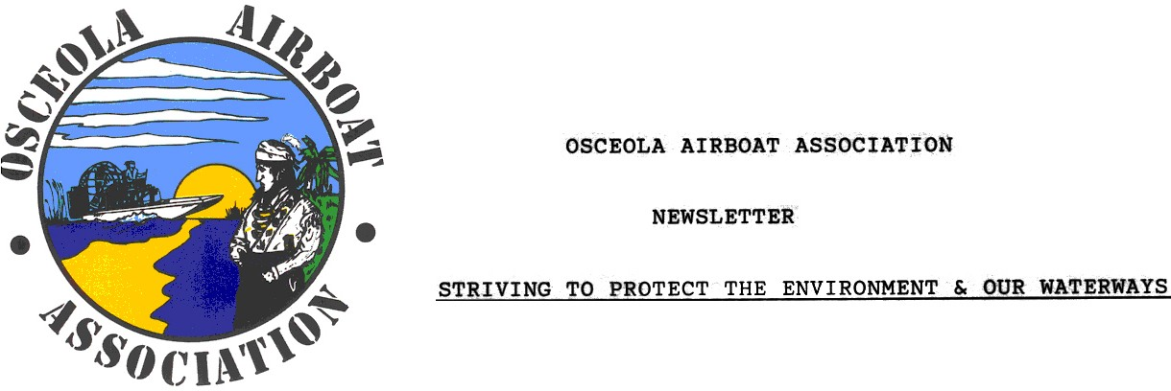

MEMBERSHIP APPLICATION
(Please Print Legibly)

NAME: _______________________________________________

ADDRESS: ___________________________________________

HOME PHONE: _______________________________________

WORK PHONE: _______________________________________

CELL: ________________ EMAIL: _______________________
(Please let us know if you do not want your
email address posted on our web site.)

Membership is $25.00 per family for the year. Membership dues are payable each year in the month of May. Meetings are the 2nd Thursday of each month.

If you have any questions please contact Charlene Partin, email: osceolaair@aol.com or 321-231-1960 cell.

Attendance at meetings and active participation is expected for members of the Osceola Airboat Association. We are a non-profit organization.

Web site: www.osceolairboatassociation.org

Mail application with check to: Osceola Airboat Association
PO Box 701446

St. Cloud, FL 34770

