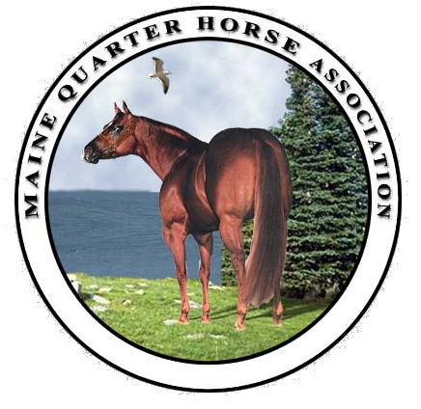

Pine Tree Classic
May 22-26, 2025
Skowhegan, Maine Fairgrounds
Maine’s only 5 day double Nationally Rated Show!

(207) 272-0082 Manager: Ricky Drew meqhanews@yahoo.com

Dear Sir or Madam, December 1, 2024

We welcome you and your business to the upcoming 2025 show season and all of its opportunities. This New Year offers you the opportunity to set new goals, make new plans, meet new people and reacquaint yourself with former friends and associates. For many of us, this means planning our advertising and sponsorship commitments for 2025. We are NATIONALLY affiliated with the American Quarter Horse Association and the American Paint Horse Association. The equine industry in Maine generates nearly 6000 jobs. The annual payroll generated by the equine industry in Maine totals over $140 million. Horse owners and equine facilities pay over $11.5 million annually in Maine State Property Taxes. We take pride in what we bring to the state. We have exhibitors come from all New England States, the Maritimes, and Quebec. Our reach is far. We hope you let us help you grow your business. Despite all of the numbers, the true economic impact on the state cannot be truly calculated as horses are more than just a business to most horse owners. Nationally, an economic study showed a direct impact of $39 billion annually.
We take very seriously the economic impact this has on the State of Maine. Everyone benefits through MeQHA programs. We have many sponsorship possibilities for you.

We have several Corporate Sponsorship Levels:

- All Around Trophy Sponsor $200 –MeQHA Facebook page listing several times, announced over the public address system several times throughout the 5 day show. This sponsorship must be made early in the year so we have the trophy at the show!
- Silver Sponsor $250 –MeQHA website listing including link to your site on MeQHA Partnership Web-Page, announcements at all MeQHA shows & events; Postings on our Facebook Page, you provide a custom-made banner displayed at our show.
- Gold Sponsor $500 - MeQHA website listing including link to your site on MeQHA Partnership Web-Page, which includes your custom logo as the link, double the announcements at all MeQHA shows & events; Postings on our Facebook Page, you provide a custom-made banner displayed at our show
- Platinum Sponsor $1000 – MeQHA website listing including link to your site on MeQHA Home-Page, which includes your custom logo as the link, announcements at all MeQHA shows; Postings on our Facebook Page, you provide a custom-made banner displayed at our show; a vendor spot at all MeQHA events, handouts to all of our exhibitors promoting your business.
- Jackpot Sponsors CUSTOM – Jackpot Sponsors are those who contribute directly to a specific class payout to exhibitors. The amount given coincides with the sponsor levels above. We also welcome members from your business to present in the ring awards.

Through your sponsorships, we provide you visibility to other businesses, patrons, exhibitors, stables, etc. It is our pleasure to do this for you in your support of the MeQHA Pine Tree Classic Horse Show. If you have any questions, please feel free to contact show manager, Ricky Drew. I will be delighted to answer your questions and work with you.

Sincerely,

Ricky Drew

Ricky H. Drew
Manager
Enc. Ad/Sponsorship form

2025 MeQHA PINE TREE CLASSIC CORPORATE SPONSORSHIPS

Please put a check mark in the circle of the sponsorship you prefer:

- Platinum Sponsorship $1000
- Gold Sponsorship $500
- Silver Sponsorship $250
- Jackpot Sponsorship $TBD
- All Around Trophy Sponsor $200

Business name as you would like it to appear on banner/MeQHA website:

____________________________________________________________

Business link to your website:

____________________________________________________________

Business name and promotion as you would like it to be announced at show:

____________________________________________________________
____________________________________________________________

Business mailing address and contact name:

____________________________________________________________
____________________________________________________________

Email address:

____________________________________________________________

Other notes:

____________________________________________________________

Checks payable to MeQHA
Mail to: Ricky Drew, 41 Gore Road, Raymond, ME 04071
Any questions you may call 207-272-0082 or email meqhanews@yahoo.com

Thank you for your support!

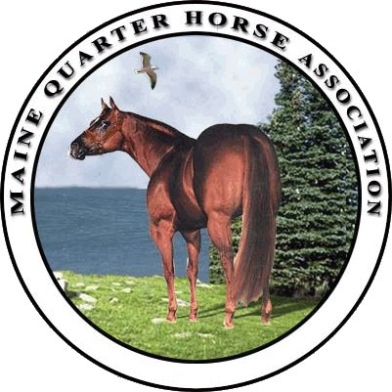
Maine Quarter Horse Association
www.meqha.org

Receipt for advertising/donation to the Maine Quarter Horse Association, 501(c5).

This certifies that________________________________________ has given $____________
(name) (amount)

in advertising/sponsorship to the Maine Quarter Horse Association.

- Platinum Sponsorship $1000

- Gold Sponsorship $500

- Silver Sponsorship $250

- Jackpot Sponsorship $TBD

- All Around Trophy Sponsor $200

- Social Event Sponsor $100

____________________________________________ __________________
MeQHA Authorized Signature Date

2025 MeQHA PINE TREE CLASSIC CLASS SPONSORSHIPS
CLASS SPONSORSHIPS $25 EACH…
OR…YOU CAN DO 3 CLASSES FOR A FLAT RATE FEE OF $50!
OR… YOU CAN DO 8 CLASSES FOR $100!!!!

List the name of class/classes you wish to sponsor

1st - _______________________________ _________________________________ _____________________

2nd : _______________________________ _________________________________ ____________________

3rd : _______________________________ __________________________________ ____________________

Name of Sponsor:_________________________________________________________________________

Address 0f Sponsor:________________________________________________________________________

Email Address:____________________________________________________________________________

Note - These class sponsorships are not jackpot classes

Mail to Ricky Drew, 41 Gore Road, Raymond, ME 04071
Or email your class sponsorships and we can add it to your show bill! meqhanews@yahoo.com

All class sponsors will be on signage in the office and announced throughout the show weekend!!! We also promote donors with Facebook mentions on our page (over 2300 people on our page!). We reach over 10,000 people on some FB posts.

MeQHA is a 501(c)5 non-profit corporation. Those sponsoring or advertising with us may list it as advertising expense for taxation purposes.

-----cut here-----------------------------------------------------------------------------------------------------------

Maine Quarter Horse Association www.meqha.org

Receipt for advertising/donation to the Maine Quarter Horse Association, 501(c5).

This certifies that________________________________________ has given $___________
(name) (amount)
in advertising/sponsorship to the Maine Quarter Horse Association.

____________________________________________ __________________
MeQHA Authorized Signature Date

