William A. Gerhardt Property Improvement

SWP BRUSH CUTTER

DO NOT use this machine unless you have been instructed
in its safe use and operation and have been given permission

PERSONAL PROTECTIVE EQUIPMENT

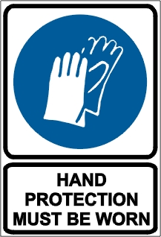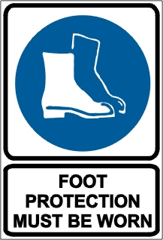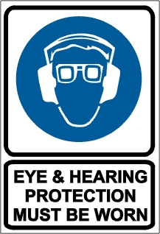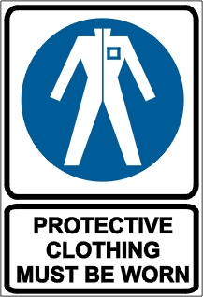

PRE-OPERATIONAL SAFETY CHECKS
- Locate and ensure you are familiar with all machine operations and controls.
- Check for loose/missing nuts, bolts and screws. Tighten and/or replace as needed.
- Inspect fuel lines, tank and area around carburetor for fuel leaks. Do not operate if leaks are found.
- Ensure all guards are fitted, secure and functional. Do not operate if guards are missing or faulty.
- Ensure the blade unit has a debris shield, either a bar handle or a U-handle, and is suspended from a shoulder harness.
- Select the correct cutting tool for the task. Refer to manufacturer’s recommendations.
- Load the nylon line cutting head only with nylon trimmer line of the proper diameter.
- Thoroughly inspect blades for damage and cracks.
- When operating the unit with a blade, ensure the blade is attached to the unit as designed (for example, with a locknut and cotter pin) and with the teeth pointing in the direction the blade head rotates.

OPERATIONAL SAFETY CHECKS
- Watch for ejected material. Ensure no person or animal is endangered when operating equipment.
- Adjust the handle/s to a position for comfort and balance.
- When starting, ensure the machine is in a clear area so the line or blade cannot contact the ground or any other obstruction.
- Make sure the muffler side of the engine is away from your body to avoid burns.
- Maintain a proper balance and secure footing. Do not work on slippery, uneven or unstable surfaces.
- Maintain a straight wrist position Avoid using your wrist in a bent, extended or twisted position.
- Always keep both hands on the control handles. Do not operate one-handed.
- Keep machine clear of fences, wires, posts and rocks to prevent kick out and cutter head damage.
- Shut down immediately if the unit starts to shake or vibrate.
- Disconnect spark plug wire before you work on the unit or leave it unattended.
- Take care when refuelling to avoid spilling fuel on hot motor or exhaust.

ENDING OPERATIONS AND CLEANING UP
- After shutting down the engine, keep fingers/feet away from the cutting line/blade until all rotation stops.
- Remove any foreign material from in and around engine, cutting tool and guards.
- Keep the work area and implement shed in a safe, clean and tidy condition.

POTENTIAL HAZARDS AND INJURIES
- The blade can push, pull or kick out.
- Noise.
- Ejected materials.
- Hair/clothing getting caught in moving machine parts.

DON’T
- Do not use faulty equipment. Report suspect machinery immediately.
- Do not operate if the line cutter is missing.
- Do not raise the line or blade head above knee height.

