William A. Gerhardt Property Improvement

SWP WOOD CHIPPER

DO NOT use this machine unless you have been instructed
in its safe use and operation and have been given permission

PERSONAL PROTECTIVE EQUIPMENT

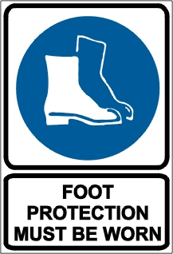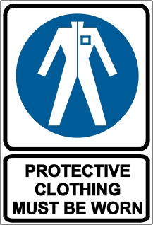

PRE-OPERATIONAL SAFETY CHECKS
- Locate and ensure you are familiar with all machine operations and controls.
- Check for loose/missing nuts, bolts and screws. Tighten and/or replace as needed.
- Ensure all guards are fitted, secure and functional. Do not operate if guards are missing or faulty.
- Ensure the chipper chute, feed intake, and cutting chamber are empty and free of all debris.

OPERATIONAL SAFETY CHECKS
- Know how to stop the machine and disengage it quickly.
- Keep bystanders well clear from the machine while it is operating.
- If you need to push material through the shredder hopper, use a small diameter stick. Do not use your hands or feet.
- If the impeller strikes a foreign object or if the machine starts making an unusual noise or vibration, immediately shut the engine off. Inspect for damage and make repairs as necessary.

ENDING OPERATIONS AND CLEANING UP
- Remove any foreign material from in and around the motor, blades and guards.
- Before cleaning, repairing, or inspecting, stop the engine and make sure the impeller and all moving parts have stopped. Disconnect the spark plug wire and ground it against the engine to prevent unintended starting.
- Keep the work area and implement shed in a safe, clean and tidy condition.

POTENTIAL HAZARDS AND INJURIES
- Rotating cutting blades.
- Noise.
- Hair/clothing getting caught in moving machine parts.
- Eye injuries.
- Kickback.
- Flying debris.

DON’T
- Do not use faulty equipment. Report suspect machinery immediately.
- Never operate without the shredder hopper, chipper chute, or discharge chute properly attached to the machine.
- Never run an engine indoors or in a poorly ventilated area.
- Do not attempt to shred or chip material larger than specified on the machine or in manual.
- Do not put your hands and feet near rotating parts or in the feeding chambers and discharge opening.
- Do not allow processed material to build up in the discharge area.
- Never remove fuel cap or add fuel while the engine is hot or running. Allow engine to cool for at least two minutes before refuelling.
- Never attempt to unclog the feed intake or discharge opening or inspect and repair the machine while the engine is running.

