William A. Gerhardt Property Improvement

SWP GAS OPERATED CHAINSAW

DO NOT use this machine unless you have been instructed
in its safe use and operation and have been given permission

PERSONAL PROTECTIVE EQUIPMENT

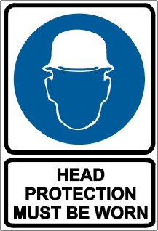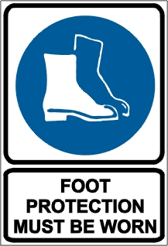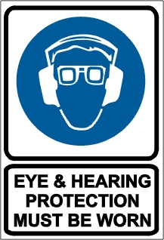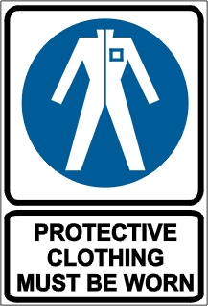

PRE-OPERATIONAL SAFETY CHECKS
- Locate and ensure you are familiar with all machine operations and controls.
- Ensure the machine is clean so you can see any loose, worn or defective parts and other safety hazards.
- Inspect fuel lines, tank and area around carburetor for fuel leaks. Do not operate if leaks are found.
- Check the effectiveness of chainbrakes and operating controls.
- Ensure all guards are fitted, secure and functional. Do not operate if guards are missing or faulty.
- Check condition of the anti-vibration mountings of the handles.
- Ensure chain is sharp and correctly tensioned.

OPERATIONAL SAFETY CHECKS
- When starting the chainsaw on the ground:
- Ensure no obstructions are present, particularly near the tip of the guide bar.
- Ensure the chainbrake is applied
- Place your right foot through the rear handle and place your left hand on the front handle.
- Operate the starter with the right hand.
- Keep a firm grip on the chainsaw with both hands and the thumb of the hand holding the front handle wrapped around the handle.
- Maintain a proper balance and secure footing.
- Start the cut with the saw chain rotating at full speed and the spiked bumper in contact with the wood.
- Be aware of the guidebar nose at all times when the saw chain is in motion.
- Pay full attention to the operation and be alert for movement of the material being cut.
- Be alert to situations that may cause material to pinch the top of the saw chain.
- Apply chainbrake when saw is at rest.
- Allow the unit to cool before refuelling.

ENDING OPERATIONS AND CLEANING UP
- Remove any foreign material from in and around motor and guards.
- Keep the work area and implement shed in a clean and tidy condition.

POTENTIAL HAZARDS AND INJURIES
- Kick-back.
- Push-back.
- Pull-in.
- Hair/clothing getting caught in moving machine parts.
- Rotating chain.
- Flying debris.
- Trip hazards.
- Noise.

DON’T
- Do not use faulty equipment. Report suspect machinery immediately.
- Never use a chainsaw over shoulder height.

