The Lutheran Church of the Covenant
“Reaching Out, Reflecting Christ, Renewing Lives”

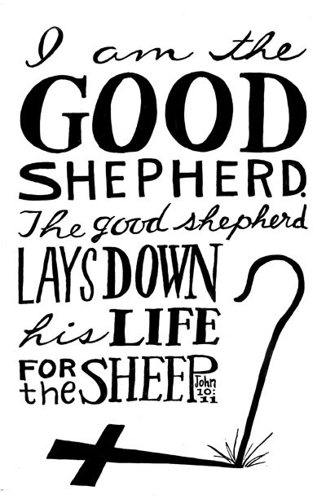

Fourth Sunday of Easter
April 30, 2023

We welcome you to worship here at the Lutheran Church of the Covenant! Here are a few notes to make you feel more at home as we praise this God of new life together!

- Bulletins and Communion (wheat or gluten-free wafers, wine or grape juice options) are available to be picked up at the back of the sanctuary.
- Portions marked with * are when we invite you to stand as you are able to do so.
- We encourage you to participate throughout the worship by speaking the bold print and singing along with the hymns!
- There will not be a separate time for an offering, so a basket is placed in the back for those who wish to support our local ministry as well as the wider church.
- We will commune from our respective seats, where the presiding minister will invite you to open your respective cups with the Communion elements. We believe this meal is for everyone who wishes to partake, regardless of church affiliation or lack thereof. This tangible gift of God’s love is meant for the world to enjoy!

Our Worship Leaders & Staff

Ministers All People
Presiding Minister The Rev. Bradley Ross
Organist Aaron Carter-Enyi
Lector
Parish Administrator Jennifer Lasher-Dobush
Custodian Vince Besednjak

The Lutheran Church of the Covenant
19000 Libby Rd.
Maple Heights, OH 44137
Phone: 216-662-0370, Website:covenantmaplehts.org, Email: covenantlc@sbcglobal.net
Fourth Sunday of Easter
Today is sometimes called “Good Shepherd Sunday.” Jesus is called the “gate” of the sheep in today’s gospel. The risen Christ opens the way to abundant life. He anoints our heads with oil and guides us beside the still (and not-so-still) waters of our baptism. Each Sunday, he spreads a feast before us amid the world’s conflict and chaos. We go forth to be signs of the resurrection and extend God’s tender care to all creation.

Prelude Rondo Jubilee United Handbell Choir

Welcome & Greetings

Alleluia! Christ is Risen!
Christ is Risen, indeed! Alleluia!

*Thanksgiving for Baptism
We praise God for the gift of baptism that forever unites us through God’s love with one another, and sets us free to serve as disciples for the sake of the world.

Blessed be the holy Trinity, ☩ one God,
by whose hand we are given new birth,
by whose speaking we are given new life.
Amen!

Joined to Christ in the waters of baptism,
we are welcomed, restored, and supported
as children of the new creation.
Let us give thanks for the gift of baptism.

Holy God, holy and merciful, holy and mighty,
you are the river of life,
you are the everlasting wellspring.
In mercy and might you have freed us from death
and raised us with Jesus, our resurrection and the life.
In baptismal waters, our old life is washed away,
and in them we are born anew.

Glory to you for oceans and lakes,
for rivers and streams.
Honor to you for waters that wash us clean,
quench our thirst, and nurture both crops and creatures.
Praise to you for the life-giving water of baptism,
the outpouring of the Holy Spirit of the new creation.

Satisfy the world’s need through this living water.
Where drought dries the earth, bring refreshment.
Where despair prevails, grant hope.
Where chaos reigns, bring peace.
We ask this through Jesus Christ,
who with you and the Holy Spirit reigns forever.
Amen!

*Gathering Hymn My Shepherd, You Supply My Need ELW #782

*Greeting

The grace of our Lord, Jesus Christ, the love of God, and the communion of the Holy Spirit be with you all! And also with you.

Hymn of Praise This is the Feast ELW pg. 101

Prayer of the Day

O God ,our good shepherd, you know your sheep by name and lead us to safety through all the hills and valleys of this life. Guide us by your voice, that we may walk in certainty and security to the joyous feast prepared in your house, through Jesus Christ, our Risen Savior and Lord, who lives and reigns with you and the Holy Spirit, one God, now and forever. Amen!

First Lesson Acts 2:42-47
Today’s reading is a description of life in the community following Peter’s sermon on the day of Pentecost, when the Spirit was poured out on God’s people. The new community is sustained in worship and fellowship, shares what they have, and ensures that everyone has enough.

⁴²[The baptized] devoted themselves to the apostles’ teaching and fellowship, to the breaking of bread and the prayers.
⁴³Awe came upon everyone, because many wonders and signs were being done by the apostles. ⁴⁴All who believed were together and had all things in common; ⁴⁵they would sell their possessions and goods and distribute the proceeds to all, as any had need. ⁴⁶Day by day, as they spent much time together in the temple, they broke bread at home and ate their food with glad and generous hearts, ⁴⁷praising God and having the goodwill of all the people. And day by day the Lord added to their number those who were being saved.

Word of God, word of life! Thanks be to God!

Psalm Psalm 23
The bold verses are sung by the congregation using the tone below:
Antiphon: The Lord is my shepherd; I shall not be in want. (Ps. 23:1)
¹The Lord | is my shepherd;
I shall not | be in want.
²The Lord makes me lie down | in green pastures
and leads me be- | side still waters.
³You restore my | soul, O Lord,
and guide me along right pathways | for your name’s sake.
⁴Though I walk through the valley of the shadow of death, I shall | fear no evil;
for you are with me; your rod and your staff, they | comfort me. Antiphon
⁵You prepare a table before me in the presence | of my enemies;
you anoint my head with oil, and my cup is | running over.
⁶Surely goodness and mercy shall follow me all the days | of my life,
and I will dwell in the house of the | Lord forever. Antiphon
Second Lesson 1 Peter 2:19-25
Doing the right things does not guarantee that one will not experience difficulties, hardships, rejection, or even suffering. Here Christ is presented as the model for our path of endurance and loyalty to God, particularly amid adversity.

¹⁹It is a credit to you if, being aware of God, you endure pain while suffering unjustly. ²⁰If you endure when you are beaten for doing wrong, what credit is that? But if you endure when you do right and suffer for it, you have God’s approval. ²¹For to this you have been called, because Christ also suffered for you, leaving you an example, so that you should follow in his steps.
²²“He committed no sin,
and no deceit was found in his mouth.”
²³When he was abused, he did not return abuse; when he suffered, he did not threaten; but he entrusted himself to the one who judges justly. ²⁴He himself bore our sins in his body on the cross, so that, free from sins, we might live for righteousness; by his wounds you have been healed. ²⁵For you were going astray like sheep, but now you have returned to the shepherd and guardian of your souls.

Word of God, word of life! Thanks be to God!

*Gospel Acclamation

*Gospel John 10:1-10
Jesus uses an image familiar to the people of his day to make a point about spiritual leadership. Those who listen to Jesus are led to abundant life.

The Gospel according to John the 10th chapter. Glory to you, O Lord!

[Jesus said:] ¹“Very truly, I tell you, anyone who does not enter the sheepfold by the gate but climbs in by another way is a thief and a bandit. ²The one who enters by the gate is the shepherd of the sheep. ³The gatekeeper opens the gate for him, and the sheep hear his voice. He calls his own sheep by name and leads them out. ⁴When he has brought out all his own, he goes ahead of them, and the sheep follow him because they know his voice. ⁵They will not follow a stranger, but they will run from him because they do not know the voice of strangers.” ⁶Jesus used this figure of speech with them, but they did not understand what he was saying to them.
⁷So again Jesus said to them, “Very truly, I tell you, I am the gate for the sheep. ⁸All who came before me are thieves and bandits; but the sheep did not listen to them. ⁹I am the gate. Whoever enters by me will be saved, and will come in and go out and find pasture. ¹⁰The thief comes only to steal and kill and destroy. I came that they may have life, and have it abundantly.”

This is the holy Gospel of our Lord! Praise to you, O Christ!

Sermon

Hymn of the Day The King of Love My Shepherd Is Verses 1, 4 & 6 ELW #502

*Nicene Creed

We believe in one God,
the Father, the Almighty,
maker of heaven and earth,
of all that is, seen and unseen.
We believe in one Lord, Jesus Christ,
the only Son of God,
eternally begotten of the Father,
God from God, Light from Light,
true God from true God,
begotten, not made,
of one Being with the Father;
through him all things were made.
For us and for our salvation
he came down from heaven,
was incarnate of the Holy Spirit and the virgin Mary
and became truly human.
For our sake he was crucified under Pontius Pilate;
he suffered death and was buried.
On the third day he rose again
in accordance with the scriptures;
he ascended into heaven
and is seated at the right hand of the Father.
He will come again in glory to judge the living and the dead,
and his kingdom will have no end.
We believe in the Holy Spirit, the Lord, the giver of life,
who proceeds from the Father and the Son,
who with the Father and the Son is worshiped and glorified,
who has spoken through the prophets.
We believe in one holy catholic and apostolic church.
We acknowledge one baptism for the forgiveness of sins.
We look for the resurrection of the dead,
and the life of the world to come. Amen.

* Prayers of Intercession
United in the hope and joy of the resurrection, let us pray for the church, the world, and all in need.

A brief silence.

Gracious God, you are the shepherd who gathers us in your compassionate arms. Help your whole church, including our Covenant family, to listen for your voice of hope, especially when the voices of sin, idolatry, and oppression threaten to overpower us. Hear us, O God. Your mercy is great.

The green pastures, still waters, and dark valleys of this earth all belong to you, O Lord. Continue to sustain your creation with a care that is both mighty and just. Where there is destruction, bring healing. Where there is desolation, bring abundance. Hear us, O God. Your mercy is great.

You proclaim shepherding love, comfort, and protection for all people and all of creation. Direct leaders in our own time to learn from your example and instruction. Give them servant hearts, that they generously seek the good of all. Hear us, O God. Your mercy is great.

You journey with us wherever our paths may lead. We pray for those feeling overwhelmed by anxiety or depression or suffering in any way. Hear us, O God. Your mercy is great.

You are the sheepgate that gives safety to your beloved flocks. Provide protection for refugees, victims of domestic violence, those who are imprisoned, and all people who are vulnerable to violence and mistreatment. Hear us, O God. Your mercy is great.

You call your sheep by name and lead them through the valley of death. We give you thanks for those who have died and now dwell in your house forever. Be with those who mourn, and give them hope in the promise of resurrection. Hear us, O God. Your mercy is great.

Rejoicing in the victory of Christ’s resurrection, we lift our prayers and praise to you, almighty and eternal God; through Jesus Christ, our risen Lord. Amen!
*Sharing of the Peace

The peace of the risen Christ be with you always! And also with you.

Music Interlude

*Great Thanksgiving

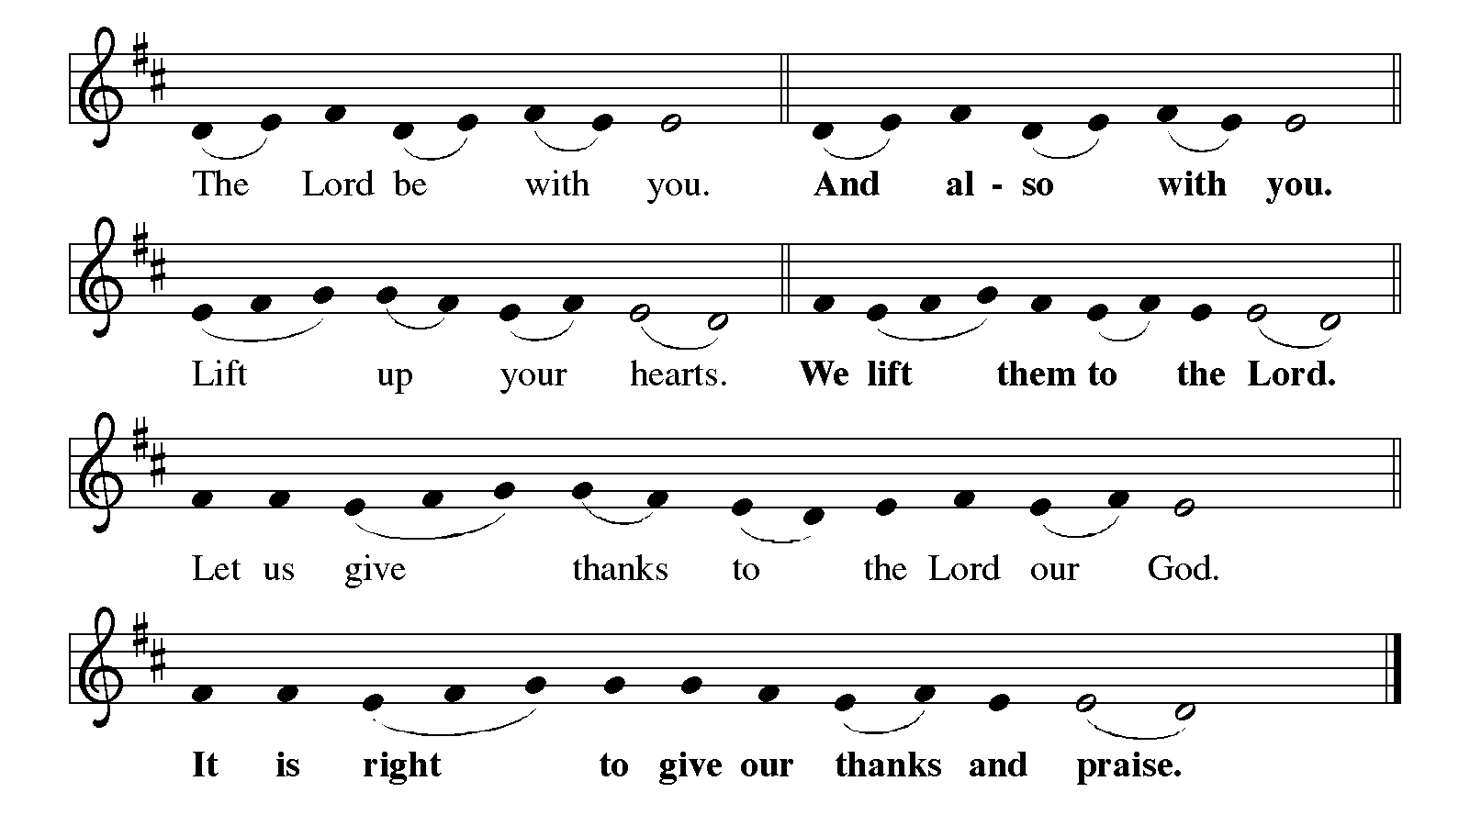

It is indeed our delight
that we give thanks and praise to you, loving and gracious God,
for the glorious resurrection of our Savior Jesus Christ,
who in dying has destroyed death,
and in rising has brought us to eternal life.
And so, with Mary Magdalene and Peter and all the witnesses of the resurrection,
with earth and sea and all their creatures,
and with angels and archangels, cherubim and seraphim,
we praise your name and join their unending hymn:

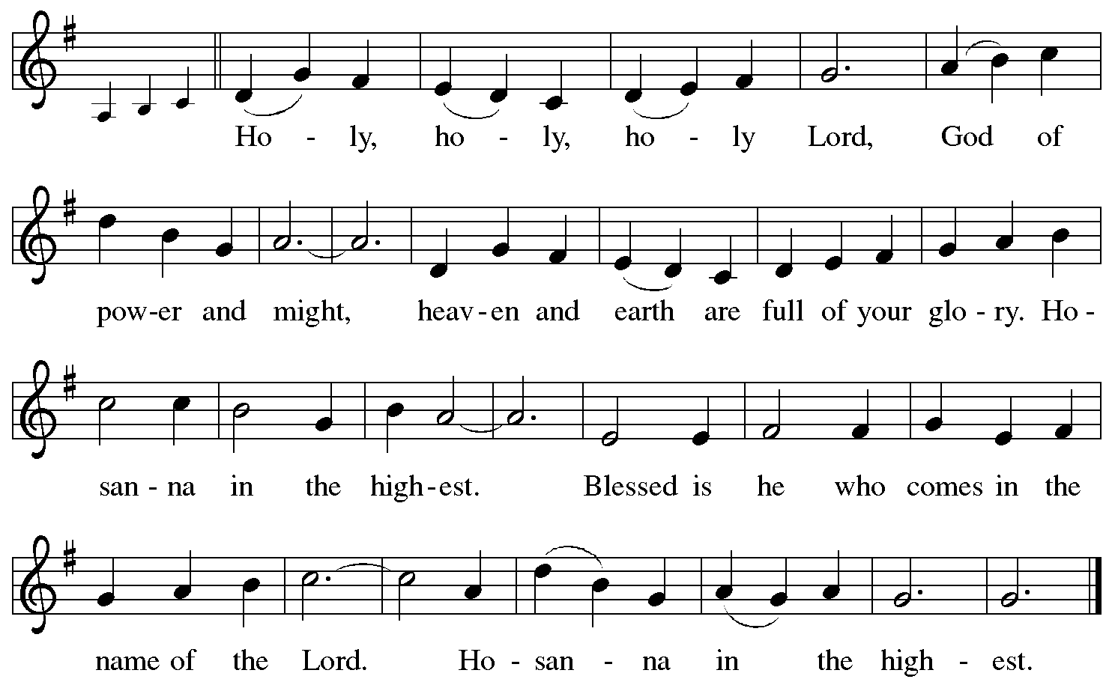
*Thanksgiving at the Table

Holy, living, and loving God,
we praise you for creating the heavens and the earth.
We bless you for bringing Noah and his family through the waters of the flood,
for freeing your people Israel from the bonds of slavery,
and for sending your Son to be our Redeemer.

We give you thanks for Jesus
who, living among us,
healed the sick,
fed the hungry,
and with a love stronger than death,
gave his life for others.

In the night in which he was betrayed,
our Lord Jesus took bread, and gave thanks;
broke it, and gave it to his disciples, saying:
Take and eat; this is my body, given for you.
Do this for the remembrance of me.

Again, after supper, he took the cup, gave thanks,
and gave it for all to drink, saying:
This cup is the new covenant in my blood,
shed for you and for all people for the forgiveness of sin.
Do this for the remembrance of me.

Remembering, therefore,
his life-giving death and glorious resurrection,
we await your promised life for all this world you still adore.

Holy Spirit, breathe on us and on this bread and cup:
carry us in your arms from death to life,
that we may live as your disciples,
clothed in the everlasting grace of Christ.

Through him all glory and honor is yours,
Almighty Father, with the Holy Spirit,
both now and forever. Amen!

Our Father in heaven,
hallowed be your name,
your kingdom come,
your will be done,
on earth as in heaven.
Give us today our daily bread.
Forgive us our sins
as we forgive those who sin against us.
Save us from the time of trial
and deliver us from evil.
For the kingdom, the power,
and the glory are yours, now and forever. Amen.
*Invitation to Communion

Taste and see the joy of new life for us all!
Thanks be to God!

Communion

Music Interlude

Prayer after Communion

Gracious God,
in you we live and move and have our being.
With your word and this meal of grace,
you have nourished our life together.
Strengthen us to show your love
and serve the world in Jesus’ name.
Amen!

*Blessing

The God of all,
who raised ☩ Jesus from the dead,
bless you by the power of the Holy Spirit
to live in the new creation.
Amen!

*Sending Hymn Savior, Like a Shepherd Lead Us ELW #789

*Dismissal

Alleluia! Christ is Risen!
Christ is Risen, indeed! Alleluia!
Go in peace. Serve the Risen Christ!
Thanks be to God!

Postlude
Praying Together
... for those who are homebound, ill, hospitalized or recuperating: Gayle Agg, Sheena Cameron, Joan Clarke, Christina Copeland, Barbara Fossa, Carolyn Frajter, Ken Frajter, Donna Franz, Barb Gaglione, Michelle Garnett, Rosa Garnett, Jane Gradert, Dylan King, Elaine Knerem, Jason Lanese, Sara Mendes, Phyllis Nemeth, Arlene Stoltz, Marie Storms, Tom Susanek, Phyllis Welker, Maud Wright, Wilma Dancy, Bill Helmick, Nancy Helmick, Robert Lambrecht, Kim (Novak) Leonhardt, Laura Mele, Shannon Meskill, Judy Morgan, Kris Sandor, Bill Wilkens, Eugene Winfrey, the Copeland/Lane Family.
LAST WEEK
General Fund receipts for week ending 4/23/2023: $1,054.25

Lectionary Blog: On Doors and Disciples
Too often much of Christianity is about gatekeeping. Do you think the right things, believe the right things, confess the right things and maybe hate the right things? If so, welcome to the club—if not, get out of here. If we’re honest, Lutheran Christians do this as much as anyone. After all, the first step is to admit that there’s a problem and correctly identify it. In this week’s lectionary texts, we have an example of good gatekeeping by Jesus and then some descriptions of what is behind that gate.
John 10 begins with an extended metaphor in which Jesus compares himself to two things. We all know about Jesus as the good shepherd from verses 11-18. But we spend less time on his introductory metaphor of Jesus as the gate of the sheep pen. For all the non-shepherds out there: in places of danger, whether from wild animals or from brigands, shepherds work together to make sheep pens. Several flocks may be kept together (penned in, so to speak) so the shepherds can take some time off from their vigilance. A professional guard may be employed to keep the sheep safe. Or one of the shepherds may lay in front of the door to the pen, making sure that no sheep escape and no wild animals or thieves break in. You can be sure that anyone who tries to avoid the door and the gatekeeper doesn’t have good intentions for the sheep.
In this metaphor, Jesus is speaking to shepherds, that is, other leaders of God’s people. Later he will call himself the good shepherd who lays down his life for the sheep, but here he is the door, the access point to the sheep. If a shepherd doesn’t go through Jesus to collect the sheep, he isn’t trustworthy and doesn’t have the sheep’s protection, safety and care in mind. Sheep will follow all sorts of shepherds if they know their voices—frequently to our own detriment. Again, not all leaders put their highest priority on the good of the flock that has been entrusted to their care. Jesus insists to his disciples, and to us, that a trustworthy shepherd will have to pass through him to gain access to the people he keeps safe and guards.
So then, what does a trustworthy shepherd do? What are the hallmarks of someone who would be trusted by Jesus to lead the sheep for whom Christ has laid down his life? One of my most favorite sections of Scripture in Acts 2 gives us a good picture of excellent Christian leadership. For lack of a better term, the disciples, and those who followed Jesus because of them, “did life together.” The four verbs of real church—study, hang out, pray and eat (Acts 2:42)—were necessities. The disciples held everything in common, meeting together in both the holy places and in the normal, everyday places to eat and simply be together.
A trustworthy shepherd acts as Jesus did by hanging out with people, eating, walking, asking and answering (and not answering) questions. Jesus absolutely took plenty of alone time, and I think any healthy shepherd, introverted or not, should be alone frequently. But Jesus also says the sheep will know the shepherd because she walks with the sheep, leading them with her presence and voice. If the sheep encounter the leader for only a couple hours once a week, that sort of intimacy isn’t possible.
Now, a pastoral question arises: how does one create a healthy intimacy between sheep and shepherds? Again, remember that in this metaphor Jesus is the doorkeeper who releases the sheep to the shepherd. I, for one, love Lenten Wednesday suppers and Friday prayers. I used to think that I wouldn’t have time for those things when we had kids. But now, as parents, it’s more important than ever that we eat together with other members of the body of Christ. I simply can’t allow for church to be only a Sunday morning thing for my kids. I think Jesus calls us to more and better. As an example, Amy Beitelschees-Albers, an ELCA pastor, leads So Much More Ministries, which weekly provides free meals to unify communities across Fort Wayne, Ind. They eat together and hang out to practice exactly the type of ministry that Jesus and the early church did.
The early church ate together, studied, prayed and hung out, and God added daily to their numbers. Jesus, as the door to the sheepfold, grants shepherds time off, but then releases the sheep to the shepherds for daily care and feeding. May we learn from their ministries.
- Cory Driver (LivingLutheran.org)

