The Lutheran Church of the Covenant
“Reaching Out, Reflecting Christ, Renewing Lives”

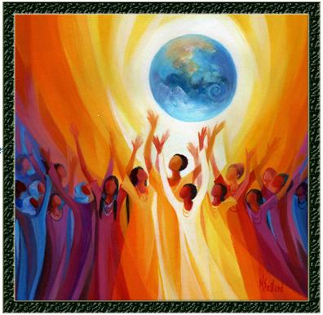

Day of Pentecost
May 28, 2023

We welcome you to worship here at the Lutheran Church of the Covenant! Here are a few notes to make you feel more at home as we praise this God of new life together!

- Bulletins and Communion (wheat or gluten-free wafers, wine or grape juice options) are available to be picked up at the back of the sanctuary.
- Portions marked with * are when we invite you to stand as you are able to do so.
- We encourage you to participate throughout the worship by speaking the bold print and singing along with the hymns!
- There will not be a separate time for an offering, so a basket is placed in the back for those who wish to support our local ministry as well as the wider church.
- We will commune from our respective seats, where the presiding minister will invite you to open your respective cups with the Communion elements. We believe this meal is for everyone who wishes to partake, regardless of church affiliation or lack thereof. This tangible gift of God’s love is meant for the world to enjoy!

Our Worship Leaders & Staff

Ministers All People
Presiding Minister The Rev. Bradley Ross
Organist Aaron Carter-Enyi
Lector Bert Zahn
Parish Administrator Jennifer Lasher-Dobush
Custodian Vince Besednjak

The Lutheran Church of the Covenant
19000 Libby Rd.
Maple Heights, OH 44137
Phone: 216-662-0370, Website:covenantmaplehts.org, Email: covenantlc@sbcglobal.net
Day of Pentecost
Pentecost derives its name from the Jewish festival celebrating the harvest and the giving of the law on Mount Sinai fifty days after Passover. Fifty days after Easter, we celebrate the Holy Spirit as God’s presence within and among us. In Acts, the Holy Spirit arrives in rushing wind and flame, bringing God’s presence to all people. Paul reminds us that though we each have different capacities, we are unified in the Holy Spirit that equips us with these gifts. Jesus breathes the Holy Spirit on his disciples, empowering them to forgive sin. We celebrate that we too are given the breath of the Holy Spirit and sent out to proclaim God’s redeeming love to all the world.

Prelude

Welcome & Greetings

Alleluia! Christ is Risen!
Christ is Risen, indeed! Alleluia!

*Thanksgiving for Baptism
We praise God for the gift of baptism that forever unites us through God’s love with one another, and sets us free to serve as disciples for the sake of the world.

Blessed be the holy Trinity, ☩ one God,
by whose hand we are given new birth,
by whose speaking we are given new life.
Amen!

Joined to Christ in the waters of baptism,
we are welcomed, restored, and supported
as children of the new creation.
Let us give thanks for the gift of baptism.

Holy God, holy and merciful, holy and mighty,
you are the river of life,
you are the everlasting wellspring.
In mercy and might you have freed us from death
and raised us with Jesus, our resurrection and the life.
In baptismal waters, our old life is washed away,
and in them we are born anew.

Glory to you for oceans and lakes,
for rivers and streams.
Honor to you for waters that wash us clean,
quench our thirst, and nurture both crops and creatures.
Praise to you for the life-giving water of baptism,
the outpouring of the Holy Spirit of the new creation.

Satisfy the world’s need through this living water.
Where drought dries the earth, bring refreshment.
Where despair prevails, grant hope.
Where chaos reigns, bring peace.
We ask this through Jesus Christ,
who with you and the Holy Spirit reigns forever.
Amen!

*Gathering Hymn Spirit of Gentleness ELW #396

*Greeting

The grace of our Risen Lord, Jesus Christ, the love of God, and the communion of the Holy Spirit be with you all! And also with you.

Hymn of Praise This is the Feast ELW pg. 101

Prayer of the Day

O God, on this day you open the hearts of your faithful people by blessing us with hope and joy as the Holy Spirit. Direct us by that relentless light, that we may have a compassionate heart in all things and rejoice at all times in your most soothing peace, through Jesus Christ, our Risen Lord, who lives and reigns with you and the Holy Spirit, one God, now and forever. Amen!

First Lesson Acts 2:1-21
Pentecost was a Jewish harvest festival that marked the fiftieth day after Passover. Luke portrays the Holy Spirit being poured out upon the disciples before the gathered and astonished people assembled in Jerusalem for the festival. Filled with the Spirit, the disciples were able to witness to the power of Christ’s resurrection.

¹When the day of Pentecost had come, [the apostles] were all together in one place. ²And suddenly from heaven there came a sound like the rush of a violent wind, and it filled the entire house where they were sitting. ³Divided tongues, as of fire, appeared among them, and a tongue rested on each of them. ⁴All of them were filled with the Holy Spirit and began to speak in other languages, as the Spirit gave them ability.
⁵Now there were devout Jews from every nation under heaven living in Jerusalem. ⁶And at this sound the crowd gathered and was bewildered, because each one heard them speaking in the native language of each. ⁷Amazed and astonished, they asked, “Are not all these who are speaking Galileans? ⁸And how is it that we hear, each of us, in our own native language? ⁹Parthians, Medes, Elamites, and residents of Mesopotamia, Judea and Cappadocia, Pontus and Asia, ¹⁰Phrygia and Pamphylia, Egypt and the parts of Libya belonging to Cyrene, and visitors from Rome, both Jews and proselytes, ¹¹Cretans and Arabs—in our own languages we hear them speaking about God’s deeds of power.” ¹²All were amazed and perplexed, saying to one another, “What does this mean?” ¹³But others sneered and said, “They are filled with new wine.”
¹⁴But Peter, standing with the eleven, raised his voice and addressed them, “Men of Judea and all who live in Jerusalem, let this be known to you, and listen to what I say. ¹⁵Indeed, these are not drunk, as you suppose, for it is only nine o’clock in the morning. ¹⁶No, this is what was spoken through the prophet Joel:
¹⁷‘In the last days it will be, God declares, that I will pour out my Spirit upon all flesh,
and your sons and your daughters shall prophesy,
and your young men shall see visions, and your old men shall dream dreams.
¹⁸Even upon my slaves, both men and women,
in those days I will pour out my Spirit; and they shall prophesy.
¹⁹And I will show portents in the heaven above
and signs on the earth below, blood, and fire, and smoky mist.
²⁰The sun shall be turned to darkness and the moon to blood,
before the coming of the Lord’s great and glorious day.
²¹Then everyone who calls on the name of the Lord shall be saved.’”

Word of God, word of life! Thanks be to God!
Psalm Psalm 104:24-34, 35b
The bold verses are sung by the congregation using the tone below:
Antiphon: Send forth your Spirit and renew the face of the earth. (Ps. 104:30)

²⁴How manifold are your | works, O Lord!
In wisdom you have made them all; the earth is full | of your creatures.
²⁵Yonder is the sea, great and wide, with its swarms too man- | y to number,
living things both | small and great.
²⁶There go the ships | to and fro,
and Leviathan, which you made for the | sport of it.
²⁷All of them | look to you
to give them their food | in due season. Antiphon
²⁸You give it to them; they | gather it;
you open your hand, and they are filled | with good things.
²⁹When you hide your face, | they are terrified;
when you take away their breath, they die and return | to their dust.
³⁰You send forth your Spirit, and they | are created;
and so you renew the face | of the earth.
³¹May the glory of the Lord en- | dure forever;
O Lord, rejoice in | all your works. Antiphon
³²You look at the earth | and it trembles;
you touch the mountains | and they smoke.
³³I will sing to the Lord as long | as I live;
I will praise my God while I | have my being.
³⁴May these words of | mine please God.
I will rejoice | in the Lord.
^{35b}Bless the Lord, | O my soul.
Hal- | lelujah! Antiphon

Second Lesson 1 Corinthians 12:3b-13
Paul is helping the Corinthians understand the relationship between our God-given unity and Spirit-created diversity. The Spirit creates the unity of faith and gives all Christians diverse gifts for the common benefit of all. We need one another’s diverse spiritual gifts because the same Spirit has given them to each person for the common good.

^{3b}No one can say “Jesus is Lord” except by the Holy Spirit.⁴Now there are varieties of gifts, but the same Spirit; ⁵and there are varieties of services, but the same Lord; ⁶and there are varieties of activities, but it is the same God who activates all of them in everyone. ⁷To each is given the manifestation of the Spirit for the common good. ⁸To one is given through the Spirit the utterance of wisdom, and to another the utterance of knowledge according to the same Spirit, ⁹to another faith by the same Spirit, to another gifts of healing by the one Spirit, ¹⁰to another the working of miracles, to another prophecy, to another the discernment of spirits, to another various kinds of tongues, to another the interpretation of tongues. ¹¹All these are activated by one and the same Spirit, who allots to each one individually just as the Spirit chooses.
¹²For just as the body is one and has many members, and all the members of the body, though many, are one body, so it is with Christ. ¹³For in the one Spirit we were all baptized into one body—Jews or Greeks, slaves or free—and we were all made to drink of one Spirit.

Word of God, word of life! Thanks be to God!

*Gospel Acclamation

*Gospel John 20:19-23
The risen Jesus appears to his disciples, offering them a benediction, a commission, and the gift of the Holy Spirit.
The Gospel according to John, the 20th chapter. Glory to you, O Lord!

¹⁹When it was evening on that day, the first day of the week, and the doors of the house where the disciples had met were locked for fear of the Jews, Jesus came and stood among them and said, “Peace be with you.” ²⁰After he said this, he showed them his hands and his side. Then the disciples rejoiced when they saw the Lord. ²¹Jesus said to them again, “Peace be with you. As the Father has sent me, so I send you.” ²²When he had said this, he breathed on them and said to them, “Receive the Holy Spirit. ²³If you forgive the sins of any, they are forgiven them; if you retain the sins of any, they are retained.”

This is the holy Gospel of our Lord! Praise to you, O Christ!

Sermon

Hymn of the Day This is My Song ELW #887

*Nicene Creed

We believe in one God,
the Father, the Almighty,
maker of heaven and earth,
of all that is, seen and unseen.
We believe in one Lord, Jesus Christ,
the only Son of God,
eternally begotten of the Father,
God from God, Light from Light,
true God from true God,
begotten, not made,
of one Being with the Father;
through him all things were made.
For us and for our salvation
he came down from heaven,
was incarnate of the Holy Spirit and the virgin Mary
and became truly human.
For our sake he was crucified under Pontius Pilate;
he suffered death and was buried.
On the third day he rose again
in accordance with the scriptures;
he ascended into heaven
and is seated at the right hand of the Father.
He will come again in glory to judge the living and the dead,
and his kingdom will have no end.
We believe in the Holy Spirit, the Lord, the giver of life,
who proceeds from the Father and the Son,
who with the Father and the Son is worshiped and glorified,
who has spoken through the prophets.
We believe in one holy catholic and apostolic church.
We acknowledge one baptism for the forgiveness of sins.
We look for the resurrection of the dead,
and the life of the world to come. Amen.

*Prayers of Intercession For the Healing of Nations (see insert)
*Sharing of the Peace

The peace of the risen Christ be with you always! And also with you.

Music Interlude

*Great Thanksgiving

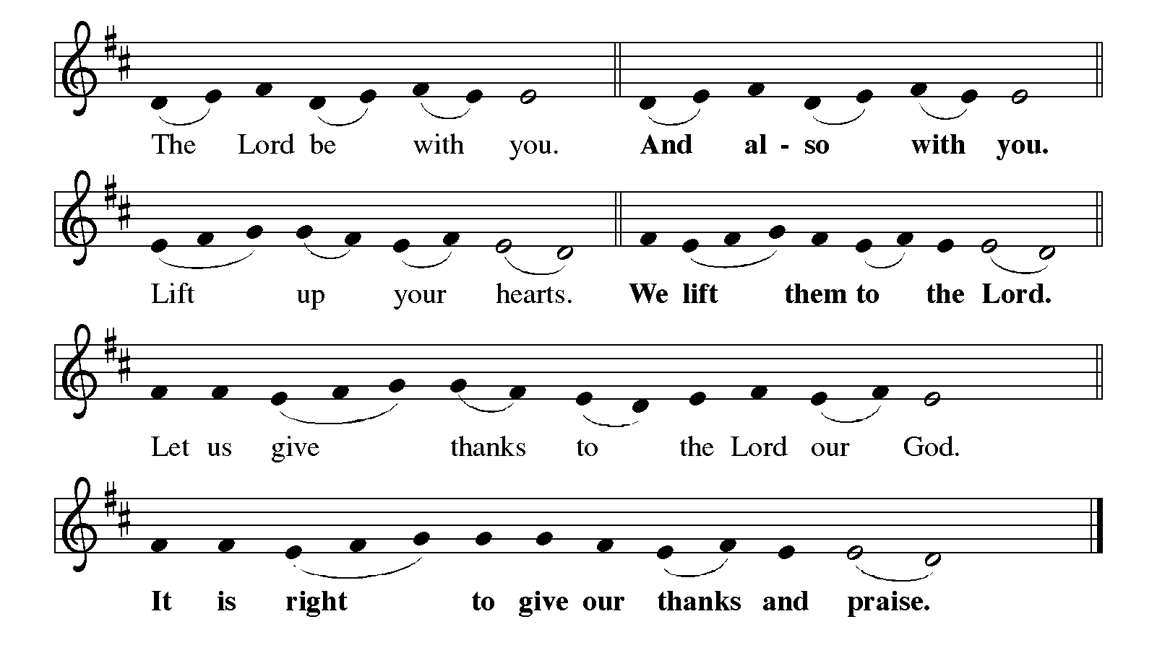

It is indeed our joy,
that we should give thanks and praise to you,
loving and gracious God,
through our Savior Jesus Christ.
Fulfilling the promise of the resurrection,
you pour out the fire of the Holy Spirit,
uniting in one body people of every nation and tongue.
And so, with Mary Magdalene and Peter and all the witnesses of the resurrection,
with earth and sea and all their creatures,
and with angels and archangels, cherubim and seraphim,
we praise your name and join their unending hymn:

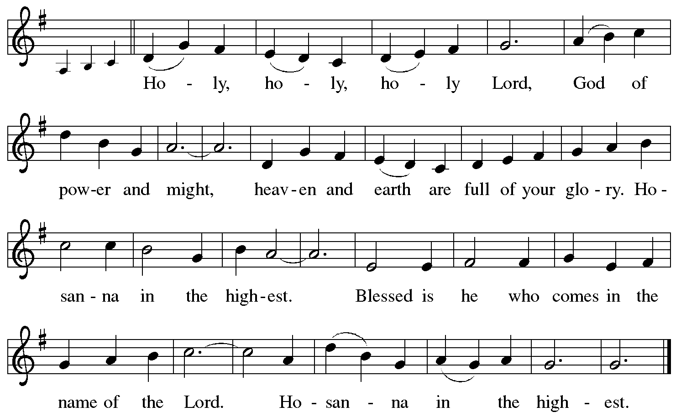

*Thanksgiving at the Table

Holy God,
Breath of life and Fire of love:
with a mighty wind you brought creation into being,
and by a pillar of fire you led your people into freedom.
We praise you for the gift of your Son,
who brought forth the Holy Spirit on his disciples of every race and nation.

In the night in which he was betrayed,
our Lord Jesus took bread, and gave thanks;
broke it, and gave it to his disciples, saying:
Take and eat; this is my body, given for you.
Do this for the remembrance of me.

Again, after supper, he took the cup, gave thanks,
and gave it for all to drink, saying:
This cup is the new covenant in my blood,
shed for you and for all people for the forgiveness of sin.
Do this for the remembrance of me.

Remembering, therefore,
his death, resurrection,
and the sending of the holy and life-giving Spirit,
we await his coming again to renew the face of the earth.

Holy Spirit, pour out your new life upon us and upon this meal:
anoint us with your gifts of faith, hope, and love,
that, with thankful hearts,
we may be witnesses to our Risen Lord.

Through him all glory and honor is yours,
Almighty Father, with the Holy Spirit,
both now and forever.
Amen!

Our Father in heaven,
hallowed be your name,
your kingdom come,
your will be done,
on earth as in heaven.
Give us today our daily bread.
Forgive us our sins
as we forgive those who sin against us.
Save us from the time of trial
and deliver us from evil.
For the kingdom, the power,
and the glory are yours, now and forever.
Amen.

*Invitation to Communion

Taste and see the joy of new life for us all!
Thanks be to God!

Communion

Music Interlude

Prayer after Communion

Gracious God,
in you we live and move and have our being.
With your word and this meal of grace,
you have nourished our life together.
Strengthen us to show your love
and serve the world in Jesus’ name.
Amen!

Farewell and Godspeed

The Scriptures are filled with stories of people
who have been called to move to new places:
Abraham and Sarah, Mary and Joseph,
Paul and Barnabas, Priscilla and Aquilla.
Filled with uncertainty about what lay ahead,
these people of God could not have found their moves easy.
Yet, they were also filled with excitement,
trusting that God was guiding them to a new place.
And now you, Aaron and your family,
are preparing to leave
and go to a new place, to a new home,
and a new way of bringing God’s gift of music to life.

As a part of this body of Christ,
you have given yourself
in ways that we have appreciated and will miss.
So, we ask God’s blessing upon you as we lift our hearts in prayer:

Blessed are you, O God,
for you have shaped the wide and wonderful world in which we live.
We praise you for your constant care
for those who have trusted you in ages past,
who journeyed in faith to new lands of promise.
We trust that now you will hold Aaron and his family
securely in your steadfast embrace.
May they take with them
hearts filled with your love and grace,
that those with whom they live and work and play,
may see in them the face of Jesus Christ.
Bless them that they may be a blessing.
May they continue to grow
in your hopeful presence
through Jesus Christ, our Risen Lord.
Amen!

*Blessing

The God of all,
who raised ☩ Jesus from the dead,
bless you by the power of the Holy Spirit
to live in the new creation. Amen!

*Sending Hymn God of Tempest, God of Whirlwind ELW #400

*Dismissal

Alleluia! Christ is Risen! Christ is Risen, indeed! Alleluia!
Go in peace. Serve the Risen Christ! Thanks be to God!

Postlude

Praying Together
... for those who are homebound, ill, hospitalized or recuperating: Gayle Agg, Sheena Cameron, Joan Clarke, Christina Copeland, Barbara Fossa, Carolyn Frajter, Ken Frajter, Donna Franz, Barb Gaglione, Michelle Garnett, Rosa Garnett, Jane Gradert, Dylan King, Elaine Knerem, Jason Lanese, Sara Mendes, Phyllis Nemeth, Arlene Stoltz, Marie Storms, Tom Susanek, Phyllis Welker, Maud Wright, Wilma Dancy, Bill Helmick, Nancy Helmick, Robert Lambrecht, Kim (Novak) Leonhardt, Laura Mele, Shannon Meskill, Judy Morgan, Kris Sandor, Bill Wilkens, Eugene Winfrey, the Copeland/Lane Family, Karla & Drew Perry at the death of Drew’s father Doyle Perry.

LAST WEEK
General Fund receipts for week ending 5/21/2023: $698
On behalf of the entire Covenant family, we thank you, Aaron, for your wonderful ministry of inspiration in helping us praise God with your gift of music. We pray God’s blessings to you and your entire family! Thank you!
Lectionary Blog: The Spirit Defies Separation

All too often we like our comfortable boundaries. We hang out with people who think like us and who frequently look like us too. We want all our sermons to follow good Lutheran law and gospel patterns. And we want our coffee and fellowship time to be short, positive and unintrusive to the rest of the week, right? Well, I know that’s making too many assumptions, but comfortable patterns are comfortable for a reason. They are what we are used to and have settled into, like a well-loved easy chair. This week we have stories in the lectionary texts about God removing comfort zones and confronting humans with the movement of the Spirit, who defies our categories and separations.
I love the Numbers text, and I hope everyone will find a way to use it this week. Moses has been over-functioning in his role as prophet and community leader. God, recognizing that Moses is worn out and needs help from other leaders, tells him to constitute another council of 70 elders (a similar group will eventually be known as the Sanhedrin). Moses gathers most of these leaders at the tent of meeting, which was set apart from the rest of the Israelite camp. Taking the Spirit that rested on Moses, God gives some to the rest of the leaders to empower and inspire them for the ministry to which they had been called.
But not all from this group of elders attend the meeting. Eldad and Medad remain among the people, who see them prophesy. A young man goes to tell Moses that prophesy was breaking out in the camp. Joshua ben Nun then urges Moses to shut Eldad and Medad up. Joshua is probably trying to protect Moses’ holy status and the centrality of the tent of meeting. After all, folks hearing God’s words directly might mean that Moses and the holy place aren’t as essential as thought! But Moses rebukes Joshua, saying he wished all the people would prophesy.
Proclaiming God’s words is not to be the honored domain of only a few privileged folks who leave their neighbors for a time to go to a special training center—whether it be the tent of meeting or a seminary. Instead, Medad and Eldad were chosen, empowered and inspired by God while they stayed in their contexts. When I teach seminarians in remote study programs, I make sure to read this text. Of course, there is value in residential training programs in which students come to centers of learning and ministry! But we must never look down on folks whom God chooses to lead who have alternative journeys. God’s Spirit breaks down barriers and expectations of who can lead and what their commissioning must look like.
Much later, in the Jerusalem Pentecost after Jesus’ death and resurrection, God’s Spirit once again shatters expectations and boundaries. God inspires Galileans to speak in the languages of all the people who stayed in Jerusalem to celebrate the pilgrimage festival. Jews from across—and, crucially, outside—the Roman Empire hear Galileans speaking their languages and testifying to what God had done in and through Jesus.
Everyone had come for the same festival, to be sure. But, as now, holiday traditions and customs varied by ethnicity. Arab Jews behaved differently from Persian Jews, from Greek Jews and from Roman Jews. And suddenly, some Galilean Jews are crossing boundaries and participating in formerly separate conversations that they had no prior access to because of the boundary-breaking power of God’s Spirit.
Some, of course, can’t stand this breakdown of linguistic and ethnic separation. Despite the clear intelligibility of the disciples, the scoffers say the Galileans must be drunk already on the new wine being gathered for the festival. Peter says it’s too early for that (not that it wouldn’t happen later …). Instead, Peter reminds the crowd of the words of the prophet Joel whom they already knew. God’s Spirit values and speaks in the voices of all people: male and female, young and old, slave and free.
What people witnessed at the Jerusalem Pentecost is what God always intended: to use the power of the Spirit to break down barriers that humans construct to separate ourselves from others, and to insulate ourselves from the ministry God is doing through people who don’t look, act, sound, train or think in the ways we do. We must follow God’s Spirit into the uncomfortable places where God is working.

This Lectionary Blog, and other resources for the journey of faith, are available on LivingLutheran.org.

Cory Driver is the assistant to the bishop for emerging ministers and ministries for the Indiana-Kentucky Synod. His book on wilderness spirituality, Life Unsettled, is available from Fortress Press.
Day of Pentecost
Fifty days after Passover, Jews kept the Pentecost festival, which originally celebrated the wheat harvest but had become the commemoration of the giving of the law on Mount Sinai. As the fiftieth day of Easter, Christians maintained the festival, altering its focus to a celebration of the Spirit of the risen Christ in the church. In an oblique reference to Sinai, the fire of God’s word is now on the foreheads of the faithful. In John, all believers receive the peace of the Lord. In Luke, especially the leaders are lauded. Pentecost concludes the Easter season.

God Gives More than Enough
It is the “first day of the week” (John 20:19), the day of the new creation, but to those locked away in the upper room in fear, the world is as it always has been. So entrenched are they in the ways of grief and guilt that the Risen One in their midst needs to offer his life-giving invitation twice: “Peace be with you.” The logic of the new age is peace, not retribution; forgiveness, not vengeance. With the invitation to new life comes also the means: the gift of the Holy Spirit, breathed upon them and within them. Just as the Father sent Jesus into the world, so now are these disciples sent as witnesses to God’s saving work.
Pentecost is therefore the crowning achievement of the Jesus story. Now, more than ever, these huddled disciples would have just cause to sing the “Dayenu” (“It would have been enough”) verses from the Passover seder meal, but revised: It would have been enough for the Word and wisdom of God to have been born in the flesh . . . Dayenu! It would have been enough for the Word to grow to adulthood and share his stunning parables about God’s gracious activity in the world . . . Dayenu! It would have been enough for this Word to say to his enemies, “Father, forgive them” . . . Dayenu! It would have been enough for this Word to have died on a cross for us . . . Dayenu! It would have been enough that he rose again in blessing, not vengeance . . . Dayenu! But now, beyond what we would even expect—the Word becomes our word and it is written on our hearts at Pentecost . . . Dayenu! It is enough, and more than enough to enflame our ministry of reconciliation in a world in need of a healing word.

John 20:19-23
In the Gospel of John, Jesus appears to the disciples on the day of his resurrection to enact his living power through his gift of the Holy Spirit. Thus John offers theologically what Luke presented narratively. For John, the resurrection is the empowering of the church by the Spirit. John’s language of divine breath recalls God’s breathing on the first creation.
Acts 2:1-21
Once again, Luke presents a narrative to convey meaning. The fire and wind, associated with God’s presence on Mount Sinai, are now experienced in the assembly of believers, and miraculous events, seen in the ministry of Jesus, occur now in the church. Acts is moving the church into all the ends of the earth, and Acts 2 begins this multilingual proclamation. Luke cites the apocalyptic vision of the prophet Joel to authenticate the power of God among the leaders of the church. Although some Christians who practice glossolalia tie their ecstatic speech to this narrative, Luke referred instead to actual languages that were spoken in the Greco-Roman world.

1 Corinthians 12:3b-13
In about 54 CE, Paul wrote to the church in Corinth correcting some of their behaviors and calling them to unity in Christ. It seems that the Corinthians had introduced a status system in which some ministries were more valued than others. Paul described an ideal community in which all persons valued each other as manifestations of God’s Spirit for the common good.

Images in the Readings
Anthropologists describe fire as one of the markers of the human species. For tens of thousands of years, humans gathered around fire for light, warmth, protection, community, and better food. Many passages in the Bible liken God to fire. The Holy Spirit of God appeared on Sinai in flames of fire, which on Pentecost appeared on the forehead of each believer. Moses experienced God in fire; through fire the Israelites presented offerings to God; God led the people through the wilderness with a pillar of fire. Seraphim are fire-spirits, extensions of the divine. Yet fire is also a sign of divine judgment: the angel in Eden hides the tree of life from humanity with a sword of fire, and John the Baptist predicts that fire will consume the chaff. Fire both occasions human life and has the power to destroy. Think fire, think God.
The Hebrew noun ruah can be translated into English as spirit, breath, or wind. Spirit is the most amorphous of these words. In Christian theology, the Spirit that we experience is the Spirit of the risen Christ, a spirit of service, a spirit of love, a spirit of resurrection beyond death.

