The Lutheran Church of the Covenant
“Reaching Out, Reflecting Christ, Renewing Lives”

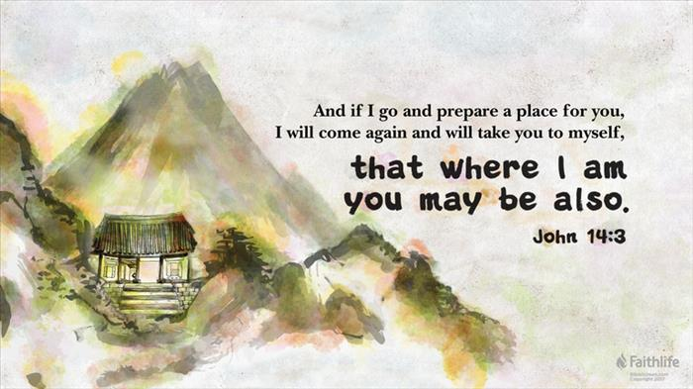

Fifth Sunday of Easter
May 7, 2023

We welcome you to worship here at the Lutheran Church of the Covenant! Here are a few notes to make you feel more at home as we praise this God of new life together!

- Bulletins and Communion (wheat or gluten-free wafers, wine or grape juice options) are available to be picked up at the back of the sanctuary.
- Portions marked with * are when we invite you to stand as you are able to do so.
- We encourage you to participate throughout the worship by speaking the bold print and singing along with the hymns!
- There will not be a separate time for an offering, so a basket is placed in the back for those who wish to support our local ministry as well as the wider church.
- We will commune from our respective seats, where the presiding minister will invite you to open your respective cups with the Communion elements. We believe this meal is for everyone who wishes to partake, regardless of church affiliation or lack thereof. This tangible gift of God’s love is meant for the world to enjoy!

Our Worship Leaders & Staff

Ministers All People
Presiding Minister The Rev. Bradley Ross
Organist Aaron Carter-Enyi
Lector Ted Lockmiller
Parish Administrator Jennifer Lasher-Dobush
Custodian Vince Besednjak

The Lutheran Church of the Covenant
19000 Libby Rd.
Maple Heights, OH 44137
Phone: 216-662-0370, Website:covenantmaplehts.org, Email: covenantlc@sbcglobal.net
Fifth Sunday of Easter
As we continue to celebrate the fifty days of Easter, today’s gospel includes Jesus’ promise that he goes to prepare a place for his followers in his Father’s house. Our baptism commissions us to share Jesus’ mission in the world. As 1 Peter reminds us, we are a holy people, called to proclaim the one who called us out of darkness into light. In words and deeds, we bear witness to the risen Christ—our way, our truth, our life

Prelude

Welcome & Greetings

Alleluia! Christ is Risen!
Christ is Risen, indeed! Alleluia!

*Thanksgiving for Baptism
We praise God for the gift of baptism that forever unites us through God’s love with one another, and sets us free to serve as disciples for the sake of the world.

Blessed be the holy Trinity, ☩ one God,
by whose hand we are given new birth,
by whose speaking we are given new life.
Amen!

Joined to Christ in the waters of baptism,
we are welcomed, restored, and supported
as children of the new creation.
Let us give thanks for the gift of baptism.

Holy God, holy and merciful, holy and mighty,
you are the river of life,
you are the everlasting wellspring.
In mercy and might you have freed us from death
and raised us with Jesus, our resurrection and the life.
In baptismal waters, our old life is washed away,
and in them we are born anew.

Glory to you for oceans and lakes,
for rivers and streams.
Honor to you for waters that wash us clean,
quench our thirst, and nurture both crops and creatures.
Praise to you for the life-giving water of baptism,
the outpouring of the Holy Spirit of the new creation.

Satisfy the world’s need through this living water.
Where drought dries the earth, bring refreshment.
Where despair prevails, grant hope.
Where chaos reigns, bring peace.
We ask this through Jesus Christ,
who with you and the Holy Spirit reigns forever.
Amen!

*Gathering Hymn Christ Is Made the Sure Foundation ELW #645

*Greeting

The grace of our Risen Lord, Jesus Christ, the love of God, and the communion of the Holy Spirit be with you all! And also with you.

Hymn of Praise This is the Feast ELW pg. 101

Prayer of the Day

Gracious God, your Son Jesus Christ is the most loving way, truth, and life. So, continue to empower us to care for one another, to follow in the way of humble service, and to share his risen life with all the world, for he lives and reigns with you and the Holy Spirit, one God, now and forever. Amen!

First Lesson Acts 7:55-60
Stephen was one of the seven men chosen by the apostles to serve tables so that the apostles could be free to serve the word (Acts 6:1-6). Stephen does more than distribute food, however. For his preaching of God’s word, he becomes the first martyr of the faith.

⁵⁵Filled with the Holy Spirit, [Stephen] gazed into heaven and saw the glory of God and Jesus standing at the right hand of God. ⁵⁶“Look,” he said, “I see the heavens opened and the Son of Man standing at the right hand of God!” ⁵⁷But they covered their ears, and with a loud shout all rushed together against him. ⁵⁸Then they dragged him out of the city and began to stone him; and the witnesses laid their coats at the feet of a young man named Saul. ⁵⁹While they were stoning Stephen, he prayed, “Lord Jesus, receive my spirit.” ⁶⁰Then he knelt down and cried out in a loud voice, “Lord, do not hold this sin against them.” When he had said this, he died.

Word of God, word of life! Thanks be to God!

Psalm Psalm 31:1-5, 15-16
The bold verses are sung by the congregation using the tone below:
Antiphon: Into your hands, O Lord, I commend my spirit. (Ps. 31:5)

¹In you, O Lord, have I taken refuge; let me never be | put to shame;
deliver me | in your righteousness.
²Incline your | ear to me;
make haste to de- | liver me.
³Be my strong rock, a castle to keep me safe, for you are my crag | and my stronghold;
for the sake of your name, lead | me and guide me.
⁴Take me out of the net that they have secretly | set for me,
for you are my tow- | er of strength. Antiphon
⁵Into your hands I com- | mend my spirit,
for you have redeemed me, O Lord, | God of truth.
¹⁵My times are | in your hand;
rescue me from the hand of my enemies, and from those who | persecute me.
¹⁶Let your face shine up- | on your servant;
save me in your | steadfast love.” Antiphon

Second Lesson 1 Peter 2:2-10
Christ is the cornerstone of God’s saving work and the foundation of our lives. We are God’s chosen, holy people who continuously celebrate and declare the mercy of God we experience through Jesus Christ.

²Like newborn infants, long for the pure, spiritual milk, so that by it you may grow into salvation—³if indeed you have tasted that the Lord is good.
⁴Come to him, a living stone, though rejected by mortals yet chosen and precious in God’s sight, and ⁵like living stones, let yourselves be built into a spiritual house, to be a holy priesthood, to offer spiritual sacrifices acceptable to God through Jesus Christ. ⁶For it stands in scripture:
“See, I am laying in Zion a stone,
a cornerstone chosen and precious;
and whoever believes in him will not be put to shame.”
⁷To you then who believe, he is precious; but for those who do not believe,
“The stone that the builders rejected
has become the very head of the corner,”
⁸and
“A stone that makes them stumble,
and a rock that makes them fall.”
They stumble because they disobey the word, as they were destined to do.
⁹But you are a chosen race, a royal priesthood, a holy nation, God’s own people, in order that you may proclaim the mighty acts of him who called you out of darkness into his marvelous light.
¹⁰Once you were not a people,
but now you are God’s people;
once you had not received mercy,
but now you have received mercy.

Word of God, word of life! Thanks be to God!

*Gospel Acclamation
*Gospel John 14:1-14
On the night that he is to be arrested, Jesus shares final words with his disciples. As the one through whom God is known, he promises to go before them and act on their behalf.

The Gospel according to John, the 14th chapter. Glory to you, O Lord!

[Jesus said to the disciples:] ¹“Do not let your hearts be troubled. Believe in God, believe also in me. ²In my Father’s house there are many dwelling places. If it were not so, would I have told you that I go to prepare a place for you? ³And if I go and prepare a place for you, I will come again and will take you to myself, so that where I am, there you may be also. ⁴And you know the way to the place where I am going.” ⁵Thomas said to him, “Lord, we do not know where you are going. How can we know the way?” ⁶Jesus said to him, “I am the way, and the truth, and the life. No one comes to the Father except through me. ⁷If you know me, you will know my Father also. From now on you do know him and have seen him.”
⁸Philip said to him, “Lord, show us the Father, and we will be satisfied.” ⁹Jesus said to him, “Have I been with you all this time, Philip, and you still do not know me? Whoever has seen me has seen the Father. How can you say, ‘Show us the Father’? ¹⁰Do you not believe that I am in the Father and the Father is in me? The words that I say to you I do not speak on my own; but the Father who dwells in me does his works. ¹¹Believe me that I am in the Father and the Father is in me; but if you do not, then believe me because of the works themselves. ¹²Very truly, I tell you, the one who believes in me will also do the works that I do and, in fact, will do greater works than these, because I am going to the Father. ¹³I will do whatever you ask in my name, so that the Father may be glorified in the Son. ¹⁴If in my name you ask me for anything, I will do it.”

This is the holy Gospel of our Lord! Praise to you, O Christ!
Sermon

Hymn of the Day Son of God, Eternal Savior ELW #655

*Nicene Creed
We believe in one God,
the Father, the Almighty,
maker of heaven and earth,
of all that is, seen and unseen.
We believe in one Lord, Jesus Christ,
the only Son of God,
eternally begotten of the Father,
God from God, Light from Light,
true God from true God,
begotten, not made,
of one Being with the Father;
through him all things were made.
For us and for our salvation
he came down from heaven,
was incarnate of the Holy Spirit and the virgin Mary
and became truly human.
For our sake he was crucified under Pontius Pilate;
he suffered death and was buried.
On the third day he rose again
in accordance with the scriptures;
he ascended into heaven
and is seated at the right hand of the Father.
He will come again in glory to judge the living and the dead,
and his kingdom will have no end.
We believe in the Holy Spirit, the Lord, the giver of life,
who proceeds from the Father and the Son,
who with the Father and the Son is worshiped and glorified,
who has spoken through the prophets.
We believe in one holy catholic and apostolic church.
We acknowledge one baptism for the forgiveness of sins.
We look for the resurrection of the dead,
and the life of the world to come. Amen.
* Prayers of Intercession
United in the hope and joy of the resurrection, let us pray for the church, the world, and all in need.

A brief silence.

God of life, strengthen your whole church to proclaim your gospel even in times of trouble. As we remember Stephen, we give thanks for diaconal ministry. Bless all deacons and strengthen them for their bridge-building ministry between the church and the world. Hear us, O God. Your mercy is great.

Creating God, you show your steadfast love through mighty waters, towering mountains, verdant fields, and arid deserts. Protect the earth’s diverse habitats from the forces of pollution, erosion, extinction, and global warming. Hear us, O God. Your mercy is great.

Holy Spirit, you guide us into all truth. Give wisdom to world and local leaders and organizations as they begin, build, or renew relationships. Strengthen aid organizations in areas needing to be rebuilt following conflict, unrest, or natural disaster. Hear us, O God. Your mercy is great.

Loving God, you make your home among us. Abide with refugees, those experiencing homelessness, those fleeing war and poverty, and all who question if there is a home in your heart. Continue to tend all who are sick. Hear us, O God. Your mercy is great.

Assuring God, you accompany your people amid uncertainty and change. Uphold people in this community who have recently moved, changed jobs or schools, retired, or are going through transitions of any kind. As your Covenant family, lead us in all your ways of compassion. Hear us, O God. Your mercy is great.

Renewing God, you gather the saints at your heavenly banquet. We give you thanks for the care shown us by those who have gone before us. Grant confidence and comfort for all awaiting the place you have prepared. Hear us, O God. Your mercy is great.

Rejoicing in the victory of Christ’s resurrection, we lift our prayers and praise to you, almighty and eternal God; through Jesus Christ, our risen Lord. Amen!
*Sharing of the Peace

The peace of the risen Christ be with you always! And also with you.

Music Interlude
*Great Thanksgiving

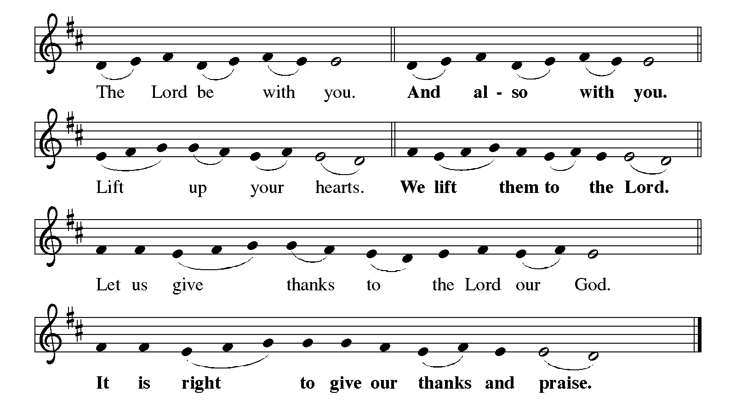

It is indeed our delight
that we give thanks and praise to you, loving and gracious God,
for the glorious resurrection of our Savior Jesus Christ,
who in dying has destroyed death,
and in rising has brought us to eternal life.
And so, with Mary Magdalene and Peter and all the witnesses of the resurrection,
with earth and sea and all their creatures,
and with angels and archangels, cherubim and seraphim,
we praise your name and join their unending hymn:

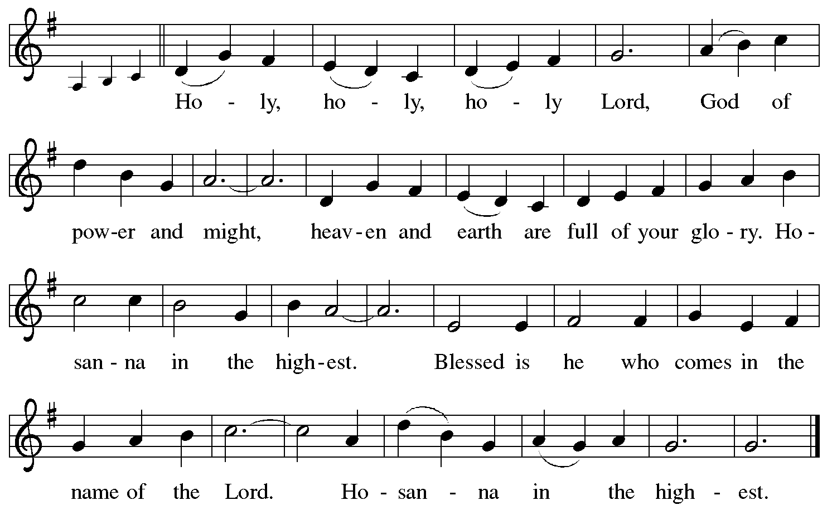

*Thanksgiving at the Table

Holy, living, and loving God,
we praise you for creating the heavens and the earth.
We bless you for bringing Noah and his family through the waters of the flood,
for freeing your people Israel from the bonds of slavery,
and for sending your Son to be our Redeemer.

We give you thanks for Jesus, who, living among us,
healed the sick, fed the hungry,
and with a love stronger than death,
gave his life for others.

In the night in which he was betrayed,
our Lord Jesus took bread, and gave thanks;
broke it, and gave it to his disciples, saying:
Take and eat; this is my body, given for you.
Do this for the remembrance of me.

Again, after supper, he took the cup, gave thanks,
and gave it for all to drink, saying:
This cup is the new covenant in my blood,
shed for you and for all people for the forgiveness of sin.
Do this for the remembrance of me.

Remembering, therefore,
his life-giving death and glorious resurrection,
we await your promised life for all this world you still adore.

Holy Spirit, breathe on us and on this bread and cup:
carry us in your arms from death to life,
that we may live as your disciples,
clothed in the everlasting grace of Christ.

Through him all glory and honor is yours,
Almighty Father, with the Holy Spirit,
both now and forever. Amen!

Our Father in heaven,
hallowed be your name,
your kingdom come,
your will be done,
on earth as in heaven.
Give us today our daily bread.
Forgive us our sins
as we forgive those who sin against us.
Save us from the time of trial
and deliver us from evil.
For the kingdom, the power,
and the glory are yours, now and forever.
Amen.

*Invitation to Communion

Taste and see the joy of new life for us all!
Thanks be to God!

Communion

Music Interlude

Prayer after Communion

Gracious God,
in you we live and move and have our being.
With your word and this meal of grace,
you have nourished our life together.
Strengthen us to show your love
and serve the world in Jesus’ name.
Amen!

*Blessing

The God of all,
who raised ☩ Jesus from the dead,
bless you by the power of the Holy Spirit
to live in the new creation.
Amen!

*Sending Hymn The Church’s One Foundation ELW #654

*Dismissal

Alleluia! Christ is Risen!
Christ is Risen, indeed! Alleluia!
Go in peace. Serve the Risen Christ!
Thanks be to God!

Postlude

Praying Together
... for those who are homebound, ill, hospitalized or recuperating: Gayle Agg, Sheena Cameron, Joan Clarke, Christina Copeland, Barbara Fossa, Carolyn Frajter, Ken Frajter, Donna Franz, Barb Gaglione, Michelle Garnett, Rosa Garnett, Jane Gradert, Dylan King, Elaine Knerem, Jason Lanese, Sara Mendes, Phyllis Nemeth, Arlene Stoltz, Marie Storms, Tom Susanek, Phyllis Welker, Maud Wright, Wilma Dancy, Bill Helmick, Nancy Helmick, Robert Lambrecht, Kim (Novak) Leonhardt, Laura Mele, Shannon Meskill, Judy Morgan, Kris Sandor, Bill Wilkens, Eugene Winfrey, the Copeland/Lane Family, Karla & Drew Perry at the death of Drew’s father Doyle Perry.

LAST WEEK
General Fund receipts for week ending 4/30/2023: $1877.75
We hope you can join us on Sunday, May 21, immediately following the worship, as we hear the latest updates about our ministry at Covenant!

Lectionary Blog: Becoming God’s Family
We all have different metaphors for God. For me, God’s kingship has always been important. Others encounter God as parent or even lover. For some, God as Creator or faithful friend make the most sense. All of these are good and right ways to interact with God, and all have abundant scriptural support. We don’t need to limit how other people interact with God or how we do so. The mothering guidance of the Spirit has begun to mean much more to me in the last year than ever before, and so maybe my primary metaphor for interaction with God is changing. As I read this week’s lectionary accounts, we have a couple examples of changing metaphors for God and God’s relationship with others.
In the martyrdom of Stephen, we have a rich description of God and Jesus’ relation to God. We must not forget that Stephen came to his position in the church as someone primarily interested in what we would today call social justice. The church was unfairly distributing resources based on ethnicity. Instead of presuming innocence and minimizing the problem, the apostles investigated, found that the accusations were true, and then appointed some from the affected group to be in charge of making sure that people were taken care of equitably (Acts 6:1-6).
Out of this consciousness that the Holy Community doesn’t always practice justice, and thereby fails to be a Beloved Community, Stephen witnessed to repeated patterns of faithlessness and abuse within Israelite history. The abuse culminated in some members of the Sanhedrin supporting Jesus’ arrest and murder by the Romans.
The truth hurts, sometimes. Some members of the Sanhedrin couldn’t abide being compared to the unfaithful in previous generations and moved to silence Stephen. They shouted him down, then violently attacked him and, finally, lynched him. Yet as the mob rushed Stephen away from his trial without verdict or formal sentence, he looked intently into heaven and saw the glory of God, with Jesus standing at God’s right hand. This is Stephen’s witness: the God who was faithfully present throughout Israelite history reveals God’s glory to humans, principally through Jesus, who lived, died, was resurrected and ascended to the right hand of God.
The Gospel of John picks up this important connection between seeing God’s glory and Jesus’ position at the right hand of God. In John’s prologue, the Gospel writer witnesses to having seen God’s glory made manifest in the only child of God the Father (1:14). In this week’s lectionary reading, Jesus makes God’s glory manifest by ensuring that he doesn’t remain an “only child.” We need to pay close attention to the language used to understand what Jesus is saying to his disciples.
Jesus tells his disciples that in his Father’s house there are many dwelling places (14:2). We need to unpack two common translation issues. First, the error of the King James Version that translates μοναὶ as “mansions” needs to be undone. Besides the logical problem of having separate mansions within a house, to think of what Jesus is talking about as detached houses in a heavenly realm misses the point. Jesus is saying that there is plenty of room to abide or dwell within God’s house. He goes ahead to ensure that this is the case and makes ready God’s household to welcome those who follow his way.
Second, and more importantly, we must not mistake “Father’s house” with a heavenly castle of some sort. The house of the Father, בית אב (beit av), could mean parents’ home. But the primary meaning is a household or a family. The “house of David” is much more about David’s family than it is about a particular physical dwelling place. So, when Jesus says that he goes to prepare a place in the “house of his Father,” we shouldn’t think of heavenly dwellings (remember, we are ultimately looking forward to resurrection in the New Earth, not disembodied ethereal heavens). Instead, Jesus prepares room for us to abide as God’s children in the divine household.
Jesus tells Thomas that Jesus is the way, the truth and the life that leads to the Father, not to some mansion in the sky. He calls his disciples to see the identifying relationship between God the Father and Jesus, his son, so that they, too, might be adopted into God’s family. Again, John foregrounds this in the prologue by saying that Jesus gives the right to become children of God to all those who receive and believe in him (1:12).
What Stephen witnesses in Jesus standing at the right hand of God is exactly what Jesus told his disciples that he would do: prepare places for them (and us) in the house of the Father. Jesus’ death and resurrection offers not just life after death but a place in God’s family.
Cory Driver is the assistant to the bishop for emerging ministers and ministries for the Indiana-Kentucky Synod. His book on wilderness spirituality, Life Unsettled, is available from Fortress Press.

