*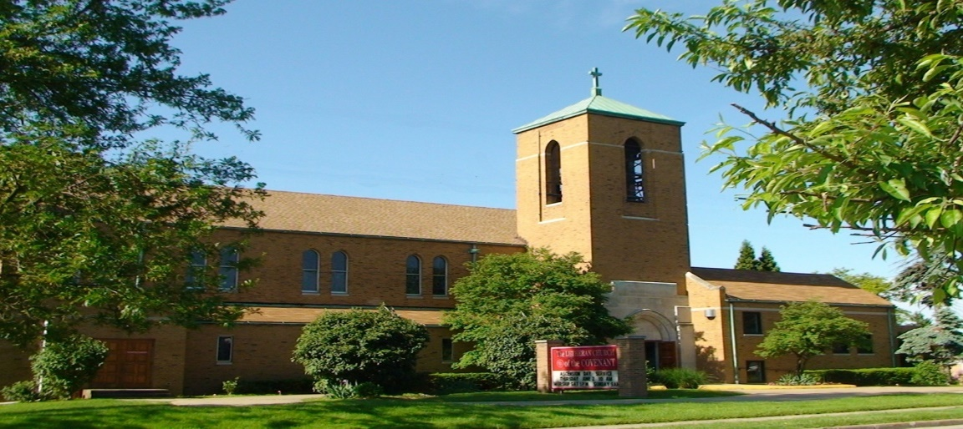Covenant News*

**May 2023**

Pastor’s Spin

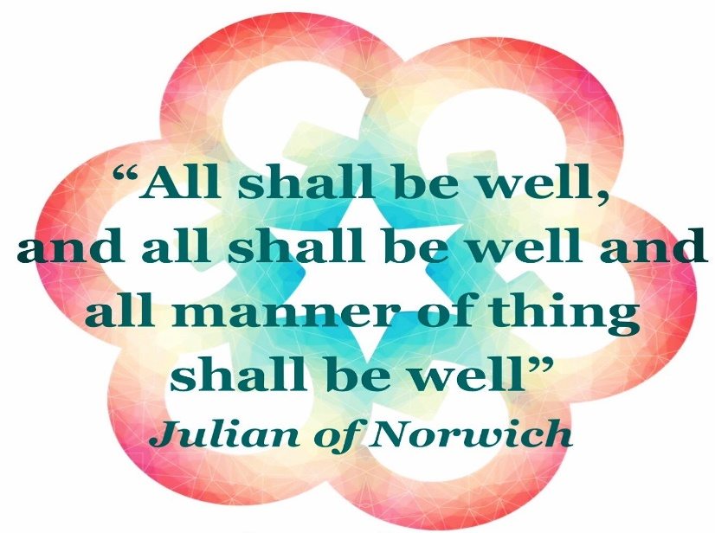 Siblings in Christ of Covenant,

Greetings! On May 8, the wider church celebrates Julian of Norwich, who lived over half a millennia ago. From our worship resource, *Sundays & Seasons*: “When she was about thirty years old, Julian (or Juliana) reported visions that she later compiled into a book, Sixteen Revelations of Divine Love, now a classic of medieval mysticism. The visions declared that love was the meaning of religious experience, provided by Christ who is love, for the purpose of love.”

Oftentimes we in the church celebrate such individuals on their respective day by uploading images of famous quotes from them. One that is frequently chosen for Julian of Norwich is, “all shall be well, and all shall be well, and all manner of thing shall be well.” Of course, it would always be better to provide a little context of such quotes that can be easily copied and pasted, but most people prefer not to spend quite as much time when going through their social media feed or scrolling through whatever else on their computer or cell phone. Regardless, Julian of Norwich becomes a significant figure in the Roman Catholic church after her near-death experience in which she writes down her encounters with the Risen Lord.

The famous words emerge from one such interaction with Christ: that, as he points the reality of sin, “but all shall be well, and all shall be well, and all manner of thing shall be well. These words were said most tenderly, showing no manner of blame to me nor to any who shall be saved.” Julian of Norwich was facing rather difficult circumstances in her life, including with her own suffering, so this was certainly an incredible source of comfort, to say the least. The words can still have soothing power for any child of God.

Now, as much as the church would prefer more time to give context to such inspirational words from saints and even with Scripture, we also need an additional space for the “yes…but…” Because, we all know first-hand not all in life turns out well. Some rather awful things happen. Some things that tear us apart. Granted, we as people of God cling to the hope, the Gospel, that at some point in the future, Christ will return to put all things well. At some holy time, the entire Creation will be restored to the true wholeness that only God can pull off. But, in the meantime, not all parts of our life will be well. Some of those instances may gradually turn out well, in due time, but sometimes, with physical health, relationships, jobs, etc., it just doesn’t happen.

So, as much as we as the church proclaim the hope of the ultimate wholeness at some point in the future, and we proudly lift up the holy moments of such wholeness in the world today, not to mention the “it is well with my soul” instances when we marvel at Jesus’ transformational work on the cross and out of the empty tomb; we will also be the place and the people to be there when it just isn’t happening…for whatever the reason may be. We will do our part to provide some sense of “all shall be well” with the Lord who still insists on pulling off miracles, sometimes in the simplest form of sitting beside another who weeps, for starters. We will not leave our Gospel to cliché quotes that “everything is going to be okay” or “everything happens for a reason,” for we are called to minister in the reality of human brokenness. But we are also called to proclaim the love and grace and compassion that can still come to life when not all is well. It may very well take longer than a simple copy and paste, but it is a holy “longer” that we are empowered by the Holy Spirit to join with our siblings in Christ, no matter the circumstances. We are in this journey of an eternal lifetime together through the boundless grace of Jesus Christ, our Risen Lord. Thanks be to God, indeed!

In Christ,

Pastor Brad

 In working with other surrounding congregations, we continue to offer a FREE meal for anyone and everyone in the community and beyond on the 4th Thursday of every month. If you are interested in helping, please contact Mary Kaye Bernardo. Otherwise, come on by for a FREE dinner Thurday, May 25 (5:00-6pm), or help spread the word to others!



5/2 Christopher Dickey

5/3 Phyllis Welker

5/14 Lynn Fridley

519 Steven Kobella

5/19 Arlene Lasher

5/21 Joan Garvin

5/25 Ron Schirmer

5/30 Jayden Kyle

5/31 Barbara Gerstenberger

5/31 Matthew Kobella



We will soon complete updating our Covenant congregation directory, not only with revised phone numbers, email and physical/mailing addresses, but we would also like to include pictures with this one as well. However, we’re going to try something new this time around. Instead of having you come to Covenant for an appointment with a photographer, we’re inviting you to send in your own picture of yourself, you and your loved one, or your family. This does not have to be professionally done. Feel free to make it your own. Make it fun and creative, if you like. Take it outside in nature. Include your pets, if you want. It can be in-the-moment laughter. We would like this to be an enjoyable Covenant family project for the summer. Then, you can send the picture in via email, mail, or dropping it off at the church. If you need help taking a picture, please contact Jen at the church office, and we will be happy to make arrangements to do so.

5/4 Michelle & Doug Pekar 5/22 Jennifer & Larry Garberich

Happy 49th Anniversary! Happy 24th Anniversary!

5/7 Charlotte & Robert Zaranka 5/22 Nanette & Ron Schirmer

Happy 57th Anniversary! Happy 42nd Anniversary!

5/11 Karen & Raymond Zack 5/25 Daralynn & Bruce Constant

Happy 55th Anniversary! Happy 44th Anniversary!



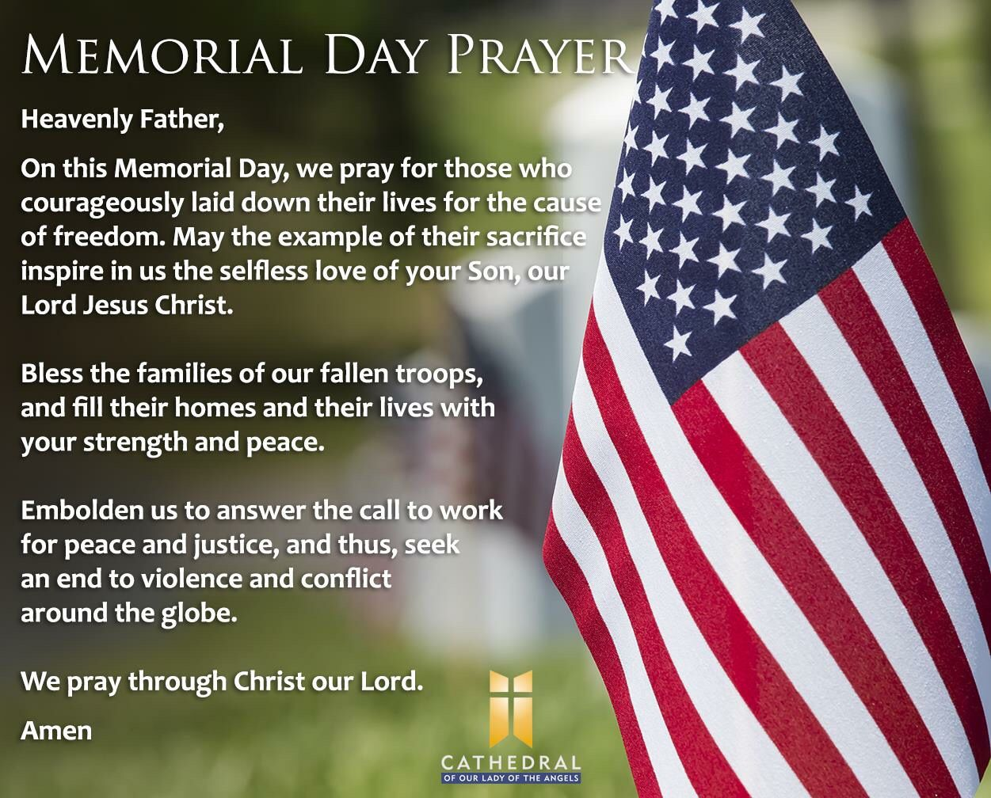



**C LW Annual Plant Sale**

Orders must be placed by Monday, May 8, at the church office or Arlene Lasher (12411 Oak Park Blvd. Garfield Heights, OH 44125).

Pick-up scheduled for Saturday, May 27, 9am -1pm.

*Note the different date for pick-up: the Saturday of Memorial Day weekend.*

Drive-thru pick-up, same as last year, at the ramp door. Please call when you are on the way to pick-up and Arlene will have your order outside to be put into your vehicle.

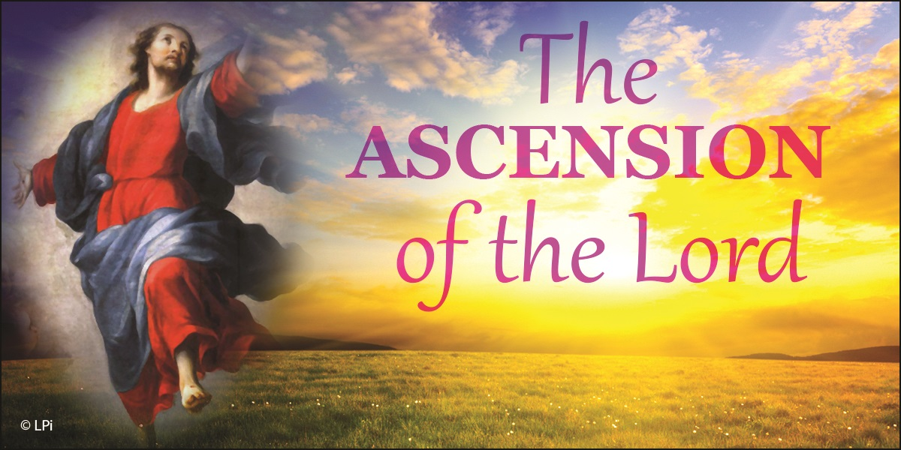We will celebrate the Ascension of Our Lord on Saturday, May 20 (5pm) and Sunday, May 21 (9am), remembering that even though Christ ascended into heaven, that the Risen Lord still remains with us.

We hope you can join us on Sunday, May 21, immediately following the worship, as we hear the latest updates about our ministry at Covenant!

We are tentatively planning to start worshiping Sundays outside from our back parking lot on June 11. Feel free to bring your own chair or stay in your vehicle, as we praise God amidst the wonderful Creation!

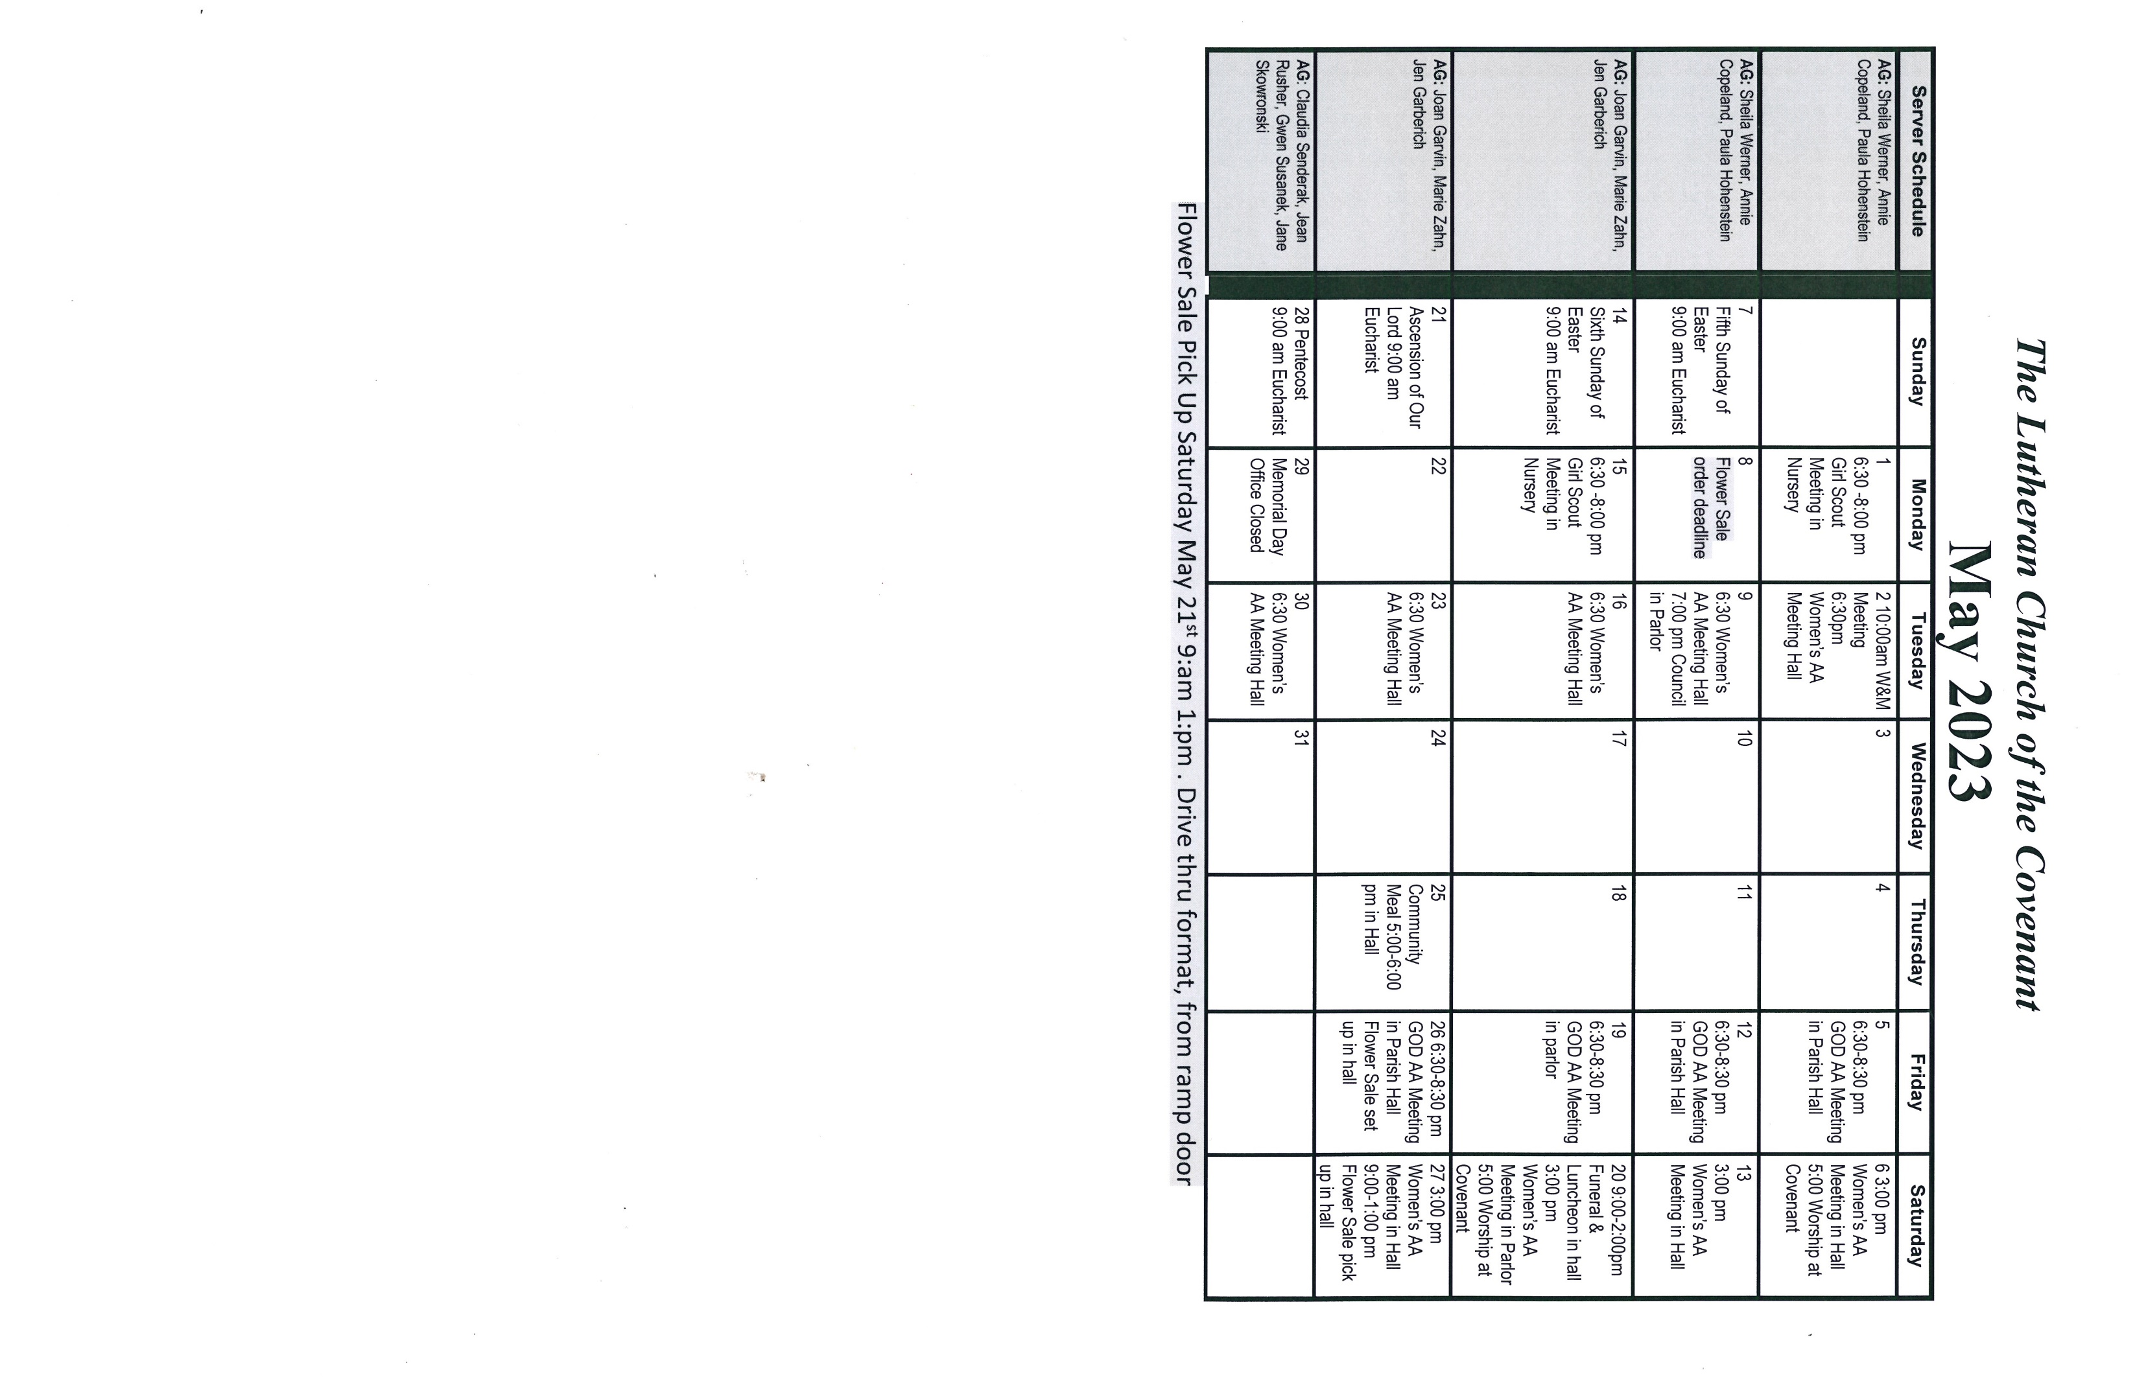

Covenant News

The Lutheran Church of the Covenant

19000 Libby Road, Maple Heights, Ohio 44137

