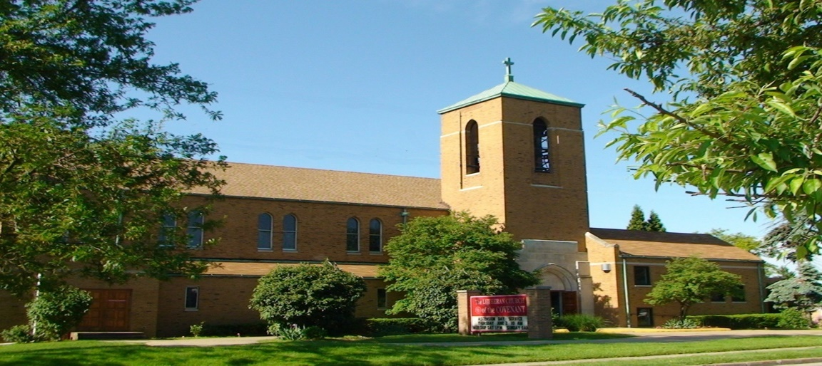
Covenant News

April 2024

Happy Spring!!

Right now we are Easter people, living in a Good Friday world. It’s just truth that this world has more than enough pain, trouble, and evil!!

Jesus spent time in this world. In scripture, the post-resurrection appearances are the Risen Christ with the first Easter People, where Jesus begins to teach everyone how to be Easter People in a world where Good Friday persists. In Luke 24, Jesus shows up, invites the disciples to poke and prod him, has something to eat, and then “opens their minds to understand the scriptures” (24:45).

Jesus expanded their understanding. The greek word here is syniemi. This is not the kind of understanding that is just intellectual— like data received, knowledge acquired. It is the kind of understanding you have when everything falls into place, everything clicks, and everything makes sense. It is also the kind of understanding that causes change, that leads to transformation. This word understand here in scripture doesn’t mean just to know something— it means that through understanding the Word of God we also seek to remove sin and hard-heartedness from ourselves and our midst because we understand what the scripture says about it— what our bible says about Jesus. Easter people in the Good Friday world are open-minded people. We are open to to listening to and learning from Jesus. We are open to looking at the world, at the kingdom in new ways. We are open to having our minds and hearts changed, we are open to learning and to thinking and to being transformed. And we don’t want disobedience or unfaithfulness to the Word of God to cloud the understanding and insight that Jesus gives us.

Jesus also says that “repentance and forgiveness of sins is to be proclaimed in his name to all nations” (24:47). But we cannot proclaim this with any authority or authenticity if we aren’t first committed to doing it ourselves. Repentance in Greek (metanoia) is compound word that means “after understanding.” Repentance is therefore a product of open-mindedness. When we understand God’s word we then examine ourselves and the world so we can deal with both our personal and systemic collective sin.

Easter people are repentant. As theologian and author Leopoldo Sanchez wrote in the book Sculptor Spirit:

“Repentance means a radical turning from sin to a new way of life oriented toward the will of God on earth. Repentance is not a one time thing either— it is a commitment to a way of being in the world. Martin Luther wrote that we are called daily— everyday— to repentance that is not focused on ourselves but focused on our neighbor and our world. In the open-mindedness of daily repentance we commit to seeing the world not through our eyes; but through God’s eyes, what Luther calls the eyes of faith. These are the eyes that see Christ as truly present in others and lead us to acts of loving Christ in strangers.”

Again this is not an intellectual exercise or a reasoned choice but a transformative experience for us, one with actual real world manifestations where we engage in making the world a better place, see Jesus in everyone, and try to bring the kingdom a little closer. This we can do— even in a Good Friday World.

Pastor Andrea

Our next FREE community meal will be Thursday, April 25, from 5:00-6pm. So, if you need a night off from cooking dinner or you know of someone else who needs it, help us spread the word. It is FREE for anyone and everyone!

We encourage you to mark your calendars for our next semi-annual congregational meeting following the worship on Sunday, May 21. We hope you can join us as we hear the latest updates of our collective ministry as the Lutheran Church of the Covenant for the sake of the world

Thank you Covenant
A big “thank you” to everyone who helped in any way at the recent Lenten Soup Suppers. Whether you cooked the soups and served them, set the tables, prepared the beverage table, readied the bread and cookie plates, helped to clear the tables afte the meal and return things ot the kitchen, washed tableware or scrubed pots, all of your help was greatly appreicated. We successfully produced 5 wonderful home-made soups and with the assistance of our friends from Church of the Master enjoyed 5 weeks of simple, but good, meals, informative lessons and meaningful worshipand fellowship. Good Job Covenant!
Thanks again, Arlene Lasher

Pastor Andrea McDonough contact info

Email: revandreamcdonough@gmail.com
Phone: 216-618-8232

4/2 James Gradert
4/5 Bruce Constant
4/7 Gary Edler
4/10 Jackie Blogna
4/10 Ted Lockmiller
4/22 Annie Copeland
4/25 Jacqui Knerem
4/27 Charlotte Zaranka

4/9 Deb & Chuck Dickey 4/15 Toni & Robert Ridgell
Happy 35th Anniversary! Happy 27^{8h} Anniversary!
4/15 Sheila & Harry Werner
Happy 45th Anniversary!

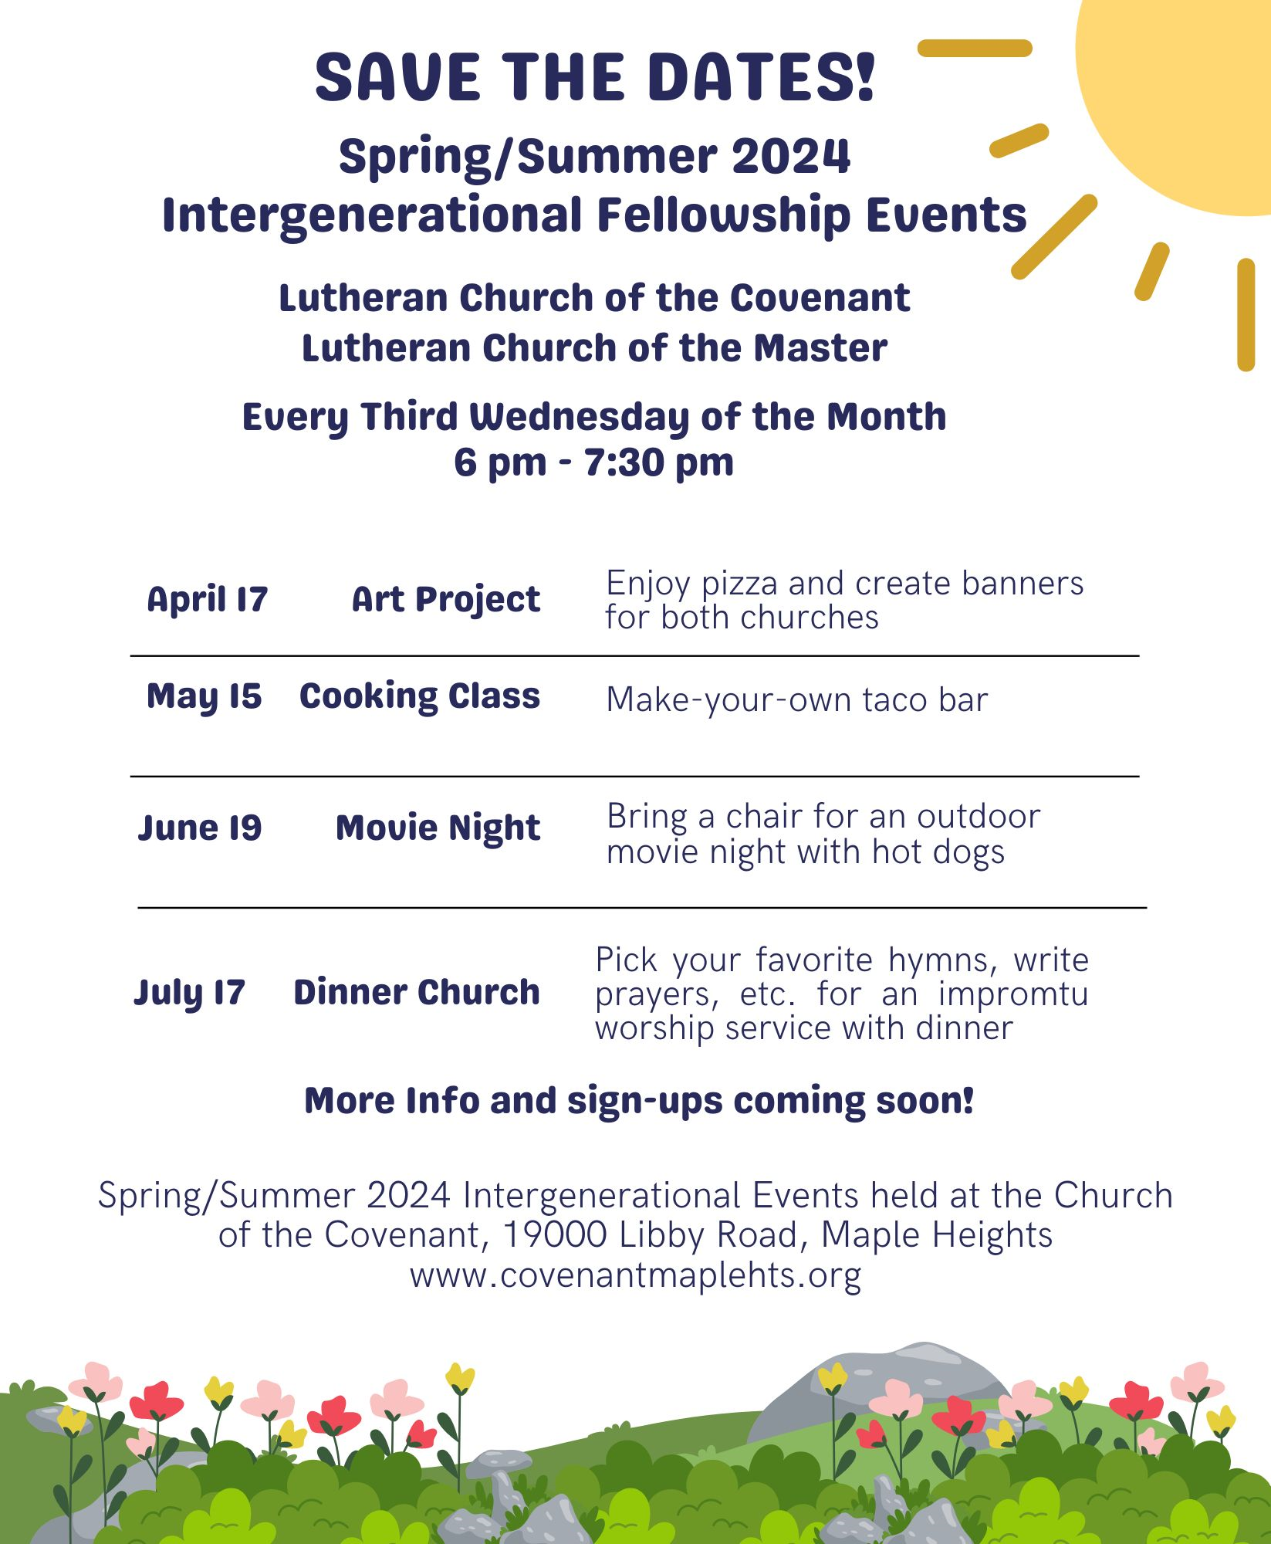
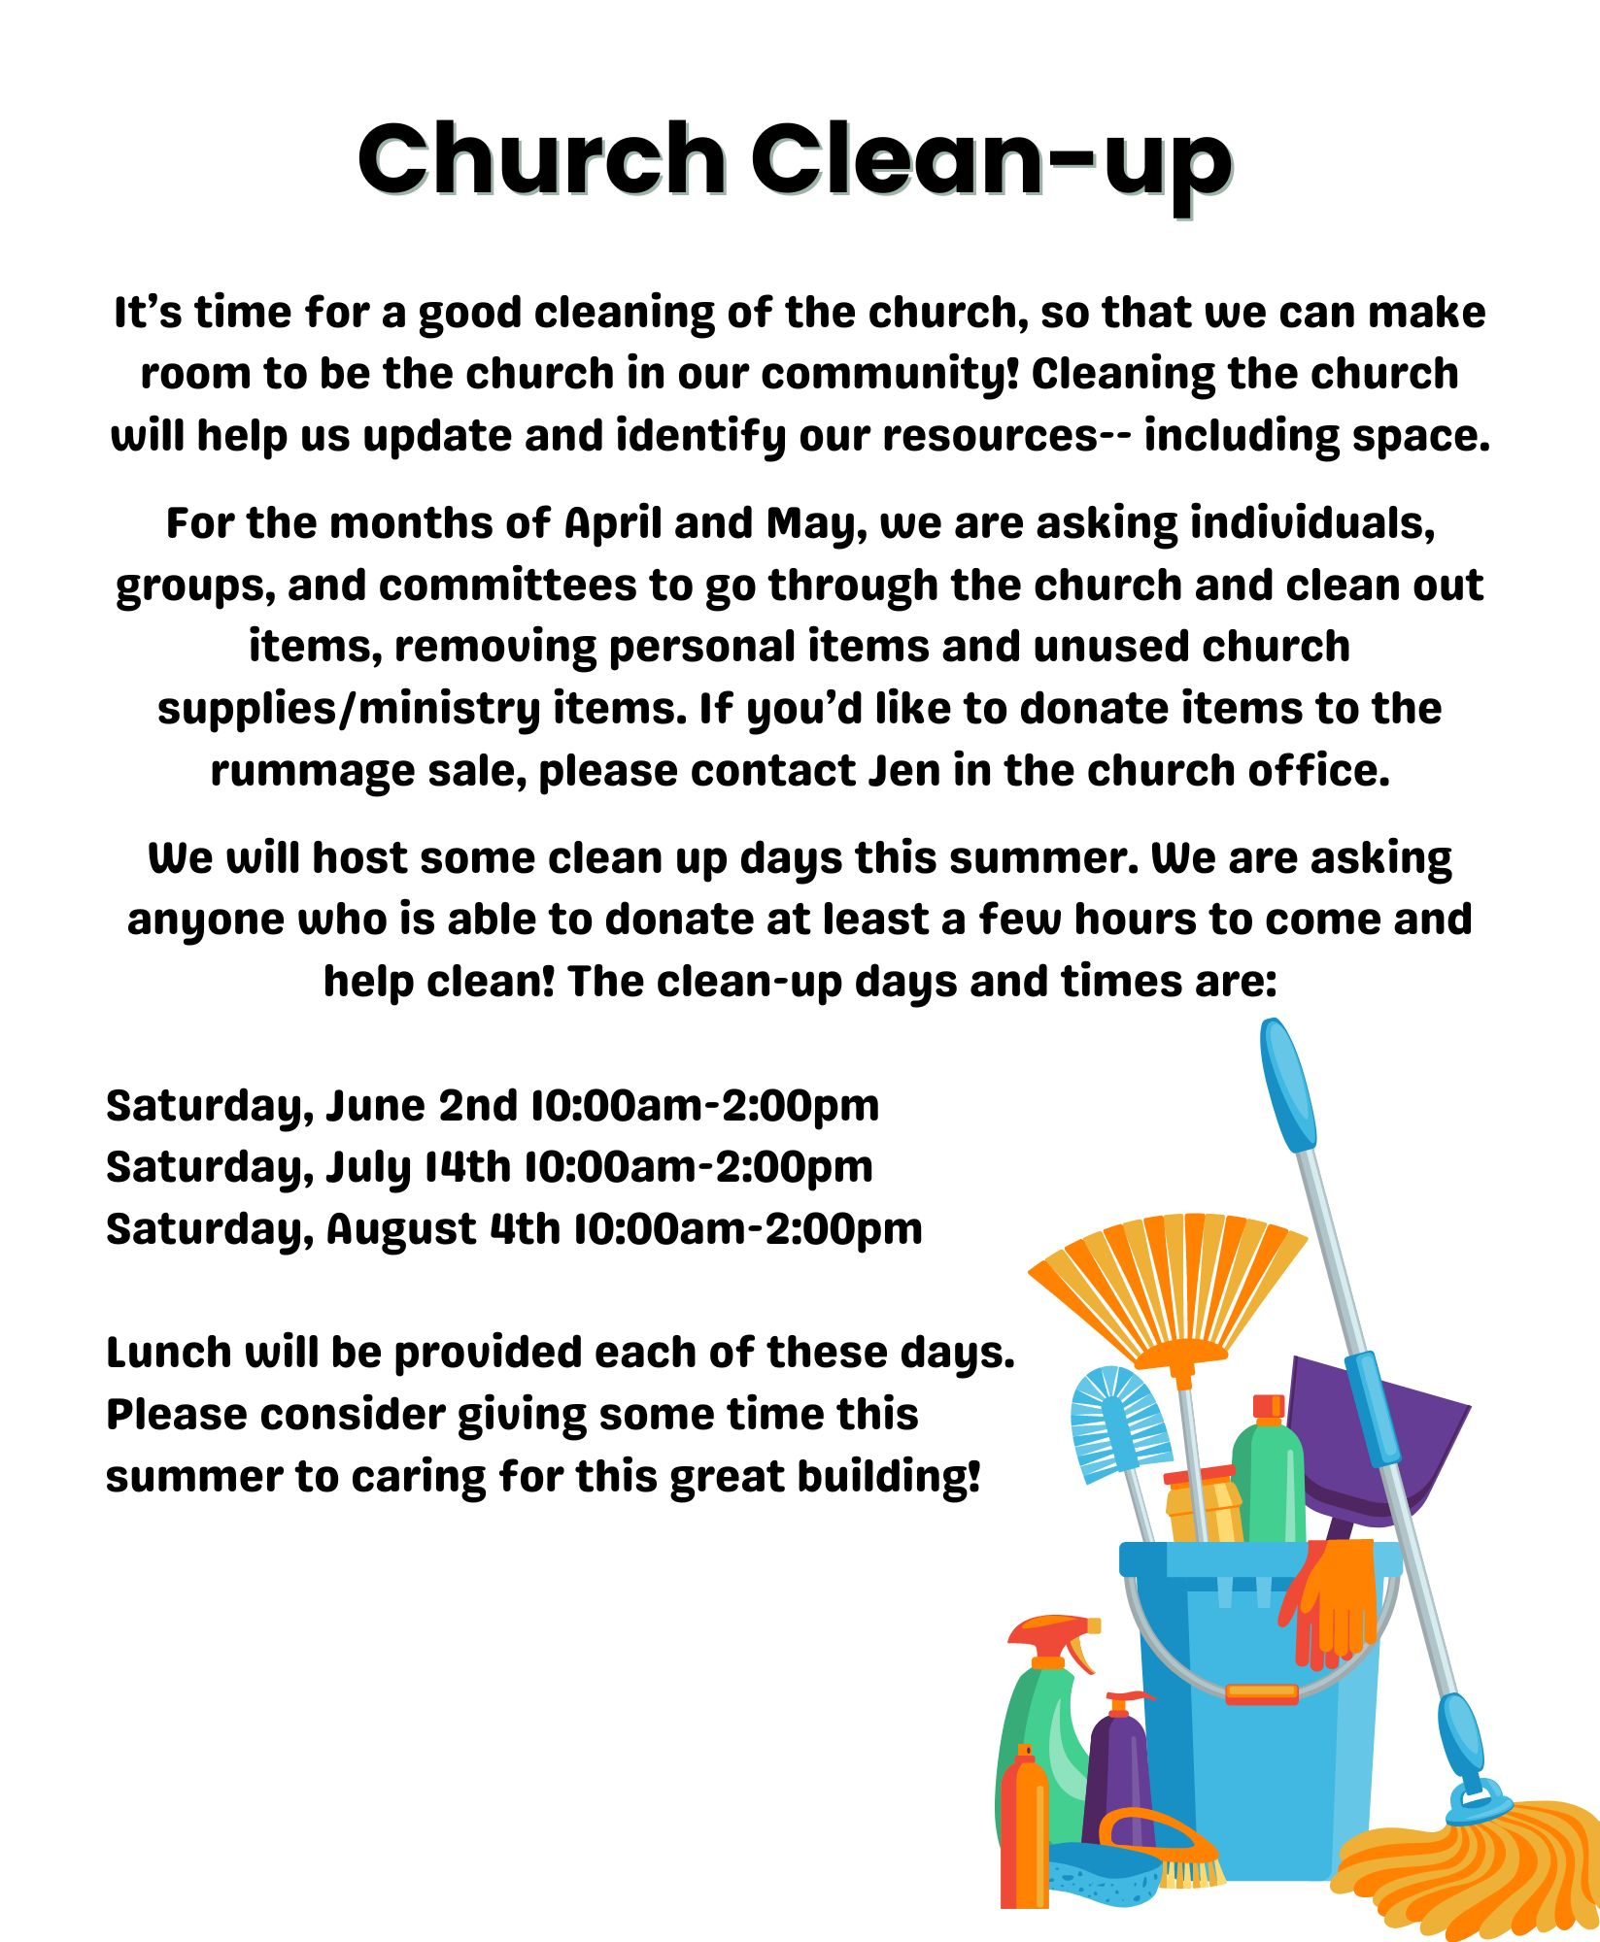
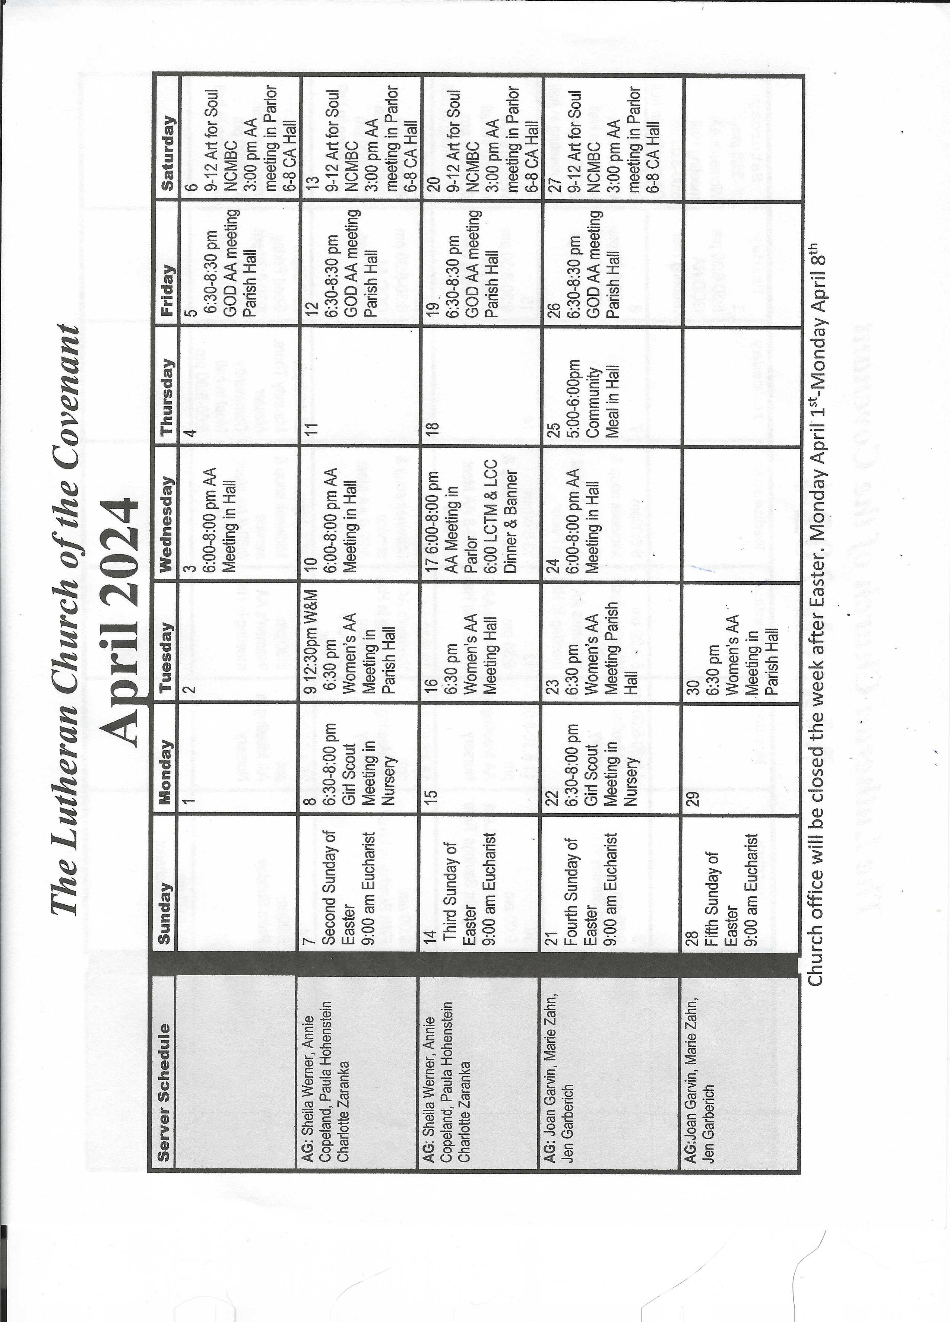
Covenant News
The Lutheran Church of the Covenant
19000 Libby Road, Maple Heights, Ohio 44137

Covenant Lutheran Women Annual Plant Sale

Order forms are coming. As soon as Arlene Lasher has the dates for order deadline confirmed for April, it will be announced in bulletin and on the website.

