*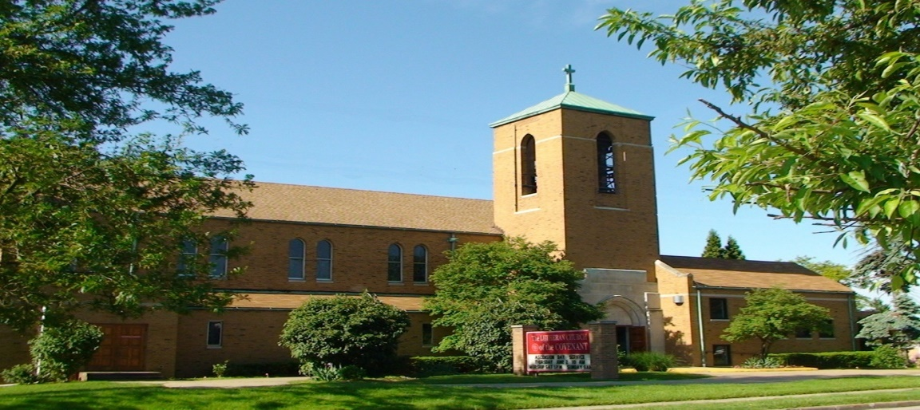Covenant News*

**April 2025**

Hope Against Hope

In Romans 4, Paul describes Abraham as someone who “hoped against hope.” It’s a strange phrase, almost contradictory. Yet it speaks to a kind of hope that rises not from circumstances, but from trust in something deeper. Before religion, before Jesus, and before Easter, Abraham believed in a God who brings life from the dead and calls into being things that do not yet exist.  
  
The ancient world was no stranger to hopelessness. People lived under the weight of empire and power. They endured poverty, injustice, violence, and silence. Many were enslaved. Many cried out and waited in the dark. And still—they believed. They resisted despair. They passed on stories of deliverance. They lit lamps in dark places and carried one another.  
  
Our times carry their own heaviness. Injustices stretch on. Trust wears thin. Yet in the midst of it all, hope remains not as a shallow optimism, but as a quiet, defiant flame. Biblical hope is not passive. It is not a denial of pain. It is the insistence that God is still at work, even when the evidence is scarce. God’s work came to an ultimate resistance when God raised Jesus from the dead for the benefit of ALL people.  
  
Hope is resistance. Hope is faith in motion. Hope chooses to live and love as if redemption is still possible—because it is. It is rooted in memory and promise, in the God who does not abandon the story.  
  
So we keep going. We tend to what we’ve been given. We hold on, not because it’s easy, but because grace has already gone ahead of us. Like Abraham, we are people shaped by promises we cannot always see, trusting in a God who is never finished.  
  
Even here, even now, we hope against hope.

Our next FREE community meal will be Thursday, April 24, from 5:00-6pm. So, if you need a night off from cooking dinner or you know of someone else who needs it, help us spread the word. It is FREE for anyone and everyone!

Covenant Lutheran Women Annual Plant Sale

Order forms are coming. As soon as Arlene Lasher has the dates for order deadline confirmed for April, it will be announced in bulletin and on the website.



4/2 James Gradert

4/5 Bruce Constant

4/7 Gary Edler

4/10 Jackie Blogna

4/10 Ted Lockmiller

4/22 Annie Copeland

4/25 Jacqui Knerem

4/27 Charlotte Zaranka



4/9 Deb & Chuck Dickey 4/15 Toni & Robert Ridgell

Happy 36th Anniversary! Happy 28th Anniversary!

4/15 Sheila & Harry Werner

Happy 46th Anniversary!

Lutheran Church of the Covenant

Congregational Council Meeting Minutes 2/18/25

Meeting called to order at 7:13pm by President Ted Lockmiller

**Present:** Mary Kaye Bernardo, Vince Besednjak, Mike Davis, Pastor Andrea, Gwen Susanek, Ted Lockmiller, Charlotte Zaranka

**Excused:**  Chuck Dickey, Jennifer Lasher-Dobush

**Devotion and prayer**: Charlotte

**Council business:**

Minutes approved/amended of meeting 12/17/24. Motion made by Gwen. Seconded by Mary Kaye

Our meeting started out this time with Brian Kljun, financial advisor with Edward Jones Investing. He brought a handout of our portfolio analysis.  Global growth is up 3%. The Federal Reserve Bank is concerned with inflation. 4% unemployment. Spending has been strong. Real Estate is slow right now. Service and manufacturing industries are strong. Not enough plumbers, electrical trades, etc.  Be patient with the tariffs for now. Take a wait and see approach. We are in deficit spending right now. We now have a budget to work with. Age 70.5 or over for QCD contributions to the church. Address your yearly withdrawal toward the church.   Can be transferred directly from your investment acct to the church very easily.

**Pastors Report:** No handout. Joint council meeting is Mon 2/25/25 at Master, 7:00pm.

**Treasurers Report**: Mike – No handout

Quarterly payroll taxes were paid. We got another tax notice from the County Treasurers office with monthly deposit form. Thought it was a one-time deal. Mike will go down to City Treasurers office to ask questions. Other half of the assessment due will be paid later this month.

**BOARDS:**

**Finance:** Gwen-no handout but had a lot to say!

Gwen met with Judy at Master to talk about ordering envelopes together for 2026. Covenant #’s will be 1-40. Master #’s will be 41-65. Keep Capital Improvement envelopes. Steve Senderak says Advent and Lent envelopes don't get used much.  Drop 1 of 2 at Easter – Holy Saturday and Ascension not used. Change Christmas Day envelope to Christmas Eve. Date and # at top of each envelope. A list for where you want money to go below.   1 time copy charge of $20 to change envelopes and $10 for # changes.  There is a form to fill out but will call for balance first before ordering. Must finalize by Sept 2025.

**Social Ministry** – Mary Kaye: Hand out.

Jan 20 free meal – 20 sat to eat and 80 takeouts. Maybe a movie in the future to keep people to stay longer and socialize. May meet with Maple Hts Superintendent to see what can be done with the youth of the city. Maybe handouts. We have dropped the word Evangelism in the title.

**Education** – Check Dickey, not present - adult Sunday school class will pick a subject for Lent to discuss. Put a line in the bulletin about coffee and bakery 10-10:30 before class. No class during summer months, June to Sept.

**Worship and Music** – Jen – not present but written report.

**MUTAL MINISTRY**

**Managers:** Vince – No handout - Need work orders for jobs that need to be done. Also need a work order box.

**Old Business: T**ed mentioned our old church insurance has ended as of 2/17/25.

**New business:** Ted – handout – New insurance company is Acrisure. There are 3 options but will take option 3 for now. Lowest premium but will maintain the same liability coverage as before.   Can change later, if needed.

Charlotte handed out info on the St Pauly Textile shed program in hope to generate some income for the church. Very minimal effort on our part.  Other than myself, Mary Kaye, Gwen and Barb have offered to help. Once we find out the shed pickup day, I can set up a calendar and each lady will only have to check the shed once or twice a week for 1 week each month. Everyone will have a key to check the shed at their leisure. The idea was passed unanimously. Ted is working on the paperwork.

Next council meeting: 3/18/25. Devotions: Mike

Adjourned:  9:39pm with the Lord’s Prayer.

Respectfully submitted,

Charlotte Zaranka

Council Secretary

Comments:

Covenant News

The Lutheran Church of the Covenant

19000 Libby Road, Maple Heights, Ohio 44137

