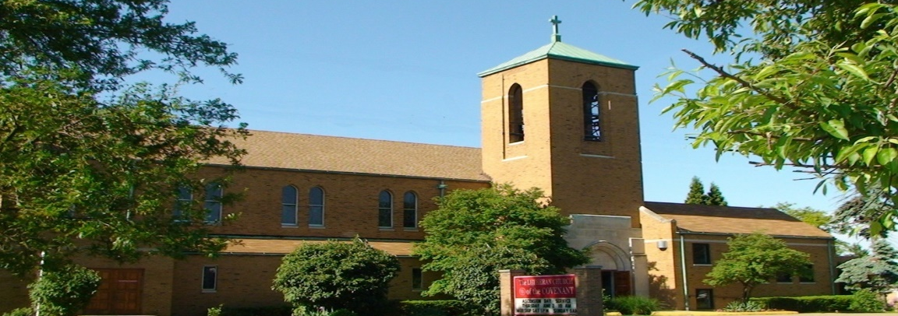
Covenant News

January 2026


What are God Dreams? God Dreams are the quiet hopes God breathes into human hearts—opportunties revealed and possibilities whispered. They are not predictions or plans set in stone; rather they are invitations for us to use our unique selves to join in what God is already dreaming of. As we step into 2026, the question before us is not What will we do this year? but What might God be dreaming among us?

Perhaps God dreams of deeper trust—people bringing their whole selves into worship, prayer, and community. Perhaps God dreams of courage: courage to love neighbors we do not yet understand, to speak honestly about pain and hope, and to try new things even when the outcome is uncertain. God may be dreaming of healing—relationships restored, burdens shared, and spirits given room to rest and be renewed.

God dreams often begin small. A conversation that opens a door. A meal that becomes a ministry. A child who feels safe and seen. A community that chooses compassion over fear. In 2026, God’s dreams may not arrive fully formed, but they will take shape as we listen, pray, and respond as the church here in our part of the world.

The new year is holy space. And God is already dreaming—patiently, lovingly—about what might yet be born among us. Here’s to a wonderful, God-dreamed 2026!

With excitement for the year ahead,
Pastor Andrea


Our next FREE community meal will be Thursday, January 22, from 5-6pm, downstairs in our fellowship hall. Again, it’s FREE to anyone and everyone who joins us.


1/10 Maud Wright
1/11 Christopher Knerem
1/12 Joshua Reddig
1/14 Kelly (Constant) Bhatnagar
1/16 Rebecca Werner
1/17 Phyllis Nemeth
1/22 Alivia Kyle
1/24 Bryan Treichel
1/25 Janet Wilkens
1/25 Karen Zack
1/28 Jean Smith

Midweek Lenten Soup Suppers and Service
We will be joining with Lutheran Church of the Master for the midweek soup Suppers and service during Lent. The time is 6:00pm and which church which Wednesday will follow next month

Wednesday February 25
Wednesday March 4
Wednesday March 11
Wednesday March 18
Wednesday March 25

Covenant News
The Lutheran Church of the Covenant
19000 Libby Road, Maple Heights, Ohio 44137


Our next Congregational Assembly Meeting is Sunday January 18th after the service, downstairs in the parish hall. Please plan to attend we will be discussing the budget for 2025.

