*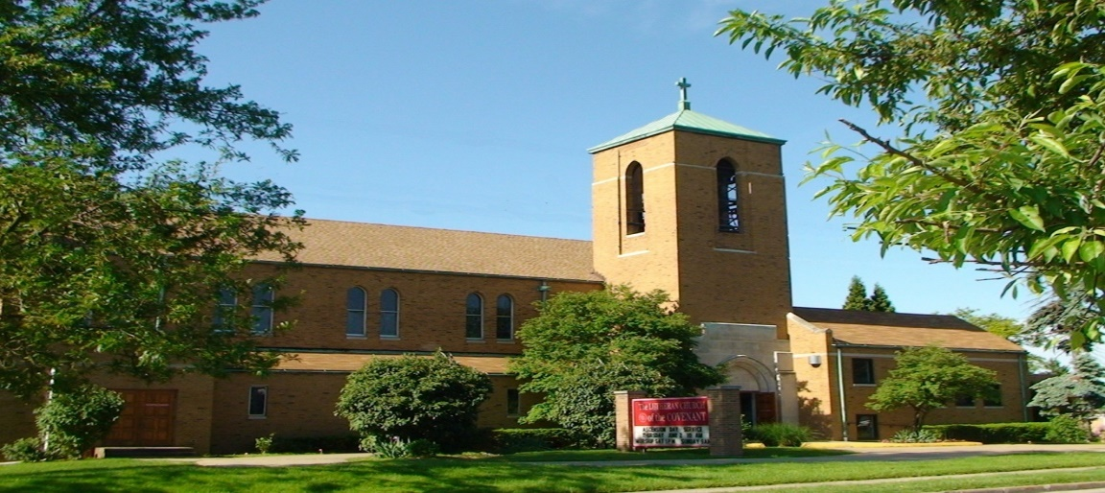Covenant News*

**June 2025**

 Pentecost: The Birth of the Church

Pentecost, observed 50 days after Easter, commemorates the descent of the Holy Spirit upon the Apostles and other followers of Jesus Christ. This event, described in Acts 2, marks a pivotal moment in Christian history, often referred to as the 'birthday of the Church.'  
  
Originally, Pentecost was a Jewish harvest festival known as Shavuot, celebrating the giving of the Law at Mount Sinai. In the Christian tradition, it signifies the fulfillment of Jesus' promise to send the Holy Spirit to guide and empower his disciples.  
  
On that day, the disciples were gathered when suddenly a sound like a rushing wind filled the house, and tongues of fire appeared, resting on each of them. Filled with the Holy Spirit, they began to speak in various languages, enabling them to communicate the gospel to people from diverse regions.  
  
Peter addressed the crowd, explaining that this phenomenon fulfilled the prophecy of Joel, indicating that God's Spirit would be poured out on all people. His message resonated deeply, leading about 3,000 individuals to be baptized that day.  
  
Pentecost underscores several key themes: the universality of the Christian message, the empowerment of believers through the Holy Spirit, and the unity of the Church across cultural and linguistic boundaries. It serves as a reminder of the transformative power of the Holy Spirit in guiding and sustaining the Christian community.

From all of us at Covenant:



6/1Mike Garvin

6/16 Michelle Pekar

6/23 Paula Hohenstein

6/29 Ken Frajter

6/29 Samuel Reddig



6/11 Kelly (Constant) & Vimal Bahatnagar

Happy 20th Anniversary!

6/13 Claudia & Steve Senderak

Happy 61st Anniversary!

6/20 Joan & Mike Garvin

Happy 56th Anniversary!

***All Gathered Together***

**Pentecost Sunday, June 8th**

10:00 Am Joint Worship @ Covenant-- Wear Red!  
   
11:00 AM Potluck and Service project  
 Bring a dish that reflects your family heritage, or an international favorite! Dishes can be brought to the Fellowship Hall before worship.  
  
Our churches will be making care packages to deliver to our neighbors in Maple Heights and Bedford, including the Fire and Police Departments and area businesses that serve the community. We will assemble the packages before we eat that day and then deliver them to the community.  
  
WE NEED donations of items for the care packages (or monetary donations to purchase items). Think small and easy individual treats: candy, snacks, mints, granola bars, chips, candy, etc.  
Items can be brought to church until June 8th and placed in the labeled box in the sanctuary (Covenant) or narthex (Master).  
   
WE ALSO NEED people to deliver the packages to our neighbors. They can be delivered any time during the week. Deliverers will receive information and directions. A signup sheet is out at both churches, or you can let Pastor Andrea know.

Lutheran Church of the Covenant

Congregational Council Meeting minutes Tues, April 15, 2025

Meeting called to order at 7:05pm by President Ted Lockmiller

**Present**: Mary Kaye Bernardo, Vince Besednjak, Mike Davis, Jennfer Lasher-Dobush, Pastor Andrea, Gwen Susanek, Ted Lockmiller, Charlote Zaranka

**Excused:** Chuck Dickey, Mary Kaye Bernardo

**Devotions and prayer:** Pastor Andrea. Matthew 11, verses 28-30.

**Council Business**: Minutes approved/amended of insurance meeting March 25 by Jen and 2nd by Gwen. Minutes approved/amended of March 16 council meeting by Jen and 2nd by Gwen.

**Pastors Report:**

$300 donated at soup supers went ½ to Maple Hts and ½ to Bedford food pantries.

Covenant and Master are doing well as shared congregations compared to some. According to a meeting of regional clergy that Pastor attended.

May be able to get grants of $10,000 1st year and $15,000 2nd year for being joint churches.

Watch the inserts in the church bulletin each Sunday for updates on church functions and services.

**Treasurers Report** – Mike – handout

We are one-quarter into the fiscal year 2025. Revenues and expenses should be in the 25th percentile. Year-to-date revenues total $25,367.00 (23.1%). Expenditures total$34,824.00 (23.8%), resulting in an excess of expenses over revenues of $-9.457.00.

March $1500.00 gas bill not paid yet due to Master late reimbursement. Low cash in bank end of March. May get a tax penalty. Pastor suggested we inform the people where we are financially to keep current with our bills.

**BOARDS**:

**Finance:** Gwen – No handout but will be meeting with Master regarding new church envelopes.

**Evangelism and Social Ministry**: Mary Kaye – Not present

**Education**: Chuck Dickey – Not present – Last adult bible class and children's Sunday school will be Sun, June 1. Summer worship outside again over summer months. Bible class and children’s Sunday school starts back Sun, Sept 7.

**Worship and Music:** Jen – Preparing for Easter services.

**Managers –** Vince **-** Iman Roofing was out to redo ceiling in parlor. May possibly redo whole roof, part metal and part tiles.

Heating problem needs to be corrected. $200 /hour for Johnson Controls to come out just to evaluate the situation. Per Mike, we should get an estimate and do a campaign in the Fall, so everyone knows. May be addressed in the Sunday bulletin.

One fire extinguisher is outdated. Need to find out which one and where it is located. All others were approved by the fire dept.

New landscaper started in April. Did a good job, better than the old one. Jen will check with him to see if he knows someone who snowplows.

Electric contract signed up to 2030. Same rate. Jen will check on rates for Gas before prices go up for 2026.

**New Business:**

May post shed amount received quarterly in bulletin. Jen will put a laminated copy of shed info on table by back door along with white info sheets for people to take showing what items can be put in shed.

Need a new church vice-president to take Dick Ptak's place.

**Next Council Meeting:** Wed, May 14, 2025, 6:30pm. (that’s when the insurance guy can make it) Next joint council meeting with Master is May 6, 2025, 7-8:30pm.

**Devotions**: Gwen

**Adjourned** 8:40 pm with the Lord’s Prayer.

Respectfully submitted,

Charlotte Zaranka

Council secretary

**Comments**: Very good devotion and prayer this meeting by Pastor.

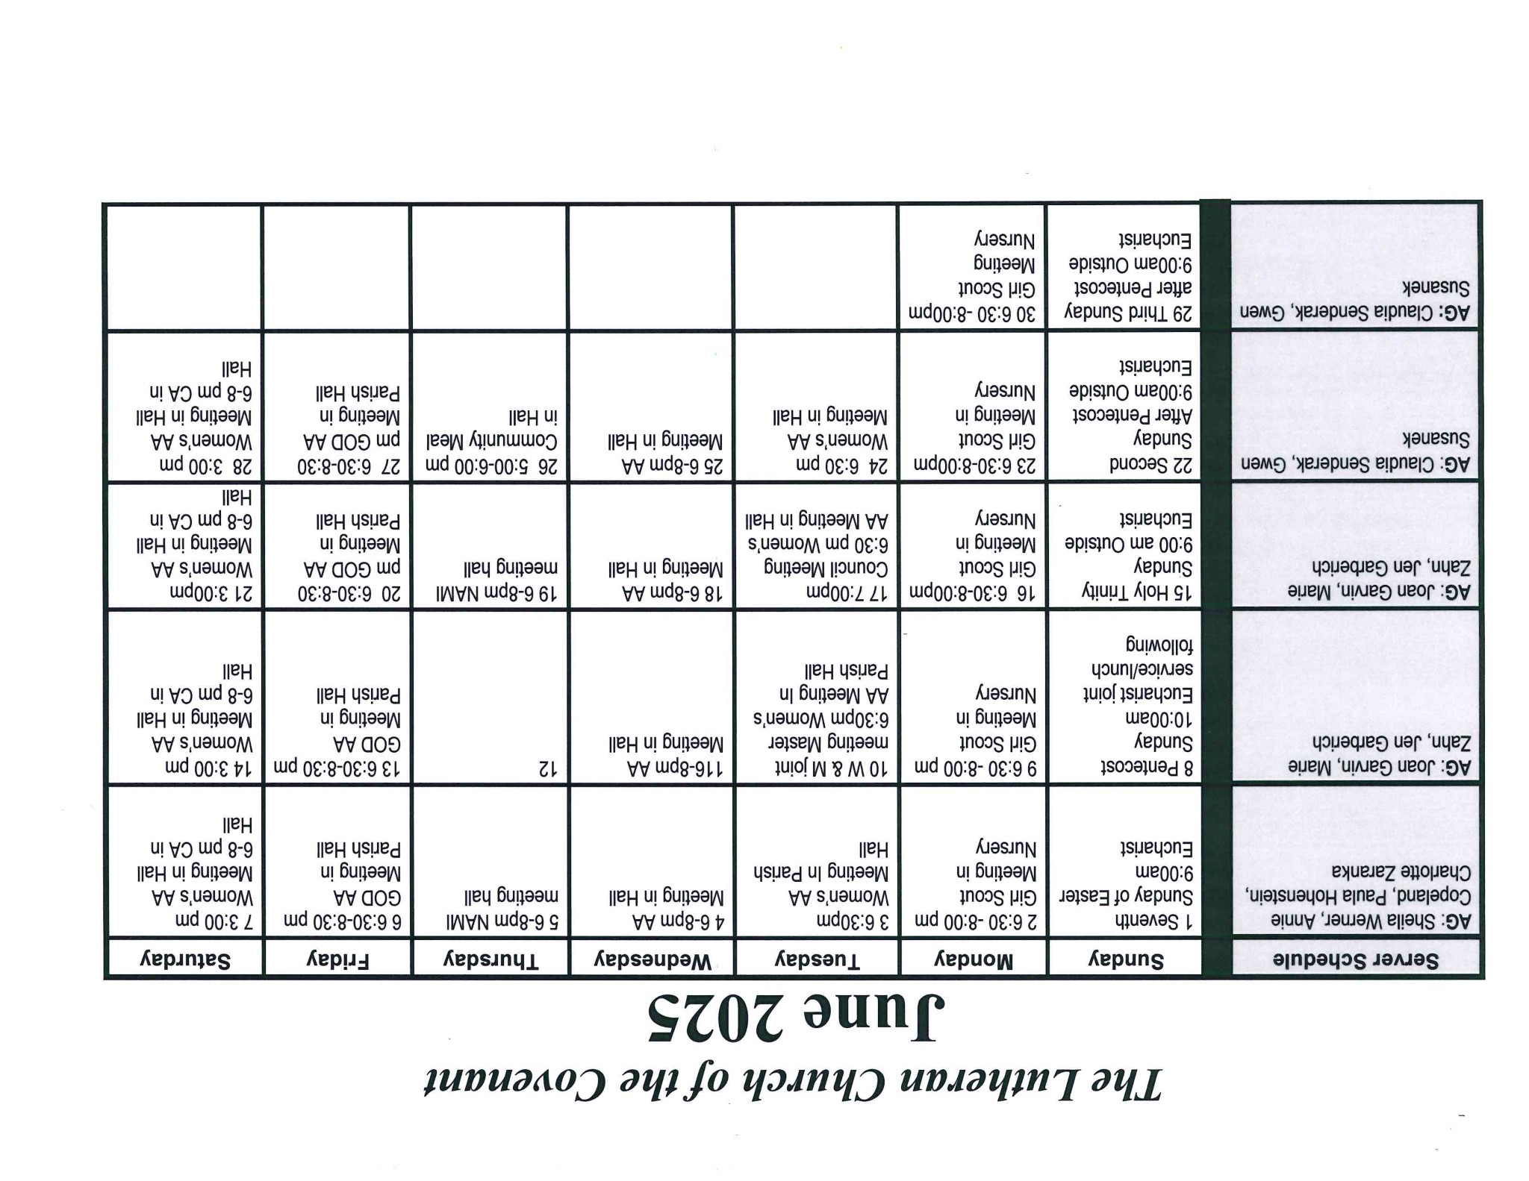

Covenant News

The Lutheran Church of the Covenant

19000 Libby Road, Maple Heights, Ohio 44137

This is a picture of one of the first pick ups of bags from the clothing shed at the back of the parking lot. Charlotte Zaranka, Barb Gaglione and Mary Kaye Bernardo went to Divinity in Parma and picked up all the clothing (which was bagged for our drivers) that was left after their rummage sale. We have pick ups weekly and it has resulted in 72.71 in proceeds for the church, from the first quarter. Thank you to the volunteer drivers and weekly shed checkers.