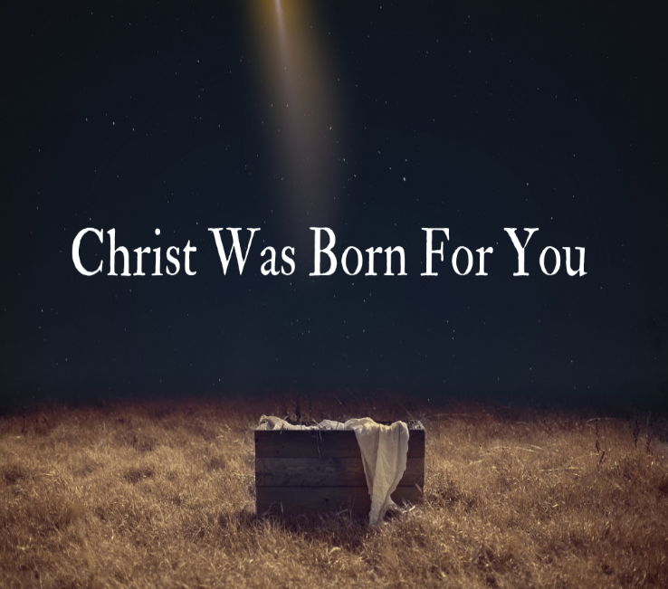
So, a couple weeks ago, I watched this Lessons & Carols service online. It was from my college alma-mater of Wittenberg University in Springfield, Ohio. It was a worship I was a part of one way or another for all four years I was there. Quite honestly, it was my favorite time spent in that beautiful campus chapel. So many memories. So many heart-warming moments. So much nostalgia that makes me miss those precious faith-shaping times. It makes me wish I could be there every year for that awe-inspiring night alone, but it hardly works out anymore for a variety of reasons, including some years, because of weather conditions.
And yet, somehow, someway, not only does Advent keep happening; Christmas keeps happening whether we are in a church building sanctuary or not. A global pandemic forced us to accept that still-Good-News reality, much to our chagrin. Yes, we still thoroughly cherish being there. But sometimes it doesn’t work…much, much to our chagrin. And yet we need to be reassured of the still-Good-News reality: it is okay when it doesn’t work for us to be physically together inside church building walls. It…really…is…okay. Somehow, someway, Christmas can still happen.
So, I go back to that aforementioned Lessons & Carols service I watched online. No, it wasn’t the same as being there. I deeply wished I could have been there, but still somehow, someway, a bit of precious, wonderful, Great News emerged through the screen. At the beginning of the worship, they turned down the electrical lights. Then, all of a sudden, many candles were lit up-front in the sanctuary. They were of the choir members holding them. And they started singing not a standard Christmas or even Advent hymn, but more of a folk-dance song with words that were just random sounds. Evidently, we weren’t supposed to get wrapped up in the words, but only to witness the light, the eternal light, the very light of Christ, that danced.
It was meant to set the stage for the opening act, so to speak, when out of darkness came the light of all creation. When out of nothingness came absolutely everything. That light, that eternal light, that very light of Jesus Christ, danced to bring life to all. And the song concluded with them raising their candles as high as they could reach, as the stage was set for the story of hope to be told to us all. As if out of our deepest depths that we may often experience not just during a holiday season of expectations and stresses galore, or even with the actual holiday supposedly altered due to weather, but whatever else interspersed throughout a lifetime: out of any depth whatsoever that we experience in this life, this Messiah, this Emmanuel, this God in our very flesh, can lift us up, no matter what.
And yes, somehow, someway that light of Christ can still dance within us in our homes, and in the far too many who will need to continue working through these dreadful conditions, and in the far too many who will need to find shelter like with our beloved Lutheran Metropolitan Ministry shelter in Cleveland. Somehow, someway, though it all, the light of Christ insists on dancing. There’s too much hope, too much joy, too much love, too much God to do so otherwise.
Granted, God understands there will be frustrations throughout a lifetime. We will experience sadness and other intense feelings over not being able to celebrate the birth of Christ together in the same church building sanctuary, for starters. The church will insist that Christmas, in fact, lasts 12 days, not just for a night into the following morning and afternoon. Nevertheless, it’s still disappointing. It is okay to have those feelings. It…really…is…okay. And yet, somehow, someway, out of nothingness came absolutely everything. Out of rather unpleasant conditions for Mary and Joseph and shepherds, came joy. Out of their frustrations and fears, the light not only danced in the sky; the light of Christ himself danced right in from of them (with a fair share of cries even from the Son of God and all).
We may not notice it within us, at this moment. But perhaps we’ll see it in the snowplow driver. Maybe in the nurses who will still show up at hospitals and nursing homes. Maybe in the volunteers at Lutheran Metropolitan Ministry. Maybe even through a phone call or text message or email, reminding us that there still is a light, an eternal light, the very light of Jesus Christ within us. And it will keep on dancing even when we don’t feel like joining in, because there’s too much hope, too much joy, too much love, too much God not just on December 24 or 25 or for 12 days after, but through all the days of our life. Whenever we feel like joining in the celebration, there will still be as much Great News then to latch onto with all our spiritual might. As if, still, nothing: no storm, no distance, no sickness; nothing in all this life can separate us from the love of God in Christ Jesus, our newborn Savior. For that Greatest News of all, we most certainly give thanks to God, indeed! Amen!

