*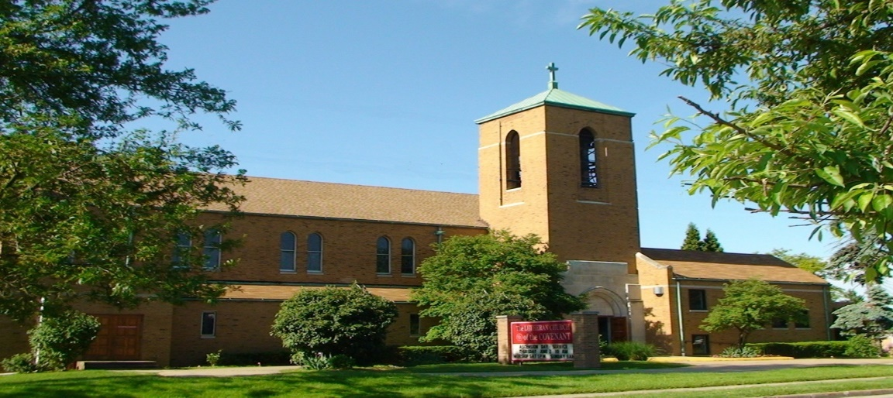Covenant News*

**August 2025**

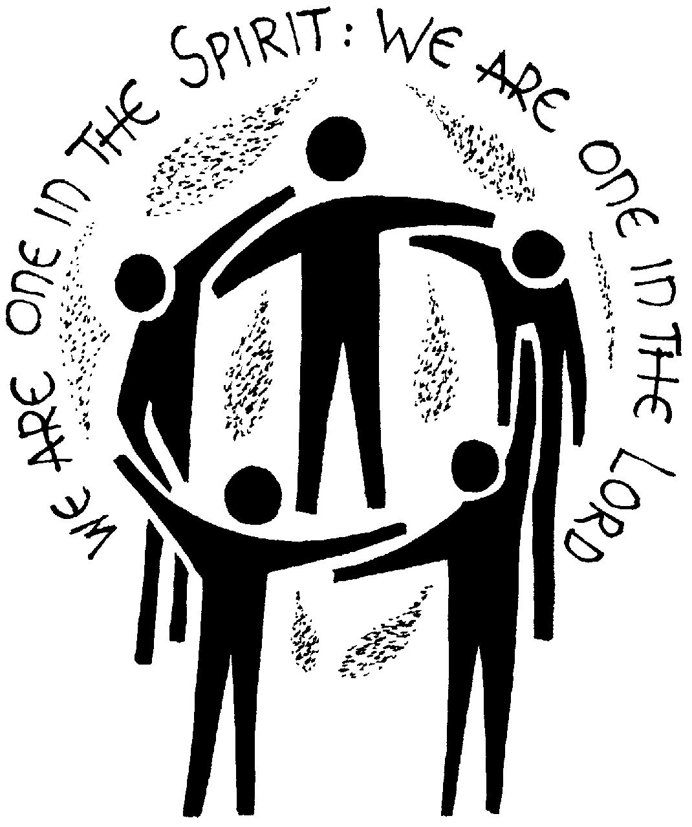“Make every effort to maintain the unity of the Spirit in the bond of peace.”

— Ephesians 4:3

Dear friends in Christ,

This summer, as we have been gathering for worship, fellowship, and service, I’ve been thinking a lot about what it means to truly be united as the Body of Christ.  United in Spirit and rooted in the deep love that Christ has shown us, even as we are beautifully and wonderfully diverse. In a world that seems to be more and more fragmented, it also seems more and more important to remember that Jesus lived, and died, for all people. And all means all when it comes to our God.

In Ephesians 4, Paul urges the church to “make every effort to maintain the unity of the Spirit in the bond of peace.” That word "maintain" reminds us that unity isn’t automatic and it isn't always easy. It takes work. It takes grace. It takes listening when we’d rather speak, reaching out when we’d rather withdraw, and choosing love even when it’s hard. And it can be hard!

Unity is not about agreeing on everything. It’s about remembering who we belong to. In Christ, we are one body, called to bear one another’s burdens and share one another’s joys.

Whether we’re gathered for worship, serving meals to our neighbors, meeting in Bible study, or praying quietly in our homes, the Spirit knits us together. And that unity becomes a powerful witness in a world that often feels divided. Perhaps it is the only thing that will reconcile us eventually, and hopefully soon and very soon.

Let’s keep showing up for one another. Let’s keep praying for each other. Let’s keep walking in peace—knowing that Christ holds us together with cords stronger than any difference.

May the unity of the Spirit continue to guide us and shape us as a church family.

In Christ’s love,

Pastor Andrea

Our next FREE community meal will be Thursday, August 28th (5-6PM). We are doing dine-in only in our fellowship hall.



2025 Rummage Sale

The church rummage sale will be on Friday, August 22 nd

and Saturday, August 23 rd , from 10am to 1pm. Donations

can be brought until Wednesday, August 20 th . All

donations should be put on the stage in the hall, please

do not put them anywhere else. Let Jen Lasher-Dobush

know if you have any questions or need to set a

time to bring donations.

Please join us for our joint

worship service with Church of the Master on Sunday September 7th at 10:00 am at Lutheran Church of the Master and fellowship to follow. More info and details coming soon. Please save the date.



8/11 Ann Droste

8/16 Marie Zahn

8/17 Maggie Hernandez

8/17 Arlene Stoltz

8/17 Chris Constant

8/19 Douglas Pekar

8/21 Jane Skowronski

8/28 Jeff Garvin



8/11 Jane & Jim Gradert - Happy 69th Anniversary!

8/12 Barb & Chuck Gaglione – Happy 53st Anniversary!

8/14 Deena Gaglione-Hernandez & Ben Hernandez –

Happy 15th Anniversary!

8/20 Arlene & Jim Stoltz – Happy 31th Anniversary!

**Yehiel Curry Elected Presiding Bishop of the ELCA**

PHOENIX — The Rev. Yehiel Curry was elected July 30 to serve a six-year term as presiding bishop of the Evangelical Lutheran Church in America (ELCA). The election took place during the 2025 ELCA Churchwide Assembly being held July 28–Aug. 2 at the Phoenix (Ariz.) Convention Center.

Curry was elected on the fifth ballot. There were 799 votes cast, with 400 votes needed for an election. Curry received 562 votes, and the Rev. Kevin Strickland, bishop of the ELCA Southeastern Synod, received 237 votes. Curry is the first Black presiding bishop of the ELCA.

Speaking to the assembly after his election, Curry reflected on his membership at Shekinah Chapel in Riverdale, Ill., where he eventually became a lay mission developer while he participated in the Theological Education for Emerging Ministries program, which prepares individuals for ordained ministry in the ELCA, with a focus on emerging ministry contexts like ethnic-specific, multicultural, rural and inner-city settings. He spoke to the assembly about his initial hesitation in accepting that first ministry role.

“Perhaps I’m out there in one of you,” Curry said. “I never saw myself as good enough, so for two years, I said no. I finally said yes. When I said yes, your support, this church’s support, of that ministry meant everything. So if you want to know what your benevolence dollars look like, it looks like me, and I want to say thank you. Thank you for your investment.”

Curry has served as bishop of the ELCA Metropolitan Chicago Synod since 2019. He previously served as mission developer (2009-2012) and pastor (2012-2019) of Shekinah.

He received a Bachelor of Arts from Lewis University in Romeoville, Ill., in 1995 and a Master of Divinity from the Lutheran School of Theology at Chicago (LSTC) in 2013. LSTC is one of seven ELCA seminaries.

The churchwide assembly, the chief legislative authority of the ELCA, is meeting under the theme “For the Life of the World.” The assembly will participate in plenary discussions to make decisions about the work of this church. They will also spend time in worship and engage in various ways of theological reflection.

Live video of the plenary sessions will be accessible at [www.elca.org/CWA](https://www.elca.org/about/leadership/churchwide-assembly).

2025 Blossom Outing

Join us on Sunday, August 31st at 7pm for the showing of Disney’s original 1994 animated film “The Lion King,” with live orchestral underscore by the Cleveland Orchestra, Sarah Hicks, conductor and accompanied by the Blossom Festival Chorus.

The original 1994 animated film “The Lion King” features unforgettable music by a notable team of Oscar and Grammy winners, including superstar Elton John, lyricist, Time Rice, and composer Hans Zimmer, plus Arican vocal and choir arrangements by Grammy-winning South African producer and composer Lebo M (Rhythm of the Pride Lands).

The cost of the tickets at the Senior reduced rate is 47.00 each for this show. Please have ticket reservations and money to Arlene Lasher as soon as possible, but no later than Sunday August 3, 2025. Please make checks out to Arlene Lasher, as she has already reserved a number of tickets. Any questions—call Arlene at: 216-662-1939.



Covenant News

The Lutheran Church of the Covenant

19000 Libby Road, Maple Heights, Ohio 44137

Thank you, Covenant gardeners!

A hardy thank you to all of you who placed orders for flower or vegetable plants at our recent annual sale. Sending the order forms via email seems to be working pretty well. I handed out paper order forms to the folks who do not have email or for whatever reason did not receive one via their mail. At any rate, we seemed to have reached everyone who-was interested in ordering, plus even adding a couple of first time participants.

Many thanks, as usual, to my hard-working volunteer crew of: Barb Gaglione; Charlotte Zaranka; Paula Hohenstein; Nancy Langtry, Vince Besednjak; Bert Zahn and Jen Lasher-Dobush. Again, as usual, this flower sale only happens because these folks are willing to spend a very long, tiring day unloading the plants from the nursery, and then filling all the orders for pick-up the next day. I mere “ thank you” does not begin to express my gratitude to all of them for their help.

Now, for the good news! All of our hard work does pay off. Due to all of your orders and generous donations, we were able to place nice planters by each of the church doors and realize a profit of 680.00 Well done Covenant!!

I know that his has probably been one of the most challenging springs we have ever had to deal with. The unseasonably cool temps and abundant rain! At least the plants like the warmer temps better than all that cool dampness. Hang in there gardeners. Maybe we will finally arrive at growing conditions that will help us realize lovely flowers and abundant vegetables by late summer and fall.

See you next Spring, same time same station.

Arlene Lasher