*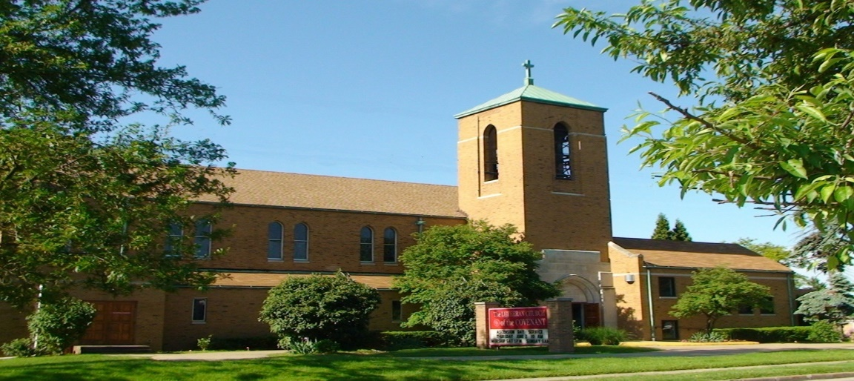Covenant News*

**May 2025**

The Tuesday Bible Study group at Master is watching and discussing *The Chosen*, a program that chronicles the gospels, focusing on the lives of those who encountered and followed Jesus. All are welcome to come participate. We meet at noon at Master (860 Northfield Road in Bedford). Hope to see you there!

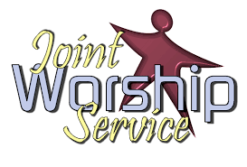

Please join us for our joint worship service with Church of the Master on Sunday June 8th at 10:00 am at Lutheran Church of the Covenant followed by a potluck meal and a service project.5/2 Christopher Dickey

5/14 Lynn Fridley

519 Steven Kobella

5/19 Arlene Lasher

5/21 Joan Garvin

5/25 Ron Schirmer

5/30 Jayden Kyle

5/31 Barbara Gerstenberger

5/31 Matthew Kobella



5/4 Michelle & Doug Pekar 5/22 Jennifer & Larry Garberich

Happy 51stAnniversary! Happy 26th Anniversary!

5/7 Charlotte & Robert Zaranka 5/22 Nanette & Ron Schirmer

Happy 59th Anniversary! Happy 44th Anniversary!

5/11 Karen & Raymond Zack 5/25 Daralynn & Bruce Constant

Happy 57th Anniversary! Happy 46th Anniversary!



In working with other surrounding congregations, we continue to offer a FREE meal for anyone and everyone in the community and beyond on the 4th Thursday of every month. If you are interested in helping, please contact Mary Kaye Bernardo. Otherwise, come on for FREE dinner Thurday, May 23 (5:00-6pm), or help spread the word to others!

We are tentatively planning to start worshiping Sundays outside from our back parking lot in June. Feel free to bring your own chair or stay in your vehicle, as we praise God amidst the wonderful Creation!

Join the Adult Sunday School class at Covenant as we dive into Dave Boice’s book *52 Churches in 52 Weeks*. The book chronicles his journey as he visits a different church each week, experiencing different faiths, denominations, and styles of worship. The book offers insight into the spiritual lives of this country, helping us to shape and appreciate our own. There’s no cost, and you can join us anytime!





**C LW Annual Plant Sale**

Pick-up scheduled for Saturday, May 17, 9am -1pm.

Drive-thru pick-up, same as last year, at the ramp door. Please call when you are on the way to pick-up and Arlene will have your order outside to be put into your vehicle.

Lutheran Church of the Covenant

Congregational Council Meeting Minutes Wed, March 18, 2025

Meeting called to order at 7:07pm by President Ted Lockmiller

**Present:** Mary Kaye Benardo, Mike Davis, Jennifer Lasher-Dobush, Pastor Andrea, Gwen Susanek Charlotte Zaranka, Ted Lockmiller

**Excused:** Chuck Dickey, Vince Besednjak

**Devotions and prayer:** Mike Davis

**Council business:** Minutes approved/amended of meeting Feb 18, 2025. Motion made by Jen and seconded by Gwen.

**Pastors report:** See handout. Additional info -

Joint worship at Covenant Sun, June 8, Pentecost, 10:00am. Plan on lunch afterward and a service project.  Possibly put together care packages and take to fire depts and other places.

Change of office hours – will put info in Sunday bulletin, separate sheet, for all to see and use at home.

Database for church management to keep track of church info. Need to clean up membership list for online directory. 43 members give to the church regularly.

Still trying to get a monitor at side door for Pastor and maybe an iPad?  Jen already has one.

**Treasurers Report –** Mike – Handout

**BOARDS:**

**Finance –** Gwen – No handout. Pastor, Gwen and Judy from Master will go over envelope info next week.

**Evangelism and Social Ministry**: Mary Kaye – No handout

Adult Bible class will start a book called **52 Churches in 52 Weeks** as a book club. Will discuss what we read each Sunday starting March 23, 2025.  June 1 will be last Bible class. Will start up again Sun, Sept 7, 2025. We will have outdoor worship again thru the summer.

**Education:** Chuck Dickey, not present

**Worship and Music** – Jen – handout

Upstairs piano went down into the hall and we will get a newer donated one about Wed, March 19 for the church.

**Managers**: Vince – absent - no handout

The bell tower might need to be redone. Not fixed correctly for drainage last time. Lawn people will start mowing in April.

P.K. Wadsworth suggested we get Johnson Controls involved with our boiler problem. Needs to be looked over for problem. Something is not communicating with another part to adjust temperature. Will do this over summer when companies are not as busy. Gas Company coming to inspect meters Fri, March 21, between 8-12:00.

**Old Business:**

Clothing shed program was at a standstill due to a paper State of Ohio needed. It has since been resolved. Waiting to hear from Alex when the shed will be delivered.  (Tues, April 1) Will hire someone for carpet cleaning in parlor and Pastors office.

**New Business:**

NAMI, National Mental Illness will start a support group at Covenant for suicide. Those who have tried, thought of it and for the families. Needed a place to hold meetings. Will be meeting 1st and 3rd Thurs of each month from 6-8:00pm in the hall.

Pastor would like new mini blinds in place of the curtains she now has. Curtains do not work properly.

Acrisure Church insurance – Liability only. Umbrella $355 additional for 1 million for each person on council. Pg 9 increase medical expense from, $5000 to ___________. Ended up keeping at $5,000. Pg 10 clarify # of business autos. Council meeting 6:00pm for insurance only Tues, March 25, 7:00. An insurance agent will attend as well as Barb Gaglione.  She is familiar with insurance.

Charlotte and Mary Kaye have been cleaning up the parlor kitchen a little each week after bible class. We cleared out most of the cupboards and packed items away for rummage sale or put down into the pantry. We now have a place for our coffee supplies that used to be strewn along the back counter. AA also has a cupboard for their supplies. The old refrigerator/sink will be taken out. Ted has a small fridge and sink he will bring in. Mary Kaye will order the cabinet below the sink, new faucet and some new countertop for each side of the sink.  She also has an installer who will take out and install the items for us. What a difference it will make when the project is finished.

**Next Council Meeting**:  Tues, April 15, 2025, 7:00pm.

**Devotions and Prayer**: Pastor Andrea

‘

Adjourned 9:20pm with the Lord’s Prayer.

Respectfully submitted.

Charlotte Zaranka

Council Secretary

Comments:

Covenant News

The Lutheran Church of the Covenant

19000 Libby Road, Maple Heights, Ohio 44137

