*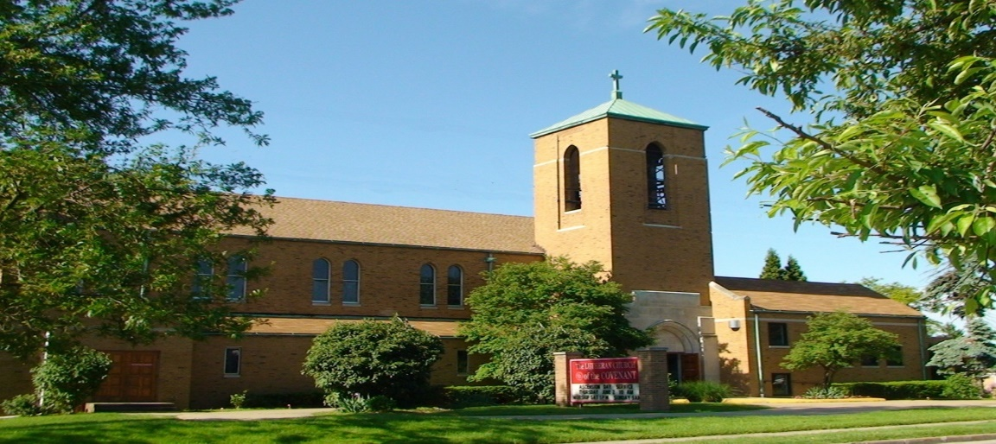Covenant News*

**July 2025**

The Gospel of Luke

This summer, we’ll be spending time in the Gospel of Luke—a story of Jesus rooted in compassion, justice, and God’s wide embrace.  
     The Gospel of Luke was likely written between 80 and 90 CE by a highly educated Greek-speaking follower of Jesus, traditionally identified as Luke the physician. He is also credited with writing the Acts of the Apostles, making him the only New Testament writer to give us a two-part account: the life of Jesus and the growth of the early church.  
       Luke wasn’t one of the original twelve disciples, and he writes for a mostly non-Jewish audience. His gospel emphasizes that the good news of Jesus is for everyone—not just for the religious elite or the powerful. Again and again, Luke highlights the stories of people on the margins: women, the poor, the sick, and those left out by society. He tells the parables of the Good Samaritan and the Prodigal Son, and he records Mary’s song of revolutionary joy (the Magnificat).  
       Historically, Luke sets his story in the broader context of the Roman Empire. He names emperors and governors, linking Jesus' life to real-world politics and power. But Luke’s Jesus doesn’t come to wield power like Caesar. He comes to lift up the lowly, feed the hungry, and proclaim release to the captives.  
       If you’re looking for a gospel filled with grace, healing, and surprising reversals, Luke is for you. It’s a story where meals become moments of transformation, where the Spirit moves in unexpected places, and where God’s love reaches all the way to the ends of the earth.

Join us in July as we celebrate mid-week during Picnic and Praise. We start with a meal and then move to a time of song and scripture reflection, all in great fellowship!!

Weds. July 9th at 6:00 we will meet in the hall for a potluck- bring a side dish to pass.

Weds. July 16 at 6:00 we will partner with Church of the Master and New Cornerstone Baptist Church for a cookout and live music in the parking lot. Bring a chair and some friends!

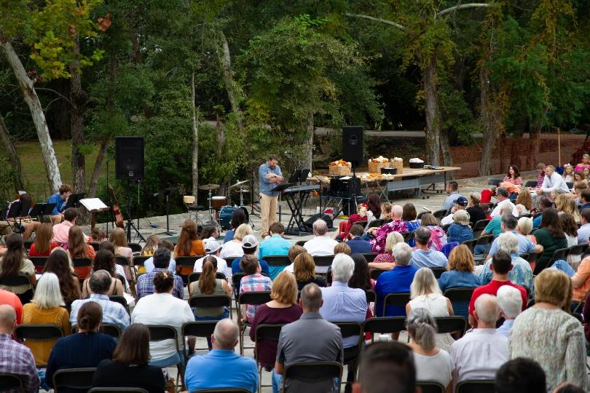

Outdoor Worship begins Sunday July 6th and goes through Labor Day.

Our next FREE community meal will be Thursday, July 24 (5-6PM). We are doing dine-in only in our fellowship hall.



7/1 Joyce Mihalek 7/10 Amber Kyle

7/3 Rosa Garnett 7/25 Mark Gabor

7/9 Linda Allende 7/31 Kristine Sandor

7/9 Emily Knerem

7/2 Jennifer & Chris Constant

Happy 14th Anniversary

7/12 Nicole & Jeff Garvin

Happy 16th Anniversary

Lutheran Church of the Covenant

Congregational Council Meeting Minutes Wed, May 14, 2025

Meeting called to order at 6:40pm by President Ted Lockmiller

**Present**: Ted Lockmiller, MaryKaye Bernardo, Vince Besednjak, Mike Davis, Chuck Dickey, Jennifer Lasher-Dobush, Pastor Andrea, Gwen Susanek, Charlotte Zaranka.

**Excused:** All attended

Insurance Agent, Justin Tuskus, attended with insurance updates.

Went to market 1 month ago to 4 separate carriers. 1 quote from CSU for $28,000 per year. Cincinnati Insurance came up with $16,251 per year. Liability only $2500. $10,000 deductible. $1,354.25 monthly. Will go back to underwriter to see it they will under-insure. If something happened, we would not rebuild parts of the church later. Justin left so we could continue with our meeting.

**Devotion & prayer**: Gwen about Unity

**Council Business:**

Minutes approved/amended of meeting April 15, 2025. Motion made by Jen and seconded by Vince.

**Pastors Report**:  Worship – I received good feedback on last Sunday's service when I wasn’t there.  Both worship committees met to plan Pentecost worship, potluck and service project. Both committees also brainstormed for Picnic and Praise this summer at Master.

Education – Covenant Adult Sunday school and Masters Tues Bible study are ending but we will be doing some educational stuff over the summer in worship (learning about the creeds and possibly hymn trivia).

Children – working on background checks and hopefully have them at $30 each. Background checks will be done for staff and anyone who works with children.  After Easter, a group from Covenant and Master will meet to update and create a child safety policy that will be recommended to both councils to approve.

Also starting a small group focused on prayer (exploring different practices for the church and praying for the church).

First Call retreat was April 29-May 1st in NW Ohio. A lot of learning and retreating. I attended breakout sessions on prayer practice and administration.

**Treasurer’s Report:** Mike – Took $5,000 out of Thrivent. Good deposit on Sun, May 11, 2025. All bills are paid. Bell choir will be paid this week.

**BOARDS:**

**Finance:** Gwen - No new info

**Social Ministry**: MaryKaye – Presentation at Case Western was very good.

**Education:** Chuck Dickey – Consistent attendance at adult bible class on Sunday after service. Book we are reading as a book club is rather interesting. We are a little over half-way thru.  Bible class will take a break after June 1, for the summer and we will continue the book in the Fall, Sunday Sept 7th.

**Worship and Music**: Jen – Pentecost potluck June 8 after 10:00 service here with Master. Potluck will be after we put together the packages of snacks, etc to deliver to places around Bedford and Maple Hts. We need people to deliver the packages. An insert will be in the Sunday bulletin to sign up.  Items needed are also listed in the Sunday bulletin insert. The packages will be delivered after the potluck lunch or the following week.

Plans for Picnic and Praise this summer at Master are being discussed.  There will be a new format for the event. More detail to follow.

Gerry knows someone to tune the piano up front in the church.

**Managers:** Vince – Frank from Power One Electric will be out to take care of electric box in mini kitchen.  Also get a price for replacing lights outside and 1 in front.

EXIT signs need light bulbs replaced so they can be seen. That has since been taken care of by Ted and Vince.  Need new EXIT battery operated signs for front and back doors, ramp door, and side door. Need sign “Please do not use sanctuary door.”

Update – Mini council meeting after church service, May 25, 2025. Everyone was present except Chuck and Jen. Frank from Power One Electric gave a quote for the above work as $1500.00. All approved.

**Old Business:**  Charlotte and MaryKaye were going to update the mini kitchen at their own expense. The mini refrigerator there now is years old, unusable, rusty and moldy inside.  It is built-in so whole area would have to be replaced. Ted had brought in another fridge for us to use instead that was kept off to the side.  Sink not well taken care of as the finish is dulled.  A new cabinet below that Kiery Knerem was going to make at no cost to the church. We had the sink and faucet w/sprayer already purchased so it will go back to the store.  MaryKaye had a person who would tear out and install for us. So, no extra work for anyone at the church. The idea was tabled by council. It was decided to try to find someone to clean the mold from the old fridge instead and possible buy new shelving for inside, at a cost.  If mold has gotten into the condenser after all these years, old fridge will have to be removed at a later date.

Ted’s refrigerator has since been moved to the conference room where we can lock the room. Altar Guild will also use it for wine and apple juice now.

Workorders – Ask Jen if you need one.

**New Business:** Shed update – The project is doing very well so far. Better than we expected. Need to check on monthly electronic deposit from St Pauley’s. Barb Gaglione and Charlotte went to Divinity Lutheran’s rummage sale in Parma. (Pastor Brad’s church).  They bagged up 77 bags of clothes, stuffed animals, bedding, etc for us to take for our shed program. They loaded 3 cars full of bags.  MaryKaye went back for a 4th load. Barb, MaryKaye and Charlotte drove to the church to pick up. Ted, Vince and Barb’s husband, Chuck, helped unload the cars at the shed.

Vince bought paint to repaint the edges of steps that need it and front curb.

**Next Council Meeting**: Tues, June 17, 2025, 7:00pm.  **Devotions**: MaryKaye

**Meeting Adjourned:** 8:47pm with the Lord’s Prayer.

Respectfully submitted,

Charlotte Zaranka

Council Secretary

**Comments:** Metaphor – We all need to row the boat in the same direction.

**Sunday, June 15, after service part of council met in the back of the church. Attending were Ted, Pastor, Vince, MaryKay and Charlotte. The date of this month's council meeting was changed to Tues, June 17, 7pm. We neglected to change back to Tuesdays from Wednesdays at last meeting. Master is also starting the Picnic & Praise on Wed, June 18, 6pm so there was a conflict.

Covenant News

The Lutheran Church of the Covenant

19000 Libby Road, Maple Heights, Ohio 44137