*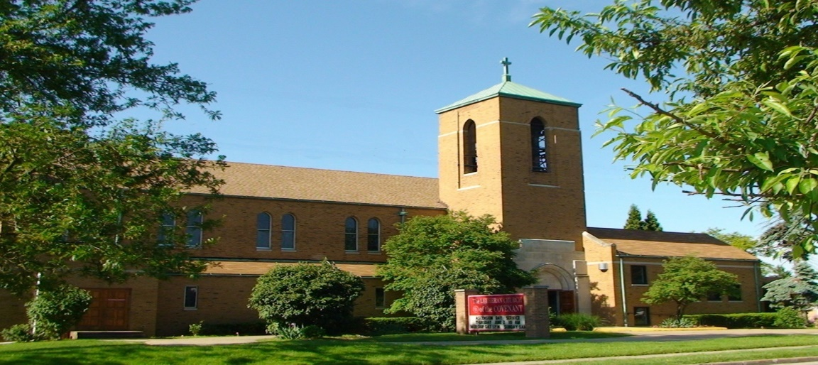Covenant News*

**September 2025**

**Worship: Rooted and Renewed**

For the month of September, we will be entering into a special worship series called “Worship: Rooted and Renewed.” Together we will explore what makes worship central in the life of the church and in our own lives of faith. Drawing from the gifts of our Lutheran heritage and the guidance of Scripture, we will look at how worship gathers us, speaks to us, feeds us, and sends us.

This series will help us remember the deep roots of worship that ground us in God’s promises, while also renewing our sense of purpose and joy as we live out our calling today. Each week will highlight a different aspect of worship and invite us to see with fresh eyes how God meets us in word, meal, and community. Join us as we enter this season of reflection and renewal, giving thanks for the gift of worship that shapes us to be God’s people in the world

 September Birthdays

9/2 William Mendat 9/22 Madeline Ptak

9/11 Doris Akerley 9/26 Allan Treichel

9/16 Barb Gaglione 9/28 Ethan Lockmiller

9/16 Jason Lanese 9/28 Evan Bernardo



9/24 Bishop Abraham Allende & Linda Godhardt Allende

Happy 20th Anniversary



Covenant Lutheran Women’s annual Rummage Sale will be Thursday September 11, Friday September 12th,10:00am-3:00pm and Saturday September 13th, from 10:00 am -3:00 pm. We are continuing the sale until this date. The items will remain in the hall, set up for all outside groups to look through and items can still be dropped off for sale.



Our next FREE community meal is Thursday, September 25 (5-6pm)! We invite you to come in through the back door into our fellowship hall and have a seat, as we serve you and our neighbors a FREE meal. However, if you don’t need this yourself, please help us let others know of this wonderful opportunity to not only have some food, but conversations with our neighbors.

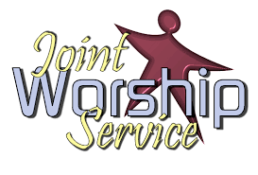Please join us for our joint

worship service with Church of the Master on Sunday September 7th at 10:00 am at Lutheran Church of the Master. Lunch and fellowship to follow.

Lutheran Church of the Covenant

Congregational Council Meeting Minutes Tues June 17, 2025

Meeting called to order at 7:08pm by President Ted Lockmiller

**Present:** Ted Lockmiller, MaryKaye Bernardo, Vince Besednjak, Mike Davis, Jennifer Lasher-Dobush, Pastor Andrea, Gwen Susanek, Charlote Zaranka

**Absen**t: Chuck Dickey

**Devotions and prayer:** Pastor – Zachariah, chapter 4:10

**Council business:**

Minutes approved/amended of meeting May 15, 2025. Motion made by Jen.  Seconded by Vince.

**Pastor Report:**

Feedback on joint service on Pentecost, Sun, June 8 was good. Thank you’s to go out to Cornerstone and Community of Faith yet with baskets.

Picnic & Praise - planning a joint picnic - at Covenant with Master, and New Cornerstone for the last date on Wednesday, July 16.  There will be food and a praise band. The neighborhood will be invited also.

Adrian is making his First Communion on Sunday, June 22, 2025.

Outdoor worship will start on Sunday, July1 thru August.

During worship in the summer, we will have some information on the Creeds and our favorite hymns. Also putting some things for the children.

A group from Covenant and Master will meet to update/create a child safety policy that will be recommended to both churches for approval. The ELCA is also working on child safety. It is in draft form now and anyone can read it and make comments.

I will be starting a small group from both churches focused on prayer.

 Still working out the details.

Barb Gaglione sent a ”thank you” to Divinity Lutheran for all the bags of clothes they gave us for the shed program in May.

**Treasurer's Report:**

We are at about 38.1 percentile and should be at about 42%. Cash flow is becoming a problem.

Offerings are at 31% and should be at 33%.  All commitments not up to date.

Need to decide on property insurance. Summer should bring lower utilities that should help our outlook.

**Boards:**

**Finance:** Gwen

Pastor suggested maybe a letter to the congregation about where we are financially. Mid-July let people know where they are contributing. Maybe a fundraiser.

**Social Ministry**: MaryKaye

MyCom is restructuring due to federal cuts. MaryKaye may ask for a grant at some point.

**Education:** Chuck Dickey/not present

Adult Bible class ended and will start up on Sept 7. We finished a little over half the book “52 Churches in 52 Weeks” as a book club. If anyone wants to join in Sept, please let MaryKaye know by mid-August so she will have books. They are free. Maybe put a notice in the weekly and weekly bulletins.

**Worship and Music**: Jen

Covenant and Master are jointly planning for Picnic & Praise. First two are on June 18th and 25th  6:00pm at Master.  They provide the main dish, and others bring sides to share. Second two will be at Covenant on July 9th and 16th at 6:00pm. The 9th will be the same format as Master. The final one on the 16th will be jointly with New Cornerstone but a different format. Still being planned and the public will be invited.

August 10 Pastor will be on vacation. We will be doing service of the word like before when she was absent. Most likely lead by council as before. It had a good response in the past.

**Managers:** Vince

Mulch pile located behind the church curtesy of Ted. Will be used around the cross on the corner of MH Blvd and Libby Rds. There is also mulch from the city of Maple Hts for anyone who may need some. Pile of dirt in front of the church is for filling holes around the property.  Lights were replaced in Exit signs with Ted. Tim brought salt that was purchased in December, 13 bags. Ted installed 4 extra exit signs above doors. Frank installed and repaired the power box in mini kitchen. He also replaced flood lights and outside light.

**Unfinished and old business:**

Ted talked to Justin the insurance agent. If we raise the deductible to $20,000 it will raise the price. He did not recommend that. Both policies together are up about $5-6,000.00 per year. (property and liability) Everyone on council accepted the proposal, $10,907.00 per year.

**New Business:**

Working on finding a new Vice President – Suggestions were Alan Triechel, Bert Zahn, Barb Gaglione, Peggy Smith, Paula Hohenstein. Ted will inquire. 

Pastor, Ted and Master met. The Synod is offering $10,000 for an experiment in shared ministry which we already do. There are several other points that we already do also.  One person from each church can take a lay-leader class. Decision needed by mid-August meeting if anyone is interested. Do not need to be on council.  Anyone can participate. A 2nd year grant is also available.

Shed amount received for May was $70.84. Charlotte stopped at the Maple Hts Library recently and left info about the shed program and some info sheets for people to take with them. Charlotte, MaryKaye and Barb might stop in at garage sales in their vicinity and inquire about left over items. Give them the info sheet. Also, later in the year when the city has their community garage sale, we can take the info sheets to the addresses listed as taking part in the sale.  Someone will have to take my shed week Sunday July 20 to Saturday 26th due to recuperating from surgery. Maybe week of Sun Aug 17 also.

Vince said Tom Russo of Russo Pizza in Northfield has good prices. Gave MaryKaye a menu for possible future use for Community Meal.  (Tom is a Maple Hts grad)

Vince suggested hiring his daughter for custodial position. He would still be manager at no pay. Will discuss at next meeting in August and figure out job description.

Parlor needs new carpeting/square carpet tiles and a fresh coat of paint on the walls. Possibly a brown that will not show spots and beige on the walls. Will discuss at a later meeting.

Jen is trying to co-ordinate a schedule with someone to look at and/or remove mold from refrigerator in the mini kitchen.

Next Council meeting Tues, Aug 19, 2025, 7:00pm.

Devotions: MaryKaye

Adjourned: 8:52pm with the Lord’s Prayer.

Respectfully submitted,

Charlotte Zaranka

Council Secretary

**Comments**: How has this meeting made you feel closer to God?

More open to doing things with others. We are rowing in the same direction.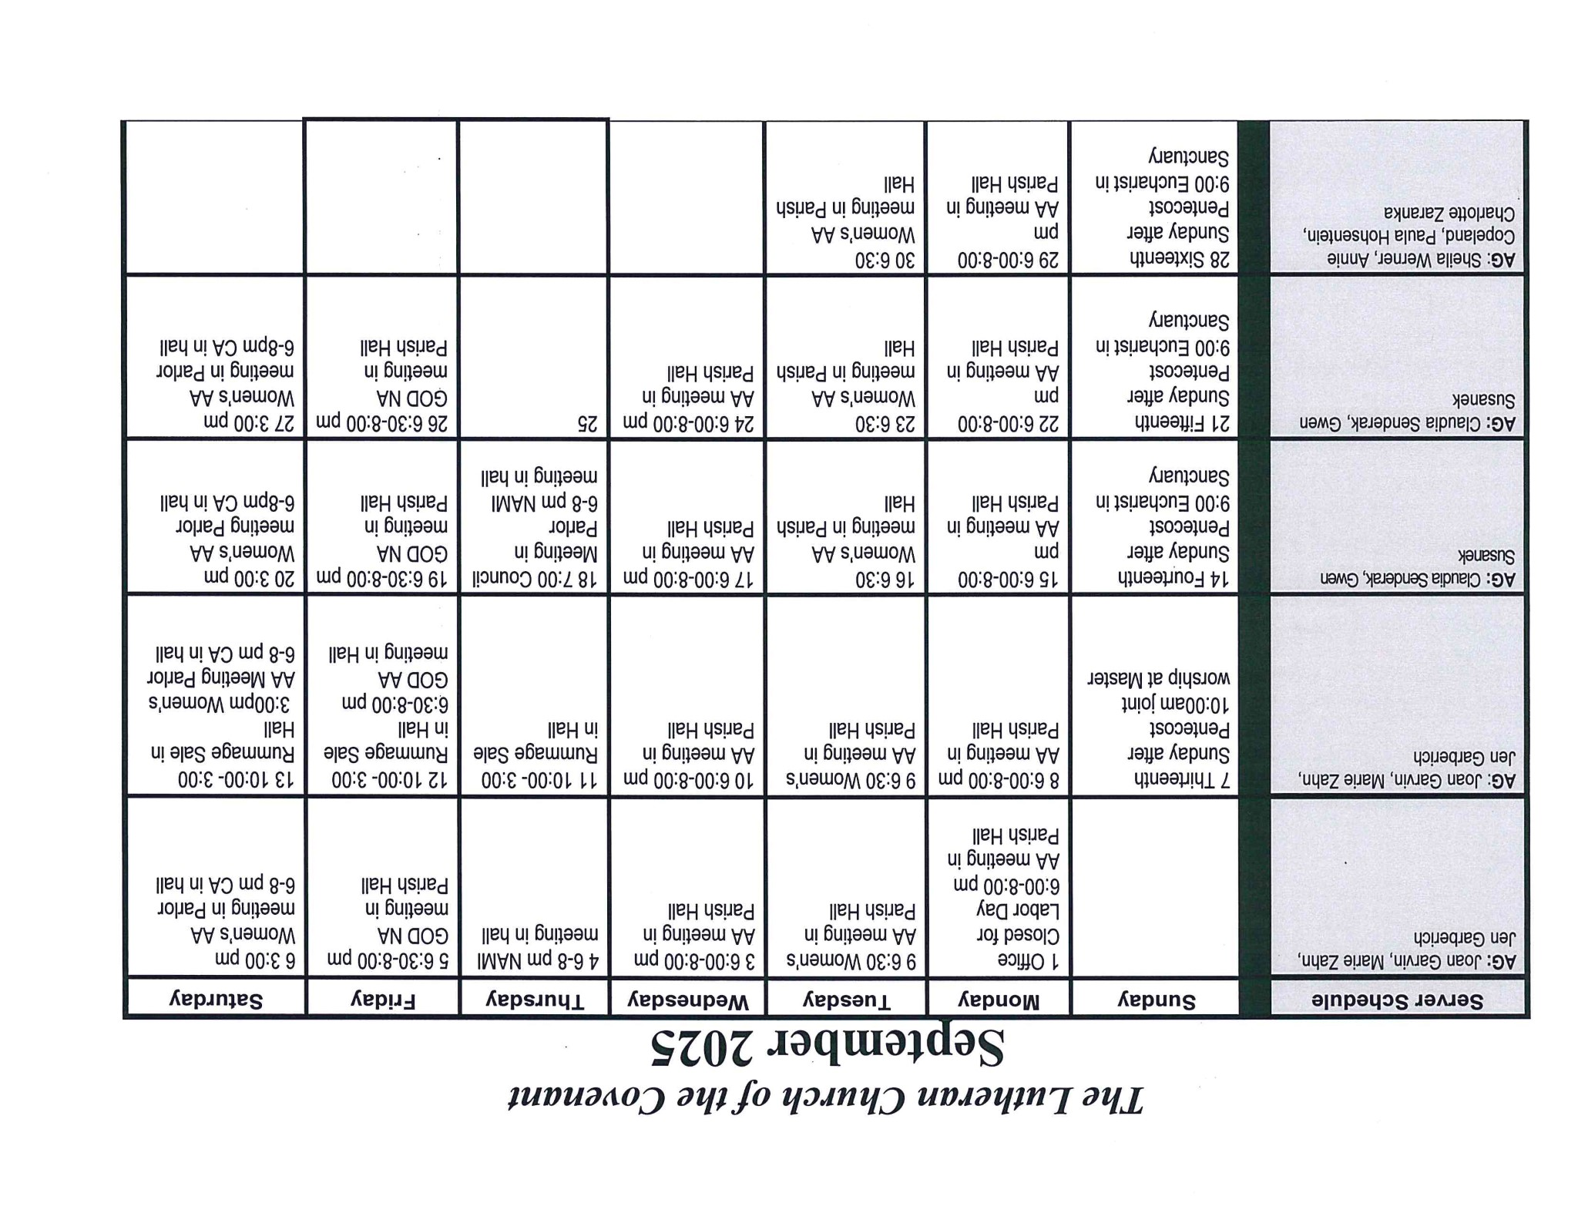

Covenant News

The Lutheran Church of the Covenant

19000 Libby Road, Maple Heights, Ohio 44137

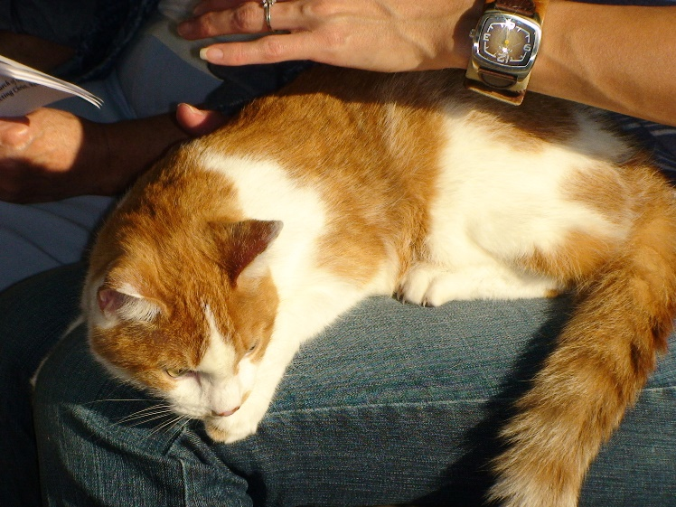Just a reminder that we are talking about planning blessing of the animals service in October. Details coming.