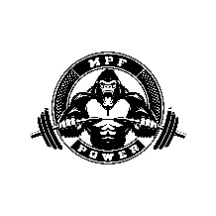
MPF-Power Meal Plan
“The Bulk”
Just Five Meal’s A Day
Breakfast Week 1-4 (Total Cal 653)
Boiled Eggs 2 (Cal 288)
Breakfast Burrito (Cal 510)
Greek Yougort 2 (Cal 200)

Lunch Week 1-4 (593)
Chicken Breast 2 (Cal 240)
Brown Rice 1 Cup (Cal 238)
Brocilli 1 Cup (Cal 34)

Dinner Week 1-4 (Cal 480)
Loaded Chef Salad

Protien Shake (x2) (Choose one)
- Core Power (Cal 170)
- Lean Body (Cal 280)

Snack Week 1-4
- Greek Yogurt 2 (Cal 204)

Total Cal – 2610g
Protiens – 245g
Fat – 97g
Sugar – 62g

Meal Plan Disclaimer

- The meal plans provided are intended for general informational and educational purposes only and are not intended as a substitute for professional medical advice, diagnosis, or treatment. While we aim to offer balanced and nutritious options, individual dietary needs and restrictions can vary widely.

- Always consult with a qualified healthcare provider or registered dietitian before beginning any new diet or meal plan, particularly if you have any pre-existing medical conditions, food allergies, or specific dietary concerns.

- By following this meal plan, you acknowledge and agree that you do so voluntarily and at your own risk. We assume no liability for any adverse effects or consequences that may arise from the use or misuse of the information provided.

