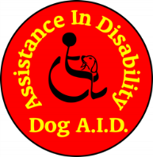

Information regarding the application process.

Thank you for your interest in receiving training with us. Dog A.I.D is composed entirely of voluntary dog trainers who give their time and expertise freely, therefore we look for commitment from our clients to keep up with regular training and keeping appointments unless illness prevents this.

There are a number of forms to be completed during the application.

1. Pre-application Questionnaire
2. Vet form (plus your dogs veterinary history will need to be sent to us by your vet)
3. GP/Consultant Form
4. Multi-dog household form (if appropriate)

(Please note Vet’s and GP’s will make a charge to complete these forms; vet forms are an annual requirement if accepted on to the programme).

These forms will be reviewed and if appropriate your dog will be seen by your prospective trainer for an eligibility assessment. There is a £50 non-refundable fee for this assessment.

If our Training Advisor is happy that your dog is a suitable candidate you will be asked to complete:

1. Contract
2. Membership Form
3. Responsibilities and Expectations Form
4. Jacket Policy
5. Copy of your Pet insurance Policy including Third Party Cover

And to pay your membership fee of £40.

I hope this will help you to decide if you wish to progress your application.

