How to Rise to the Top | SEO for Your Small Business
  - Search Engine Optimization for the Technical Communicator
Written by: Stacey Ailie | Edited by: Langdon Tower | Produced by: Genna Daniel
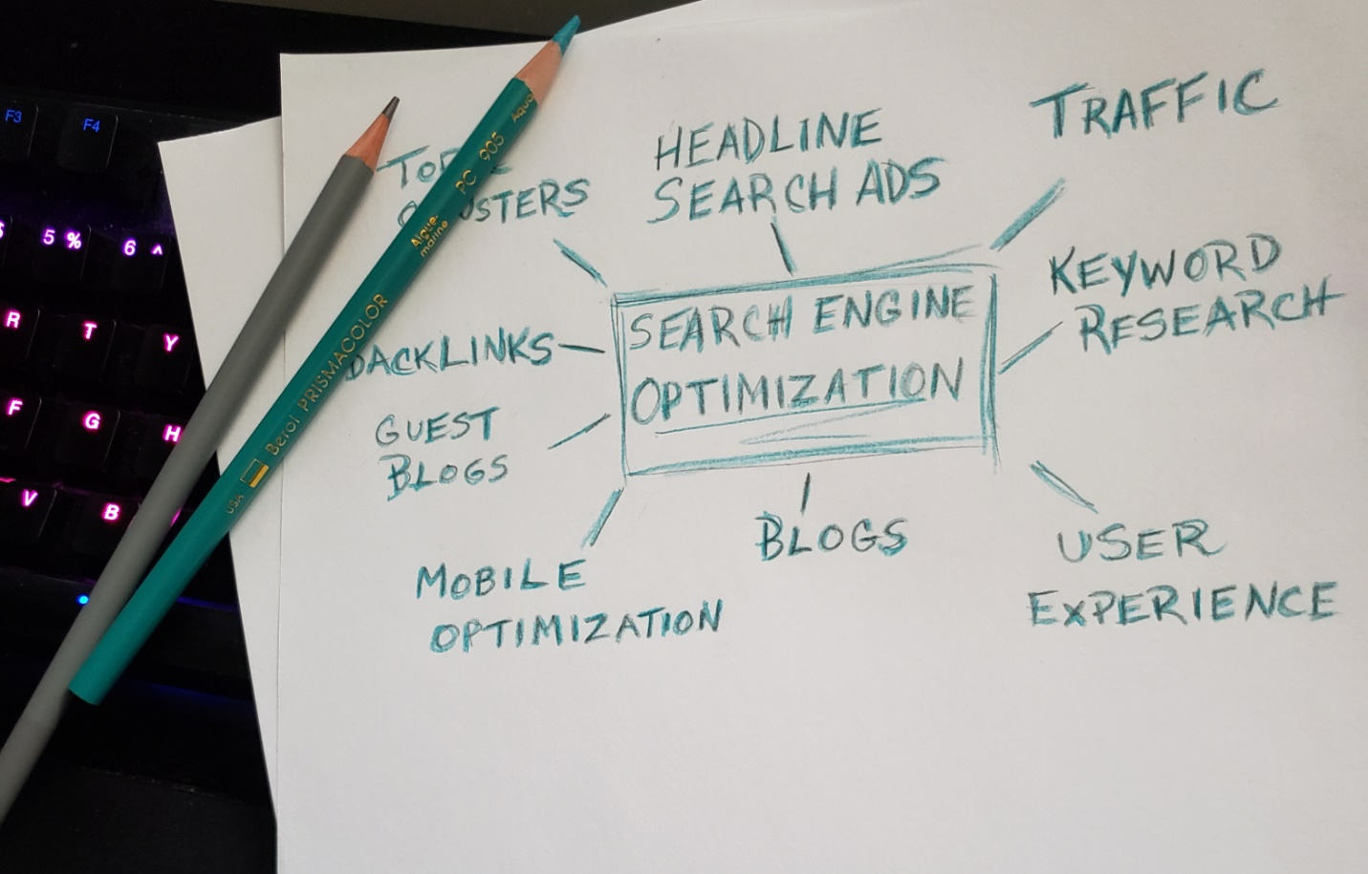

SEO for a successful business
Small businesses thrive when customers can discover them online and purchase their goods or services. The most common way customers will find your business is through a search engine. As a technical writer, you can help your employer or client use search engine optimization (SEO) to achieve their business goals. This blog will help you find success for your small business client or employer, using SEO.
Goal: To help your business's website appear high on the list in search engine results.
Definitions:
- SEO: Search Engine Optimization: the strategy of designing your website and its content to improve traffic from search engines. SEO targets unpaid traffic.
- SEM: Search Engine Marketing: the promotion of websites by increasing visibility to search engines through mostly paid advertising.
- PPC: Pay-Per-Click: Internet marketing where advertisers pay a fee each time one of their ads is clicked.
- Black hat SEO: A practice that could increase a page's ranking in a search engine but whose methods have been banned by the search engine.
- White hat SEO: A practice that improves a web page's search engine ranking while maintaining the integrity and proper practices as defined by the search engine’s terms of service.
- Gray hat SEO: A practice that is riskier than a white hat SEO and may or may not result in your site being banned from search engines.

How SEO works
Search Engine Optimization is basically understanding how search engines function to raise website content higher on search engine results pages. Let's do a quick study of how search engines work by looking at the three main techniques used by search engines:
- Crawling: The search engine scrubs the Internet for data, looking at code, content, and your area of authority once it finds your URL.
- Indexing: The search engine stores and organizes the content while crawling.
- Ranking: The search engine provides the best answer to a searcher's query and lists the results from most relevant to least.
Your primary job as an SEO technical writer is to understand your subject, understand the relevance it may have to your potential customers, and present your subject in a way that meets the search engine's terms of service. Once that is done, you can use proven techniques to set up links and blogs in a continuous manner and keep your rankings on the search engines high.

White hat, black hat, and gray hat practices
Once upon a time, when search engines were new, people realized that search engine results could be easily manipulated. Online content creators began peppering their writing with unrelated keywords, duplicate portals, and hidden links, hoping that directing any traffic to their site would result in profit. This kind of manipulation, and other banned practices, are considered black hat.
Search engines have become much more sophisticated in their algorithms and can now sniff out black hat practices banned in their terms of service, such as hidden text links. Web sites that use these practices will be banned and removed from search engine results.
White hat SEO follows approved and reputable processes to show up on search engine results pages legitimately. This blog will focus only on white hat SEO practices.
Gray hat SEO uses practices that are a little harder to scope out by the search engines but still may not meet the terms of agreement. If discovered, the website might be banned.

Mobile optimization
Currently, over sixty percent of user searches occur on a mobile device. When you're setting up an SEO strategy for your business, you and your team should consider mobile searches. Try to keep your web pages and content friendly to the mobile community. Some search engines, such as Google, use mobile-forward crawlers, which index mobile content before looking at desktop versions of content.
To accommodate this, keep in mind your page speed and amount of content. Consider a responsive site design that is friendly to mobile users. You can use tools such as Google’s free PageSpeed Insights to measure your page loading speed.

Developing your SEO strategy
There are three aspects of SEO that you want to focus on as a technical writer:
- On-page SEO: Your actual on-page content.
- Off-page SEO: Links directed to your website from elsewhere. The higher the number of backlinks from reputable sources, the higher the trust from search engine algorithms.
- Technical SEO: The behind-the-scenes structure of your website, such as code.
This is where understanding your industry, understanding what your audience cares about, and incorporating that information into your business's objectives becomes crucial to using SEO effectively.

Using complicated mathematical algorithms, search engines calculate which websites will suit a user’s search. In this graphic, each circle represents a website. Search engines examine which sites link to other sites and give these links a weight. Websites getting more inbound links are considered more relevant to what the user might need. Website A, with the most inbound links, ranks the highest. Website B, although having only one link, ranks second, due to its incoming link coming from a very popular website. C, although it does have a lot of incoming links, ranks third because none of the incoming links are from highly rated websites.

Arranging your website by topics
To create good online content, you will need a good understanding of the product or service you're writing about. If this client or company is new to you, do your research. Talk to your client/boss about the business plan and the goals for the website. These are critical to drive your writing.
Then pick ten words or terms that describe your products and content. Don't choose anything that isn't relevant to your topic or business plan. Use an SEO tool, such as Google's Keyword Tool, to identify your words’ search volume and any variations on that word that make sense for your business.
You can now identify what are called short-tail keywords. These keywords are relevant topics of your business, pulled from the list you created.
Rank your short-tailed keywords by relevance and search engine results. These words are now the pillars of your website. Choose a few related words for each pillar word. That will help narrow a user's focus on your business and help the search engines identify your content. These are your long-tailed keywords.
Long-tailed keywords can be topics for individual web pages and blogs. This creates clusters around your pillars, which helps search engines find your content and rank you higher on their search results pages.

Topic clusters
The more specific your content, the more data you're giving search engines to rank you. Specific content will assist your audience in narrowing down the information they need, converting traffic to leads and sales. The search engine will see the in-depth coverage of your topic, representing a good chance to answer user inquiries. This will drive your search result rankings up.
Your pillar words require long-tail words surrounding them to help users find what they're looking for. The more relevant those words are to your pillar, the better your chances are to generate interest. Words that are related to each other become your topic clusters and flesh out your web page topics. This can also lead to new ideas for blog topics.

Build a web page for each topic
For each pillar word or subject, create a web page or post. These pages now identify your table of contents and can be the structure for buttons, tabs, and links. Use your long-tail words no more than three or four times each. Any more than that, and a search engine algorithm may believe that you are keyword stuffing, and your ranking will drop.
Your number of topics should be in line with your business plan, such as a product page for each product or service offered. Each page should host an overview of each pillar, with the long-tail words helping clarify and enrich your content.

Create blog posts
Yes, there are hundreds of thousands of blogs out there. Yes, that's a lot of competition. But even with all that competition, a blog is a handy tool you should consider. Well-written and cleverly structured blogs can raise your ranking in search engines. Here are a few ways blogs do this:
- Blogs can delve into a topic in-depth, which shows well to crawlers.
- Blogs written between 1,500 and 3,000 words give plenty of room to drop well-used, pertinent long-tail keywords and highly searched topics that are relevant to your business.
- Front-loading information in the blog helps keep short-attention-span readers interested.
- Creating cross-links on your web pages, from the pillar pages, the home page, and the blog page, helps search engines find and rank your pages. This is an excellent way to add links to other sites in exchange for a link to your site. More on this in a minute.

Regularly schedule new blog posts and web page updates
It's important to keep active and maintain a presence online. If you're writing about relevant topics, people will come back to see what you have to say. The web crawlers from different search engines will scour your writing for content and rank it.
How often should you blog? Weekly would be great, but if coming up with new content is stressing you out, try monthly updates. Whatever you decide, be decisively, anally, religiously consistent with it. Why? Two main reasons: this builds a following in your reader base, and teaches search engine crawlers that you will have meaningful new content for them to scour and rank in a consistent timeline, thus lifting your ranking.
It's also vital to keep your content updated. Nothing is more frustrating than to find the exact answer you're looking for, for a product or service, then finding out that the page is several years old and may no longer be useable or correct. You don't want to be the reason your users become frustrated. You don't want the search engines to consider your content dated and downgrade your website.
Verify your facts. Remove old products and replace them with the latest version. Check out your links to make sure you're not sending your users to dead pages. This is where your technical SEO strategy needs to focus.

Work on link-building
You've already cross-linked all your pages with all your blogs and created a healthy path around your content. This is a great technique that will help crawlers determine your content’s importance. What really helps SEO is to get links from other websites to your pages. These are called inbound links or backlinks. These types of links will have a positive impact on your ranking. The more respected or important the site that links to you, the bigger boost you'll get.
How do you create backlinks? This is where you develop your off-page SEO strategy. Brainstorm creative ideas to get the word out about your site. Is there an established site whose customers would be interested in your products or services? Could you write a guest blog for another blogger and add a few links back to your site? What about online magazines or print magazines? Talk to friends and family and have them share links to your site. Would your local paper have an interest in a story about your product or service? Can some local businesses share flyers with QR codes, or add a link on their own web pages in exchange for the same? Do some research, set up a plan, and implement it.

Continuous improvement, or staying on the merry-go-round
You've done it. Your website is cruising along, your blogs are finding an audience, and all this new traffic is creating sales. Now the hard work is over. Right?
Not exactly. The foundation of your SEO strategy only stays solid with diligence. Trends change. Keywords become stale. Search engines update algorithms, and SEO strategy changes with it.
To protect all your hard work, keep up to date with SEO trends and strategies by researching sites and blogs dedicated to SEOs. Here are a few that are very useful:
SEOBook
Search Engine Roundtable
Search Engine Land
Track how many backlinks you have. Google Analytics is a great way to do this. You can set it up to report all the different websites that link to your content.
Set up meaningful metrics to let you know if your online presence is experiencing growth or stagnation. Choose a web analytics tool to monitor traffic. Check your rankings on various search engines. Use this data to identify your successes and point out areas where you can improve.
Keep Updating your tools to Success!
Many thanks to Bwyse internet marketing for helpful suggestions and great support. To read more about SEO, blogs and how to create great content, please check out their website at bwyseinternetmarketing.com

