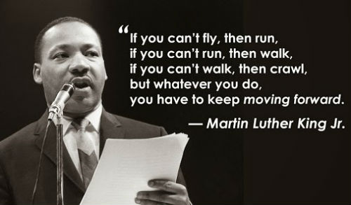  Helping people Raise their Standards one step at a time while moving forward in life.  Raising A Standard, Inc. work with People with Mental Illness and Individuals on some form of Probation or being released from Incarceration.  This will be carried out with Integrity, Commitment, Advocacy, Respect |  |  | Who We Are  About Us  Raising A Standard, Inc. was established in 1999. Providing Job Coaching, Supported Employment, Job Development and Soft Skill Trainings to person with Disabilities.  Our Agency provides motivational workshops to families and youth. We believe in dealing with the root of the issue that will eventually produce positive and successful outcomes over coming all circumstances and situations life brings. You can achieve this by Raising a Standard in life and moving forward to become a positive and successful citizen one step at a time.  Dunns & Bradstreet Sams.gov  Febdbizzopps.gov Georgia Secretary of State  Contact Us  Phone: 678-392-6224  Email: raisingastandard1@gmail.com  Website: raisingastandard1.com  RAISING A STANDARD, INC.  Post Office Box 360623  Decatur, Georgia 30036 |  |  | RAISING A STANDARD, INC.  - Moving forward despite circumstances and situations in life.

  RAISING A STANDARD PROPOSES:  Raising A Standard, Inc. would like to become your One Stop Shop for your Community Support Individual providing:  - Life Skills  - Paraprofessional Services  - Personal/Social Skills  - Parent Aide Services  - Home Visits  - Case Management  - Workshops  - Supported Employment  - Work Readiness  - Comprehensive Vocational Evaluations |  | Job Coaching: | RISING ABOVE ALL SITUATIONS AND CIRCUMSTANCES IN LIFE  Raising A Standard, Inc. believes in developing the whole person. We are your One Stop Shop to overcoming your circumstances and situations in life one step at a time.  You may write me down in history  With your bitter, twisted lies,  You may tread me in the very dirt  But still, like dust, I'll rise.  Maya Angelou  Raising A Standard Services:  JOB Program (Jump on Board):  Supported Employment Program. This is our Competitive Work program for persons with significant disabilities that have not experienced competitive employment or employment was disrupted due to a disability  CVE Program:  Comprehensive vocational evaluation sets an objective base that develops an individualized vocational plan. The assessment identifies motivators (interests and personality factors), aptitudes and achievements (readiness to work  Work Evaluations:  Short term assessment that takes up to 30 days.  Observing work behaviors, physical capacities, work habits, interpersonal and functioning skills  CWAT (Community Based Work Adjustment): This is a twelve-week comprehensive time-limited program that will assist in developing or reestablish work habits and behaviors. Improve Quality and quantity of work, personal and social skills while functioning in their community with capacities and attitudes appropriate for employment.  Job Coaching:  Intensive one on one service while client is working in a competitive integrated work setting. This includes job task analysis, job training, Behaviors in the workplace, natural supports, and employer relationship  WORKPLACE READINESS:  Interrelated classroom setting can be in groups or individual depending on client. Classes focus on services designed to help develop or re-establish employability skills as well as ethics, personal, social behaviors. Workplace readiness is designed to meet the needs of each person as they grow into their personal vocational goals. |  |  |   R.A.S. Purpose:  To empower individuals that has endured hardships to know that they can overcome all obstacles, circumstances, and situations in life by taking the next step on their journey.  Raising A Standard, Inc. Goals:  Enhance positive parenting skills  Enhancing positive and effective communication skills  Enhancing learning at home  Enhance Positive Parenting techniques  Enhance positive relationships  Enhance Social Skills/Life Skills

