Trentham Pre-School
My All About Me Book

My name is………………………..
Date of birth……………………….
Start Date…..……………………

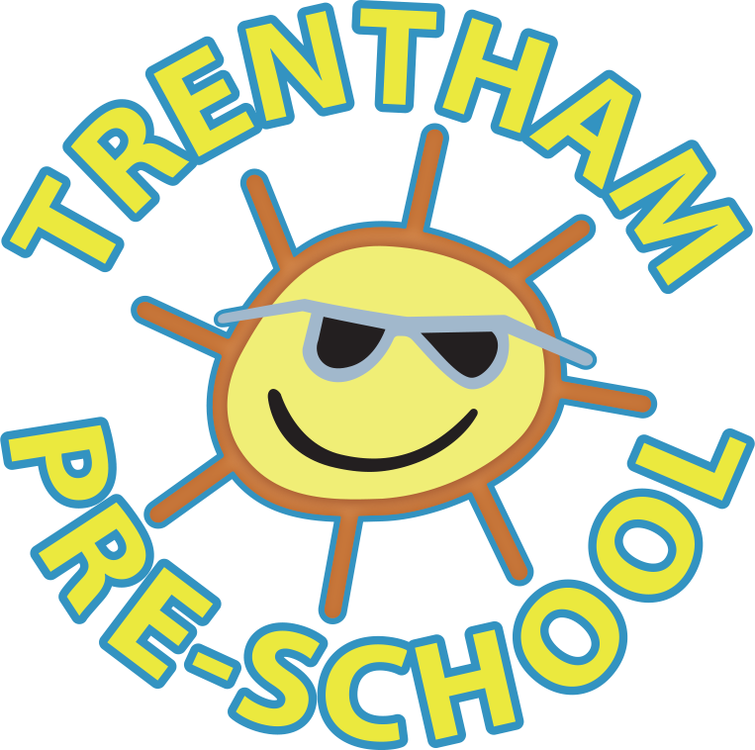

All about your child’s family
Who does your child live with? Tell us their first name and relationship to your child.
Do you have any family pets? What type of animal are they (including the breed if a dog) & what are their names?
Who are your child’s favourite people? Who do they love spending time with? Tell us about their extended family.
Tell us about your child’s background and culture. What things are important to you as a family? What celebrations and special events does your child take part in?
How your child sleeps, self-care and toileting
Does your child have a special comforter?
e.g Blanket, teddy , dummy etc
Does your child need a nap in the day? If so what time of day and for how long?
How does your child show you or tell you that they are tired?
Is your child still in nappies? Yes/No

Or

Can your child go to the toilet independently/still needs a little bit of support with their toileting?

Please provide any additional information that may help support your child’s toileting needs.

Your child’s interests and preferences
What does your child love to do?
What are your child’s favourite toys to play with?

What are your child’s interests?

Does your child have a favourite character/Tv show?
Do you have anything that you regularly do? Visits to the park, swimming etc.
Is your child registered with a dentist? Do you regularly brush their teeth, and do they take part in this or like/dislike having their teeth brushed?
Is there anything your child dislikes?
If your child is upset, what usually comforts them?

How your child eats and drinks, likes and dislikes
What does your child like to eat and drink?
What foods or drinks does your child not like?
Does your child drink water?
Can your child use a knife, fork & spoon independently?
Can your child drink from an open cup?
Any special dietary requirements or preferences?
(that is not an allergy)

How your child communicates with you and others
How does your child tell you what they need or want? If you can please give us an example.
What language is mainly spoken in your home? Are there any other languages that your child hears regularly?
What are your child’s main sounds / words or phrases?
Does your child use any gestures to communicate their needs?

All About me!
Will your child interact with familiar children and adults?
Does your child follow instructions and co-operates with the daily routine?
Does your child move with confidence and in a range of ways?
e.g running, jumping, climbing
Does your child show a preference for a dominant hand?
Is there any nursery rhymes/songs that your child enjoys?
Does your child enjoy reading stories?
Does your child have any favourite story books?
Anything you would like us to know to best support your child?

Things I would like the Pre-school to support my child to do:

My Concerns are:

Anything you would like us to know to best support your child?

We do ask that you provide Preschool with pictures of family, friends, and pets for your child’s key worker to put in their scrapbook this will help them to bond with your child and will help them settle into Preschool.
You can bring these into Preschool or Email them to trenthampreschool@yahoo.com and we will print them off for you.
First Day Checklist
- Coat (weather appropriate, with Sun hat, warm hat, gloves as necessary)
- Bag with Spare clothes
- Nappies or spare pants.
- Lunch (AM and Full Day sessions only)
- Dummy/Blanket/Favourite toy (comforter)
Please make sure everything is labelled.

