Acwerk Rural Development Foundation

Annual Report

2023 - 2024

Health Care Activities - Educational Activities - Relocating Trust Activities

May 2023 to March 2024

* Field survey, in choosing a site for farmland and Acwerk Centre in Tiruvannamalai district proximal to Jawadhu Hills
* Surveyed villages Senthamangalam, Polur, Athipadi and Vengikal

Method adopted to survey: Conducted by two office bearers of the Trust, a civil engineer, and a resident, of the surveyed villages.

1. **Preliminary Research**

* Identifying Potential Areas
* Review Existing Data

1. **Community Engagement**

* Stakeholder Meetings
* Outreach Clinics and Surveys

1. **Environmental Assessment**

* Biodiversity Survey
* Soil and Water Testing
* Climate Analysis

1. **Resource Mapping**

* Land Use Mapping
* Resource Inventory

1. **Infrastructure Planning**

* Sustainable Design
* Transportation

1. **Implementation Plan**

* Action Plan
* Funding and Associates

1. **Monitoring and Evaluation**

* Regular Monitoring
* Feedback Mechanism

1. **Documentation and Reporting**

* Documentation
* Reporting
* PPT Presentation attached
* Online Yoga classes and Therapy

Introduction to Patanjali’s Yoga Sutras

The Initiation to Eight Limbs of the Yoga Sutras

Preparation of physical and mental faculties in Yoga practice

Pranayama

Asanas

Meditation

Interactive Classes for three hours a week to each student

Therapy by Personalized Approach

Holistic Healing

Stress Reduction

Pain Management

Improved Flexibility and Strength

Enhanced Mental Clarity

Emotional Balance

Therapy provides a comprehensive approach to healing three hours a week to each person

* Outreach clinic at Periapatty village, Dharmapuri district - One day - October 2023

Venue - Panchayat Office

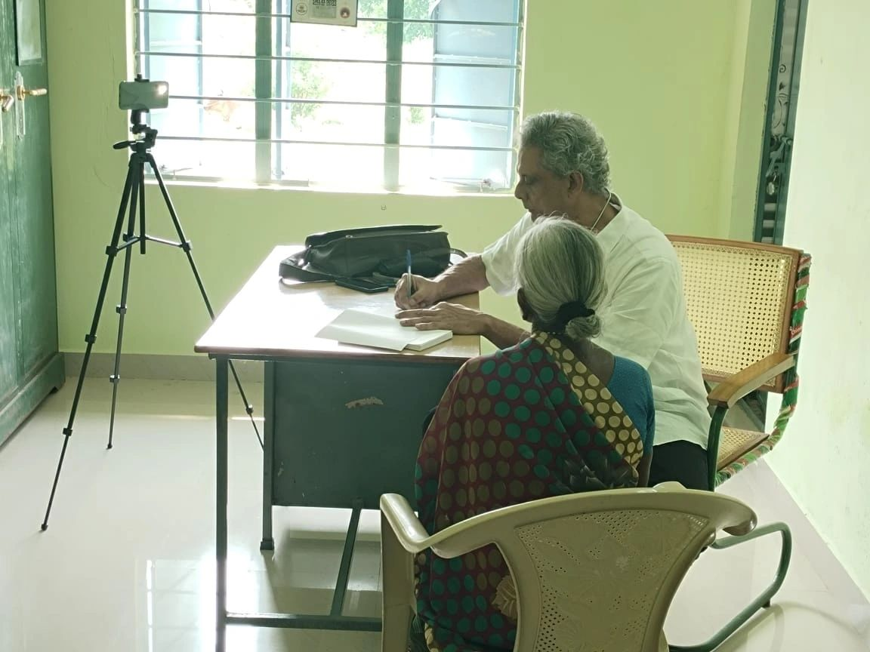

1. Dr. T.M. Chinnaiyan - treating a lady patient at Periapatty Village - Outreach Clinic

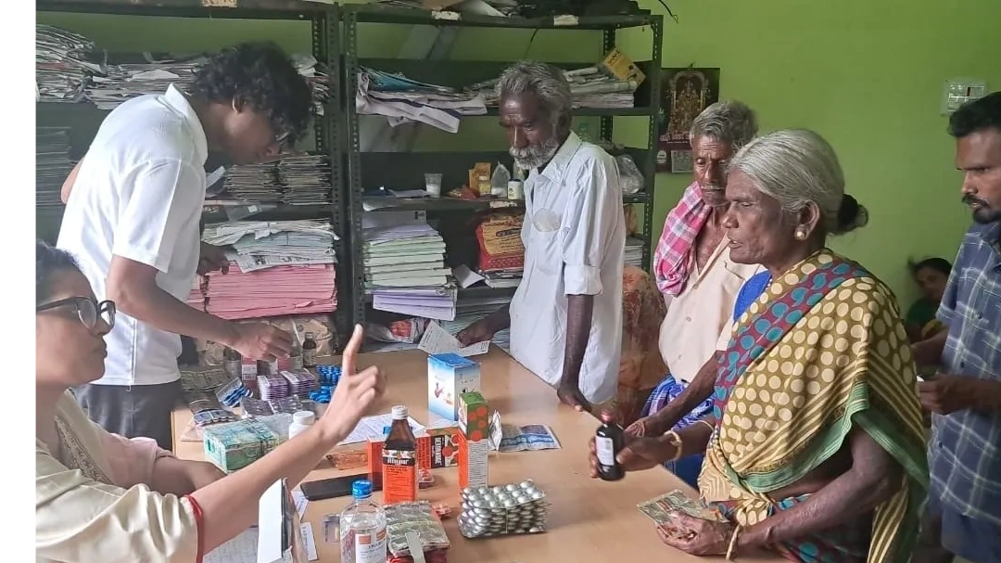

1. Health Volunteer issuing Prescription medicines to patients at Periapatty Village - Outreach Clinic

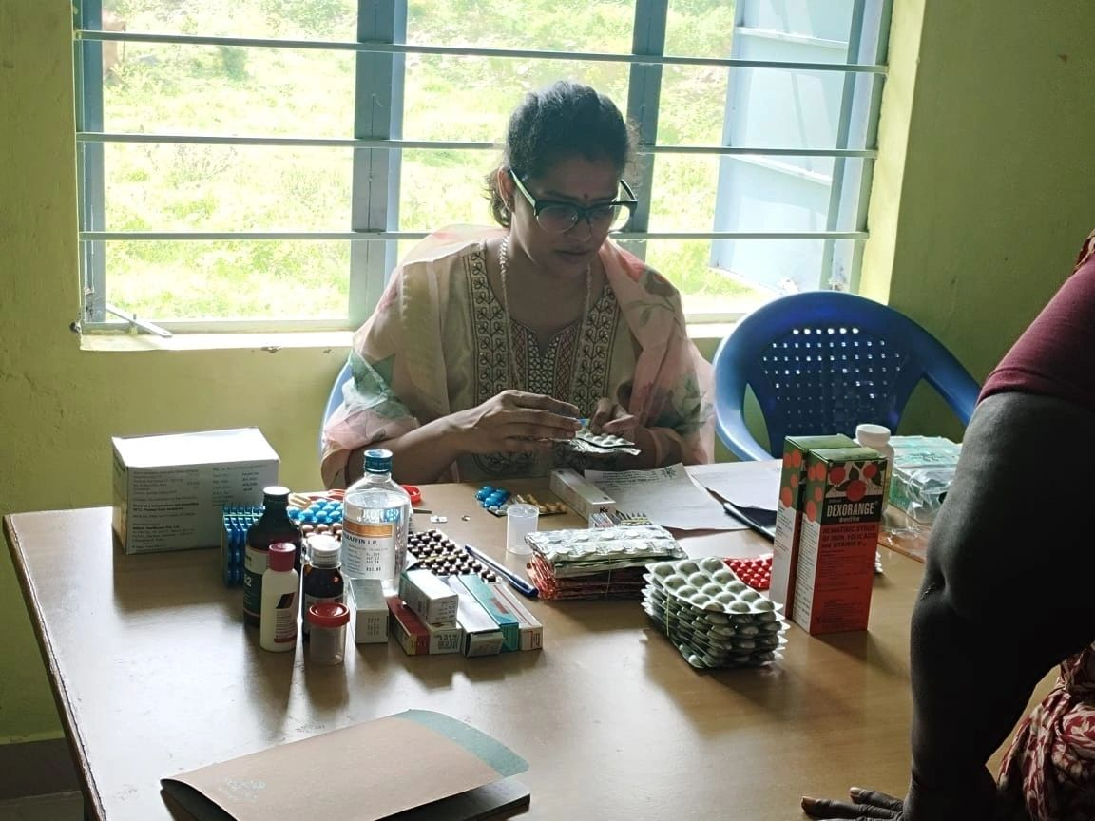

1. Athiya Chinnaiyan advises the patients to use the medication as per the doctor's prescription

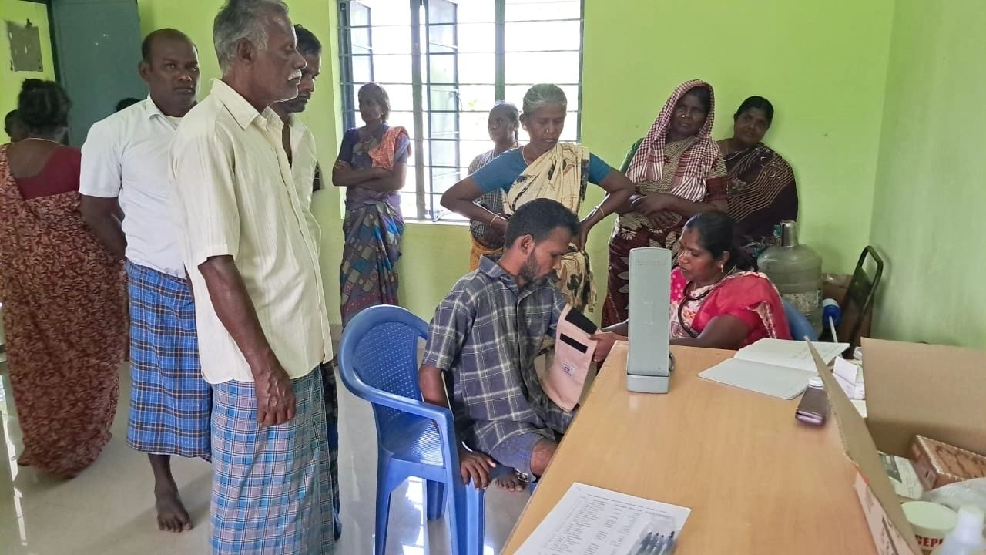

1. A Village Health Worker checking vital signs and random sugar of patients

* Medical camp and outreach clinics for 5 days in December 2023 at Jawadhu Hills - Society For Rural Development, School for Tribal Children.

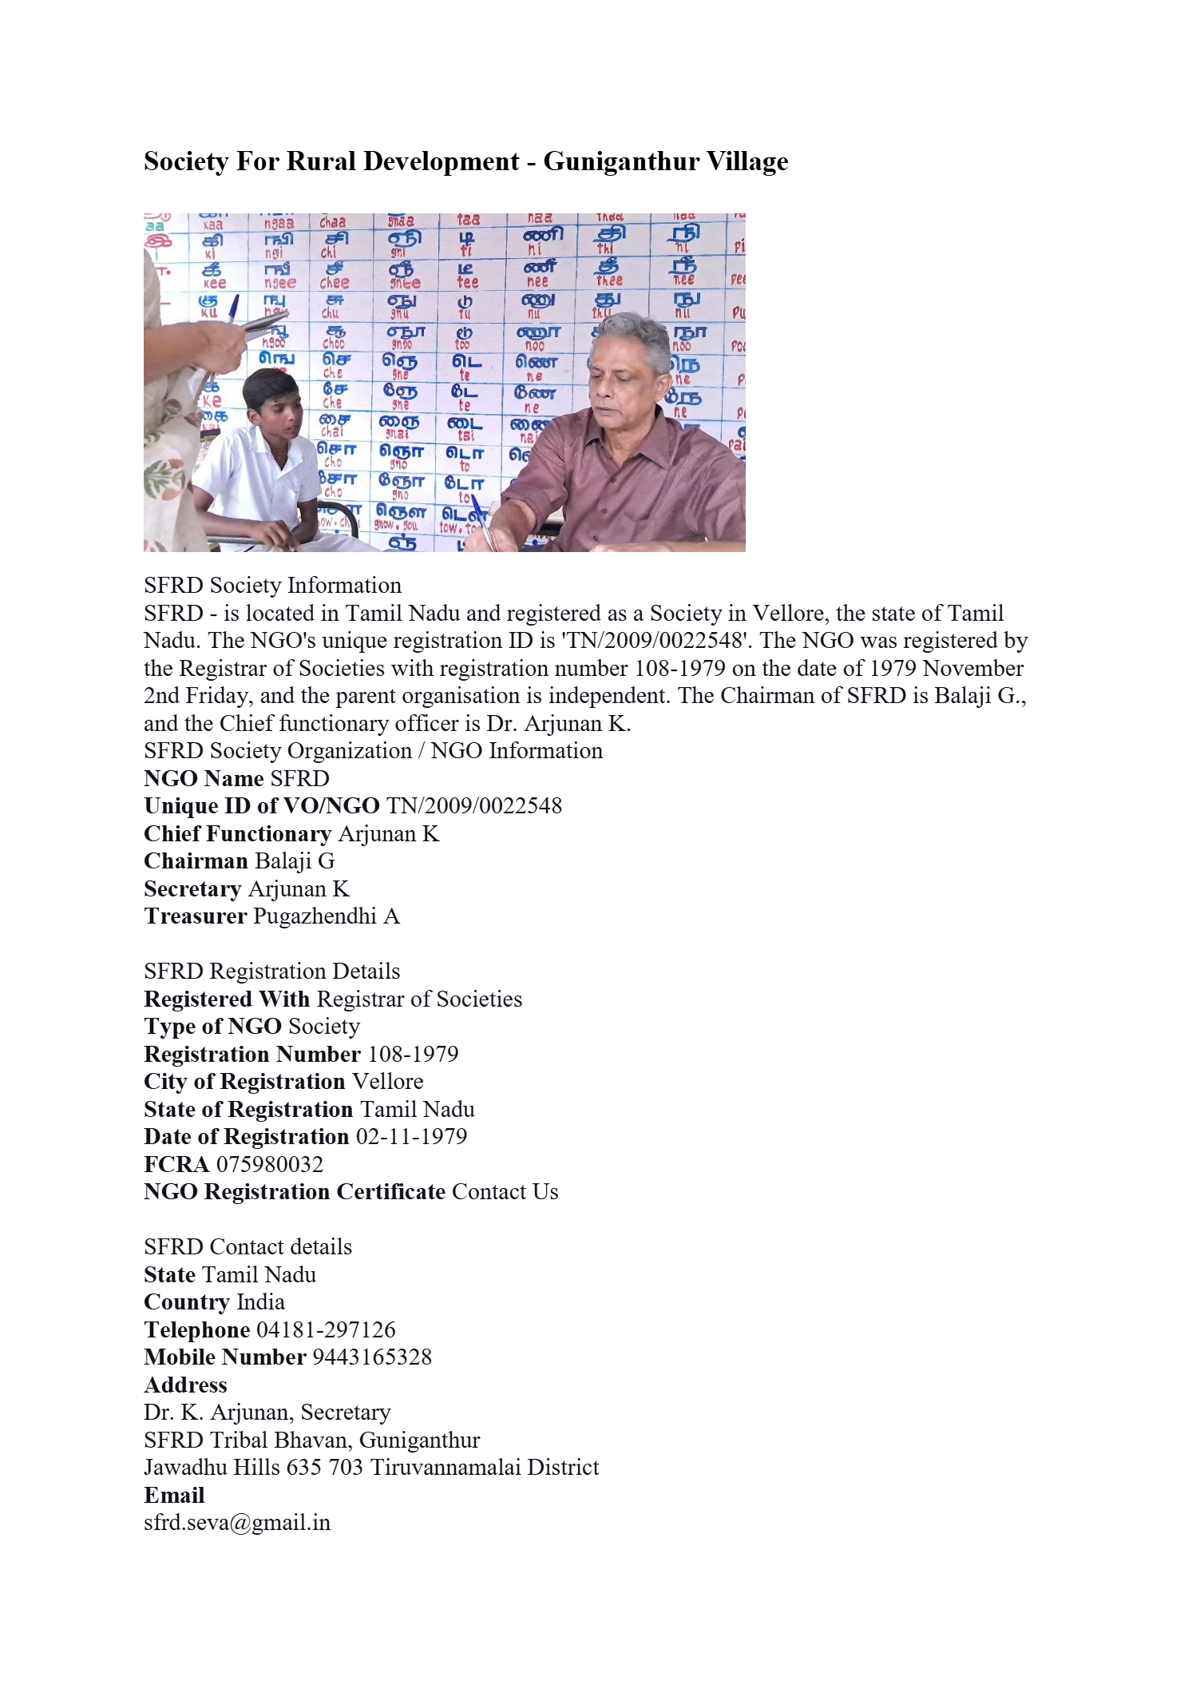

1. Outreach Clinic at SFRD - Guniganthur village-Jawadhu Hills - Dr.T.M. Chinnaiyan treating School Student

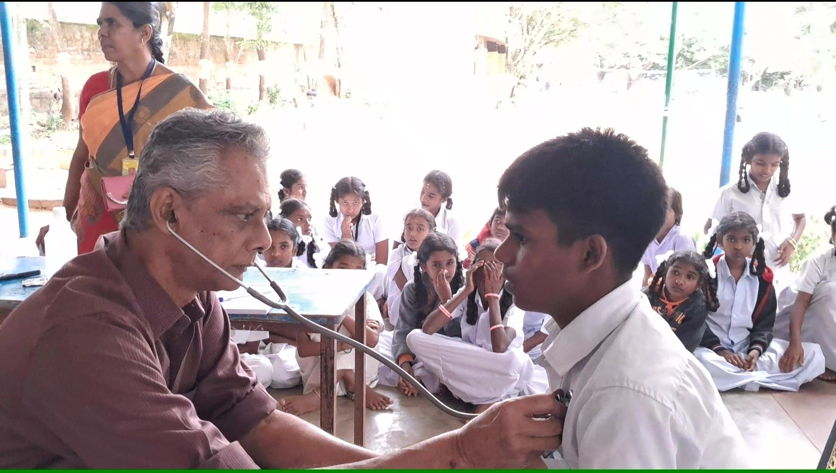

1. Outreach Clinic at SFRD - Guniganthur village-Jawadhu Hills - Dr.T.M. Chinnaiyan treating School Student

* Marganur village

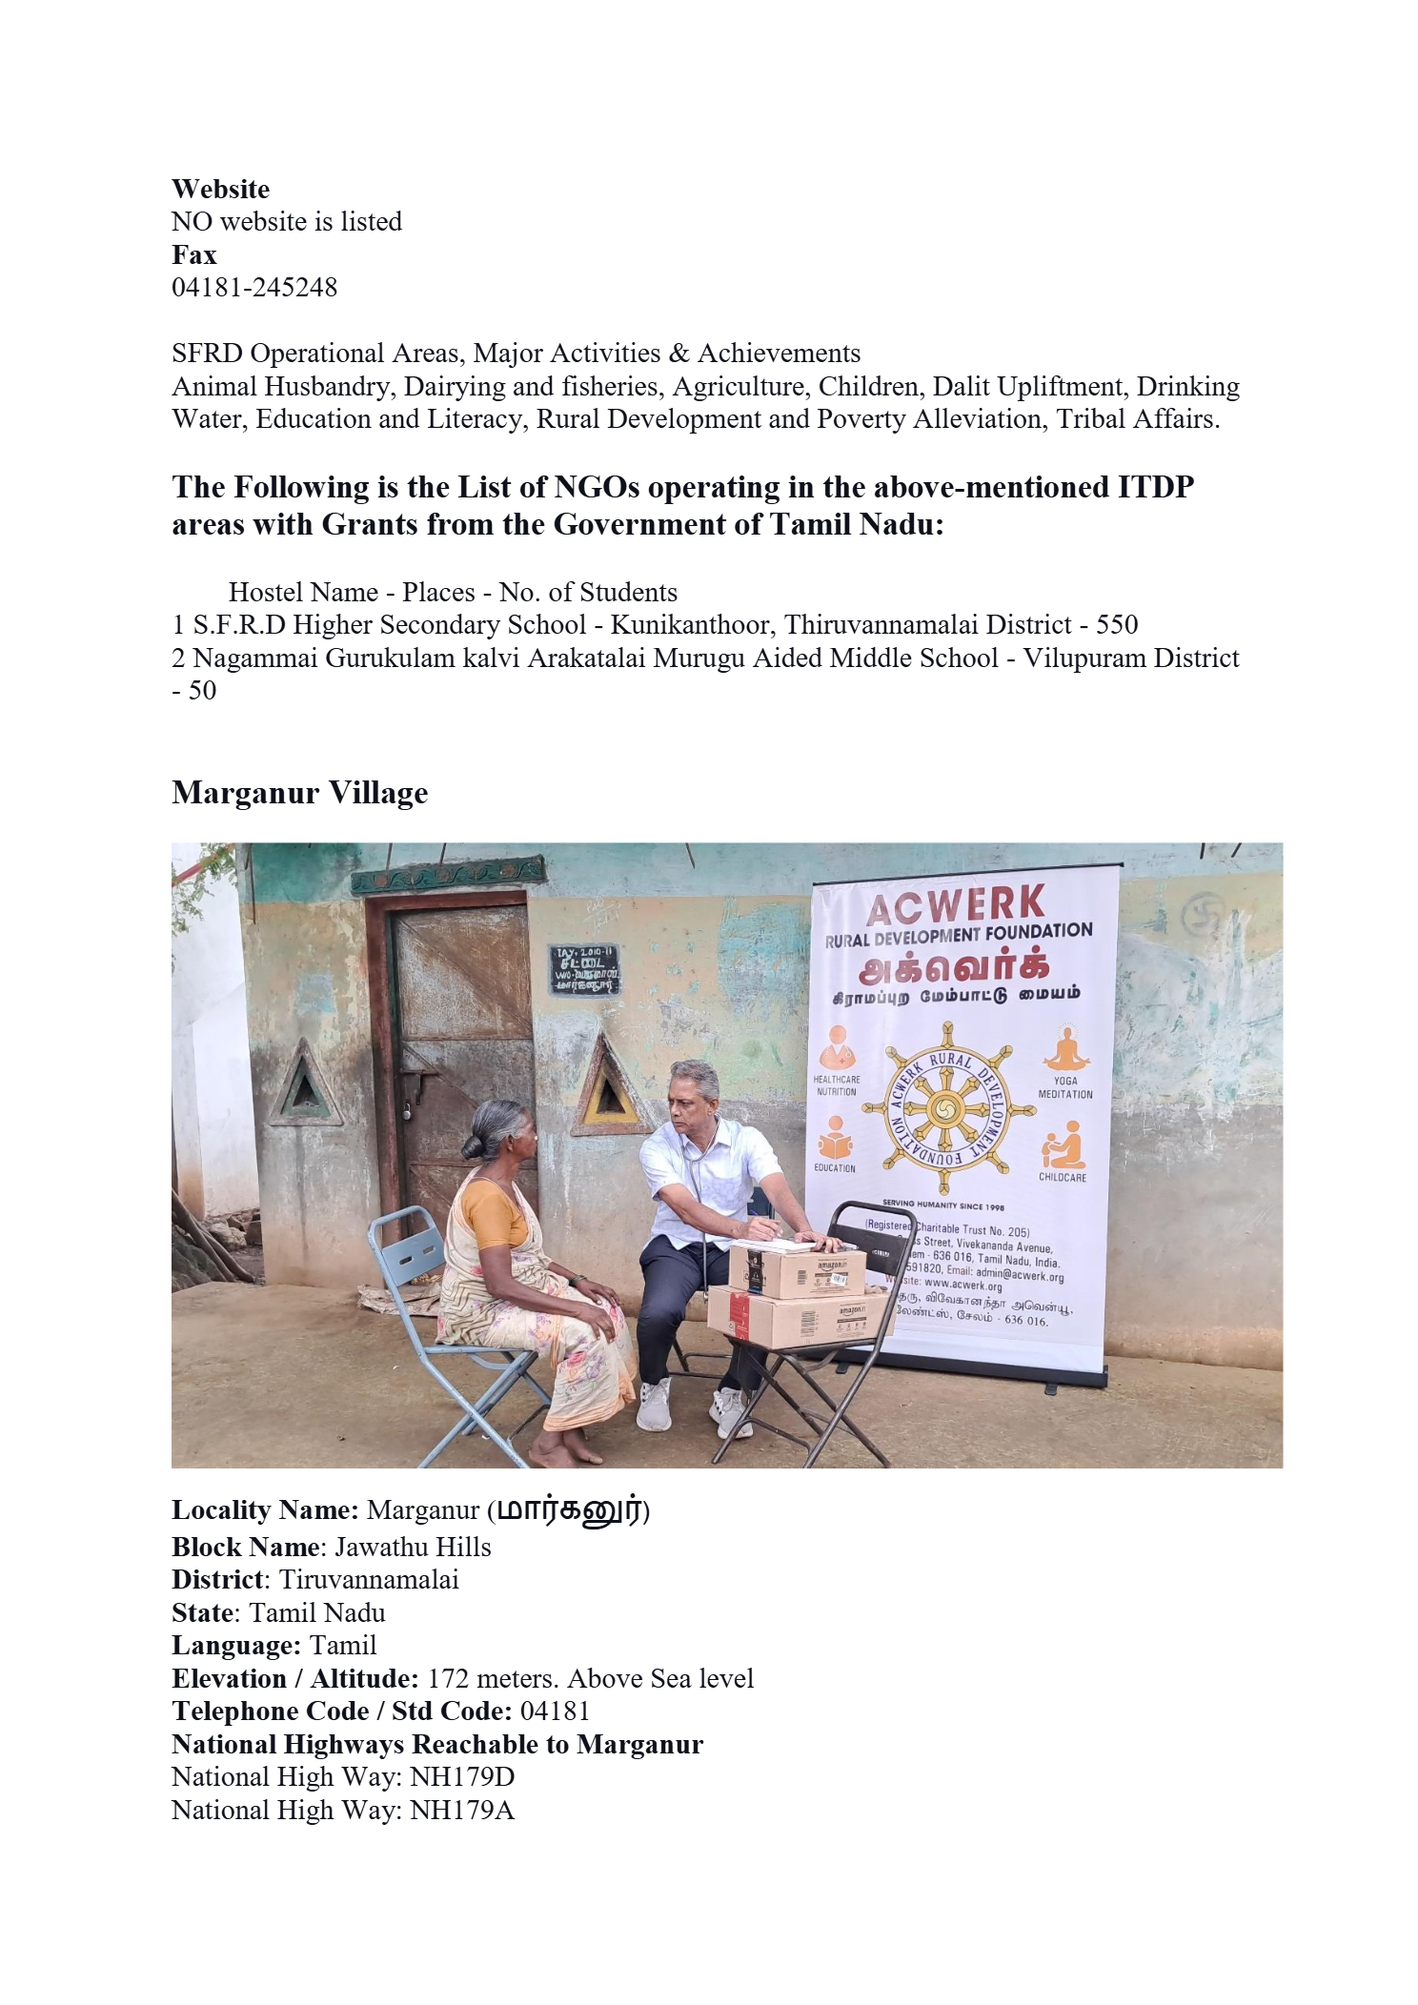

1. Outreach Clinic at Marganur Village-Jawadhu Hills- Dr. T.M. Chinnaiyan with lady resident for treatment

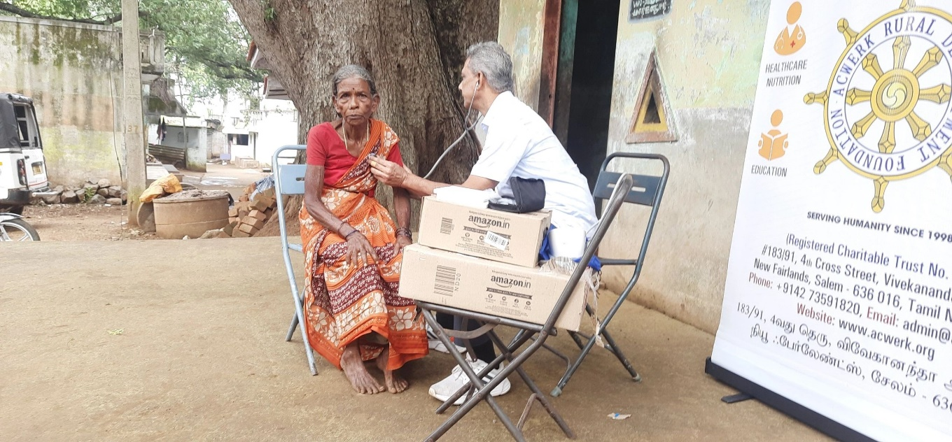

1. Outreach Clinic at Marganur Village-Jawadhu Hills- Dr. T.M. Chinnaiyan with lady resident for treatment

* Vilankuppam village

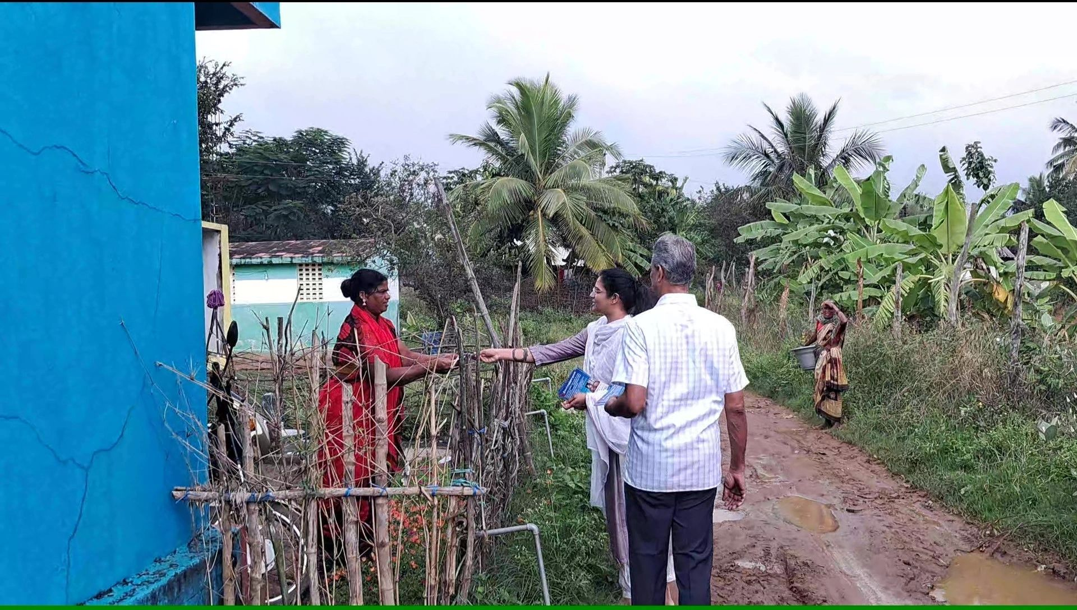

1. Dr. Chinnaiyan and Athiya Chinnaiyan meeting village residents of Vilankuppam

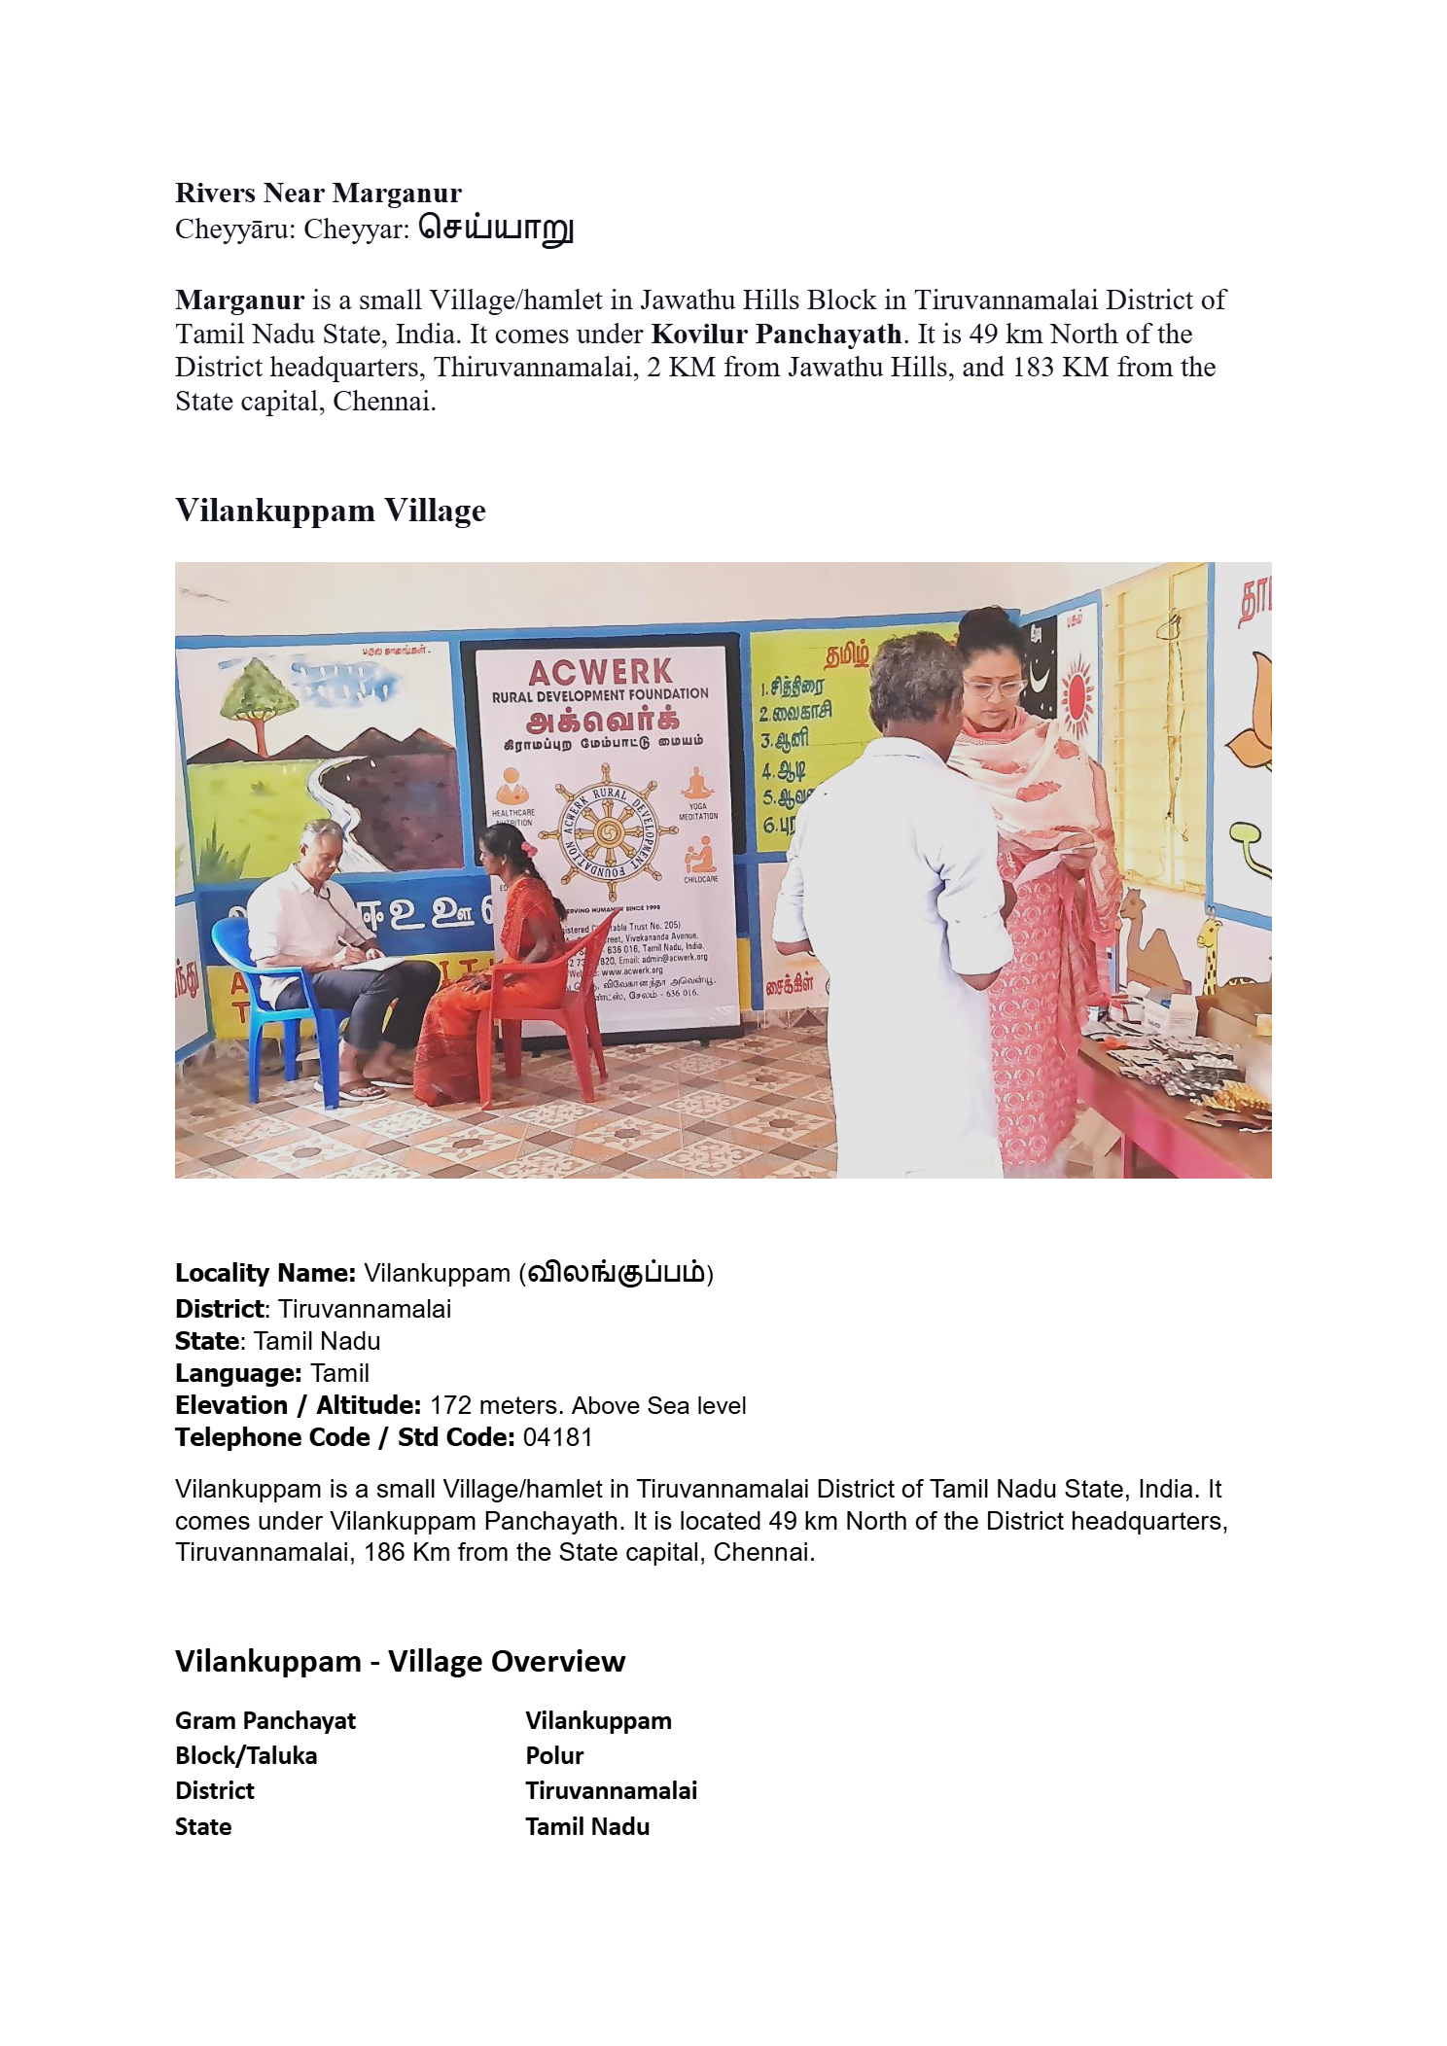

1. Outreach clinic at Vilankuppam Village Jawadhu Hills- Dr. T.M. Chinnaiyan with lady resident for treatment

Venue - SFRD building, public place in Marganur and Noon-Meal Centre in Vilankuppam villages respectively

Outreach clinics

Healthcare services to underprivileged and remote rural and tribal populations

Identifying Health Needs

Engaging Community Leaders

A healthcare team of a Doctor, Nurses and Village Health Volunteers

General Medical Problems, Dermatology, Paediatrics and Maternal Health, Health Education

Funding from national and international donors

Medical equipment, supplies and medications provided by Trust and Local donors

Preliminary village visits and distribution of pamphlets

Selection of venue for conducting a clinic - Local Residence/Public Building with easy access to villagers

Consultation practice

Issue of Prescription medicines

Minor surgical procedures

Referral services for specialised management

Regular feedback and assessment of the clinic’s impact on patients and their health

Changes in approach to the outcome of evaluation of clinic

Training of local health volunteers in follow-up

Indulging in community participation

Reporting